Assignment No-2
Name- Onkar Marbe
Note : To solve below queries use “sales” database
Q. 1. Write a query that produces all rows from the Customers table for which the salesperson’s number is 1001.
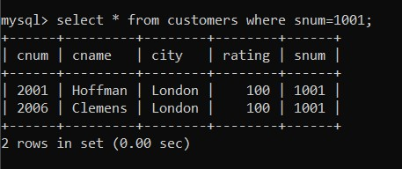
Q. 2. Write a select command that produces the rating followed by the name of each customer in San Jose.
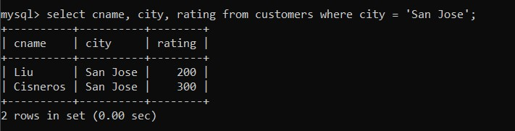
Q.3 Write a query that will produce the snum values of all salespeople from the Orders table (with the duplicate values suppressed).
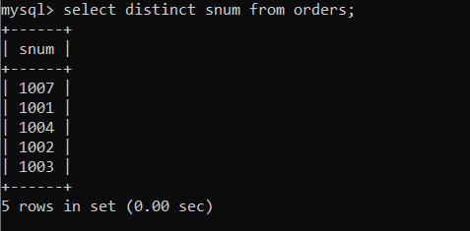
Q.4 Write a query that will display all the orders for amount more than Rs. 1,000.
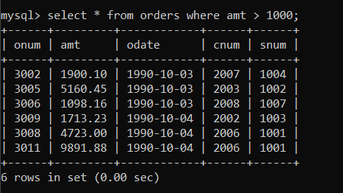
Q.5 Write a query that will give you the names and cities of all salespeople in London with a commission above 0.10.
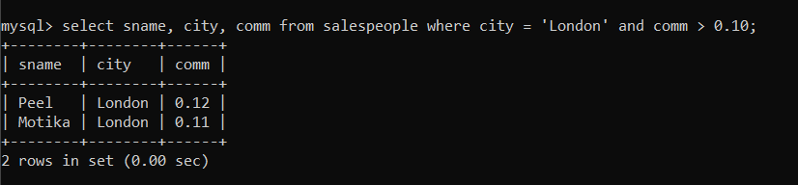
Q.6 Write an SQL query that returns all customers who have a rating greater than 100, along with the customers located in Rome regardless of their rating.
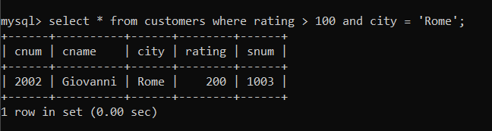
Q.7 What will be the output from the following query? Select * from Orders where (amt < 1000 OR NOT (odate = ‘1990-10- 03’ AND cnum > 2003));
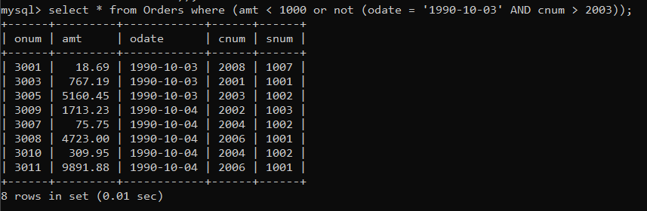
(odate = '1990-10-03' AND cnum > 2003) first it will execute this inner query and gives output and after that NOT will execute and whatever table we get from it do OR with amt<1000 .

Q.8 What will be the output of the following query? Select * from Orders where NOT (odate = ‘1990-10-03’ OR snum >1006) AND amt >= 1500;
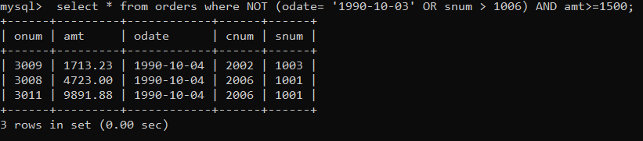
First (odate = ‘1990-10-03’ OR snum>1006) it will execute after that It apply NOT to it and whatever table we get it will AND with amt>=1500.
Q.9 What is a simpler way to write this query? Select snum, sname, city, comm from Salespeople Where (comm >= .12 AND comm <= .14);
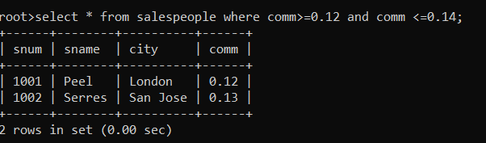
Q.10 Write a query that selects all orders except those with amount less than 100.
