Assignment 2

1.
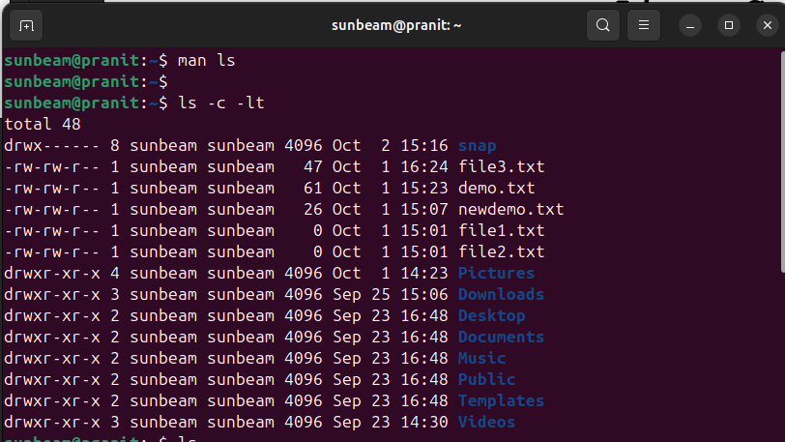
2.
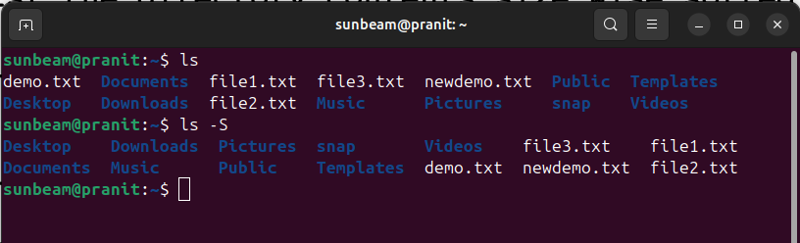

3.
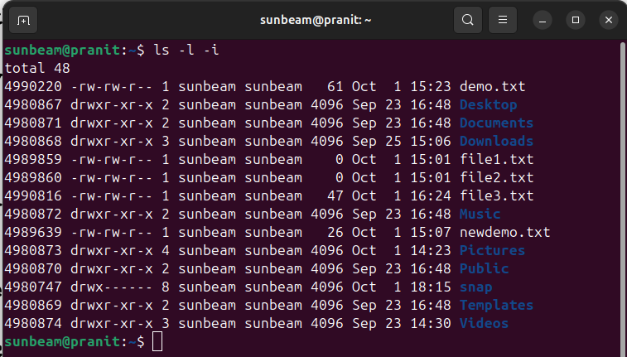
4.
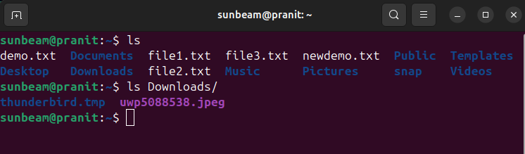

5.

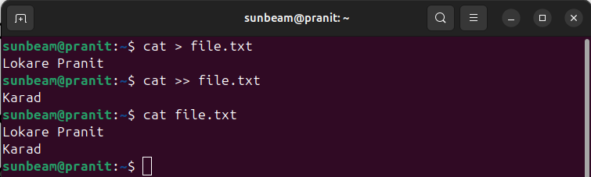

6.

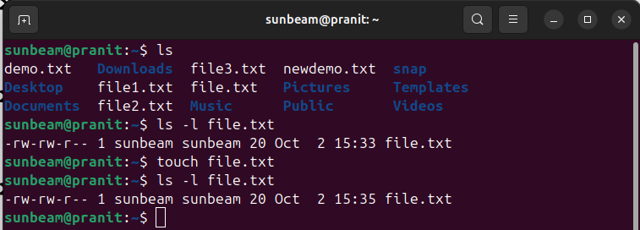
7.

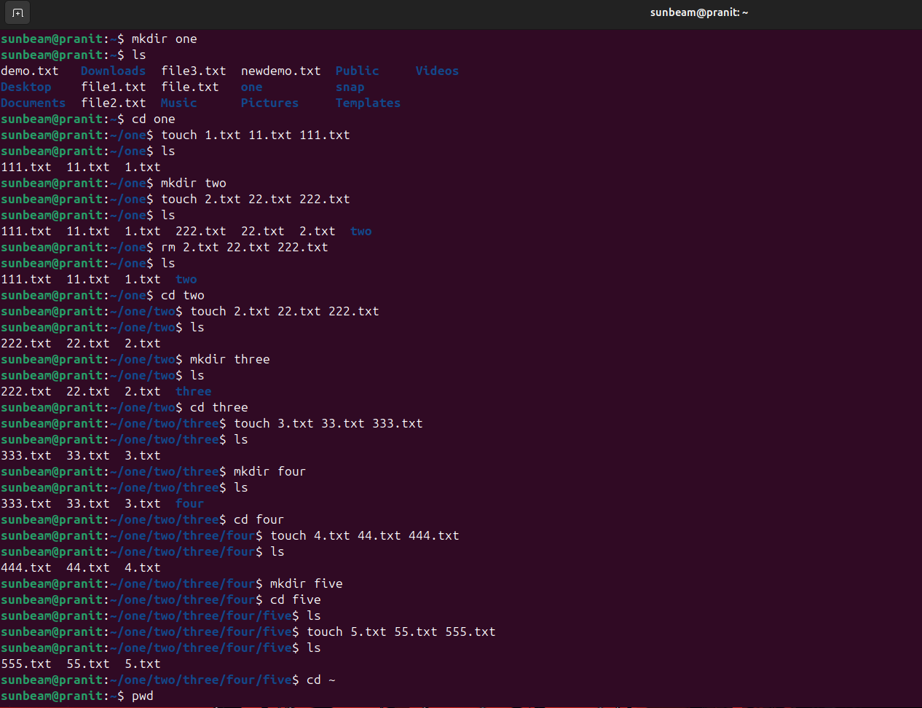

8.

i.
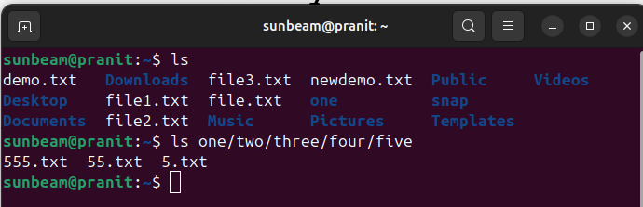
ii.
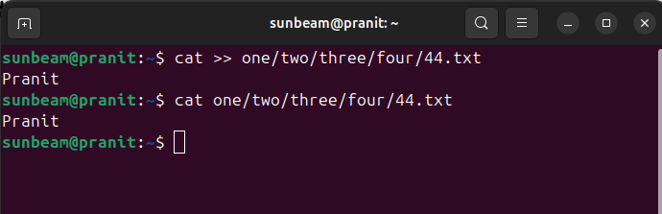
iii.
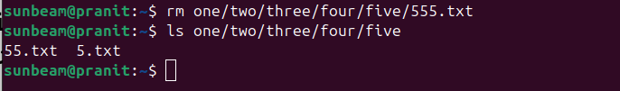
iv.
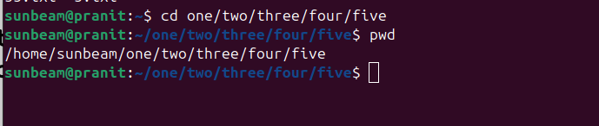

v.
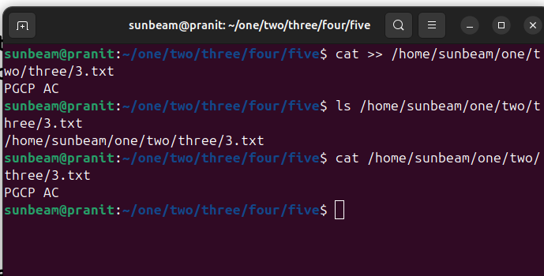

vi.
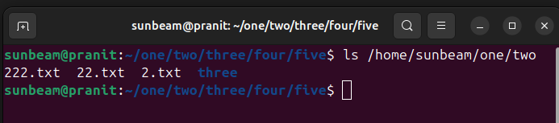
vii.
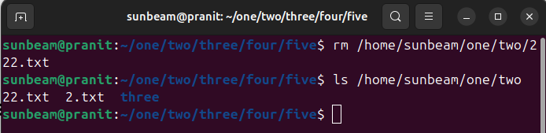

viii.

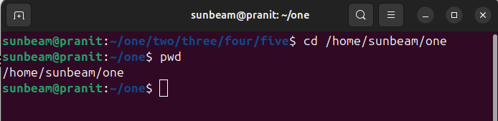
ix.
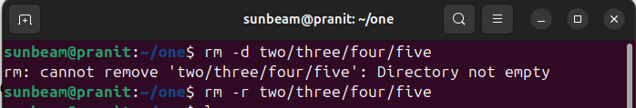
xi.
xii.

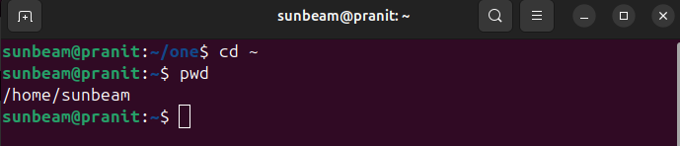

9.

