1.
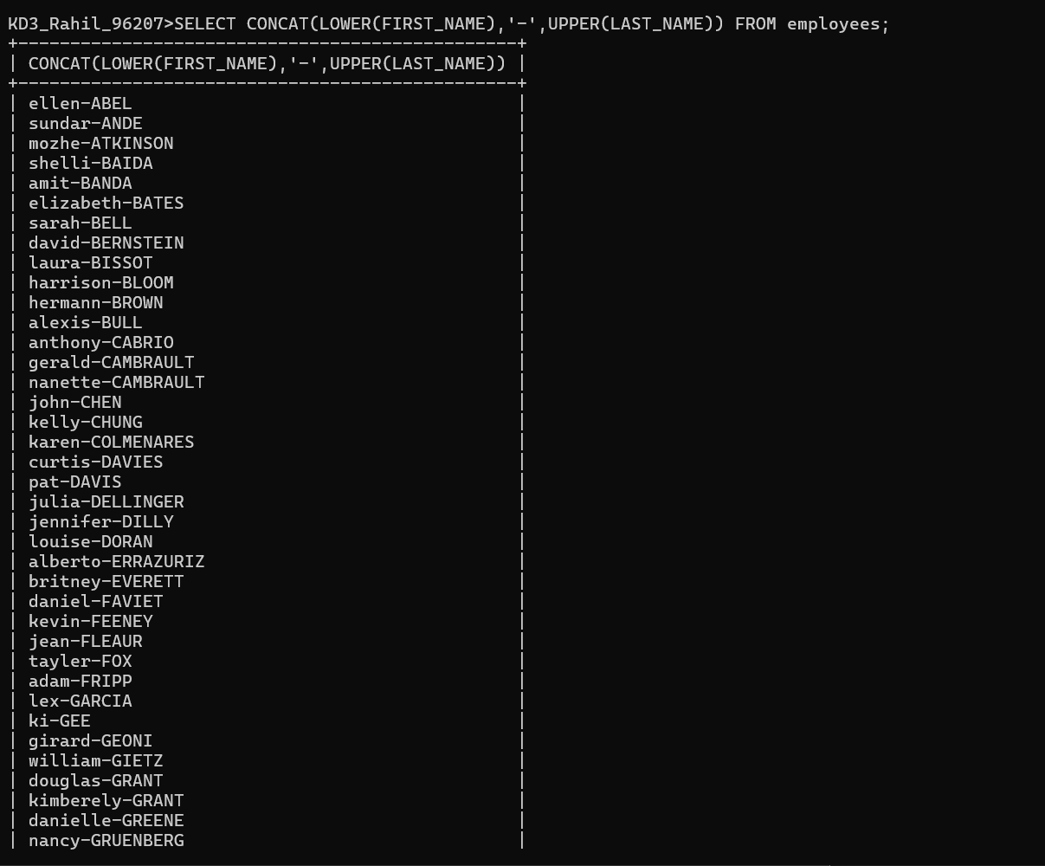

2.
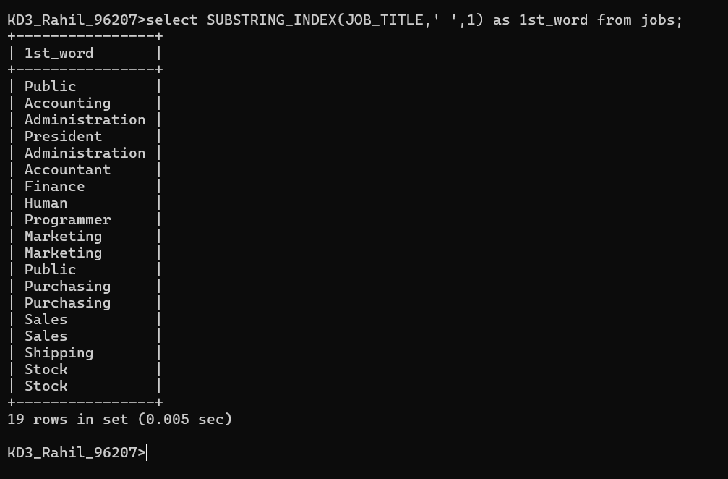
3.
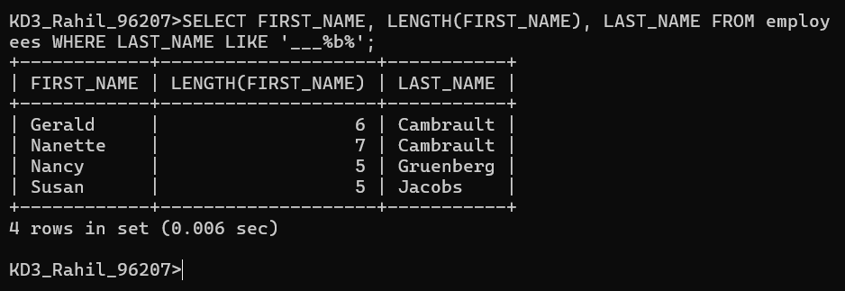

4.
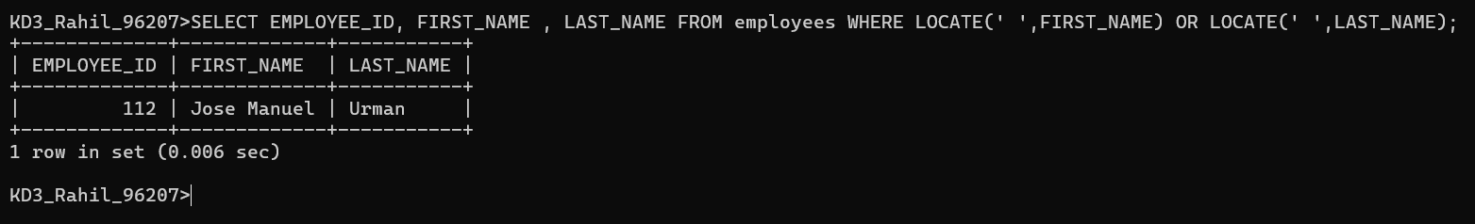
5.
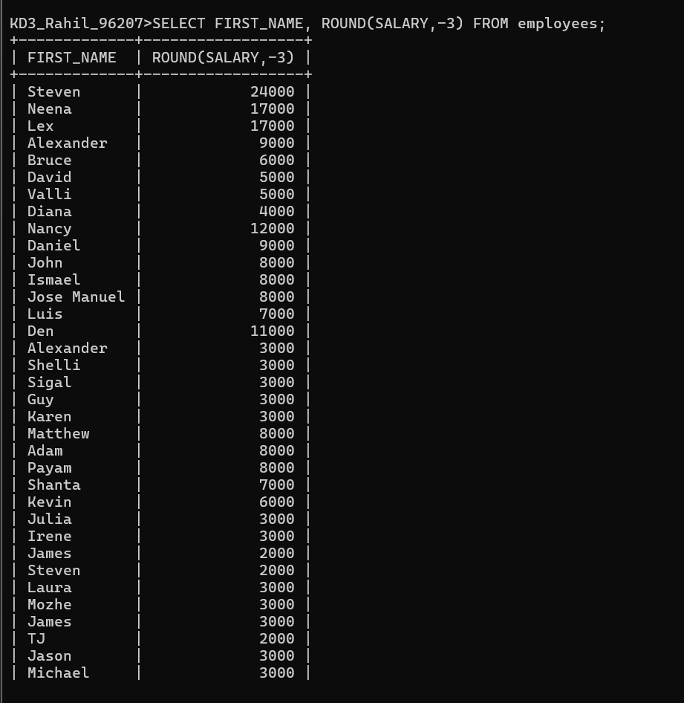

6.
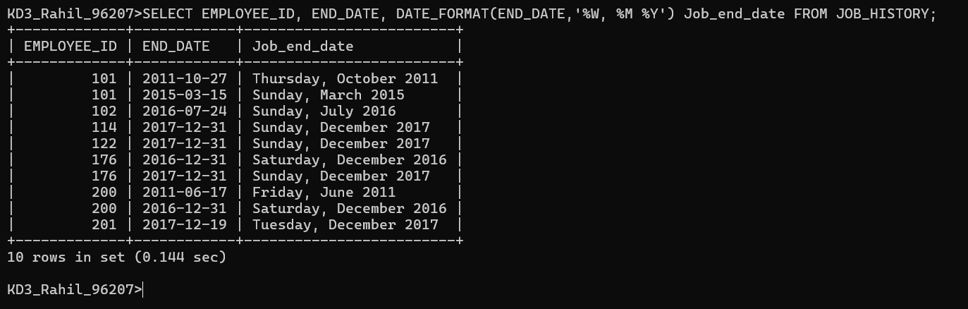

7.
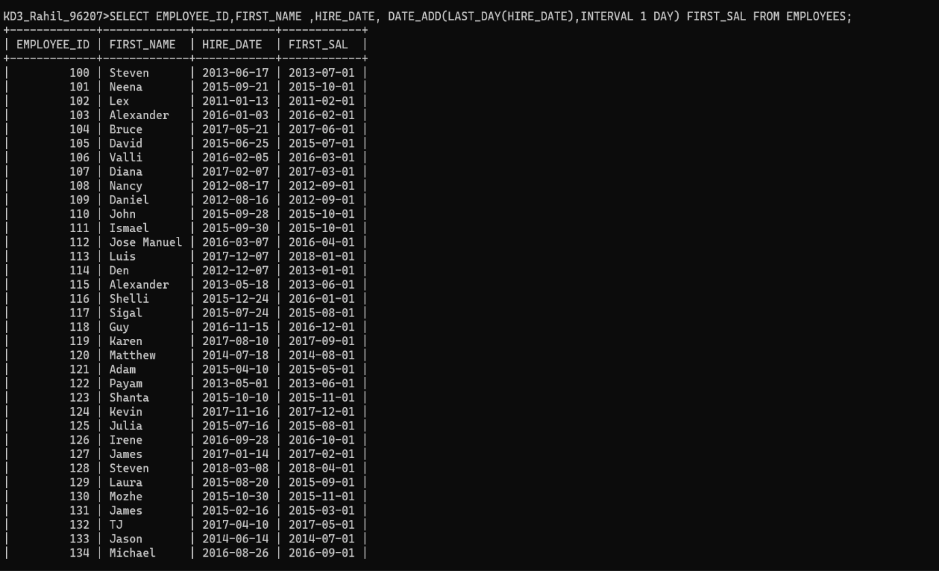
8.
DOUBT – NOT GETTING EXACT MONTHS AND DAYS IN EXPERIENCE

9.
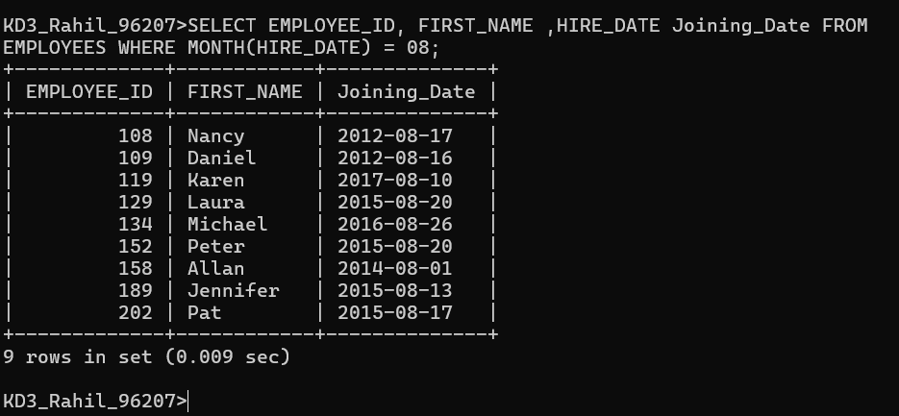

10.

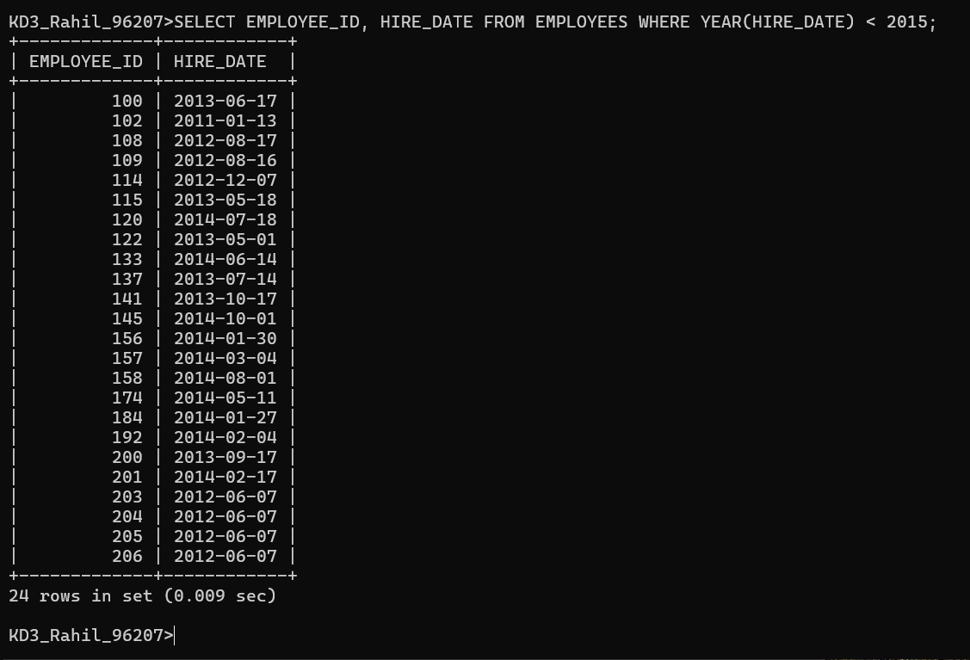
11.

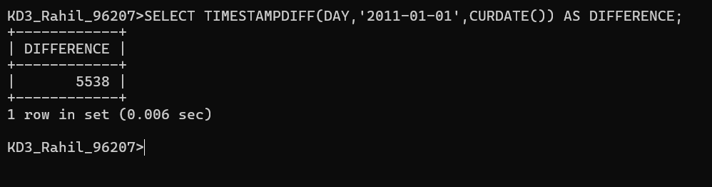
12.

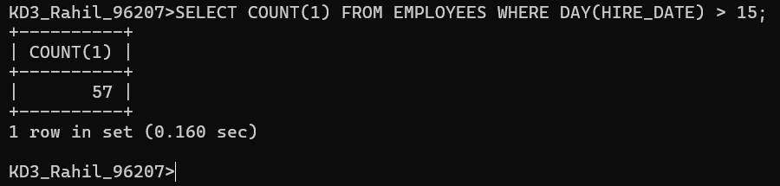

13.
USED CTE, -- WITH RANK_SAL AS (SELECT SALARY, DENSE_RANK() OVER(ORDER BY SALARY DESC) AS RNK FROM EMPLOYEES) SELECT SALARY FROM RANK_SAL WHERE RNK = 3;
