Database Technologies – Assignment 1

- Note : S denotes the Suppliers Table.
CREATE TABLE S (S# CHAR(5) NOT NULL, Sname CHAR(20), status SMALLINT, city CHAR(15)); TABLE S
Output :-
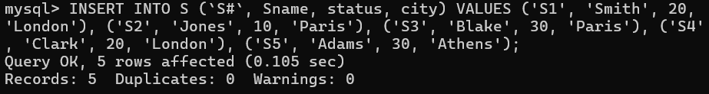
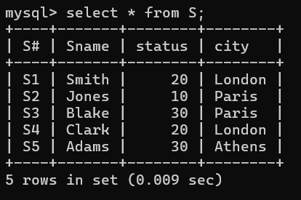

- Note : P denotes the Parts table.
CREATE TABLE P (P# CHAR(6) NOT NULL, Pname CHAR(20), color CHAR(6), weight SMALLINT, city CHAR(15));
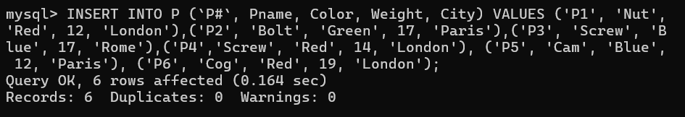
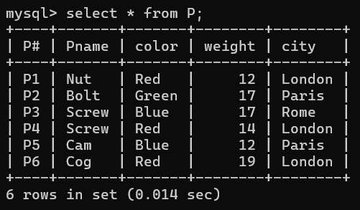

- Note : J denotes the Jobs table.
CREATE TABLE J (J# CHAR(4) NOT NULL, Jname CHAR(10), City CHAR(15));

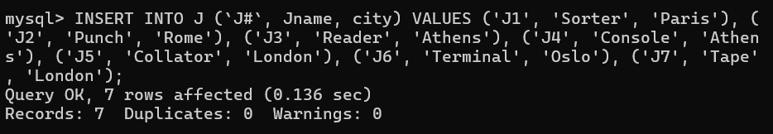

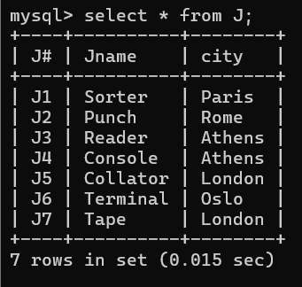
- CREATE TABLE sp (S# CHAR(4) NOT NULL, P# CHAR(4) NOT NULL, J# CHAR(4) NOT NULL, QTY INT);
