Group(Leetcode)
2. 619. Biggest Single Number
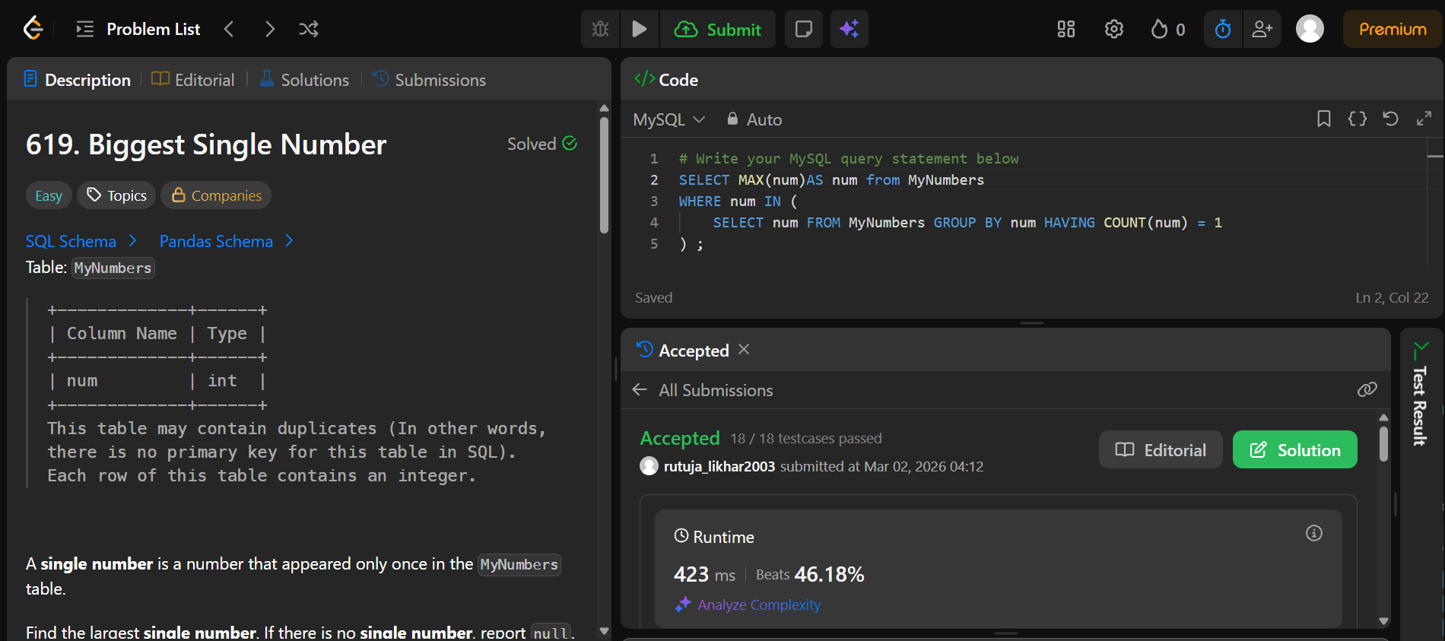
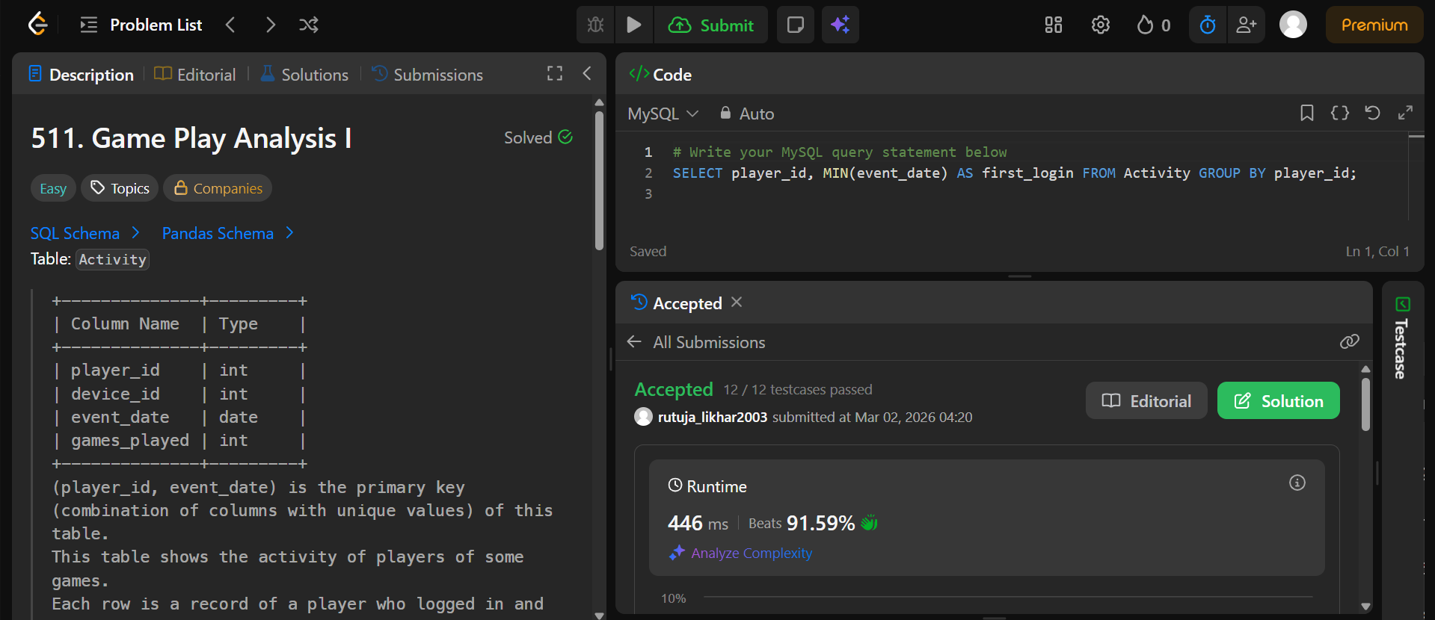
3. 511. Game Play Analysis I

5. 1741. Find Total Time Spent by Each Employee
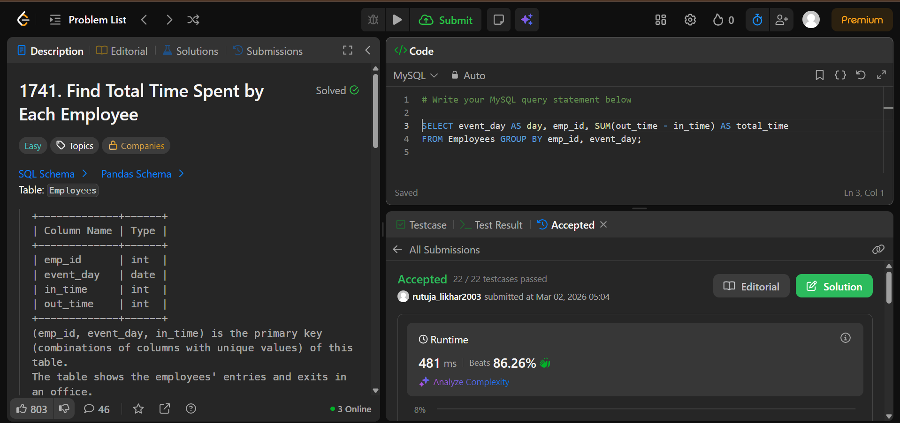
6. 1050. Actors and Directors Who Cooperated at Least Three Times
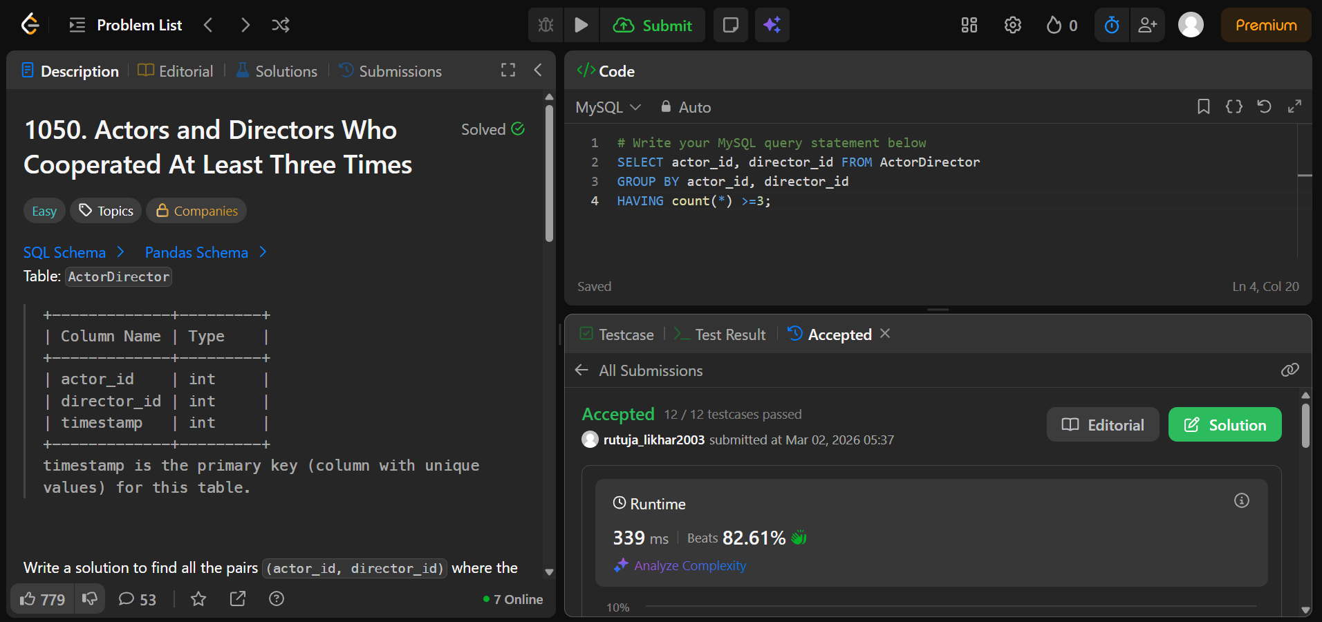
7. 1890. The Latest Login in 2020
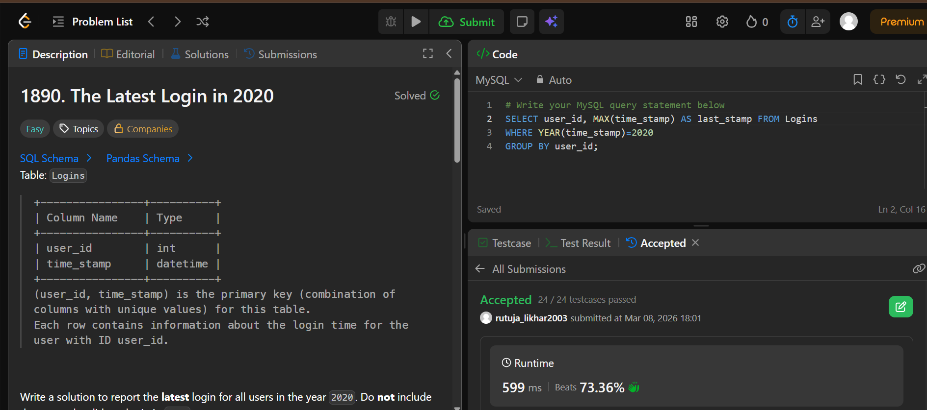
596. Classes With At Least 5 Students
