Day_4 Optional Assignment – 7

1. Display department name and manager first name.
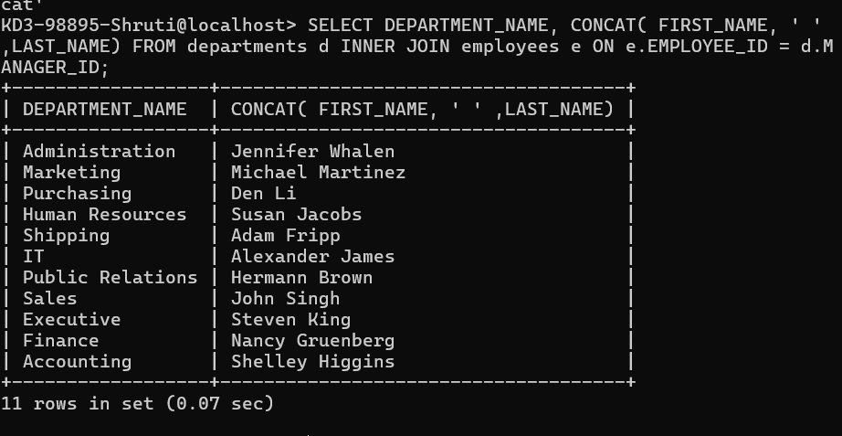

2. Display department name, manager name, and city.
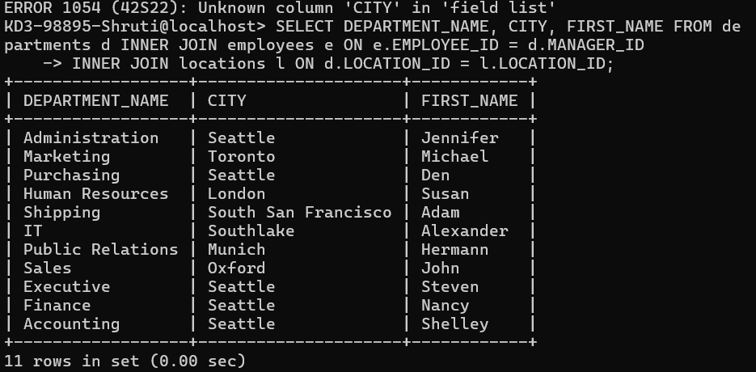

3. Display country name, city, and department name.
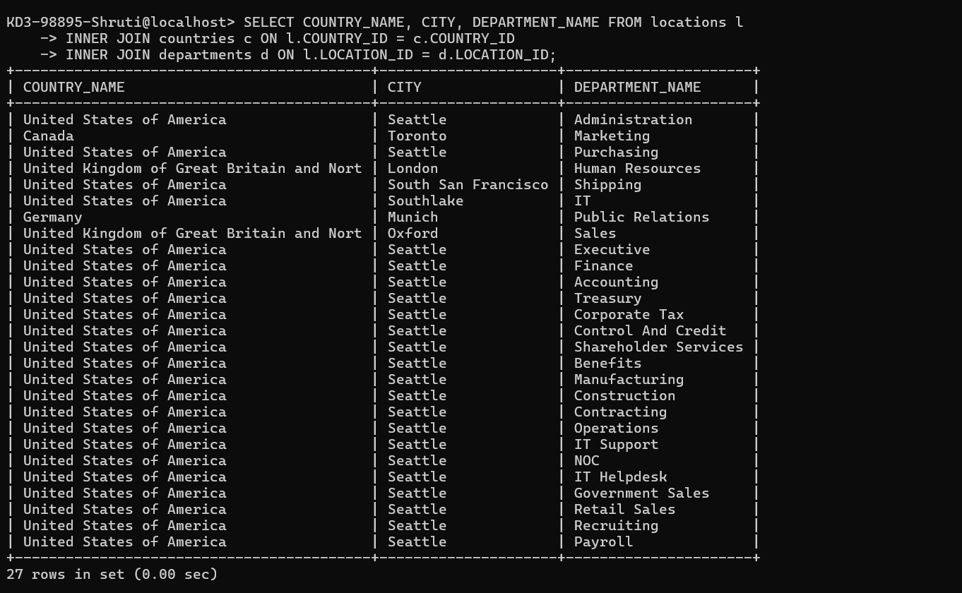

4. Display job title, department name, employee last name, starting date for all jobs from 2011 to 2015.
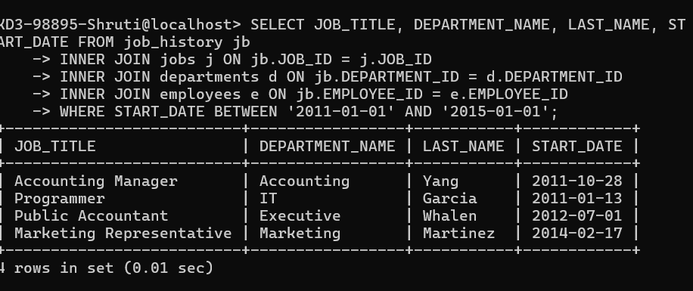

5. Display job title and average salary of employees.
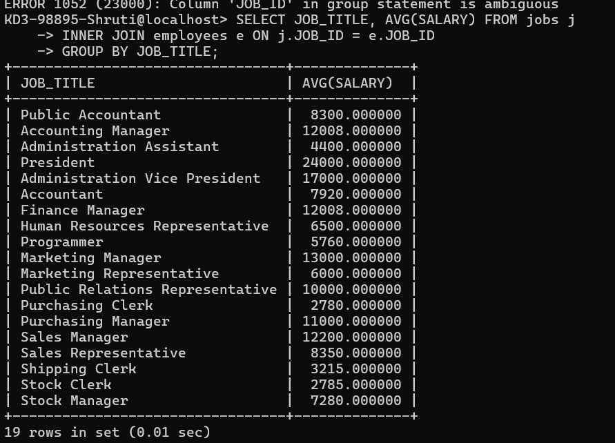

6. Display job title, employee name, and the difference between maximum salary for that job and salary of the employee.
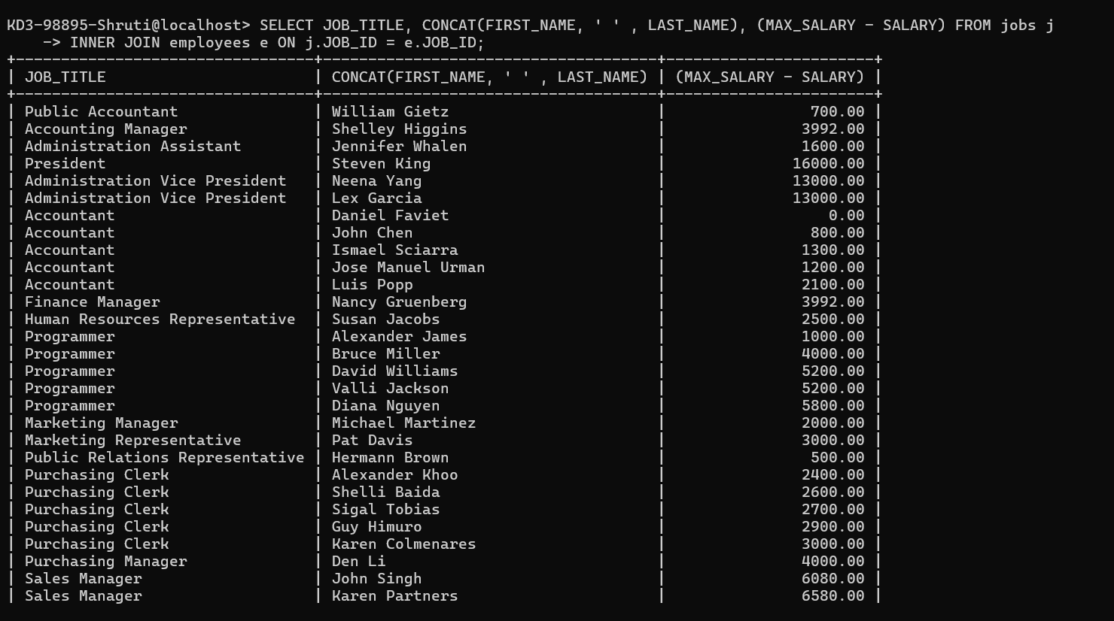
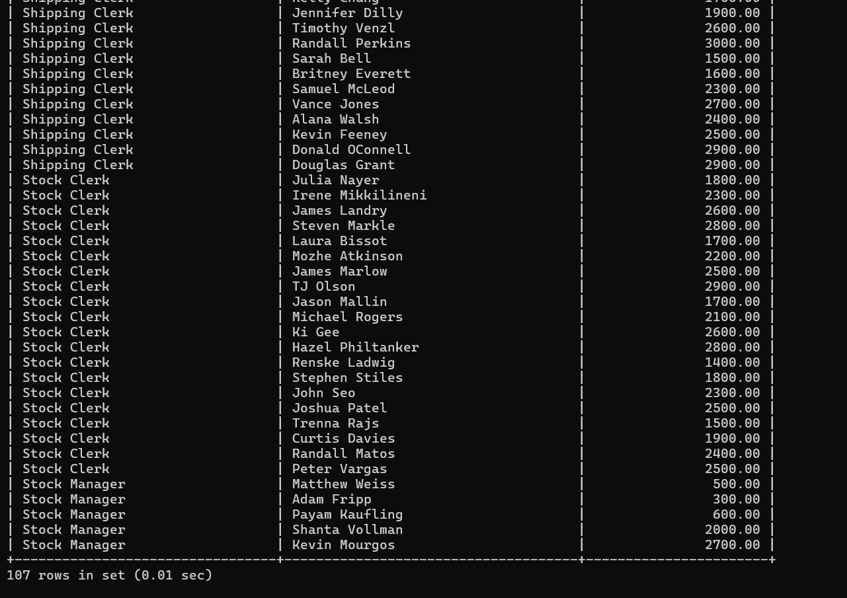

7. Display the last name and job title of employees who earn a commission but do not belong to any department.
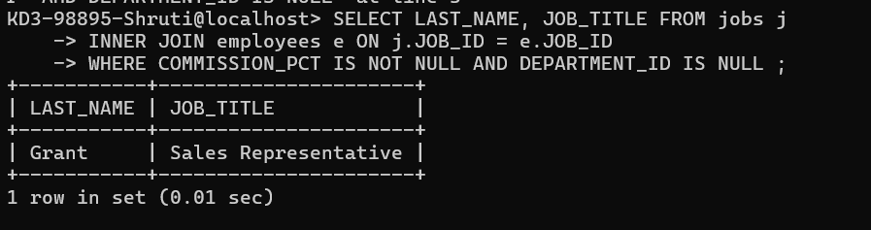

8. Display details of jobs that were done by any employee who is currently drawing more than 15000 of salary.
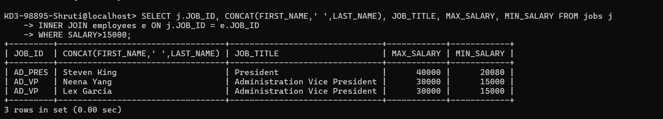
9. Display department name, manager name, and salary of the managers, who have the experience of more than 12 years.
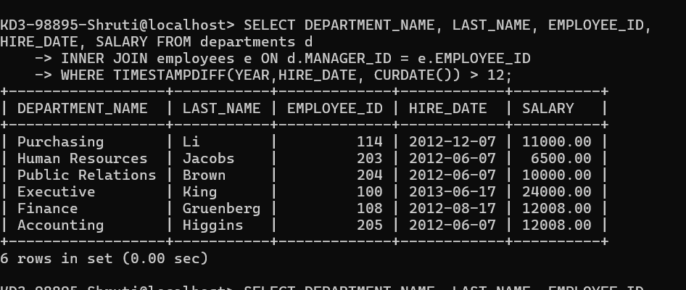

10. Display employee name if the employee joined before his manager.
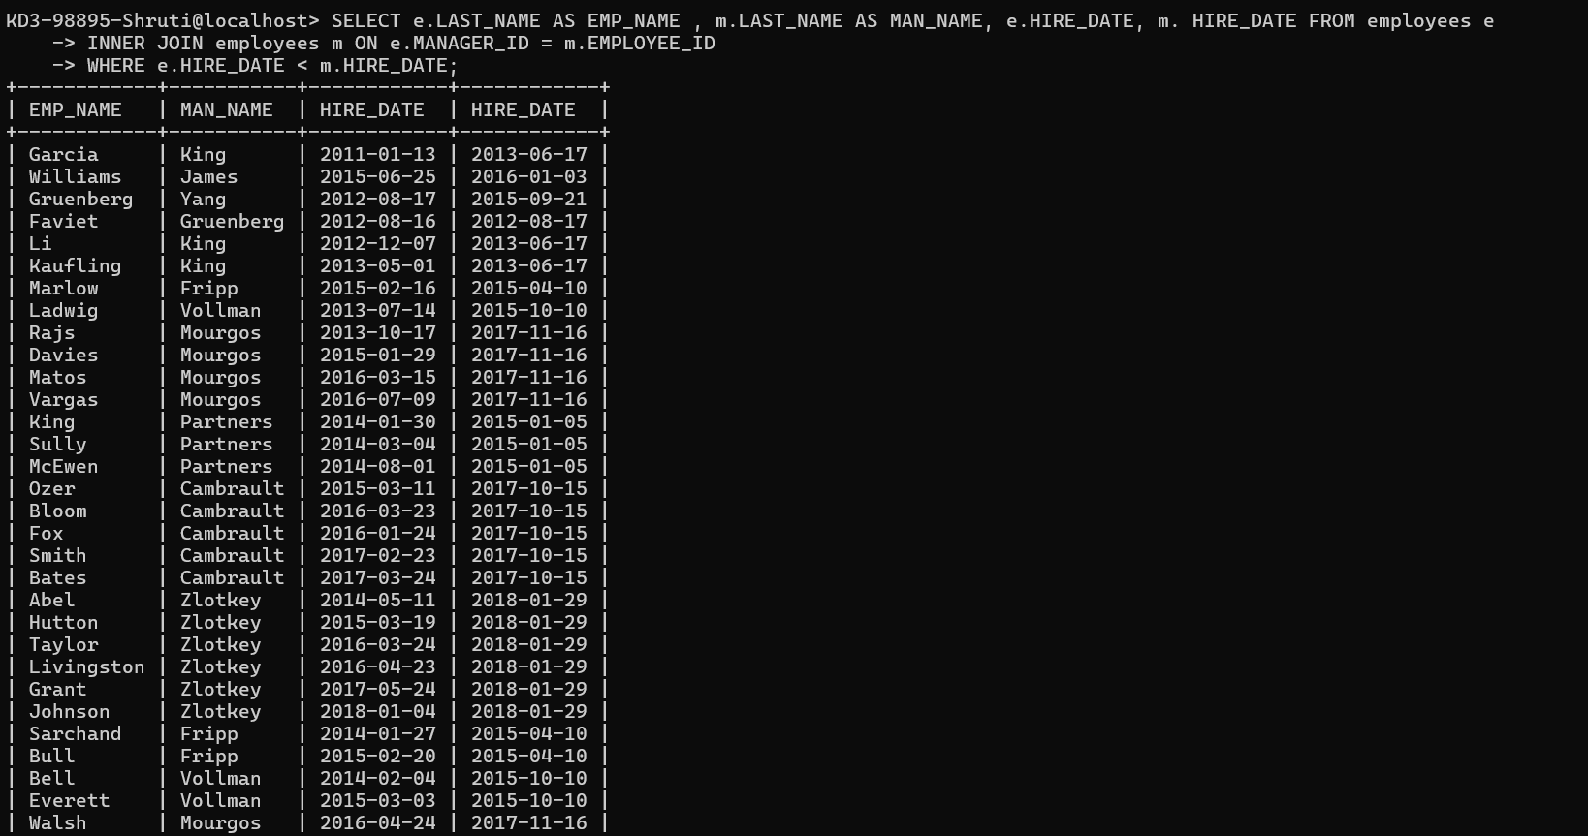
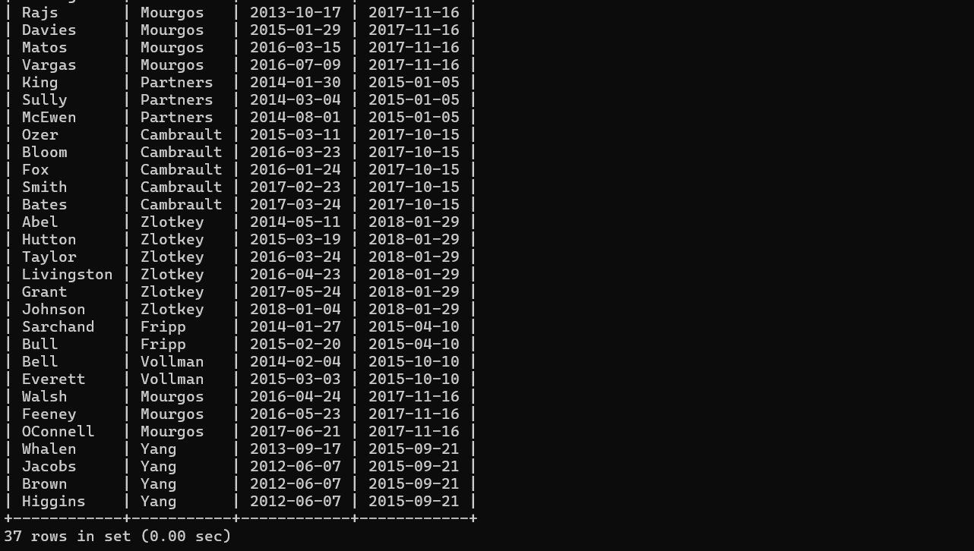

11. Display the employee’s name, job title for the jobs, employee did in the past where the job was done less than 12 months.
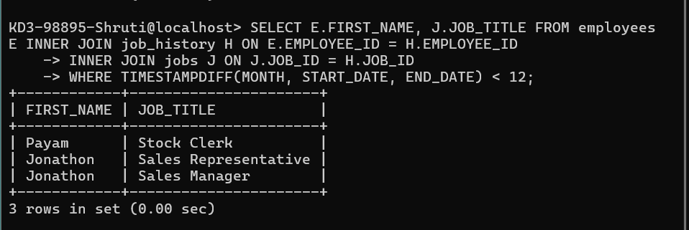

12. Display employee name and country in which he is working.
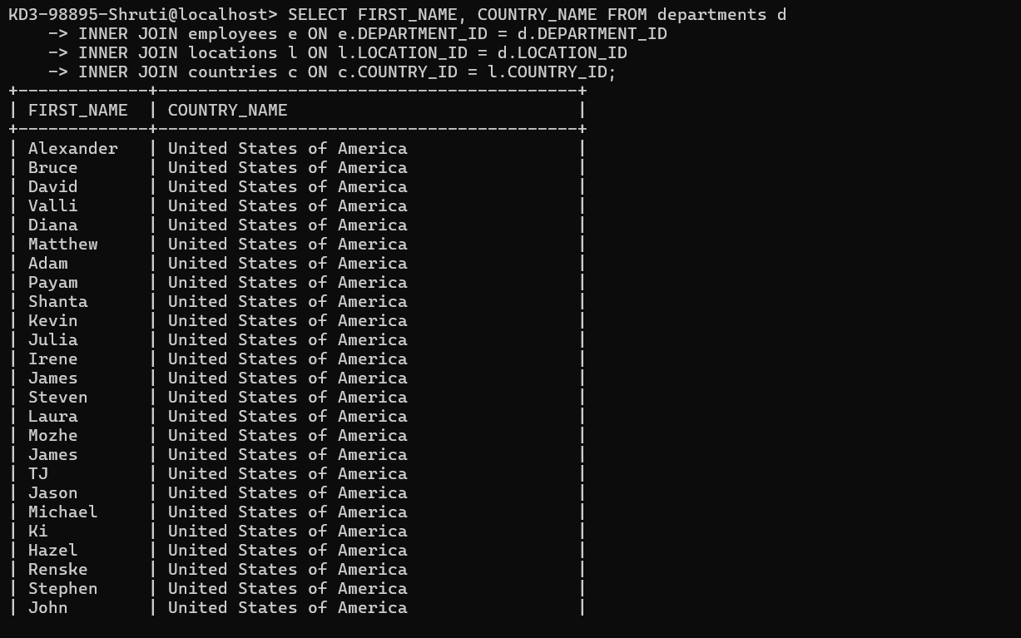
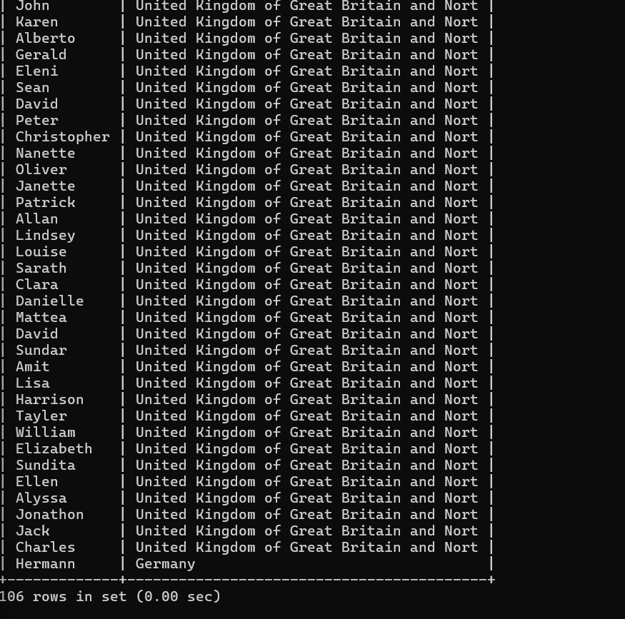

13. Display department name, average salary and number of employees with commission within the department.
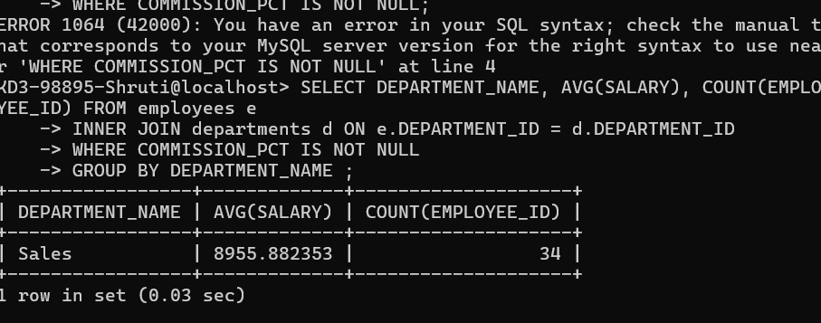

14. Display the count of employees, month and the year in which 3 or more employees joined in any department located in ‘Seattle’.

15. Display employee name, job title, start date, and end date of past jobs of all employees with commission percentage null.
