Day_1 Assignment-1
Q1.
Table S created
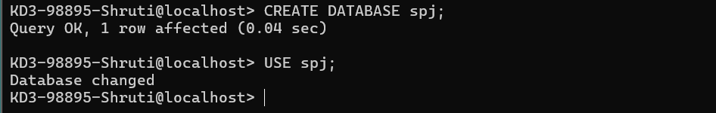
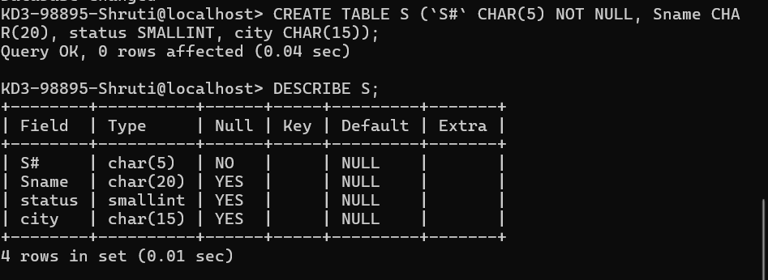
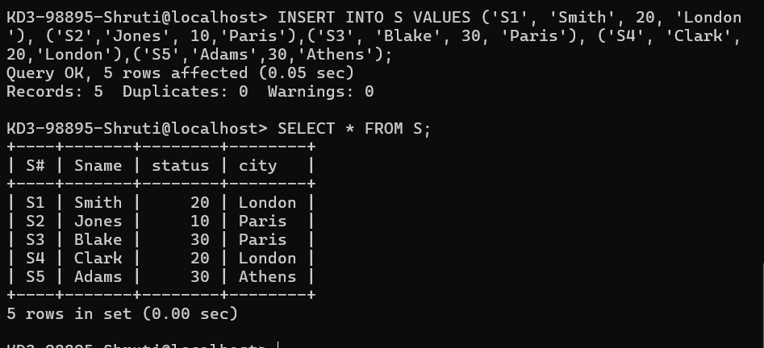

Create table P
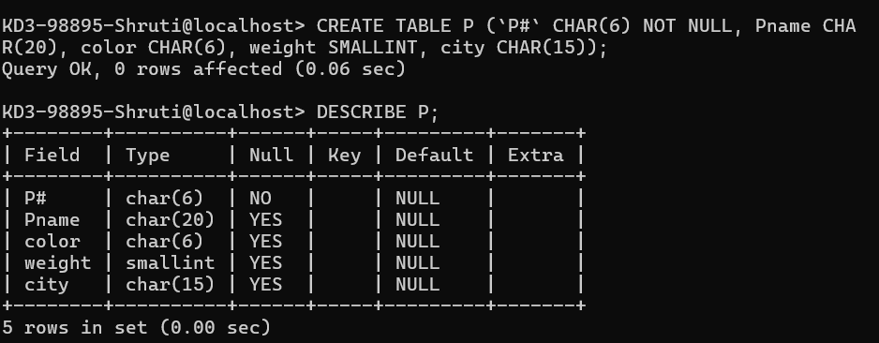
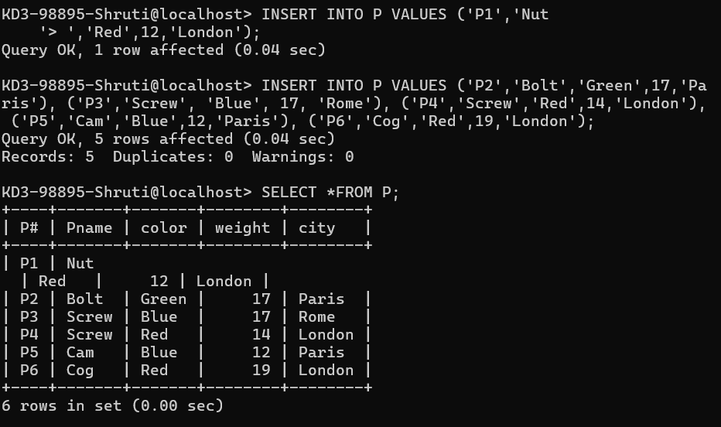

Created table J
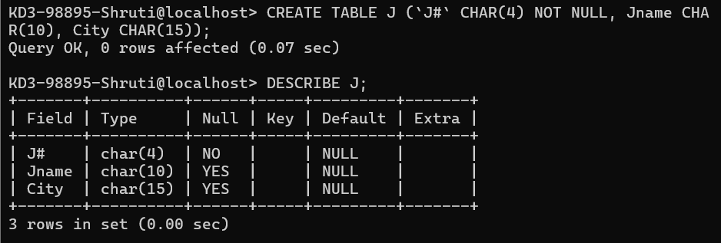
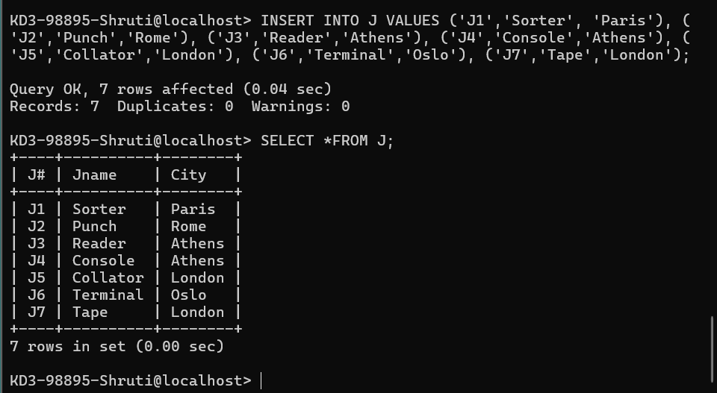

CREATE table sp
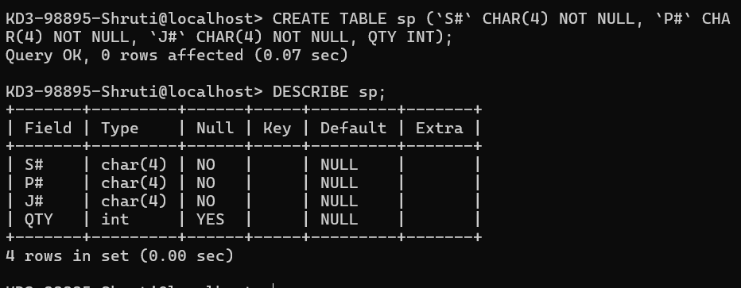
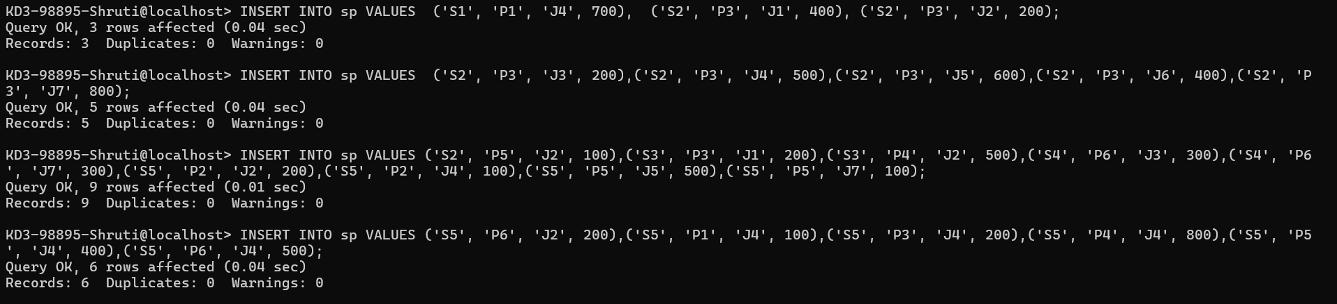
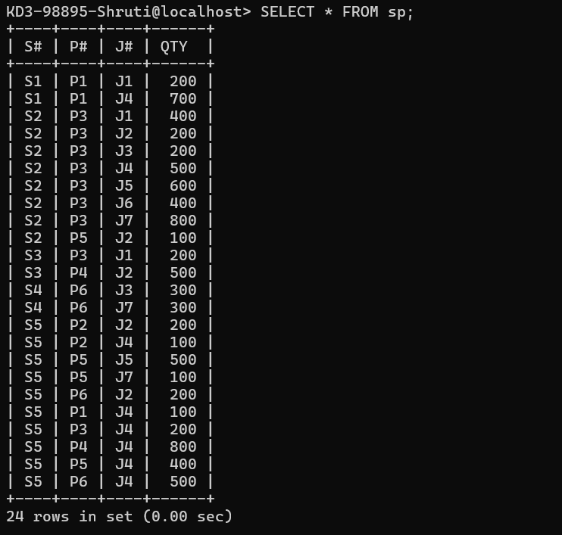

Q2.
CREATE database hr and import
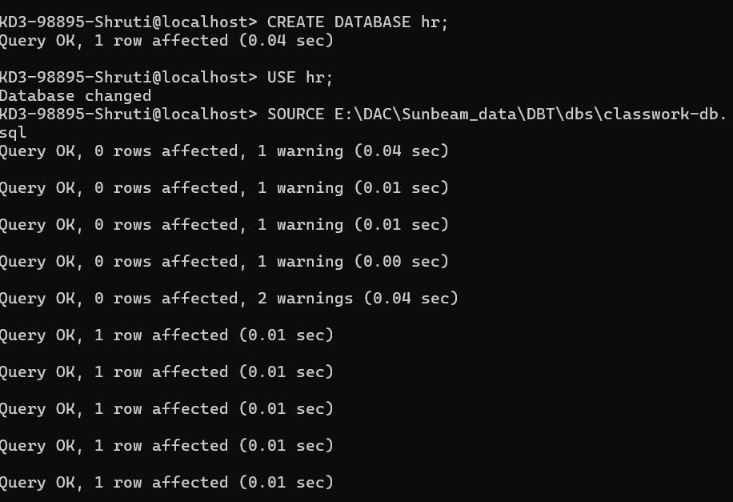
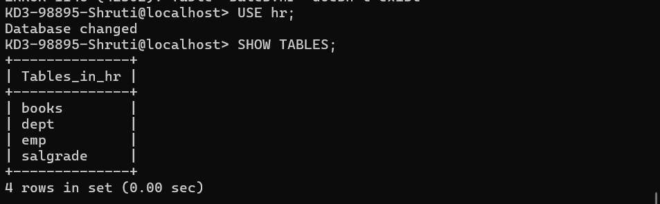
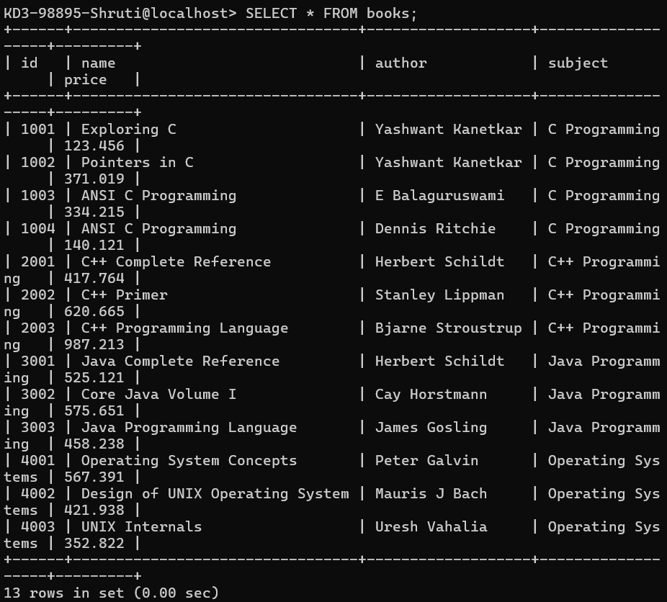
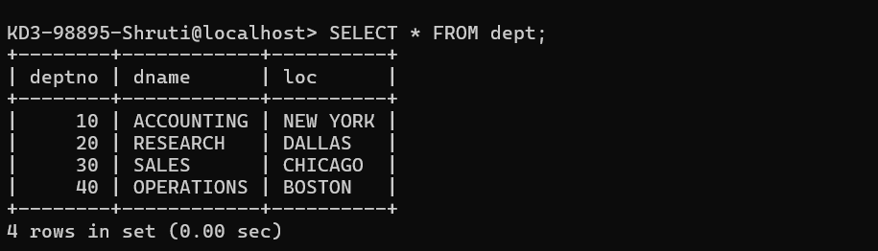
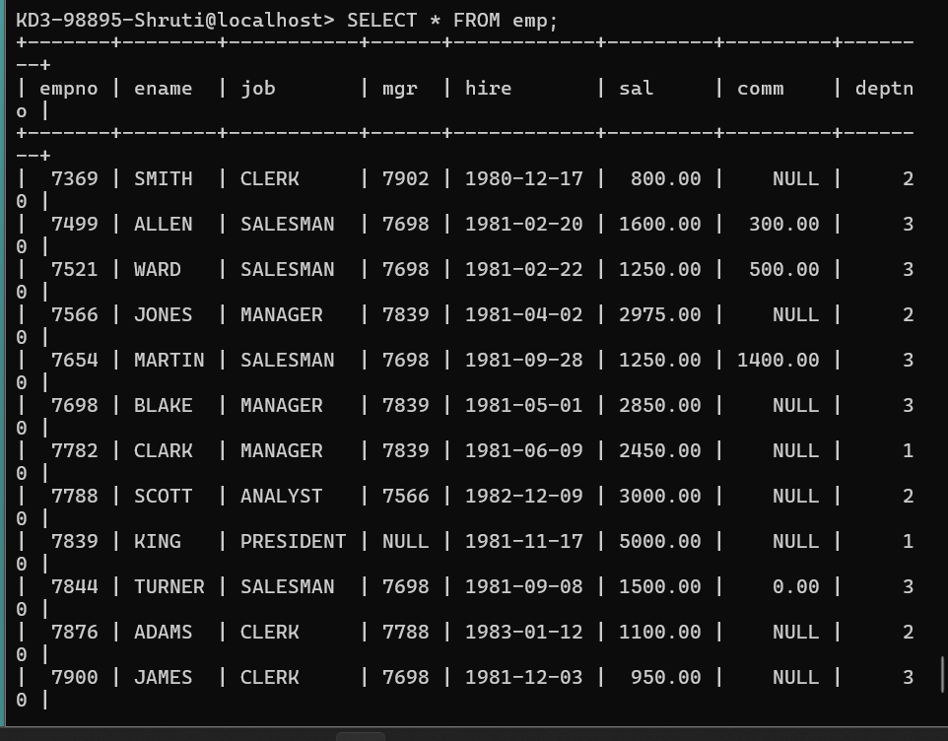
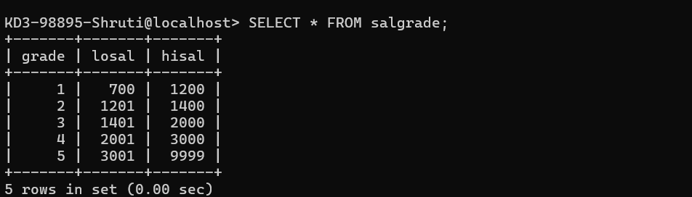

CREATE database sales import sales file
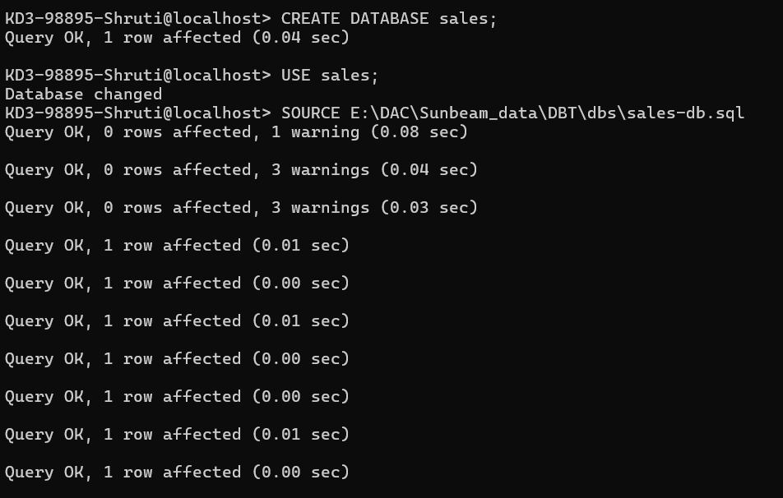
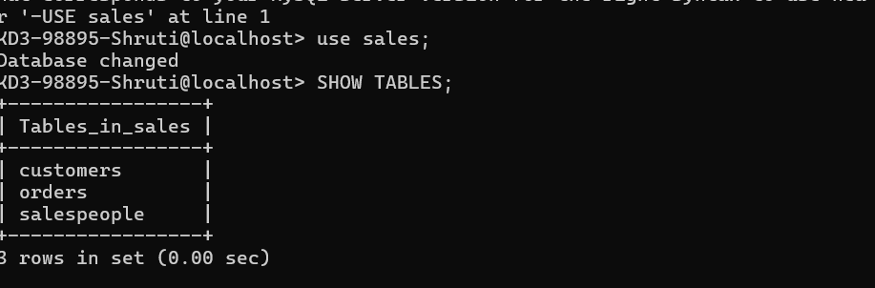
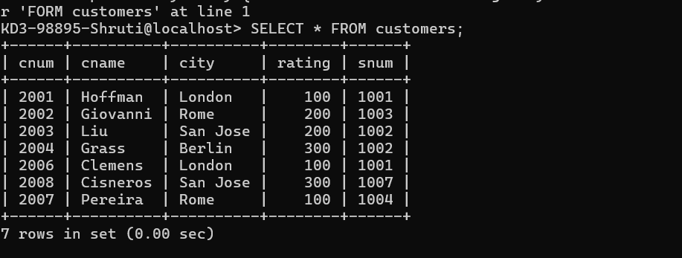
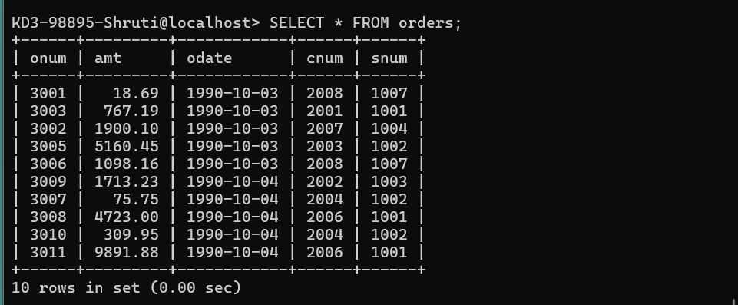
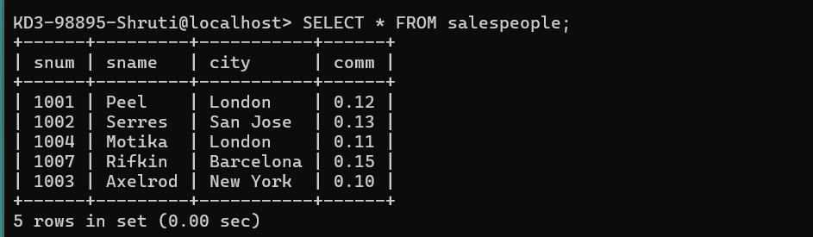

Q3
1. How many orders data is present in the database ?
- There are upto 10 orders in the order table.
2.How many custormers are present in the database?
-> There are 7 entries of in the customer table.
3.How many salespeople are present in the database?
-> There are 5 salespeople in the database.
4.On which date order with highest amount is placed?
-> On 4/10/1990 the highest amt of 9891.99 order was placed.
5.For which date order salesman got maximum commission ?
-> 1001 peel got the maximum commission on 4-10-1990.
6.Which salesman are handling more than two customers?
-> 1001 – Peel and 1002- Serres are handling more than two customers.

7.Which city have single customer?
-> Berlin has single customer.
8.Which city has multiple salespeople?
-> Rome and San Jose have multiple salespeople.
9.What is name of customer and salesman of the maximum amount order?
-> Customer – Clemens and salesperson – Peel
10.Study relationship between the tables in sales database.
-> the three tables have snum in common which is the salepersonn number.

