Database Technologies- Assignment 1
Write the SELECT queries to do the following:-
1. Write a query that produces all rows from the Customers table for which the salesperson’s number is 1001.
Ans:
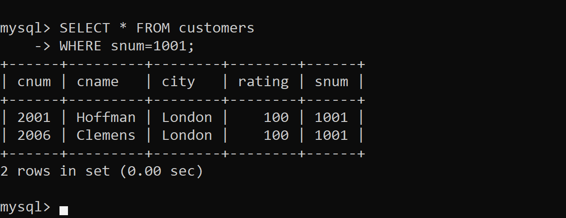

2. Write a select command that produces the rating followed by the name of each customer in San Jose.
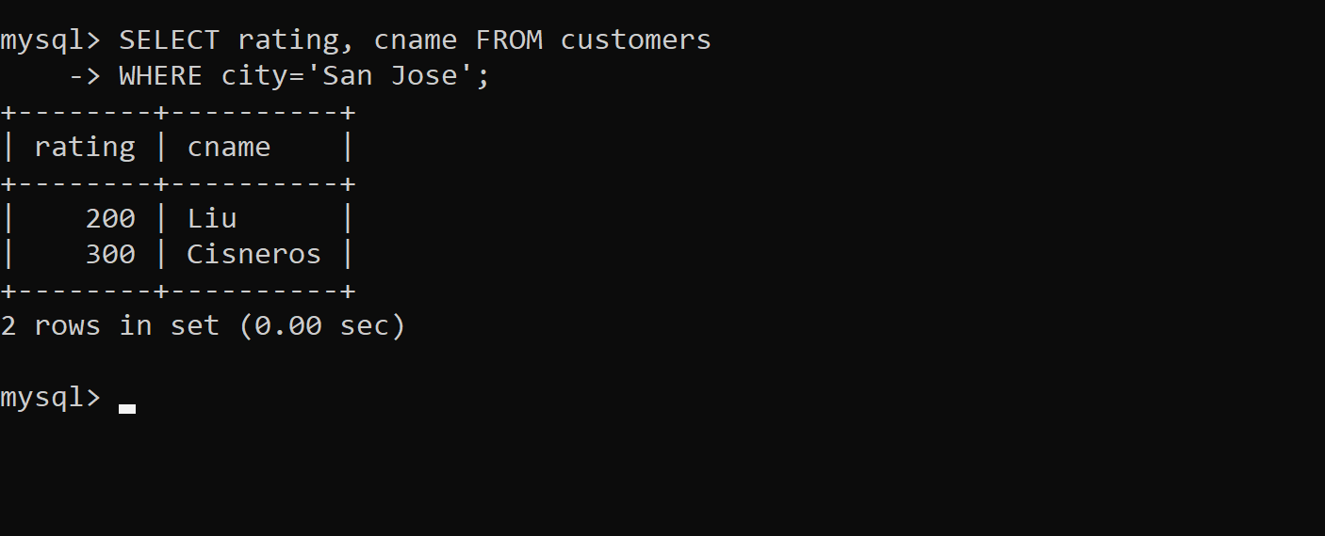

3. Write a query that will produce the snum values of all salespeople from the Orders table (with the duplicate values suppressed).

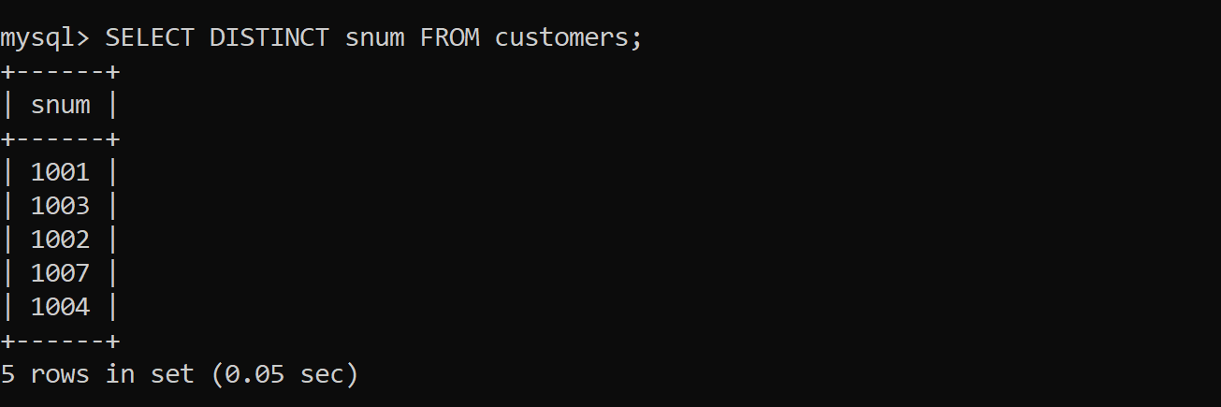

4 . Write a query that will display all the orders for amount more than Rs. 1,000.
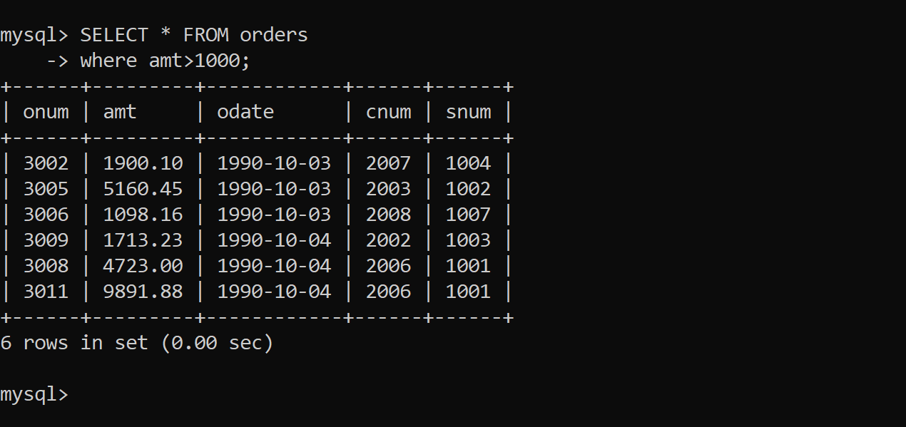

5. Write a query that will give you the names and cities of all salespeople in London with a commission above 0.10.
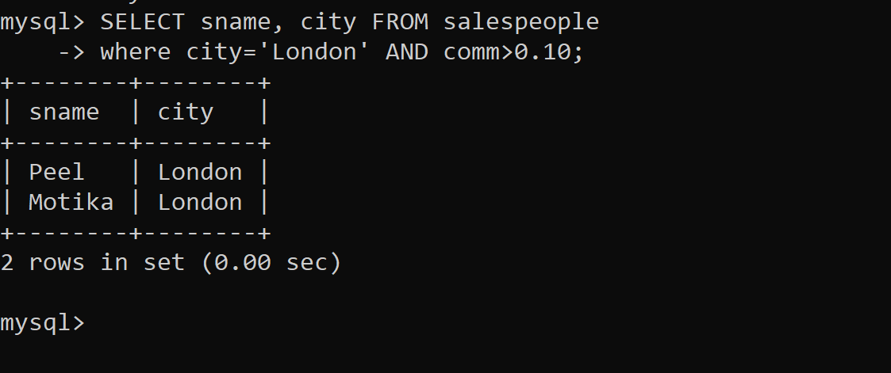
6. Write an SQL query that returns all customers who have a rating greater than 100, along with the customers located in Rome regardless of their rating.

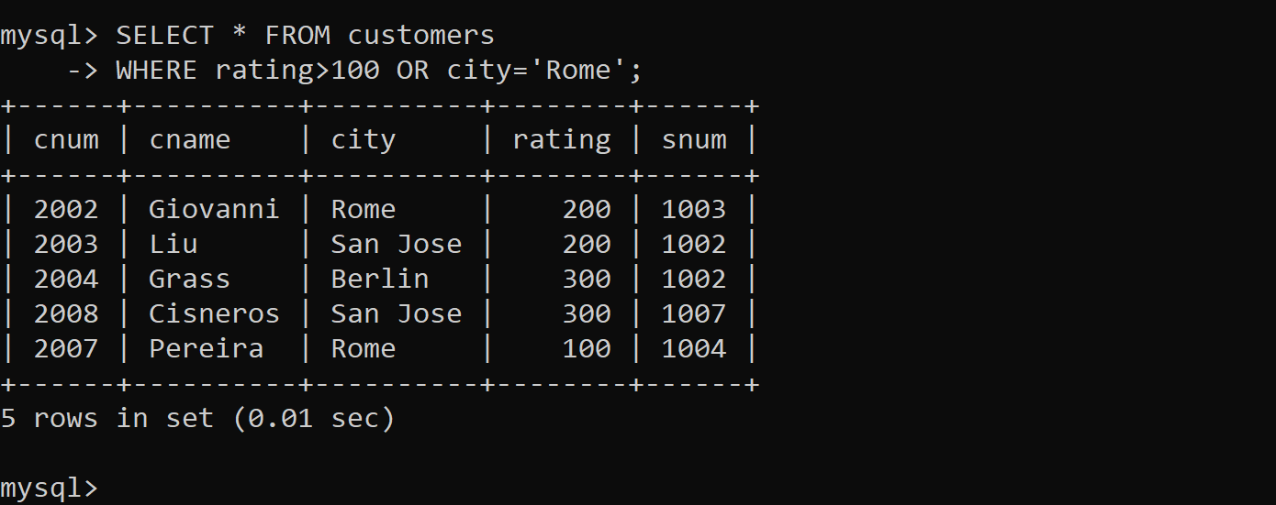

7. What will be the output from the following query? Select * from Orders where (amt < 1000 OR NOT (odate = ‘1990-10- 03’ AND cnum > 2003));
Ans: It selects almost all orders, excluding only the orders placed on 1990-10-03 with cnum > 2003 and amt >= 1000.

8. What will be the output of the following query? Select * from Orders where NOT (odate = ‘1990-10-03’ OR snum >1006)
Ans: You get orders that are not on 1990-10-03 and are handled by salespeople with snum ≤ 1006.

9. What is a simpler way to write this query? Select snum, sname, city, comm from Salespeople Where (comm >= .12 AND comm <= .14);
Ans: We can use BETWEEN claus because we want commisson between 0.12 to 0.14 .
SELECT snum, sname, city, comm
FROM Salespeople
WHERE comm BETWEEN 0.12 AND 0.14;
10. Write a query that selects all orders except those with amount less than 100.
Ans: SELECT * FROM Orders
WHERE amt<100;

