Database Technologies- Assignment 1
- Create 'spj' database'. (Database for suppliers, parts and jobs).

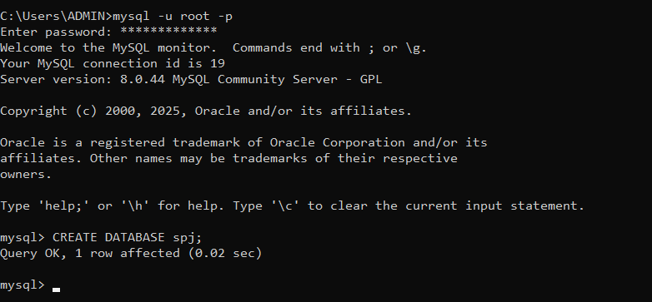
- use spj database;
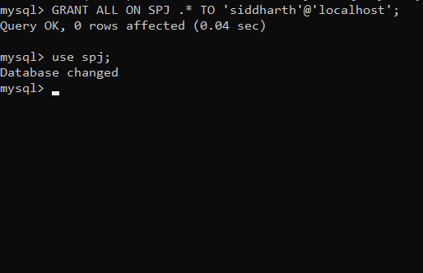

- Create following tables in spj database.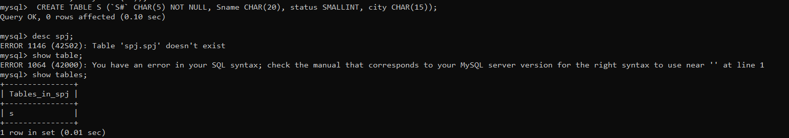
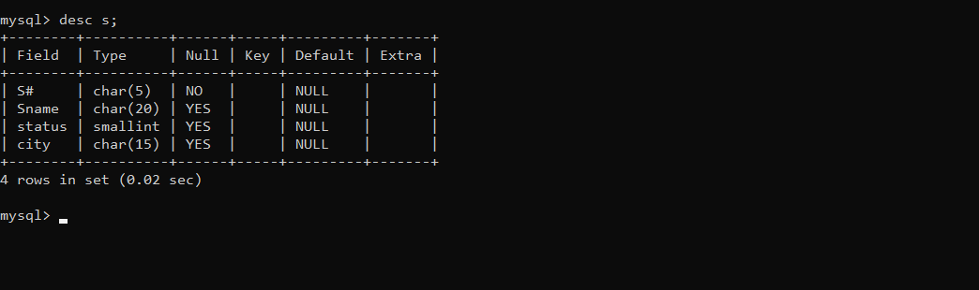

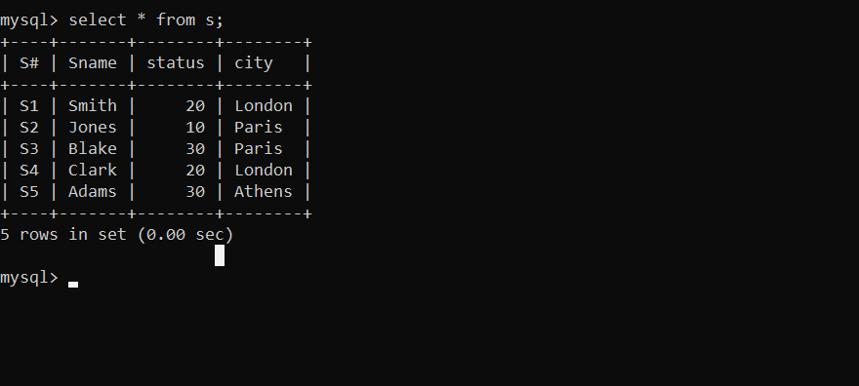
Table p:
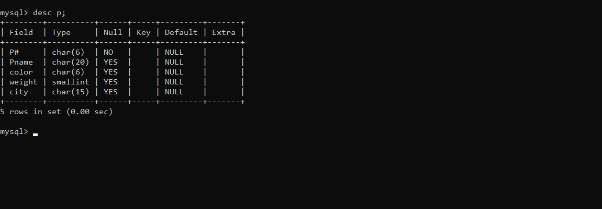
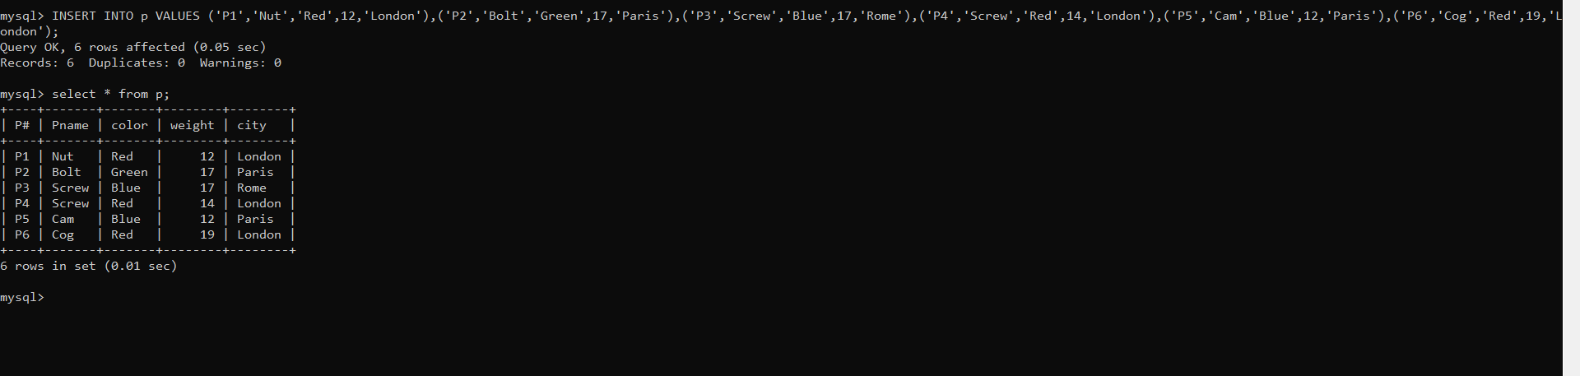
Table j:
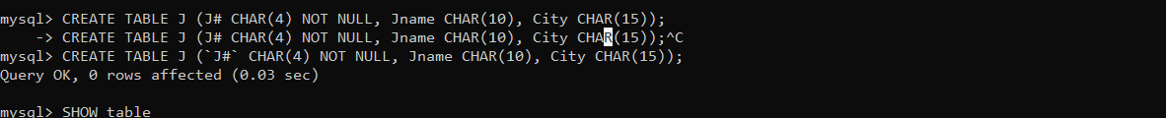

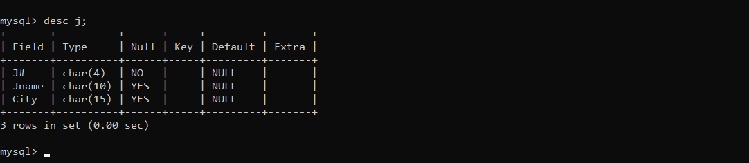

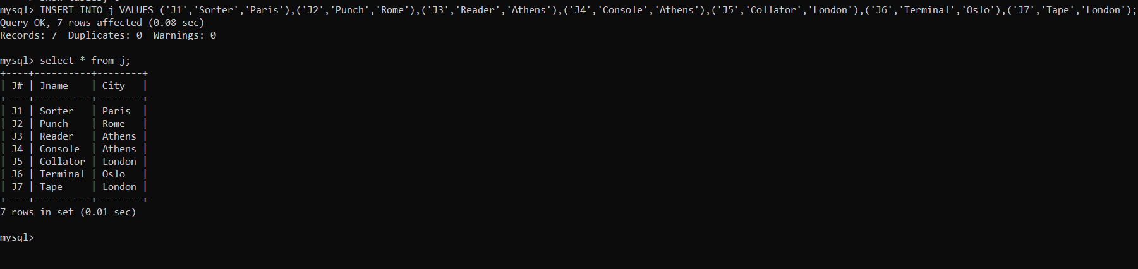

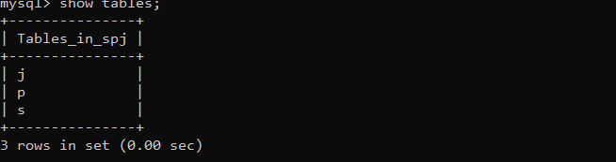
CREATE TABLE sp (S# CHAR(4) NOT NULL, P# CHAR(4) NOT NULL, J# CHAR(4) NOT NULL, QTY INT);
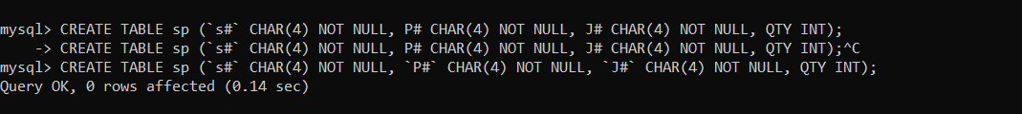

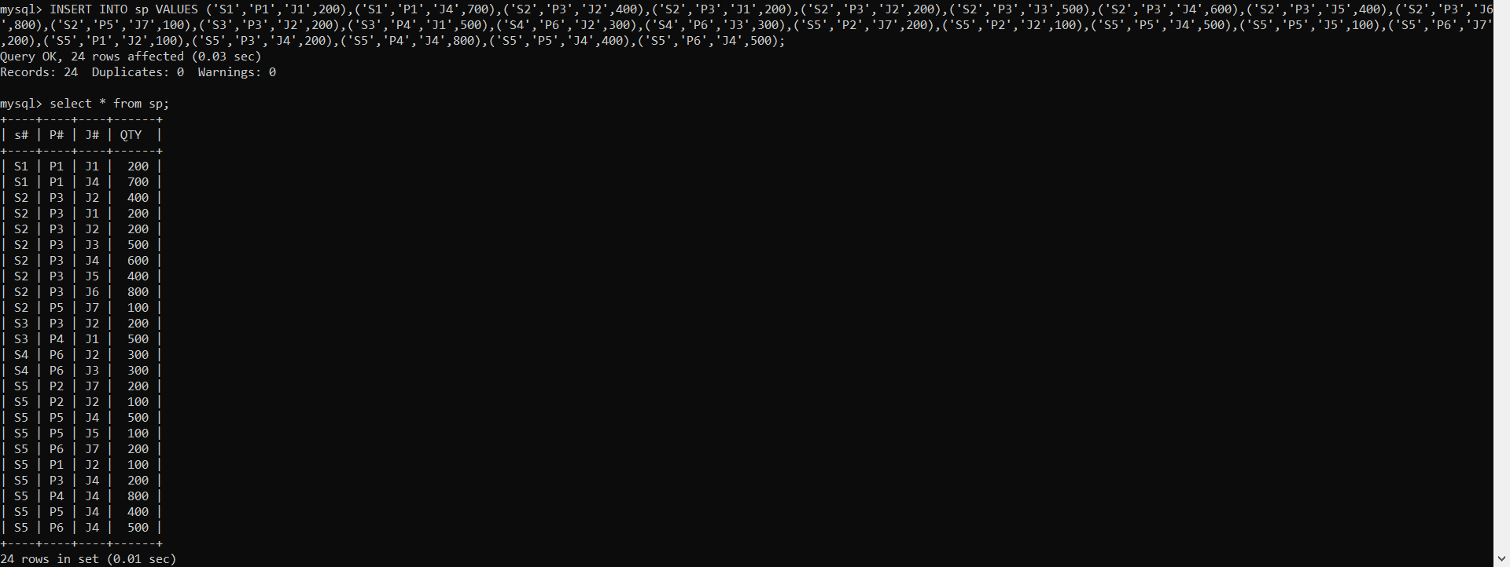

- Create 'hr' database. Import hr-db.sql.

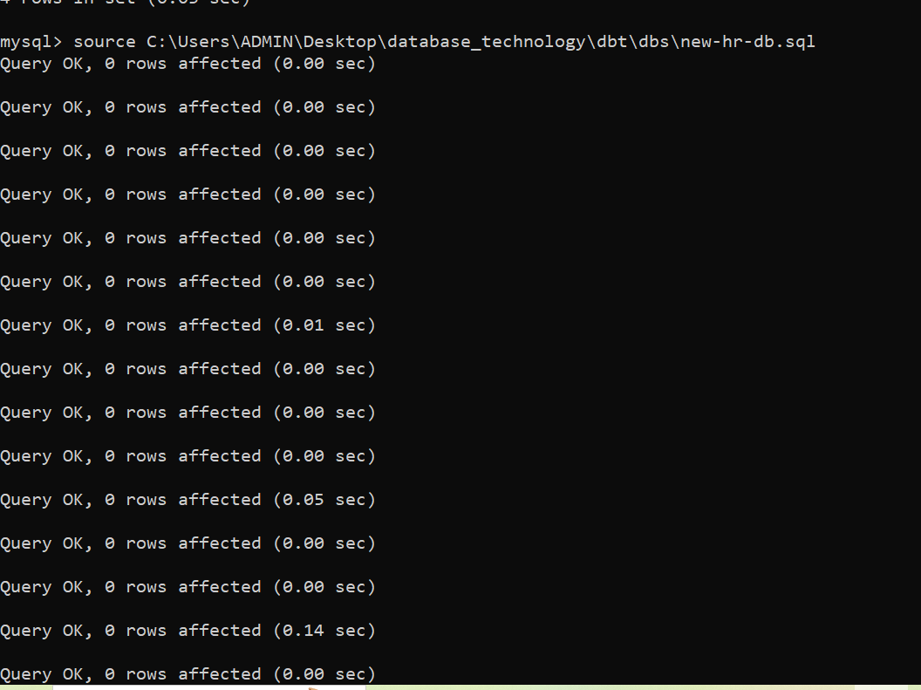

- Create 'sales' database. Import sales-db.sql.
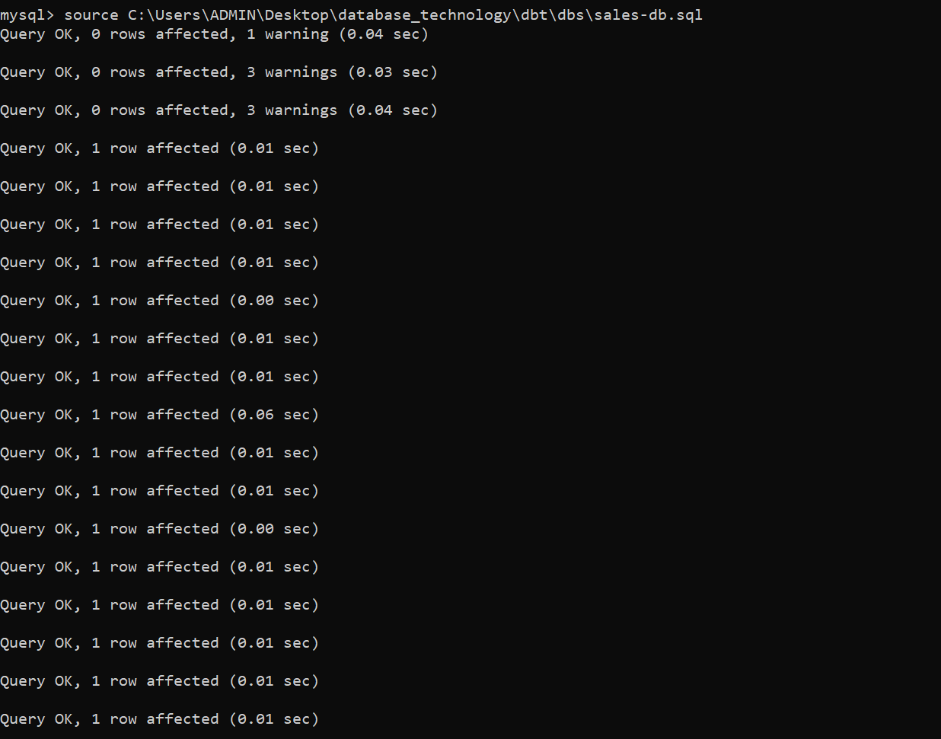
- List all tables in hr database. Display contents of all tables (one by one).

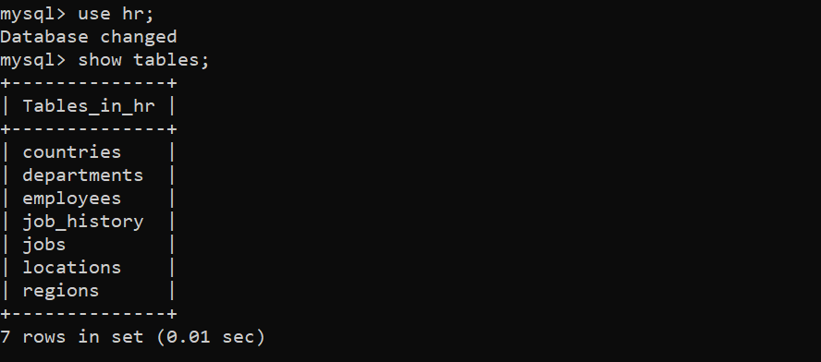

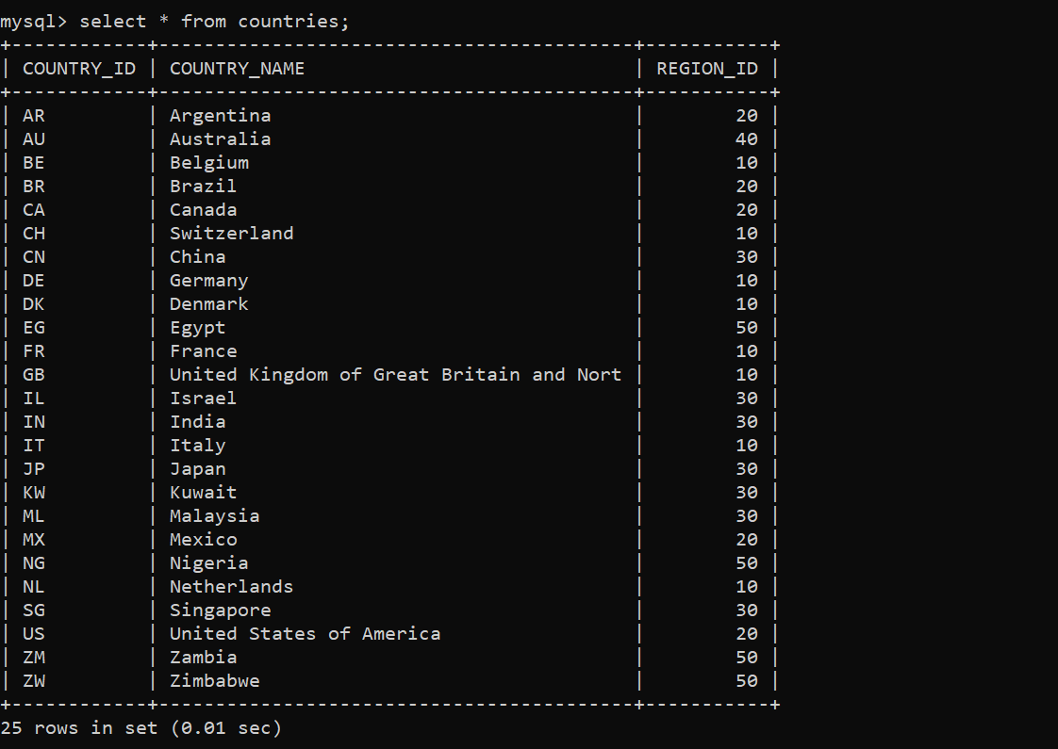

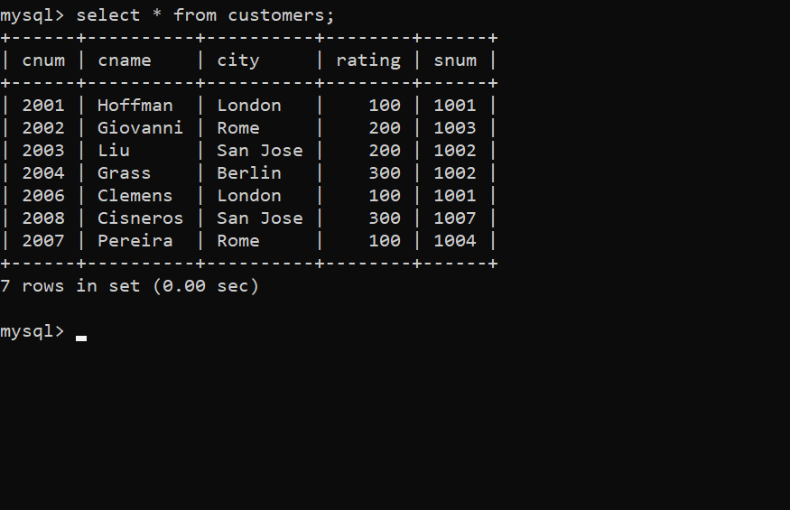

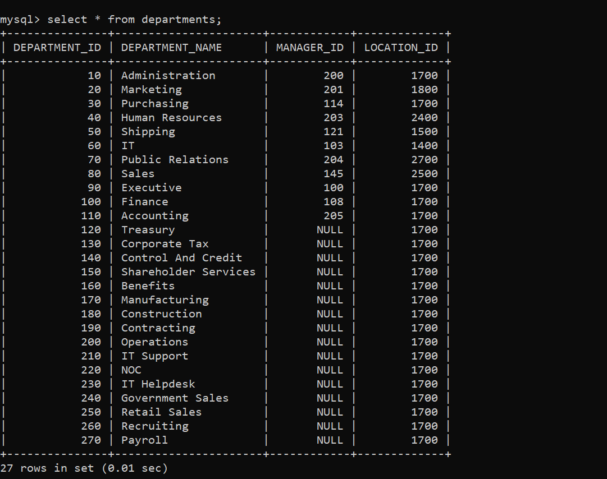

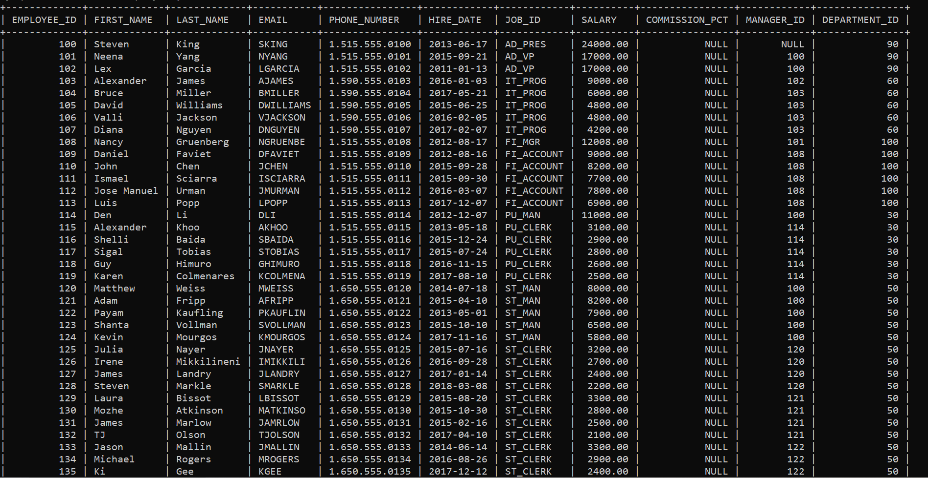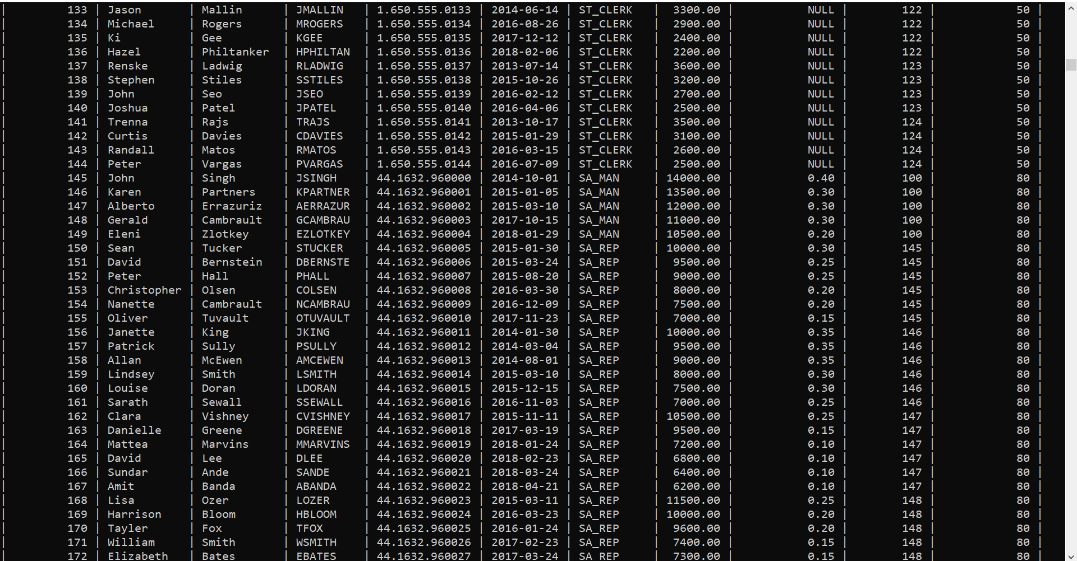
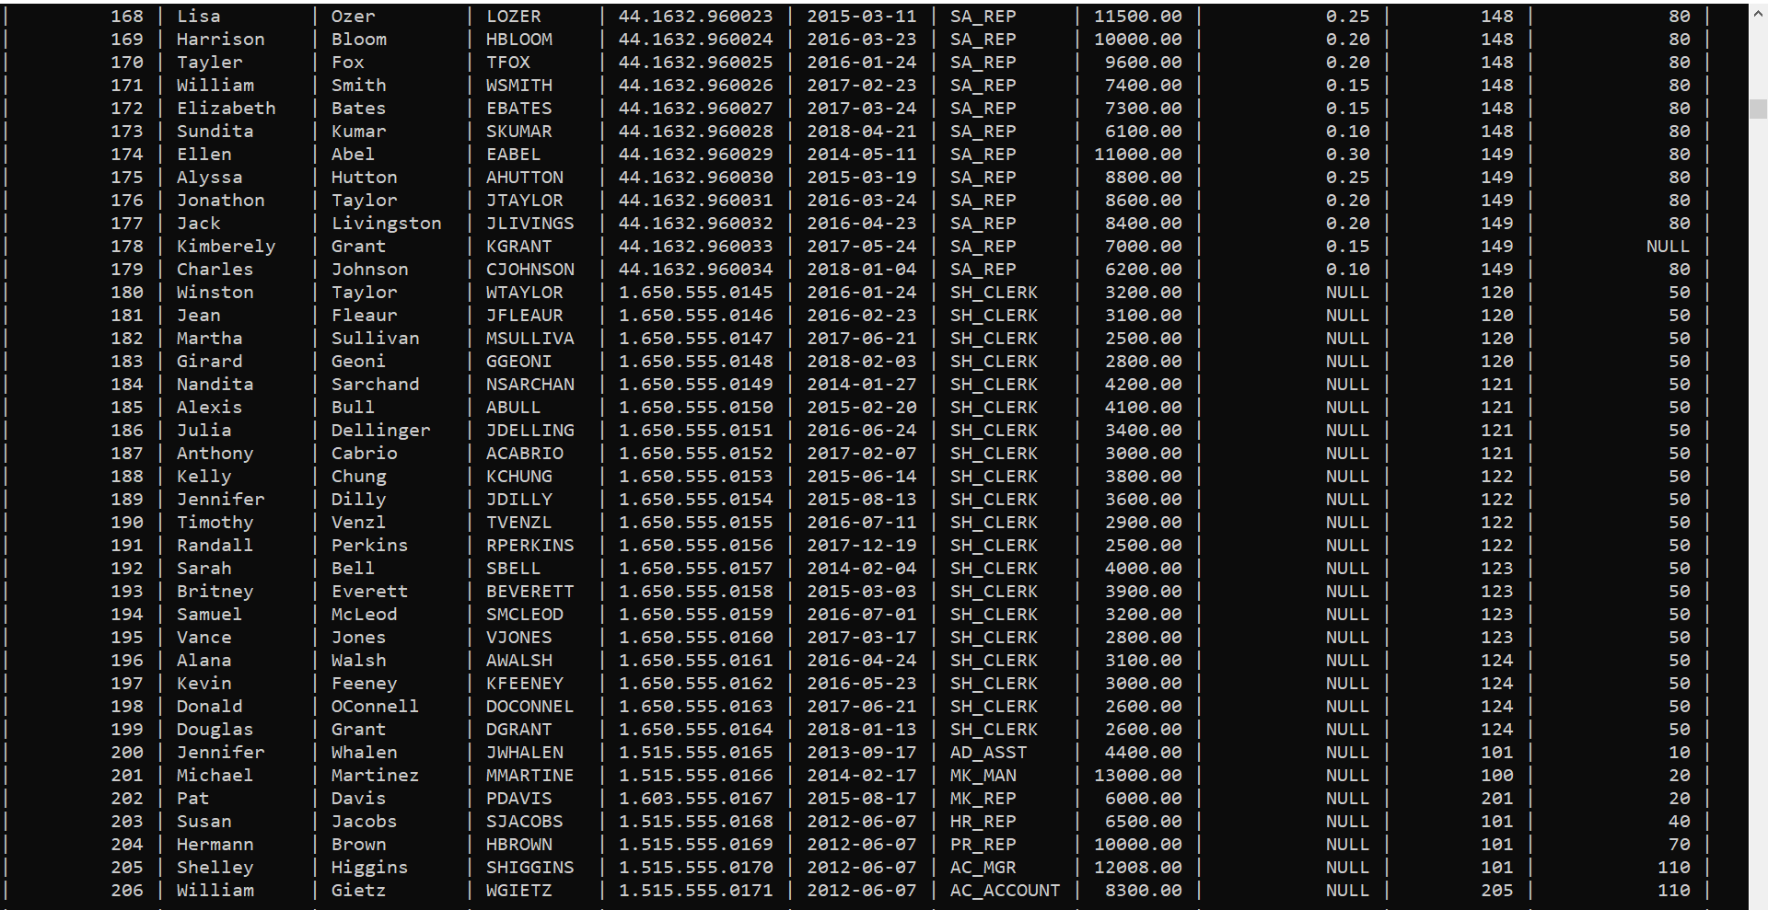

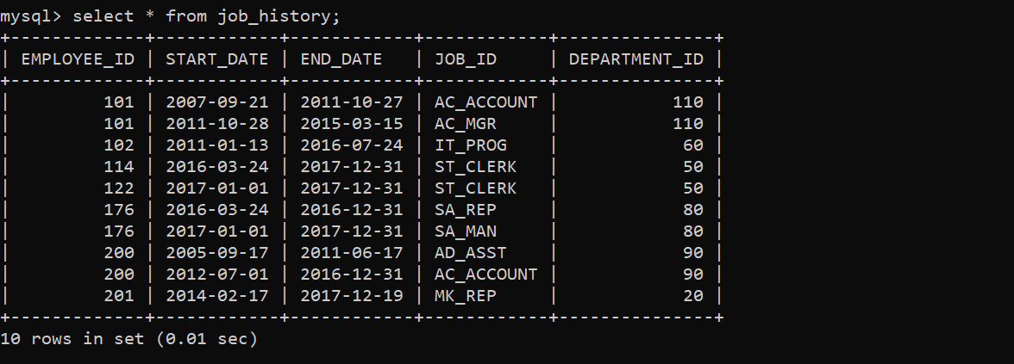

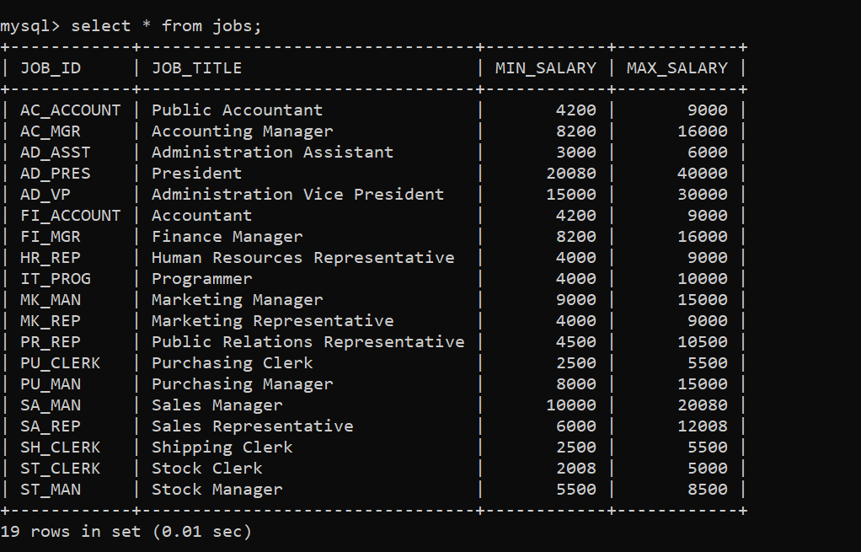

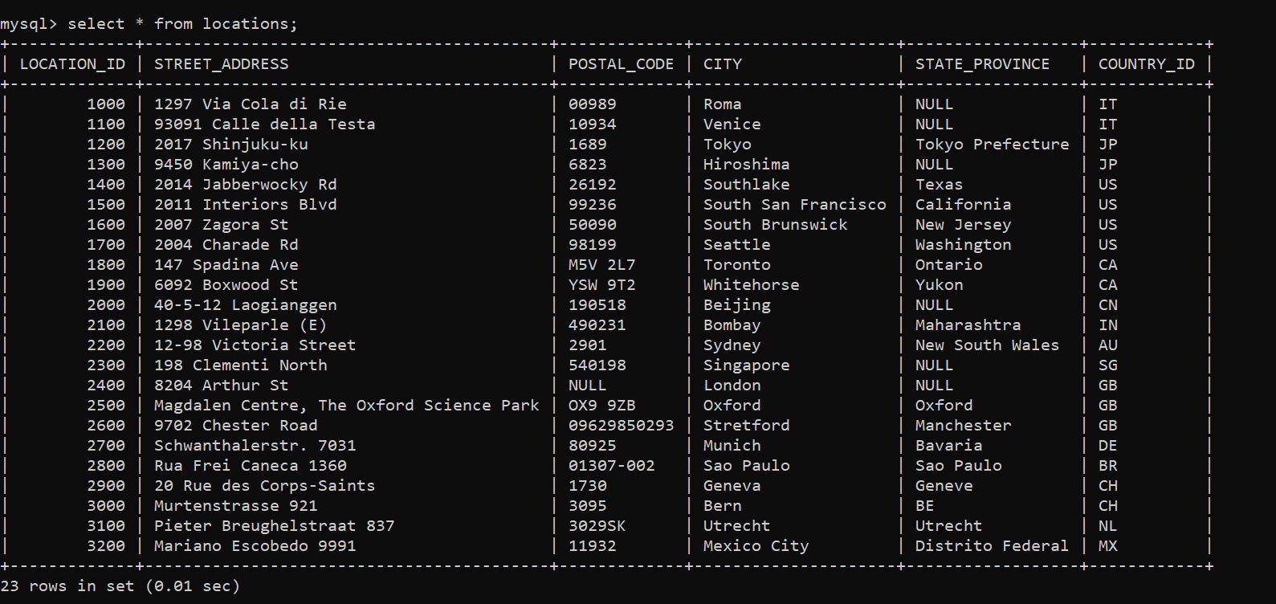

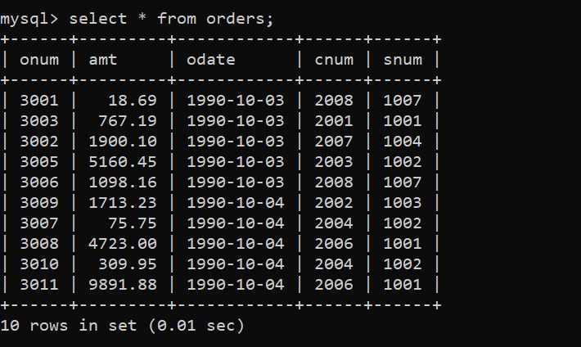

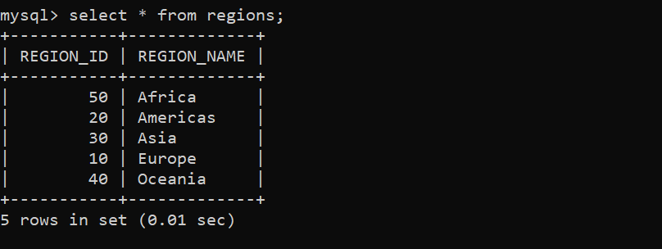

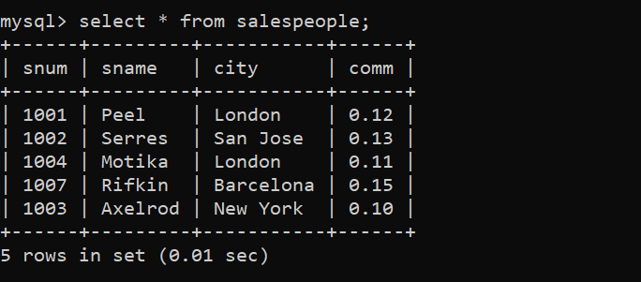

- List all tables in sales database. Display contents of all tables (one by one).

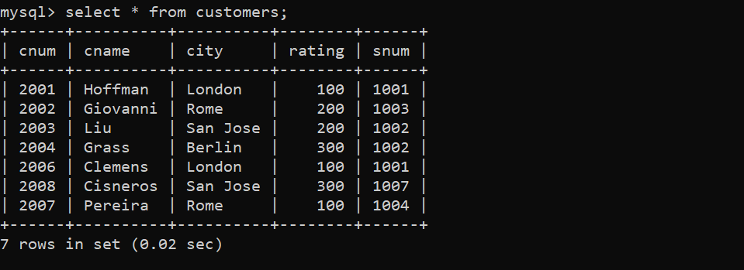

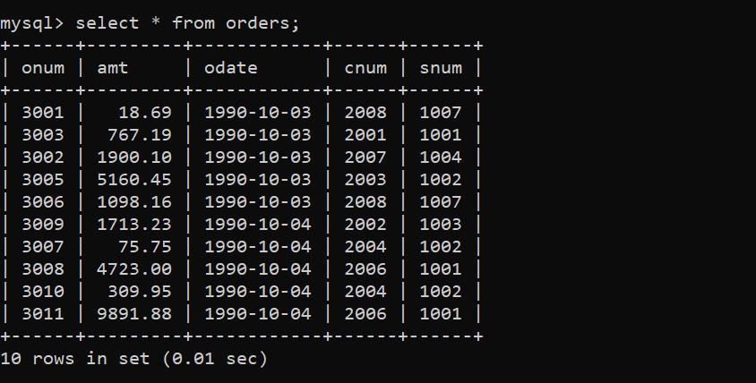
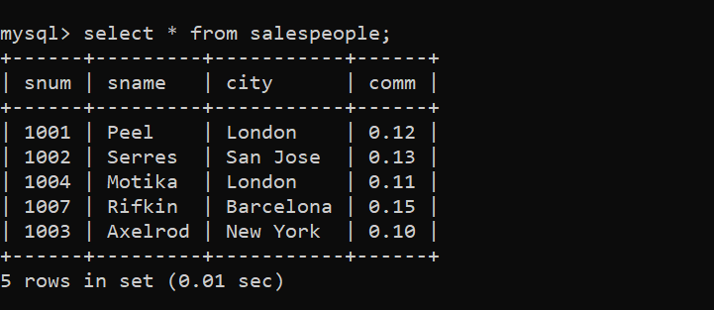

Answer the following questions (by observations only – not queries).
1. How many orders data is present in the database?
Ans: 10
2. How many customers are present in the database?
Ans: 7
3. How many salespeople are present in the database?
Ans:5
4. On which date order with highest amount is placed?
Ans:1990-10-04
5. For which order salesman got maximum commission? Hint: you need to refer data of two tables.
Ans: 3001
6. Which salesmen are handling more than two customers? Hint: you need to refer data of two tables.
Ans: Peel and Serres
7. Which city have single customer?
Ans: Berlin
8. Which city has multiple salespeople?
Ans: London
9. What is name of customer and salesman of the maximum amount order?
Clemens and Peel
10. Study relationship between the tables in sales database.

