Views - Assignment 11
1..Create a view that shows all of the customers who have the highest ratings.
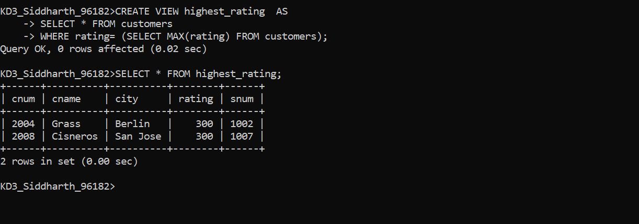

2. Create a view that shows the number of salespeople in each city.
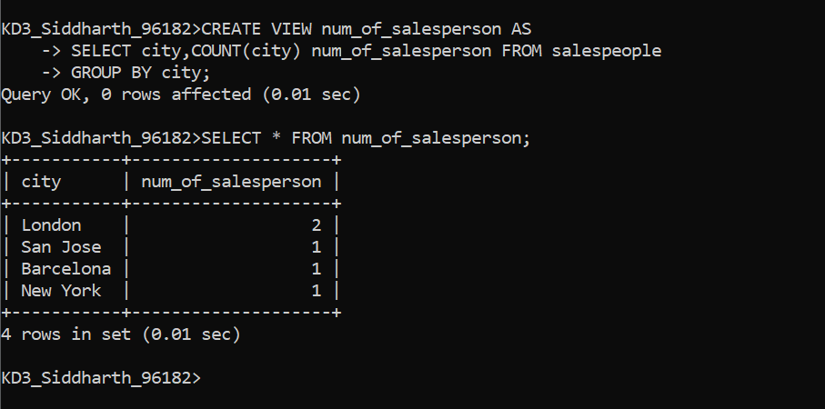
3. Create a view that shows the average and total orders for each salesperson after his or her name. Assume all names are unique.

