DATABASE-TECHNOLOGY ASSIGNMENT 5
Q1.Note: To solve below queries, use “hr” database 1. Display all the first names in lower case and the last names in upper case as the single column separated with ' - '. Provide the meaningful name to the column.

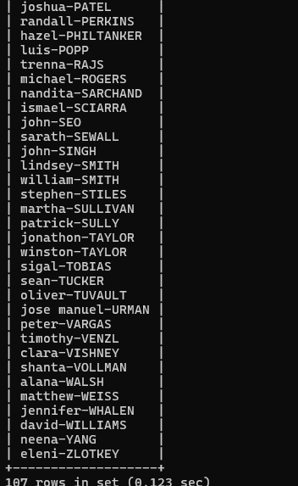
Q.2. Display the first word of the job title. (Hint : Use substring_index).

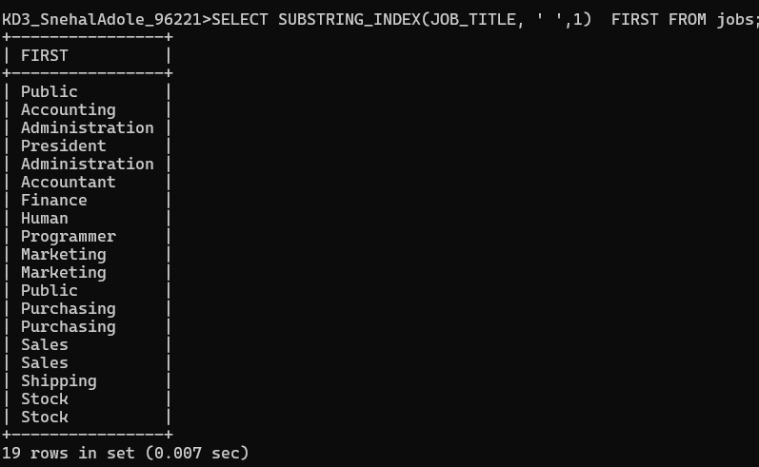
Q3.
Display the First name, last name and length of first name for the employees whose last name contains character ‘b’ anywhere after 3rd position.
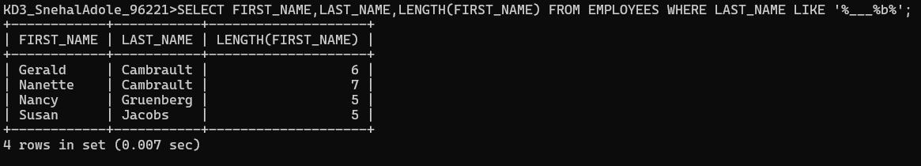
Q4.Display the employee id, first name and last name of the employees whose first or last name includes a space in between.
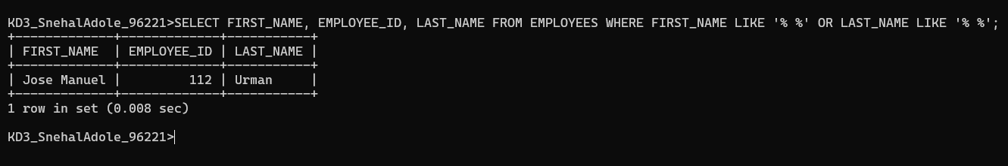

Q5.Display first name, salary, and round the salary to thousands.
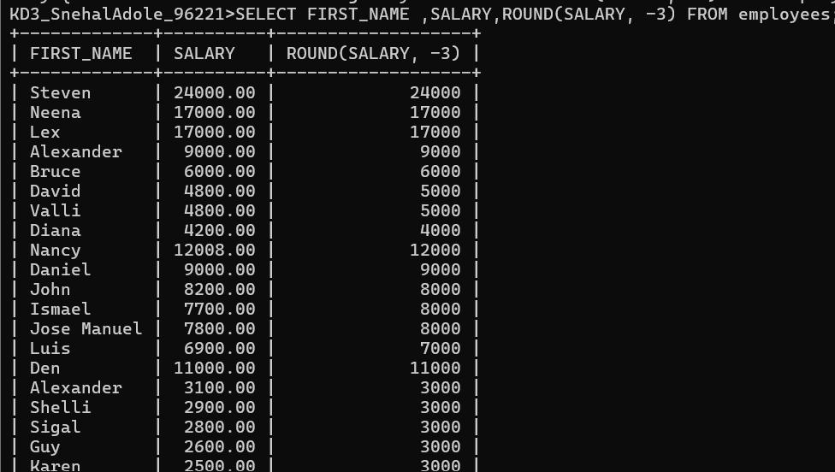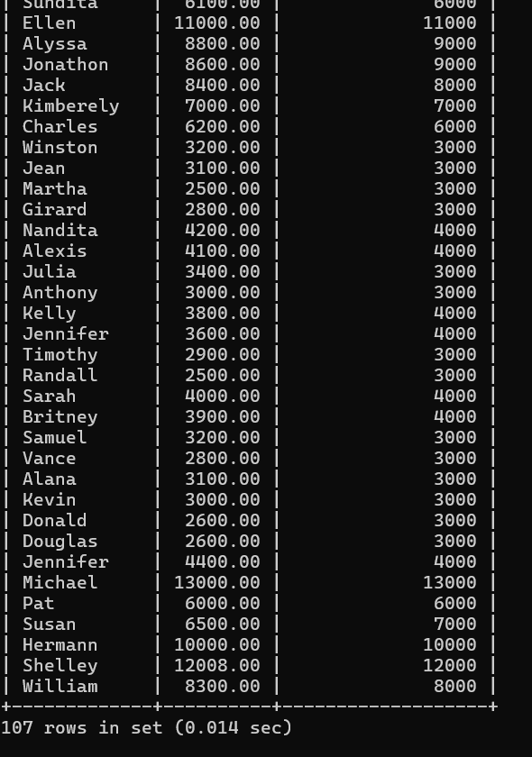
Q6. Display employee ID and the date on which he ended his previous job in the format as mentioned. (Format: Thursday, October 27th 2011)
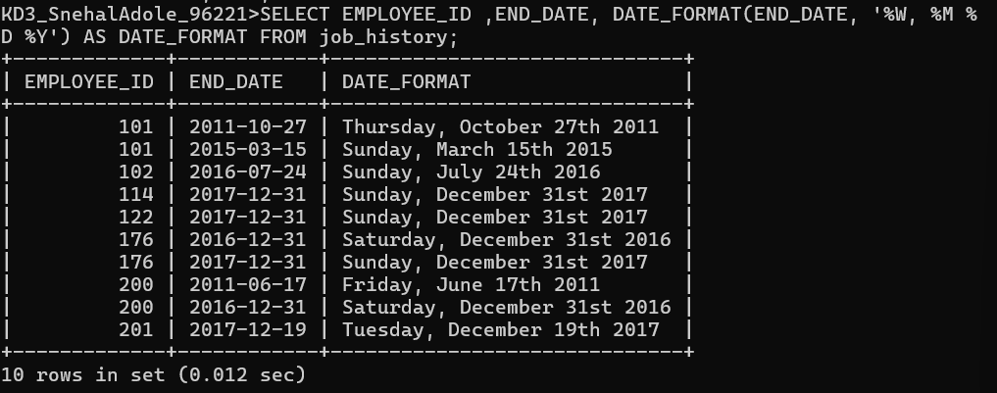

Q7 Display first name and date of first salary of the employees. (Consider 1st day of month as salary day. HINT: LAST_DAY)..
SELECT EMPLOYEE_ID ,FIRST_NAME, HIRE_DATE ,ADDDATE(LAST_DAY(HIRE_DATE), 1) FIRST_SAL FROM EMPLOYEES;
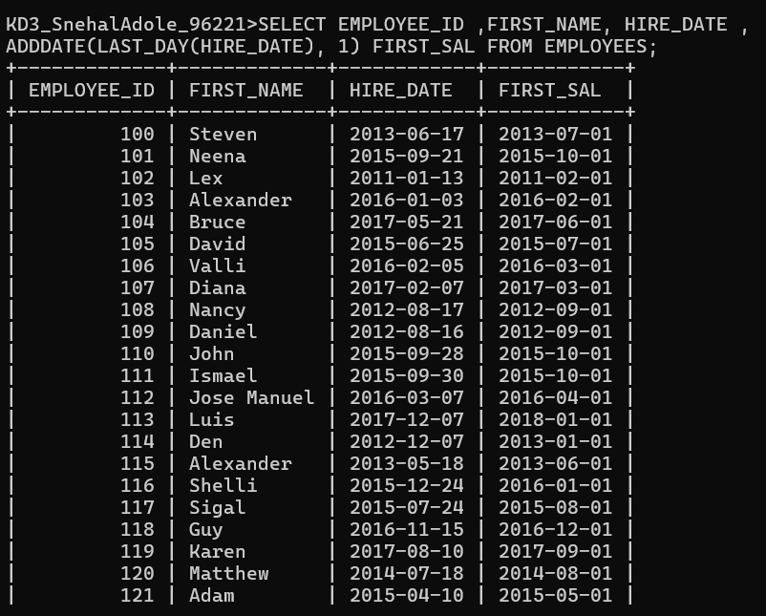
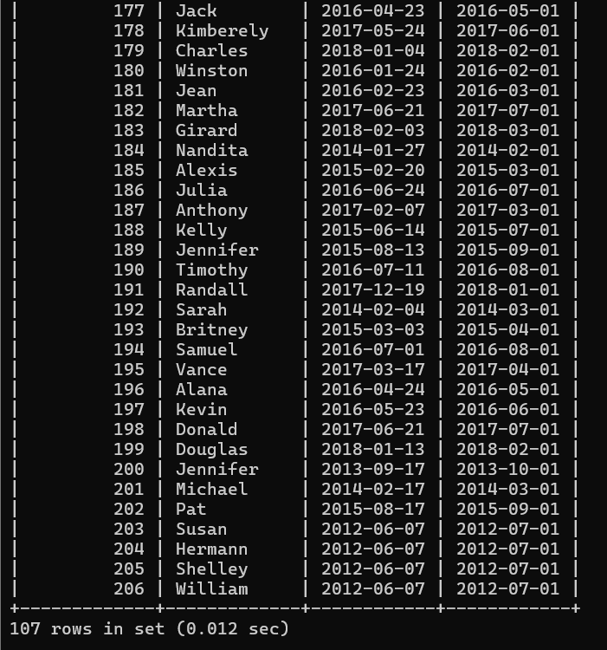
Q8. Display first name and experience of the employees in the format of number of years, months and days completed.

>SELECT
-> FIRST_NAME,
-> hire_date,
-> CONCAT(
-> TIMESTAMPDIFF(YEAR, hire_date, NOW()), ' YEARS ',
-> TIMESTAMPDIFF(MONTH, hire_date, NOW()) % 12, ' MONTHS ',
-> DATEDIFF(
-> NOW(),
-> ADDDATE(
-> ADDDATE(hire_date, INTERVAL TIMESTAMPDIFF(YEAR, hire_date, NOW()) YEAR),
-> INTERVAL TIMESTAMPDIFF(MONTH, hire_date, NOW()) % 12 MONTH
-> )
-> ),
-> ' DAYS'
-> ) AS EXPERIENCE
-> FROM EMPLOYEES;
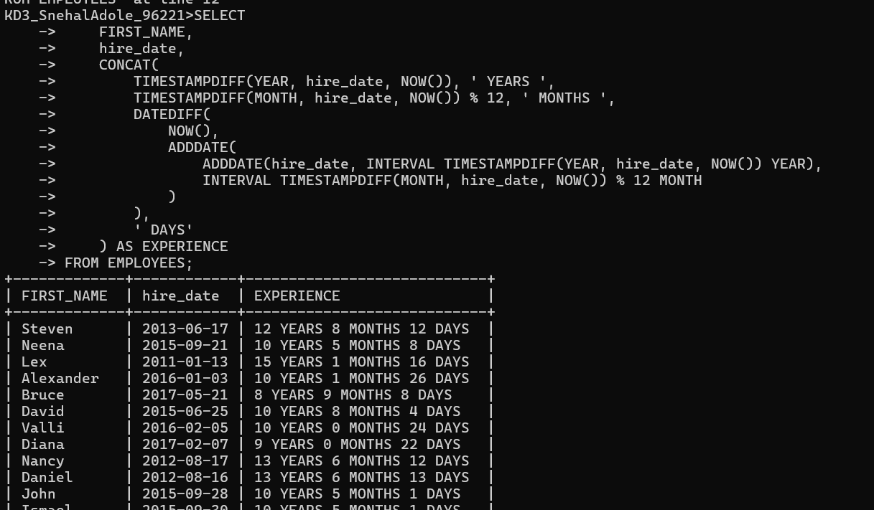
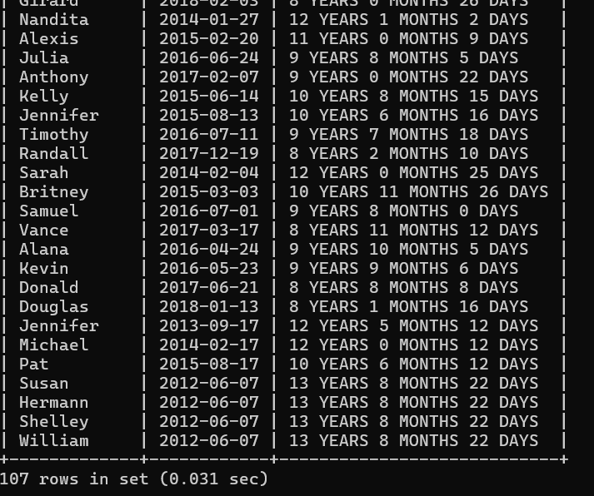
Q9.
Display the employee id, first name and joining date of the employees who joined in the month of august of any year.
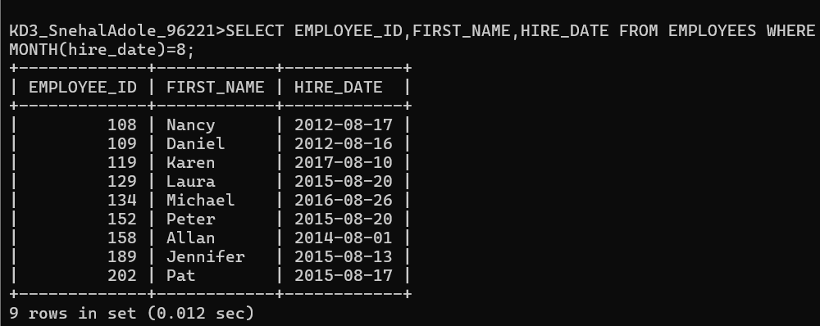

Q10. Display the details of employees who joined before the year 2015.
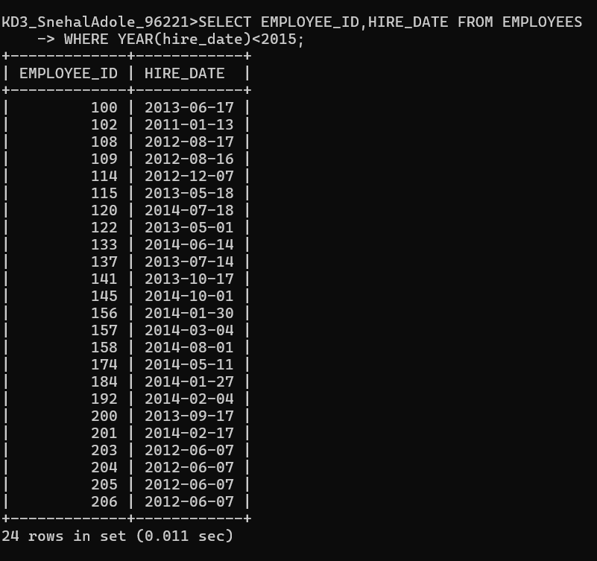
Q11. Display the number of days between system date and 1st January 2011
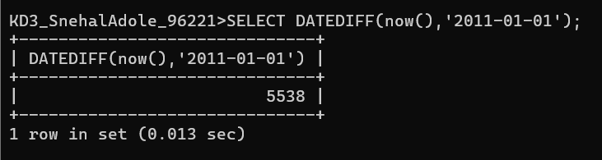

Q12. Display number of employees joined after 15th of any month.
NOTE: If day of hire_date is >15 then result = 1 (TRUE) and it will count all the 1 in 1st row
If day of hire_date is <=15 then result = 0 (FALSE) and it will count all the 0 in 2nd row
So to get the result of 1st row limit 1 is applied.
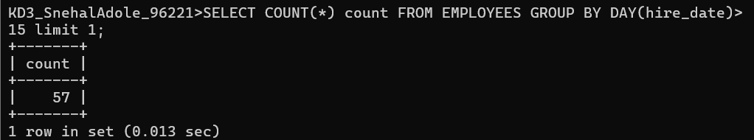
Q13. Display third highest salary of employees.
