DBT_ASSIGNMENT 9
Q1. Create an index that will enable a user to pull orders for ‘1990-10-03’ out of the Orders table quickly.
KD3_SnehalAdole_96221>CREATE INDEX O_ODATE ON ORDERS(odate);
Query OK, 0 rows affected (0.725 sec)
Records: 0 Duplicates: 0 Warnings: 0
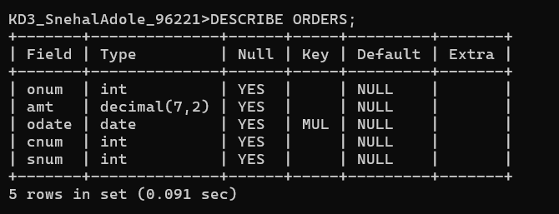
KD3_SnehalAdole_96221>SHOW INDEX FROM ORDERS;
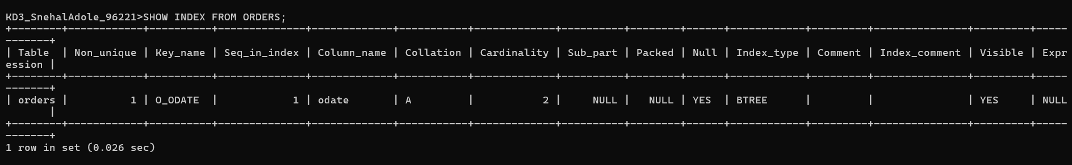
KD3_SnehalAdole_96221>EXPLAIN ANALYZE
SELECT * FROM ORDERS WHERE ODATE=’1990-10-03’
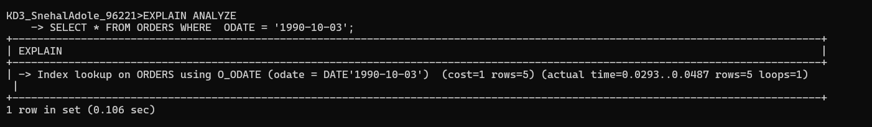
KD3_SnehalAdole_96221>EXPLAIN ANALYZE
-> SELECT * FROM ORDERS;
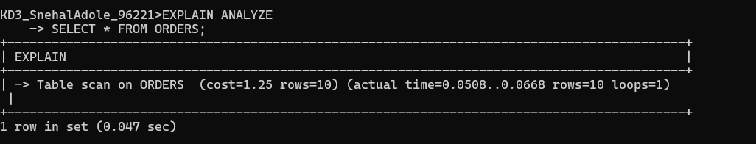

Q2.
KD3_SnehalAdole_96221>CREATE UNIQUE INDEX O_idx_onum ON ORDERS(ONUM);
Query OK, 0 rows affected (0.507 sec)
Records: 0 Duplicates: 0 Warnings: 0

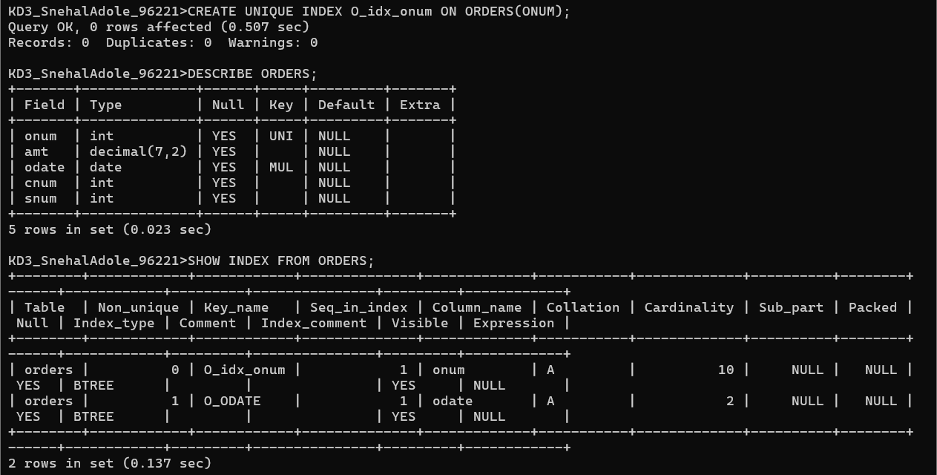

Q4. Let us assume that each salesperson is to have only one customer of a given rating, and this is currently the case. Create an index that enforces it.
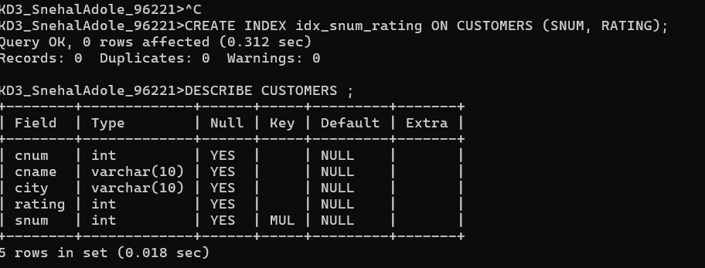

Q5. Create an index to speed up searching order on a given date by given customer
