DATABASE TECHNOLOGIES ASSIGNMENT -2
Write the SELECT queries to do the following:- Note : To solve below queries use “sales” database
Q1. Write a query that produces all rows from the Customers table for which the salesperson’s number is 1001.
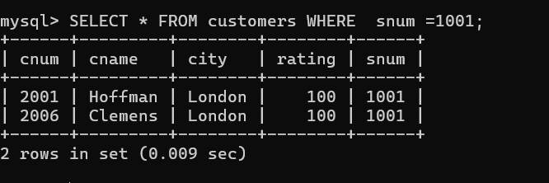

Q2. Write a select command that produces the rating followed by the name of each customer in San Jose.
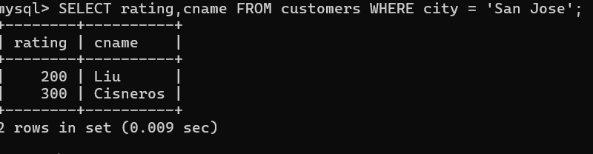
Q3. Write a query that will produce the snum values of all salespeople from the Orders table (with the duplicate values suppressed).
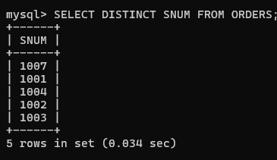
Q4. Write a query that will display all the orders for amount more than Rs. 1,000.
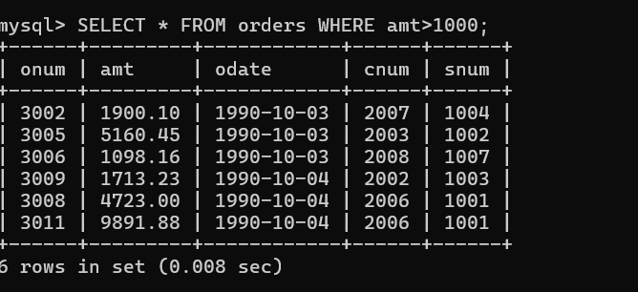

Q5. Write a query that will give you the names and cities of all salespeople in London with a commission above 0.10.
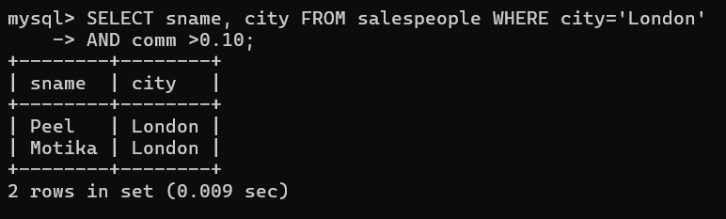
Q6. Write an SQL query that returns all customers who have a rating greater than 100, along with the customers located in Rome regardless of their rating.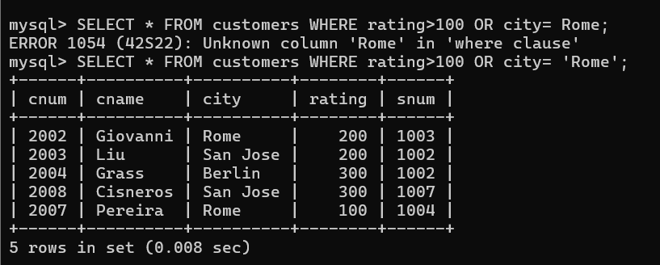
Q7. What will be the output from the following query? Select * from Orders where (amt < 1000 OR NOT (odate = ‘1990-10- 03’ AND cnum > 2003));
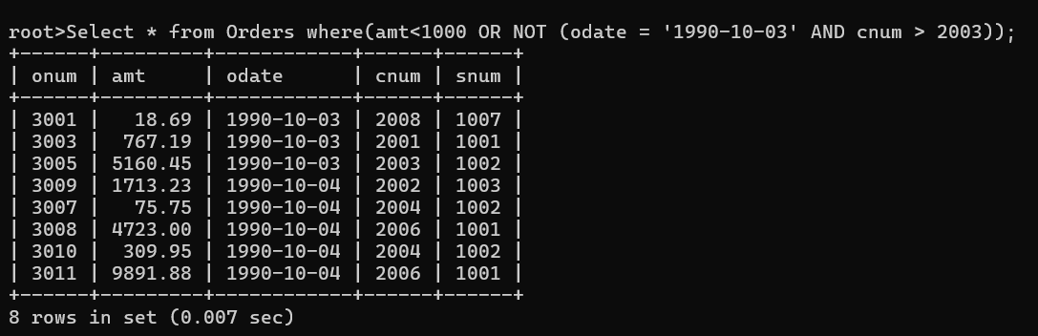
Orders where amount is less than 1000
OR orders not placed on 1990-10-03
OR orders where customer number ≤ 2003
The query will scans each row from Orders
Evaluates the WHERE condition
If condition is true row will be included
If condition is false then row will be excluded

Q8.
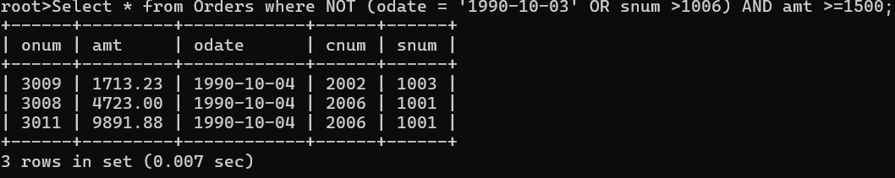

Q9. What is a simpler way to write this query? Select snum, sname, city, comm from Salespeople Where (comm >= .12 AND comm <= .14);
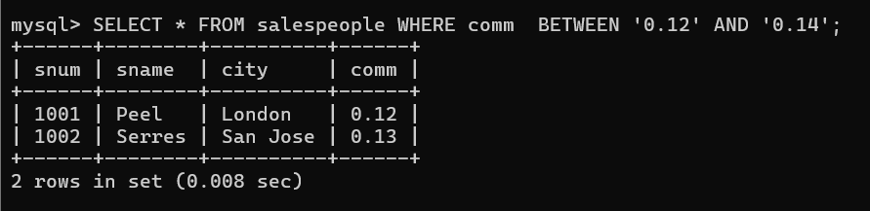
Q10. Write a query that selects all orders except those with amount less than 100.
