Q1. VIEW V1_ordder_maxRating AS SELECT * from customers WHERE RATING = (SELECT MAX(RATING) FROM CUSTOMERS); Query OK, 0 rows affected (0.104 sec) 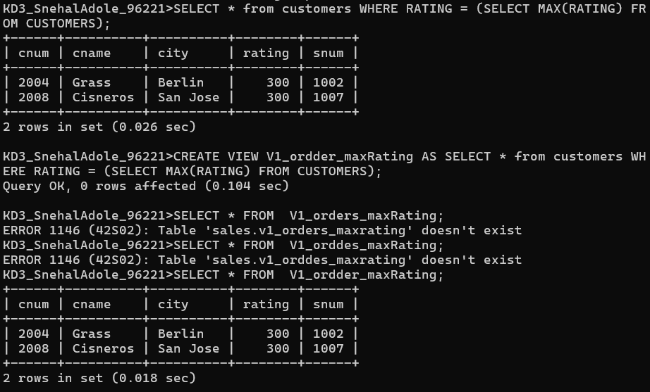
Q2.
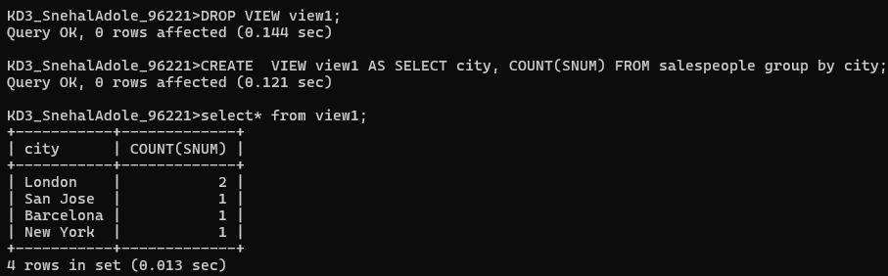
Q3.
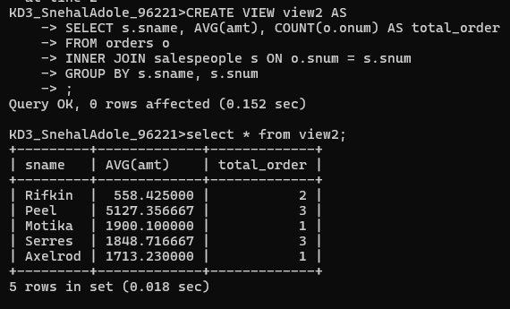
Q4.
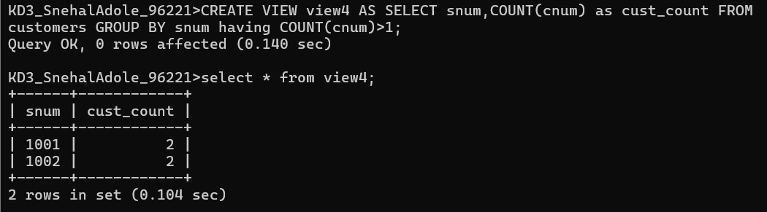
Q5.
#1. Create View Dailyorders as Select Distinct cnum, snum, onum, odate from Orders;
Can perform the DML operation on the above view.
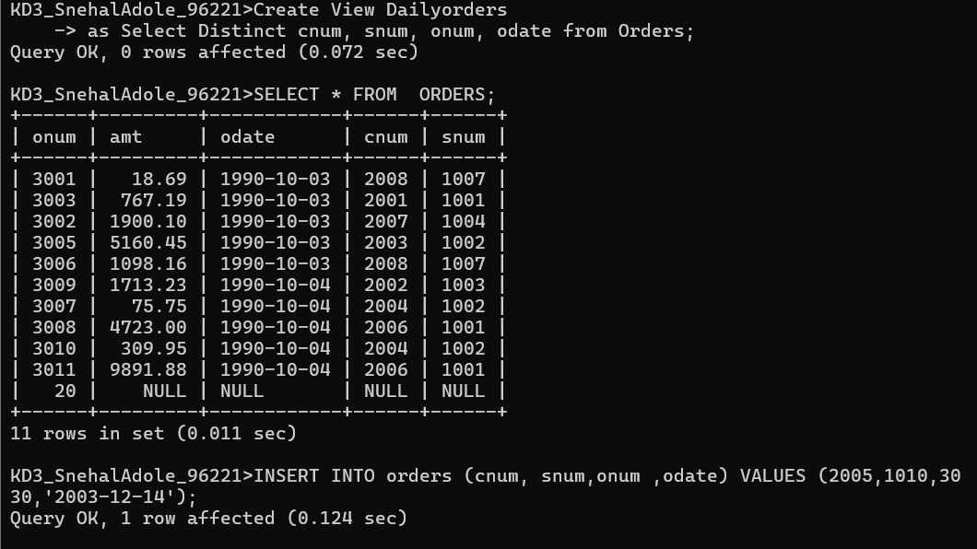
#2.
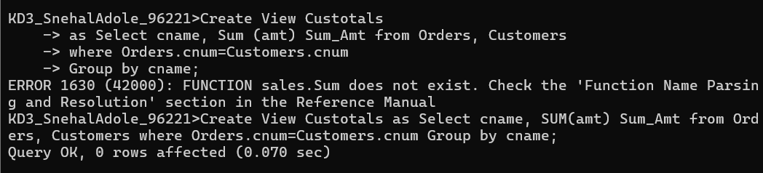
#4
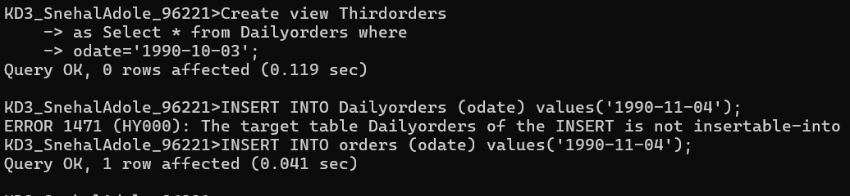
#5
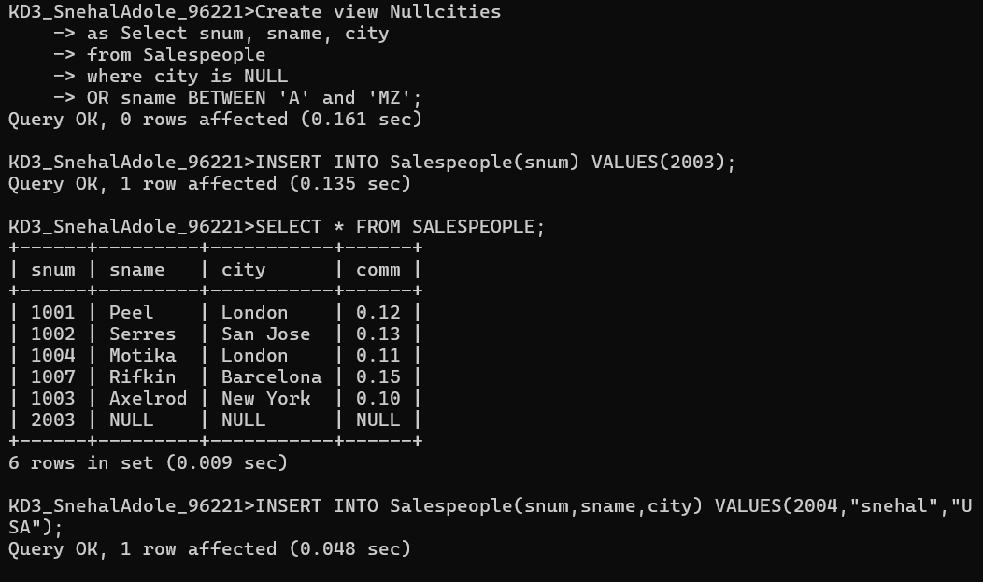
Q6. Create a view of the Salespeople table called Commissions. This view will include only the snum and comm fields. Through this view, someone could enter or change commissions, but only to values between .10 and .20.
