DBT- ASSIGNMENT -1
1. Create 'spj' database'. (Database for suppliers, parts and jobs)
2. use spj database;
3. Create following tables in spj database.
Note : S denotes the Suppliers Table.
CREATE TABLE S (S# CHAR(5) NOT NULL, Sname CHAR(20), status SMALLINT, city CHAR(15));
TABLE S
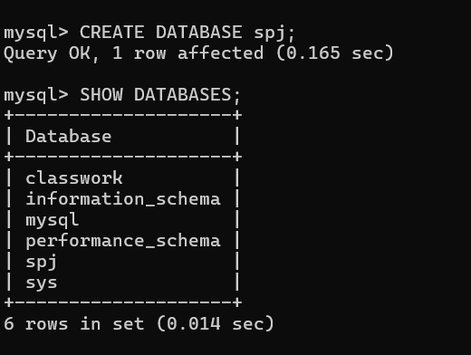

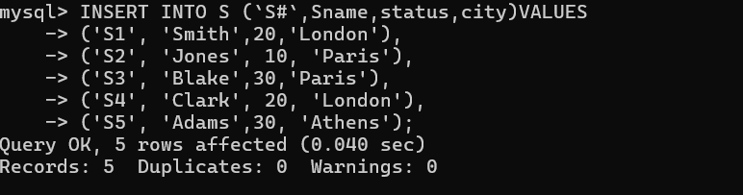

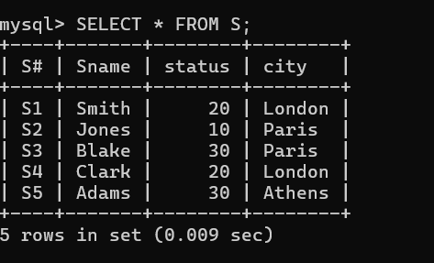

Q2. Note : P denotes the Parts table. CREATE TABLE P (P# CHAR(6) NOT NULL, Pname CHAR(20), color CHAR(6), weight SMALLINT, city CHAR(15)
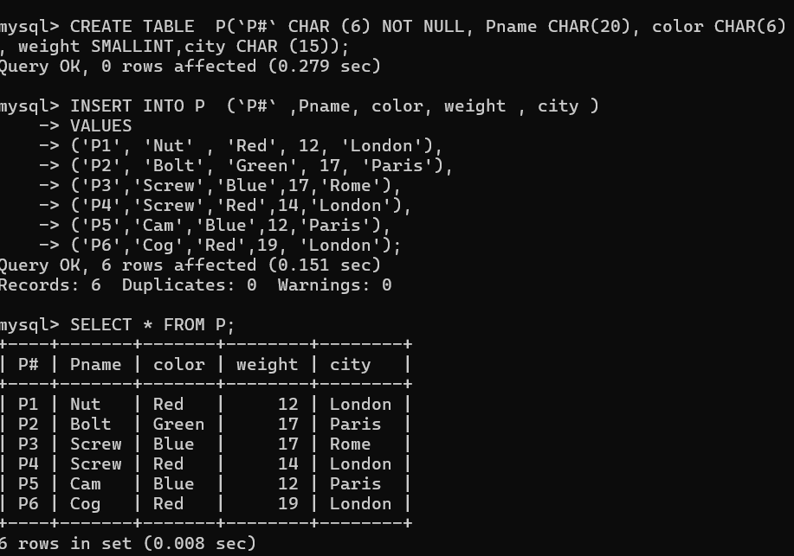

Q3.Note : J denotes the Jobs table. CREATE TABLE J (J# CHAR(4) NOT NULL, Jname CHAR(10), City CHAR(15));

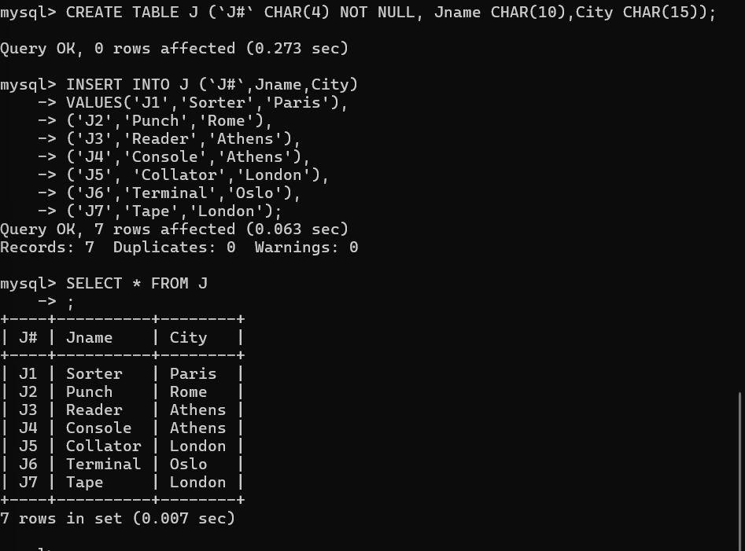

Q4.CREATE TABLE sp (S# CHAR(4) NOT NULL, P# CHAR(4) NOT NULL, J# CHAR(4) NOT NULL, QTY INT);
