Assignment 1
- Create 'spj' database'. (Database for suppliers, parts and jobs)
2. use spj database;
3. Create following tables in spj database.
Note : S denotes the Suppliers Table.
Q1.CREATE TABLE S (S# CHAR(5) NOT NULL, Sname CHAR(20), status SMALLINT, city CHAR(15)); TABLE S
S# | Sname | status | city
=============================
S1 | Smith 20 |  | London
S2 | Jones 10 |  | Paris
S3 | Blake 30 |  | Paris
S4 | Clark 20 |  | London
S5 | Adams 30 |  | Athens

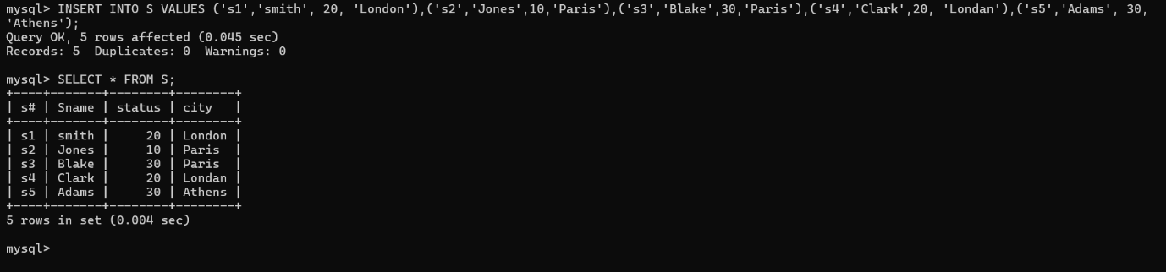
Q2.Note : P denotes the Parts table.
CREATE TABLE P (P# CHAR(6) NOT NULL, Pname CHAR(20), color CHAR(6), weight SMALLINT, city CHAR(15)); 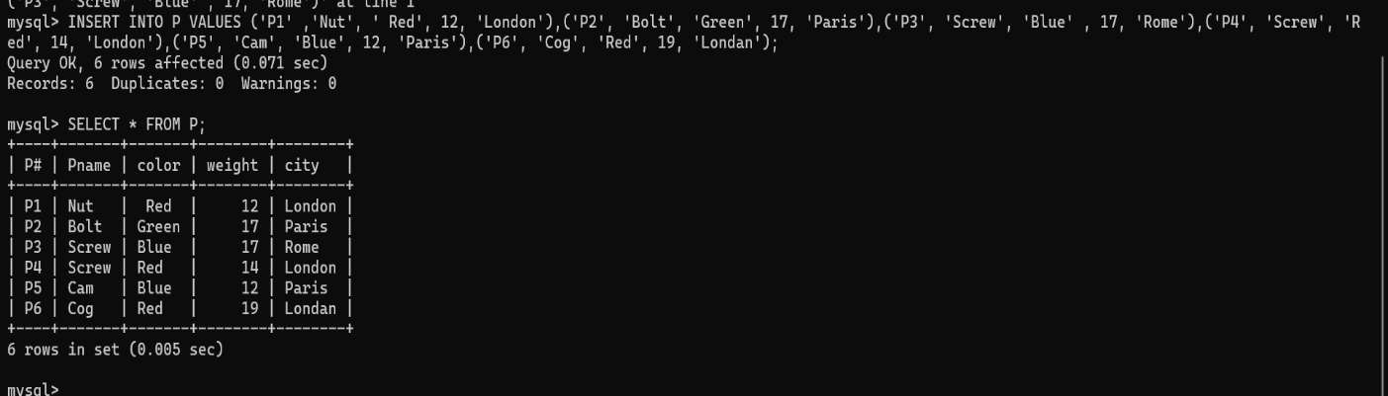

Q3. Note : J denotes the Jobs table.
CREATE TABLE J (J# CHAR(4) NOT NULL, Jname CHAR(10), City CHAR(15));

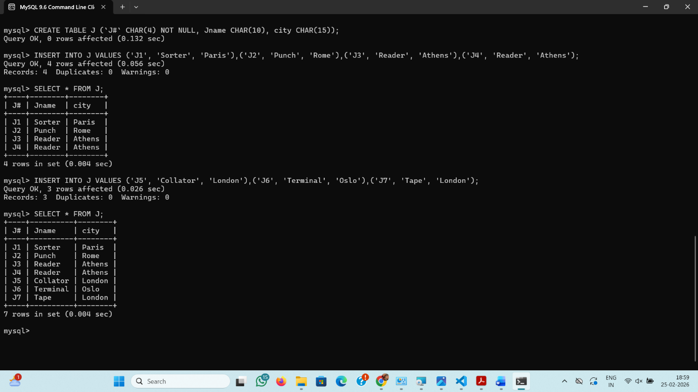

Q4.CREATE TABLE sp (S# CHAR(4) NOT NULL, P# CHAR(4) NOT NULL, J# CHAR(4) NOT NULL, QTY INT);