ASSIGNMENT 2
Write the SELECT queries to do the following:- Note : To solve below queries use “sales” database
- Write a query that produces all rows from the Customers table for which the salesperson’s number is 1001.
sol . select * from customers where snum=1001;
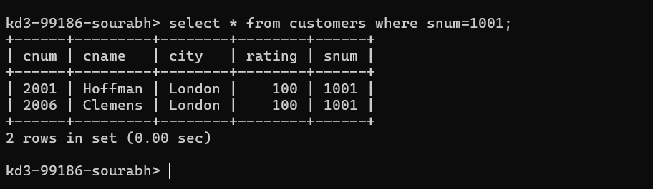
2.Write a select command that produces the rating followed by the name of each customer in San Jose.
Sol. select rating , cname from customers WHERE city='San Jose';
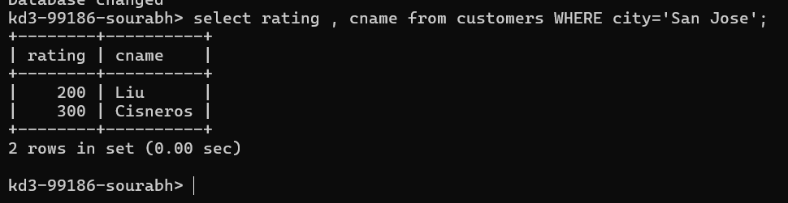

3.Write a query that will produce the snum values of all salespeople from the Orders table (with the duplicate values suppressed).
Sol. SELECT DISTINCT snum FROM orders;
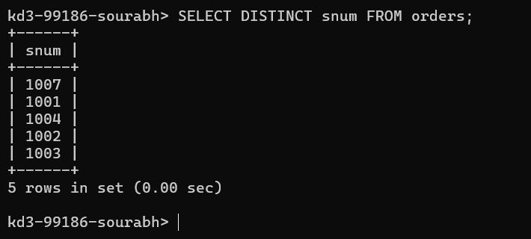
4.Write a query that will display all the orders for amount more than Rs. 1,000.
Sol.SELECT * FROM orders WHERE amt>1000;
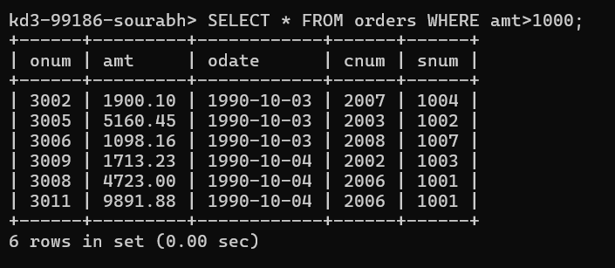
5.Write a query that will give you the names and cities of all salespeople in London with a commission above 0.10.
sol. SELECT sname, city FROM salespeople where city='London' AND comm>0.10;
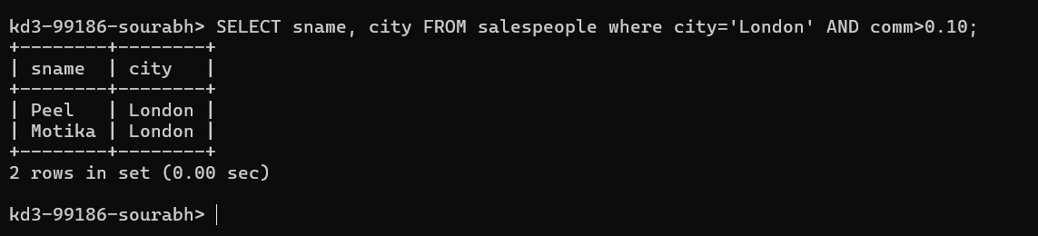
6.Write an SQL query that returns all customers who have a rating greater than 100, along with the customers located in Rome regardless of their rating.
sol. SELECT * FROM customers WHERE rating > 100 OR city='Rome';
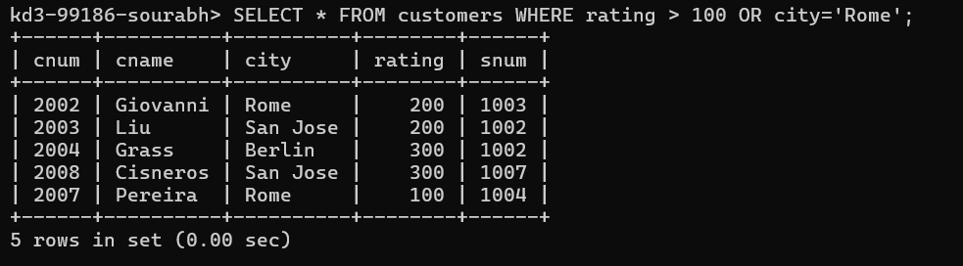
7.What will be the output from the following query? Select * from Orders where (amt < 1000 OR NOT (odate = ‘1990-10-03’ AND cnum > 2003));
sol. Qry1 . SELECT * FROM orders WHERE amt<1000; --it will return all orders of amount less then 1000.
Qry2 . SELECT * FROM orders WHERE odate='1990-10-03' AND cnum>2003;
--it will return all orders whose date is '1990-10-03' and cnum is greater than 2003.
Qry3 . SELECT * FROM orders WHERE NOT(odate='1990-10-03' AND cnum>2003);
--it will return orders whose odate and cnum is not '1990-10-03' and greater than 2003 respectively at same time.
Qry4 . SELECT * FROM orders WHERE (amt < 1000 OR NOT (odate ='1990-10-03' AND cnum > 2003));
--it will return all orders whose odate and cnum is not '1990-10-03' and greater than 2003 at same time or where amt is less than 1000.
8.What will be the output of the following query? Select * from Orders where NOT (odate = ‘1990-10-03’ OR snum>1006) AND amt >= 1500;
sol. it is very similar to last question with very little difference . it will return orders odate is not '1990-10-03' and snum is not greater than 1006 and amt is greater than 1500.

9.What is a simpler way to write this query? Select snum, sname, city, comm from Salespeople Where (comm >= .12 AND comm <= .14);
sol. select * FROM salespeople WHERE comm BETWEEN .12 AND .14;
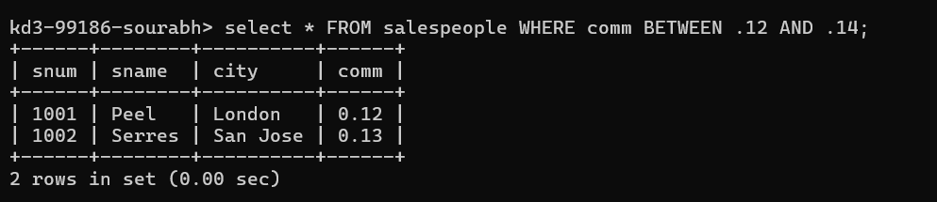
10.Write a query that selects all orders except those with amount less than 100.
sol. SELECT * FROM orders WHERE NOT(amt<100);
