ASSIGNMENT 3
Database Technologies – Assignment 3 Note : To solve below queries use “hr” database
- Write a query to get unique department ID from employee table.
sol. SELECT DISTINCT DEPARTMENT_ID FROM employees;

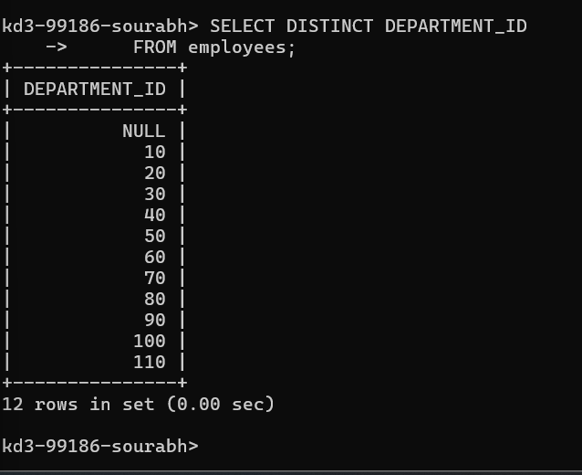
2.Write a query to get all the employee’s details from the employees table displaying the first names in descending order.
sol. SELECT * FROM employees ORDER BY FIRST_NAME DESC;

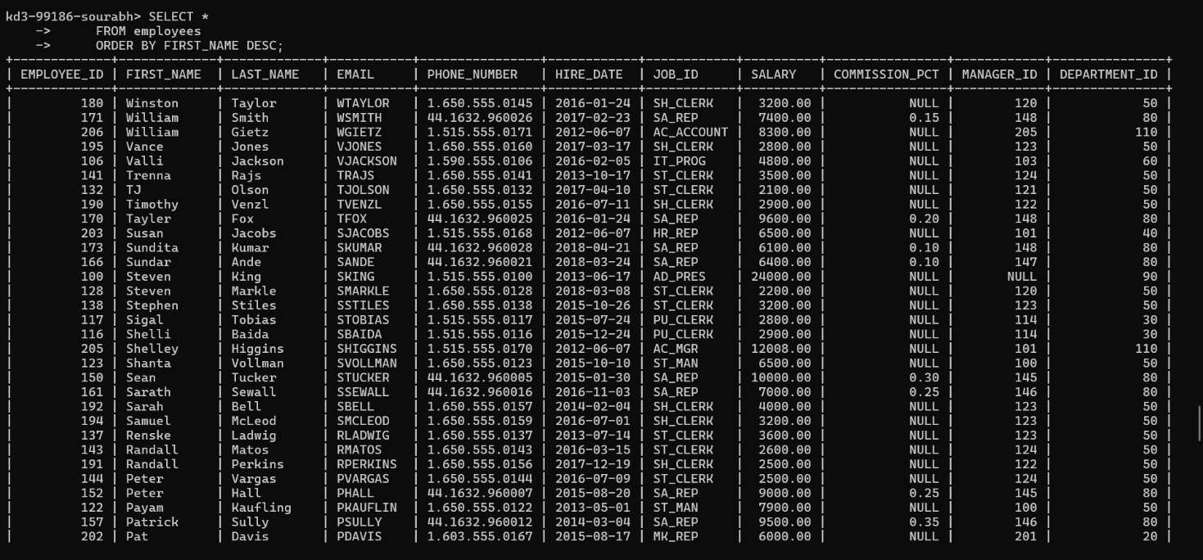
3.Write a query to get the employee ID, names (first_name and last_name), salary in ascending order of salary.
sol. SELECT employee_id ,first_name,last_name,salary FROM employees ORDER BY salary ASC;
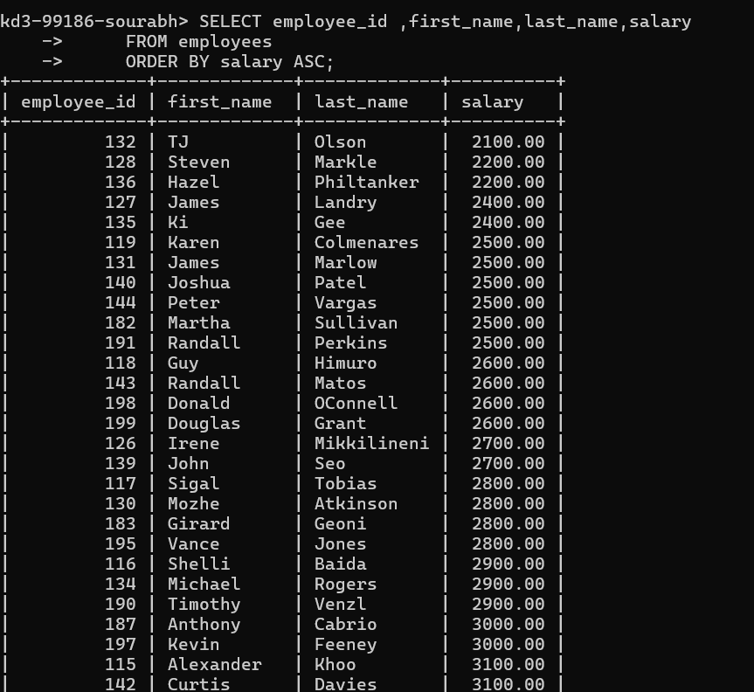
4.Display first name and joining date of the employees who are either IT Programmer or Sales Man.
sol. SELECT first_name , hire_date FROM employees WHERE job_id='it_prog' or job_id='fi_account';
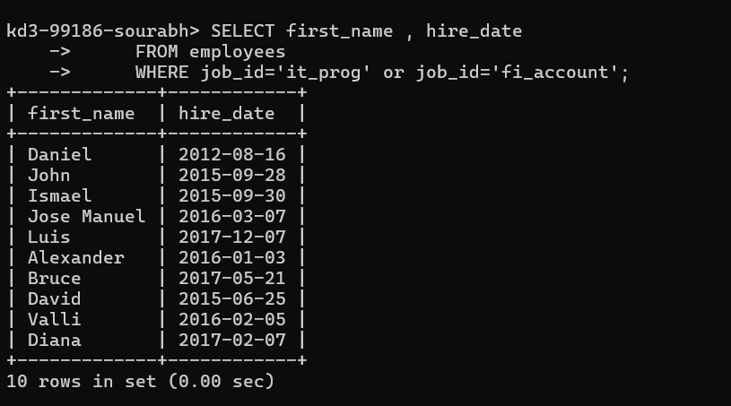
5.Display details of employees with employee ID 150 or 160.
sol. SELECT * FROM employees WHERE employee_id=150 or employee_id=160;
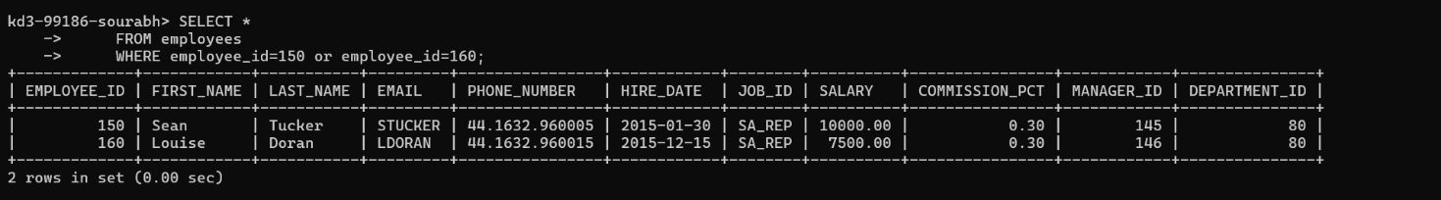
6.Display first name, salary, commission pct, and hire date for employees with salary less than 10000.
sol. SELECT first_name, salary, commission_pct, hire_date FROM employees WHERE salary<10000;
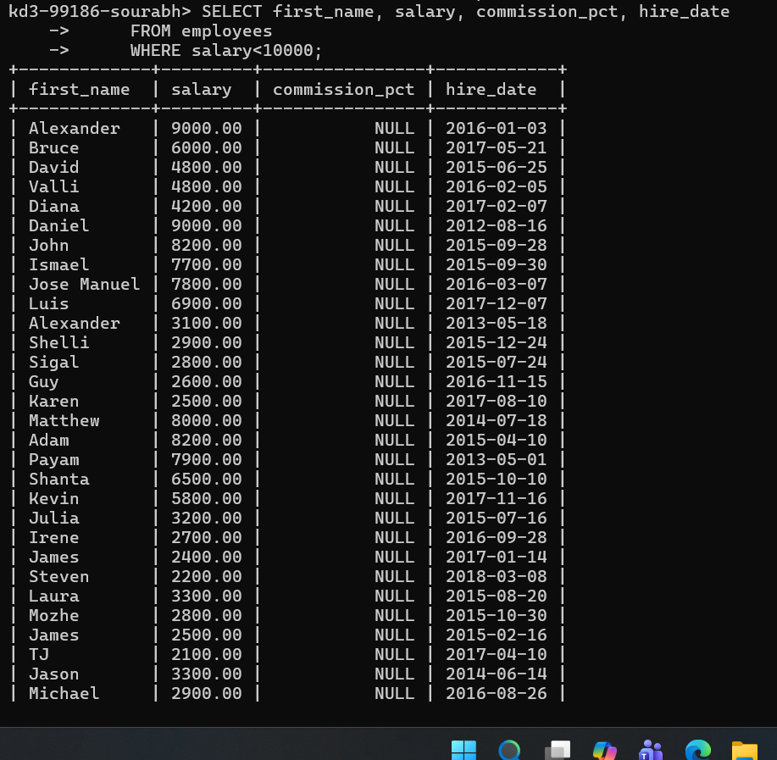
7.Display employees where the first name or last name starts with S.
sol. SELECT * FROM employees WHERE first_name LIKE 's%' OR last_name Like's%';
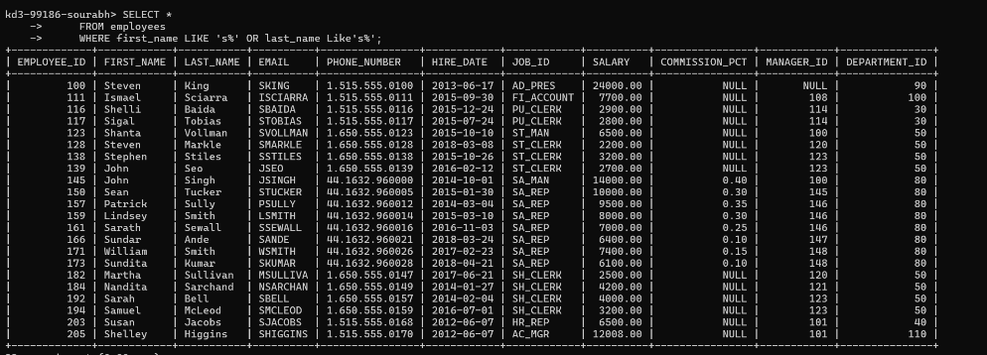
8.Display details of jobs in the descending order of the title.
sol. SELECT * FROM jobs ORDER BY job_title DESC;
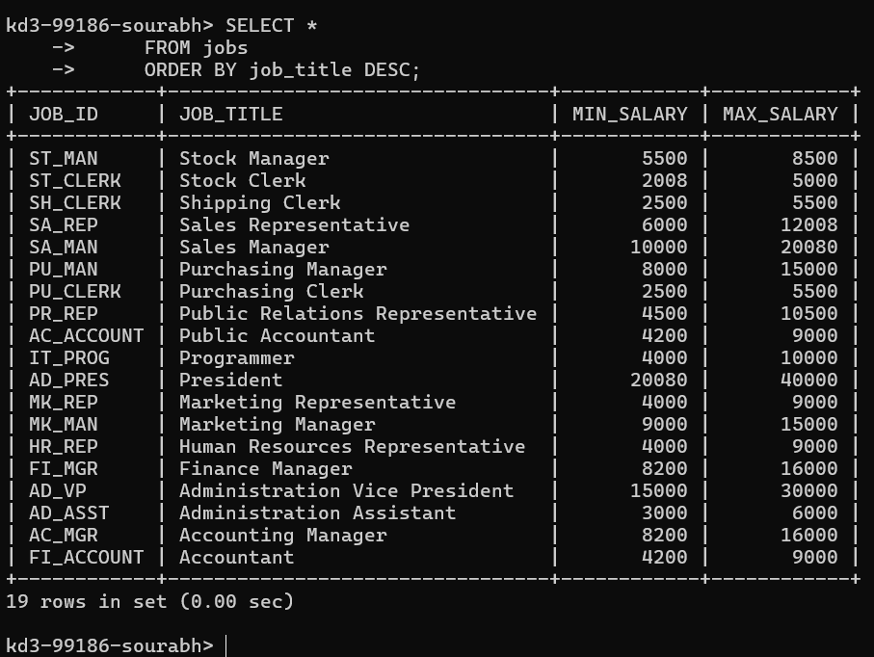
9.Display the details of the employees from department 30, earning the salary greater 10000 but do not receive the commission.
sol. SELECT * FROM employees WHERE department_id=30 AND salary>10000 AND (commission_pct IS NULL OR commission_pct<=0.0);
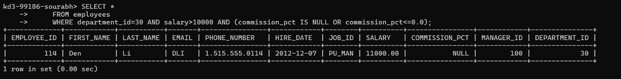
10.Display the details of employees reporting to the managers with employee id 100 and 120.
sol. SELECT * FROM employees WHERE manager_id=100 or manager_id=120;
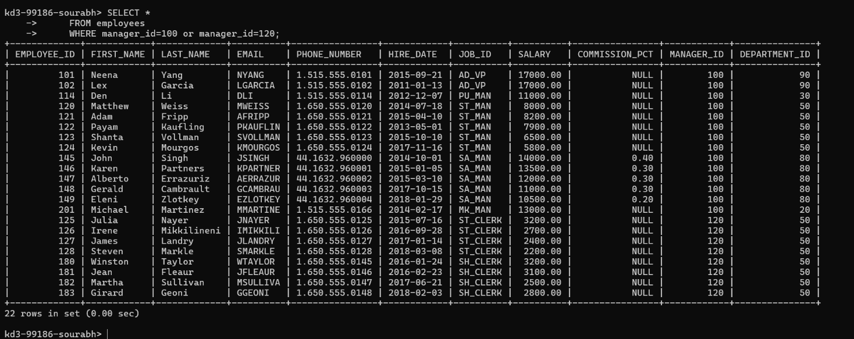
11.Display the unique country_id from locations table.
sol. SELECT DISTINCT country_id FROM locations;
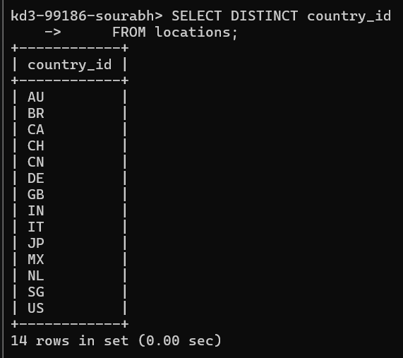
12.Display all employees whose have the job_id as IT_PROG and FI_ACCOUNT.
sol. SELECT * FROM employees WHERE job_id='IT_PROG' OR job_id='FI_ACCOUNT';
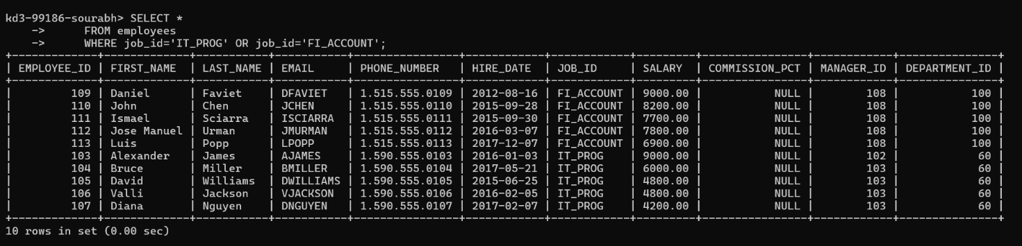
13.Display all countries in ascending order.
sol. SELECT * FROM countries ORDER BY country_name ASC;
