Group by
Q1. 586. Customer Placing the Largest Number of Orders https://leetcode.com/problems/customer-placing-the-largest-number-of-orders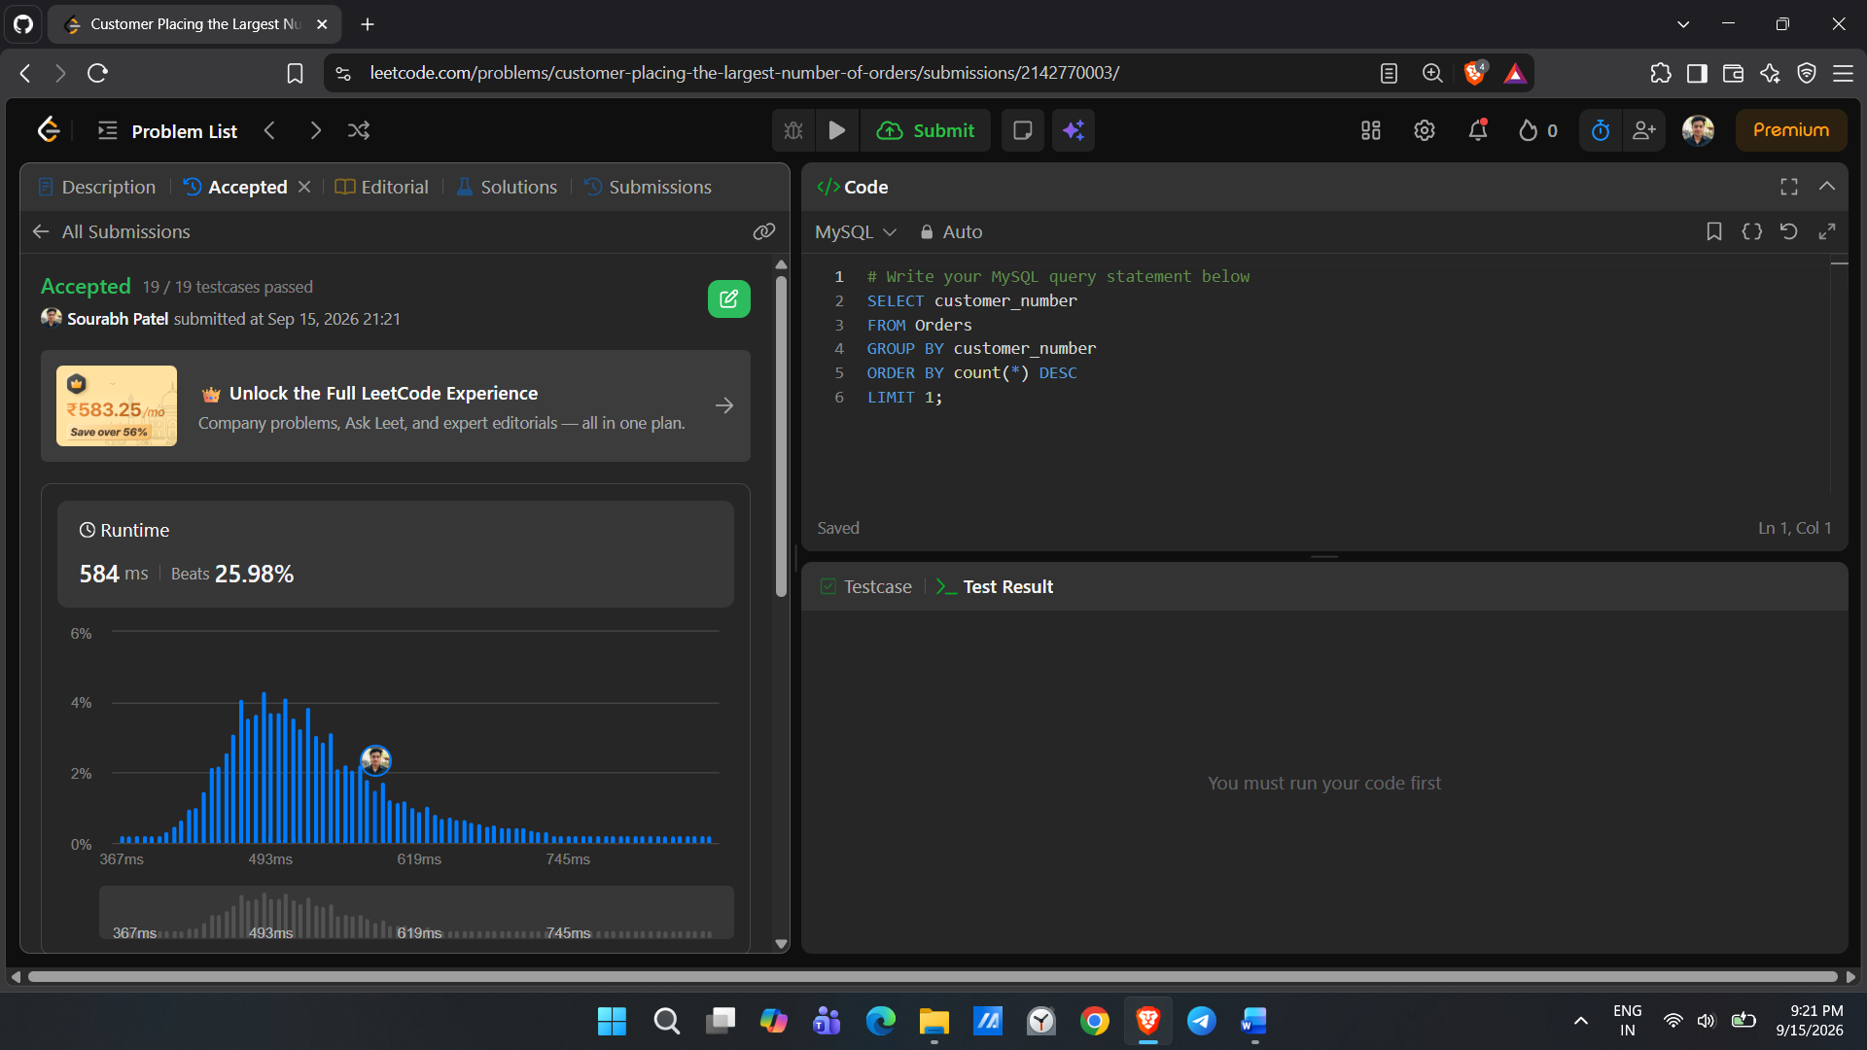
Q2. 619. Biggest Single Number
https://leetcode.com/problems/biggest-single-number
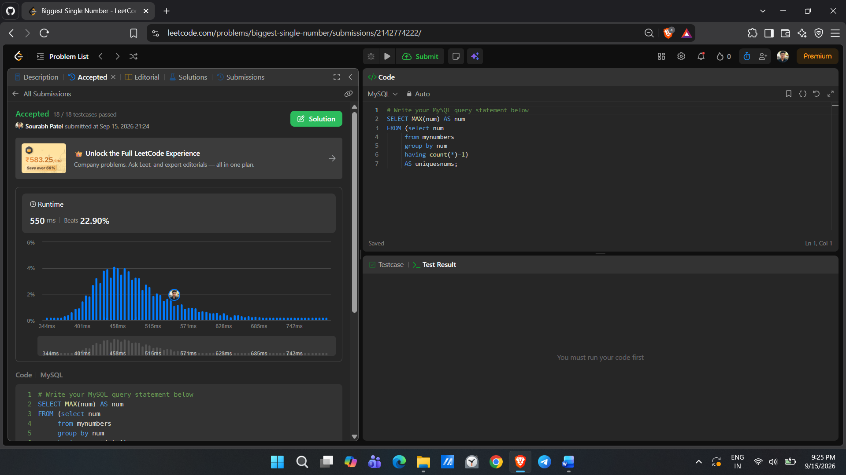
3. 511. Game Play Analysis I https://leetcode.com/problems/game-play-analysis-i
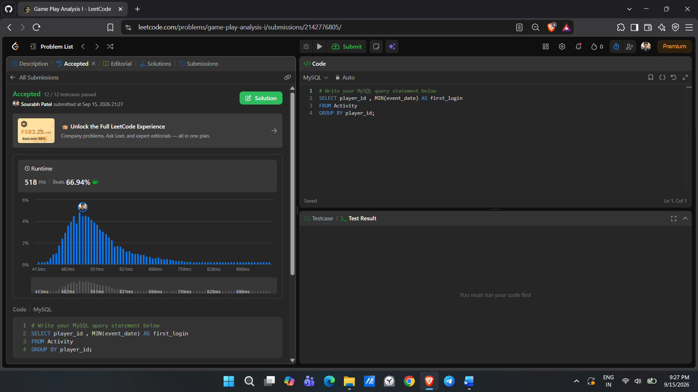
4. 1693. Daily Leads and Partners https://leetcode.com/problems/daily-leads-and-partners
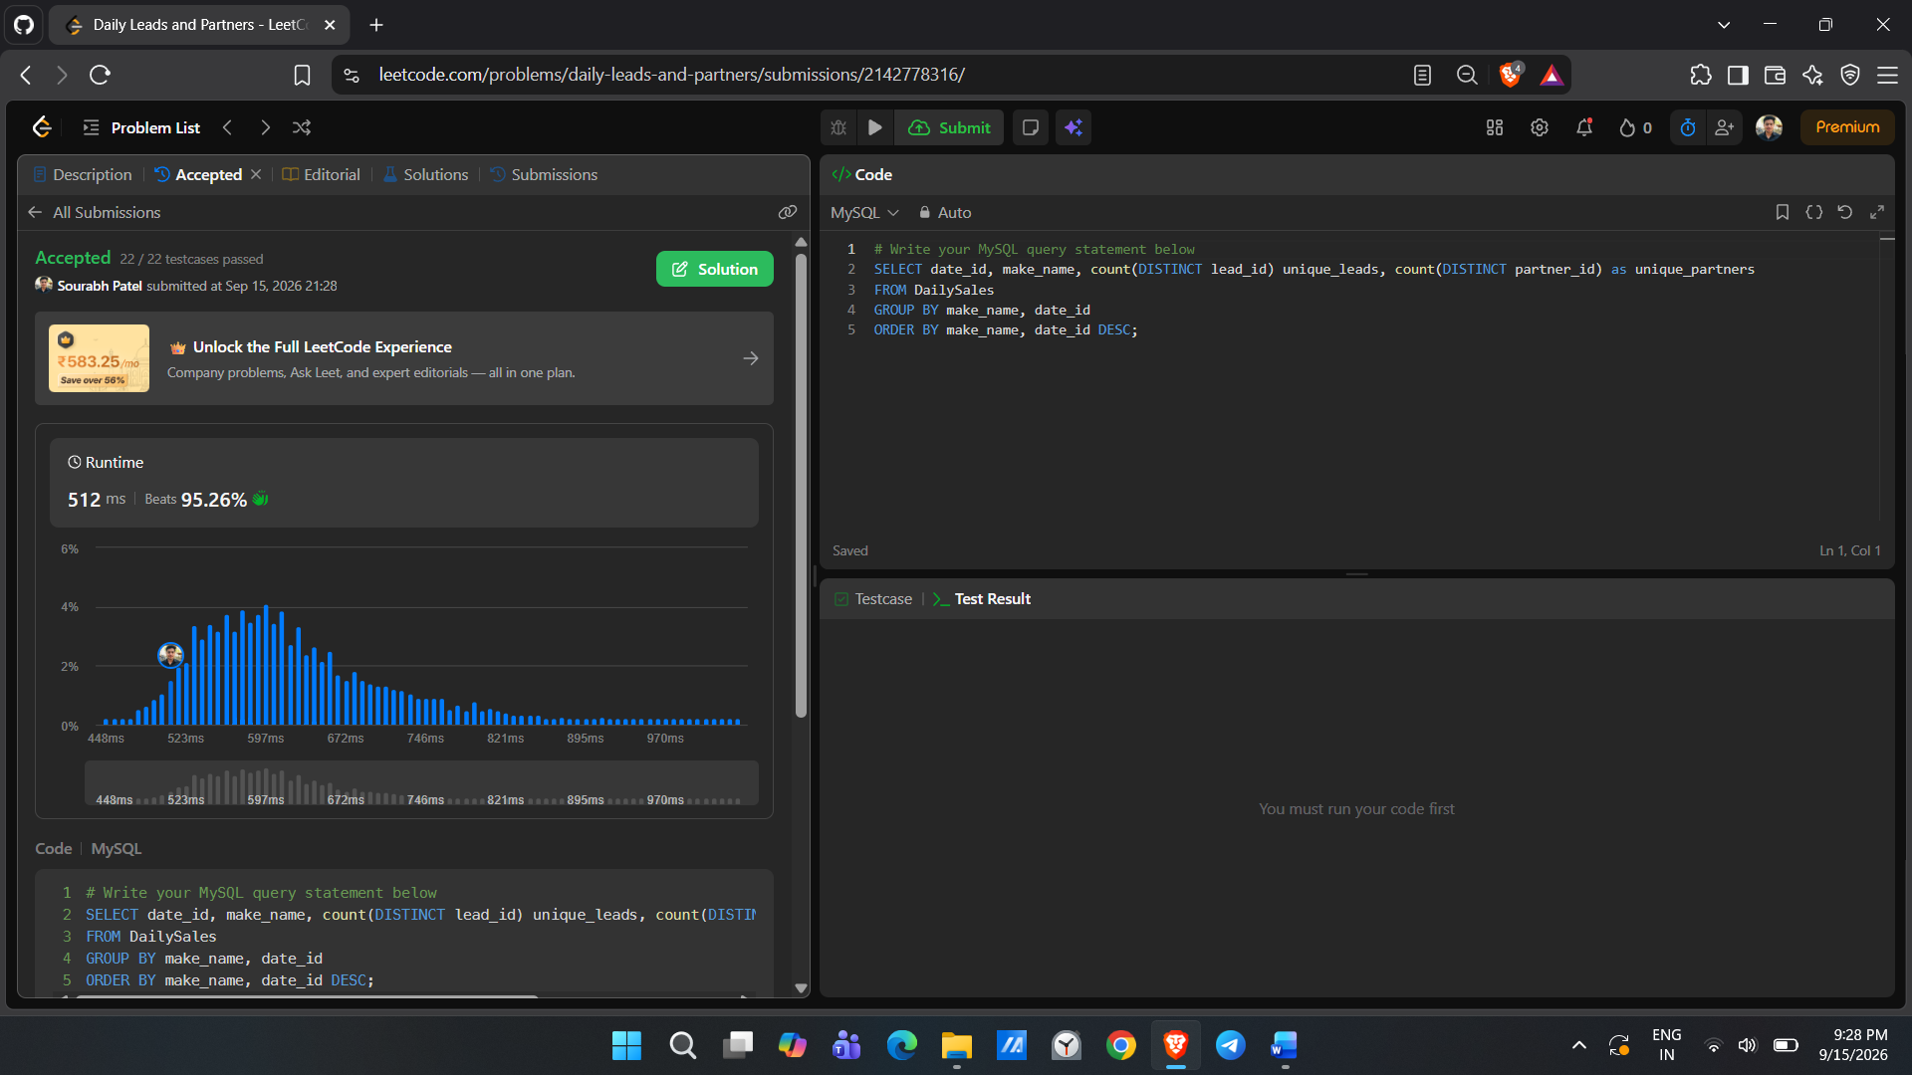
5. 1741. Find Total Time Spent by Each Employee https://leetcode.com/problems/find-total-time-spent-by-each-employee
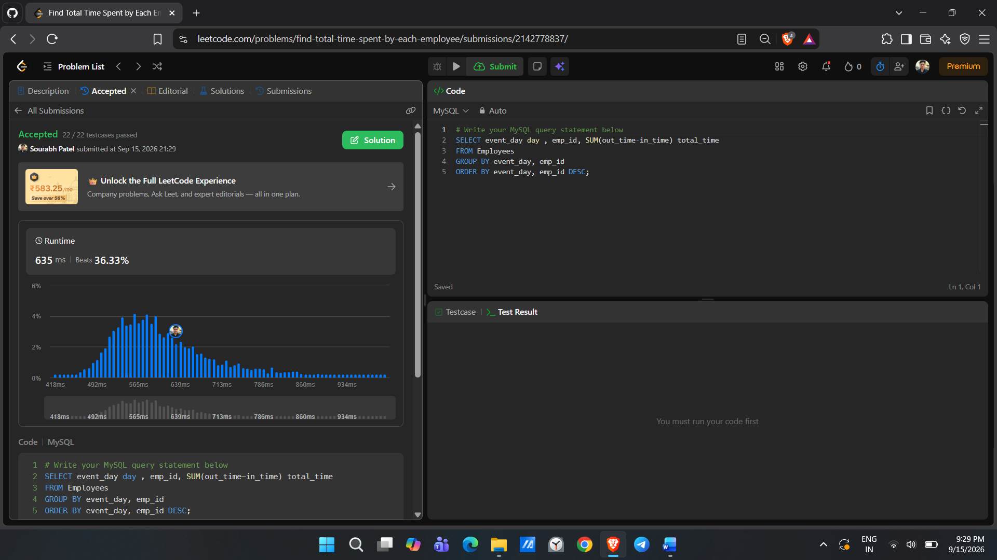
6. 1050. Actors and Directors Who Cooperated at Least Three Times https://leetcode.com/problems/actors-and-directors-who-cooperated-at-leastthree-times
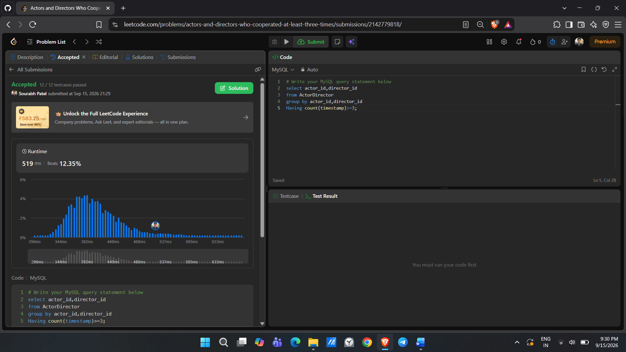
7. 1890. The Latest Login in 2020 https://leetcode.com/problems/the-latest-login-in-2020
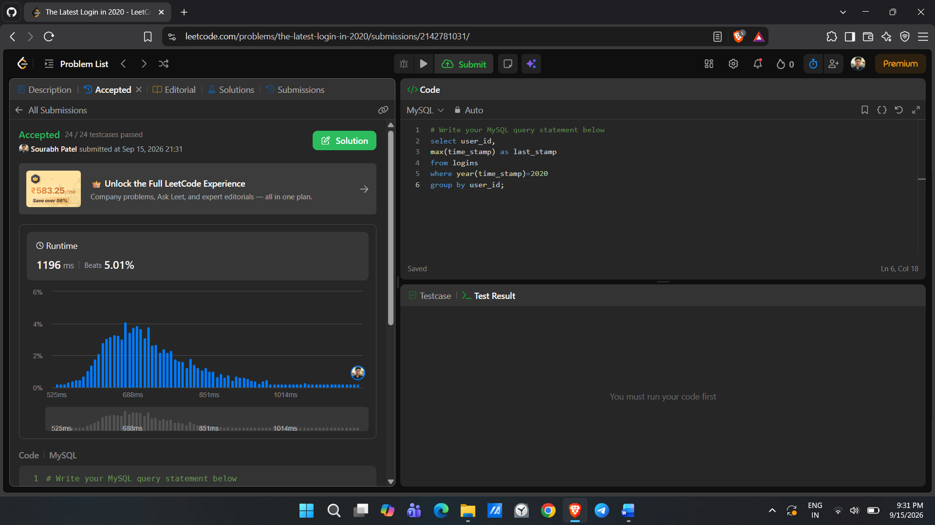
8. 1211. Queries Quality and Percentage https://leetcode.com/problems/queries-quality-and-percentage 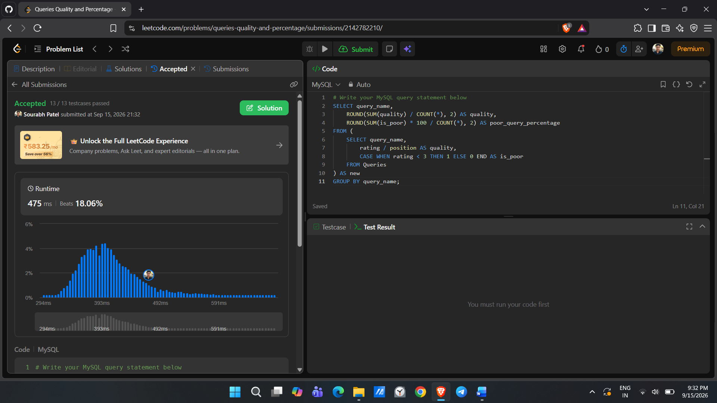
9. 1141. User Activity for the Past 30 Days I https://leetcode.com/problems/user-activity-for-the-past-30-days-i
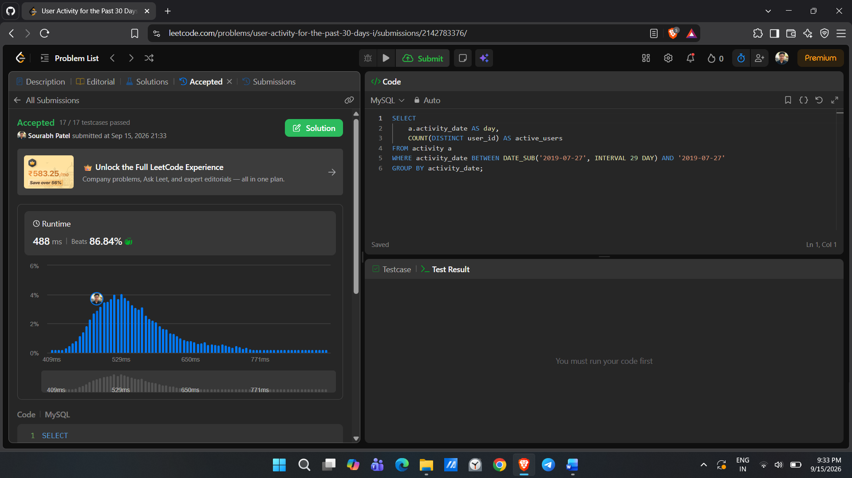
10. 596. Classes With At Least 5 Students https://leetcode.com/problems/classes-with-at-least-5-students
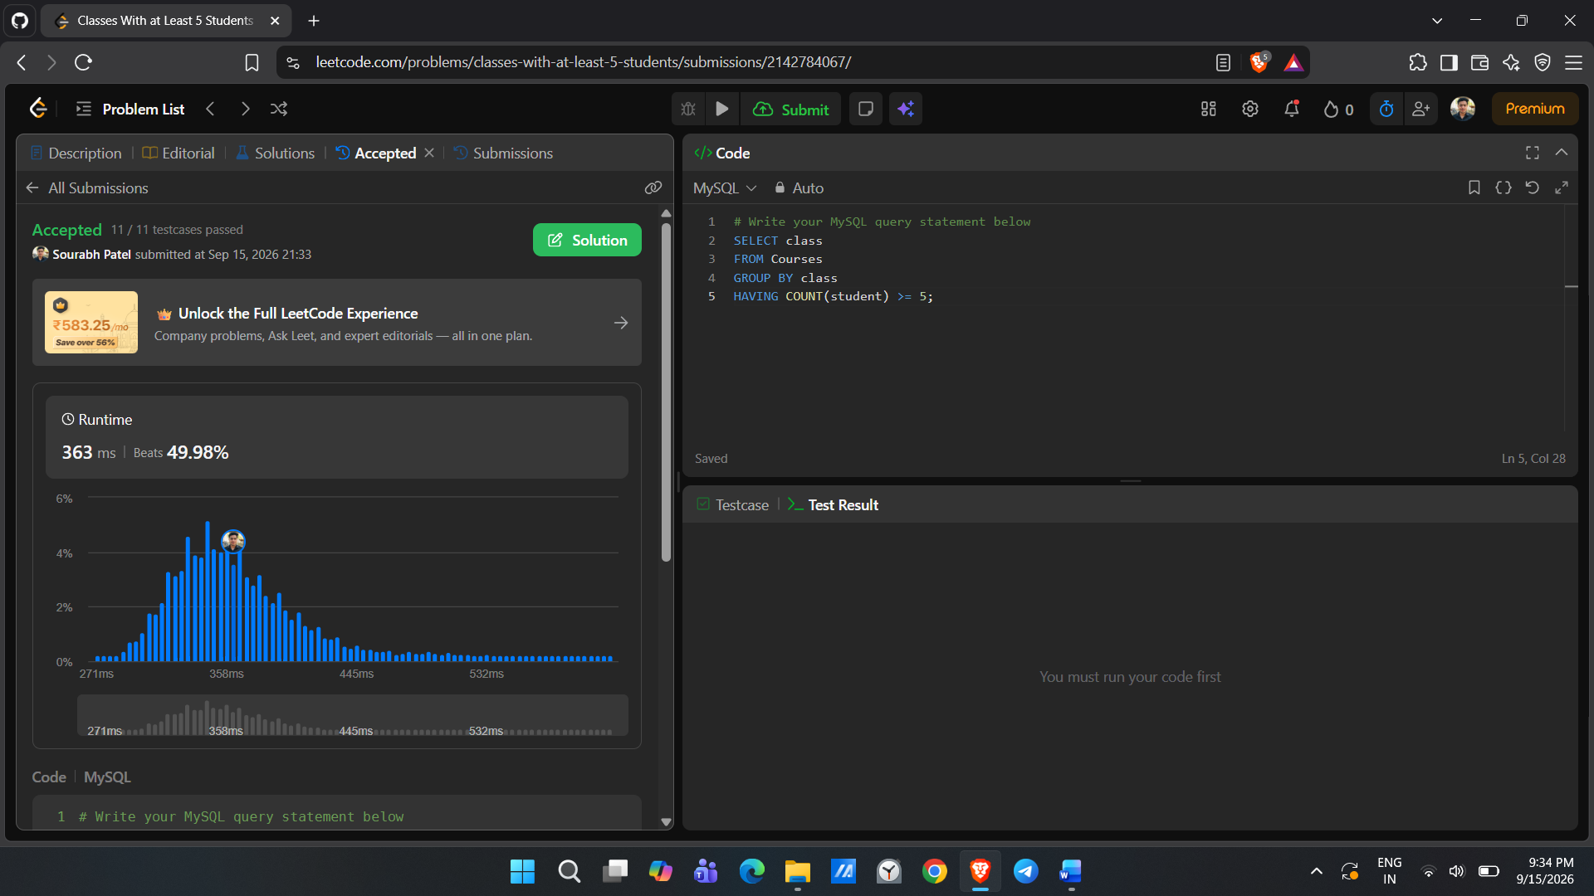
JOINS
1. Replace Employee ID With The Unique Identifier https://leetcode.com/problems/replace-employee-id-with-the-unique-identifier
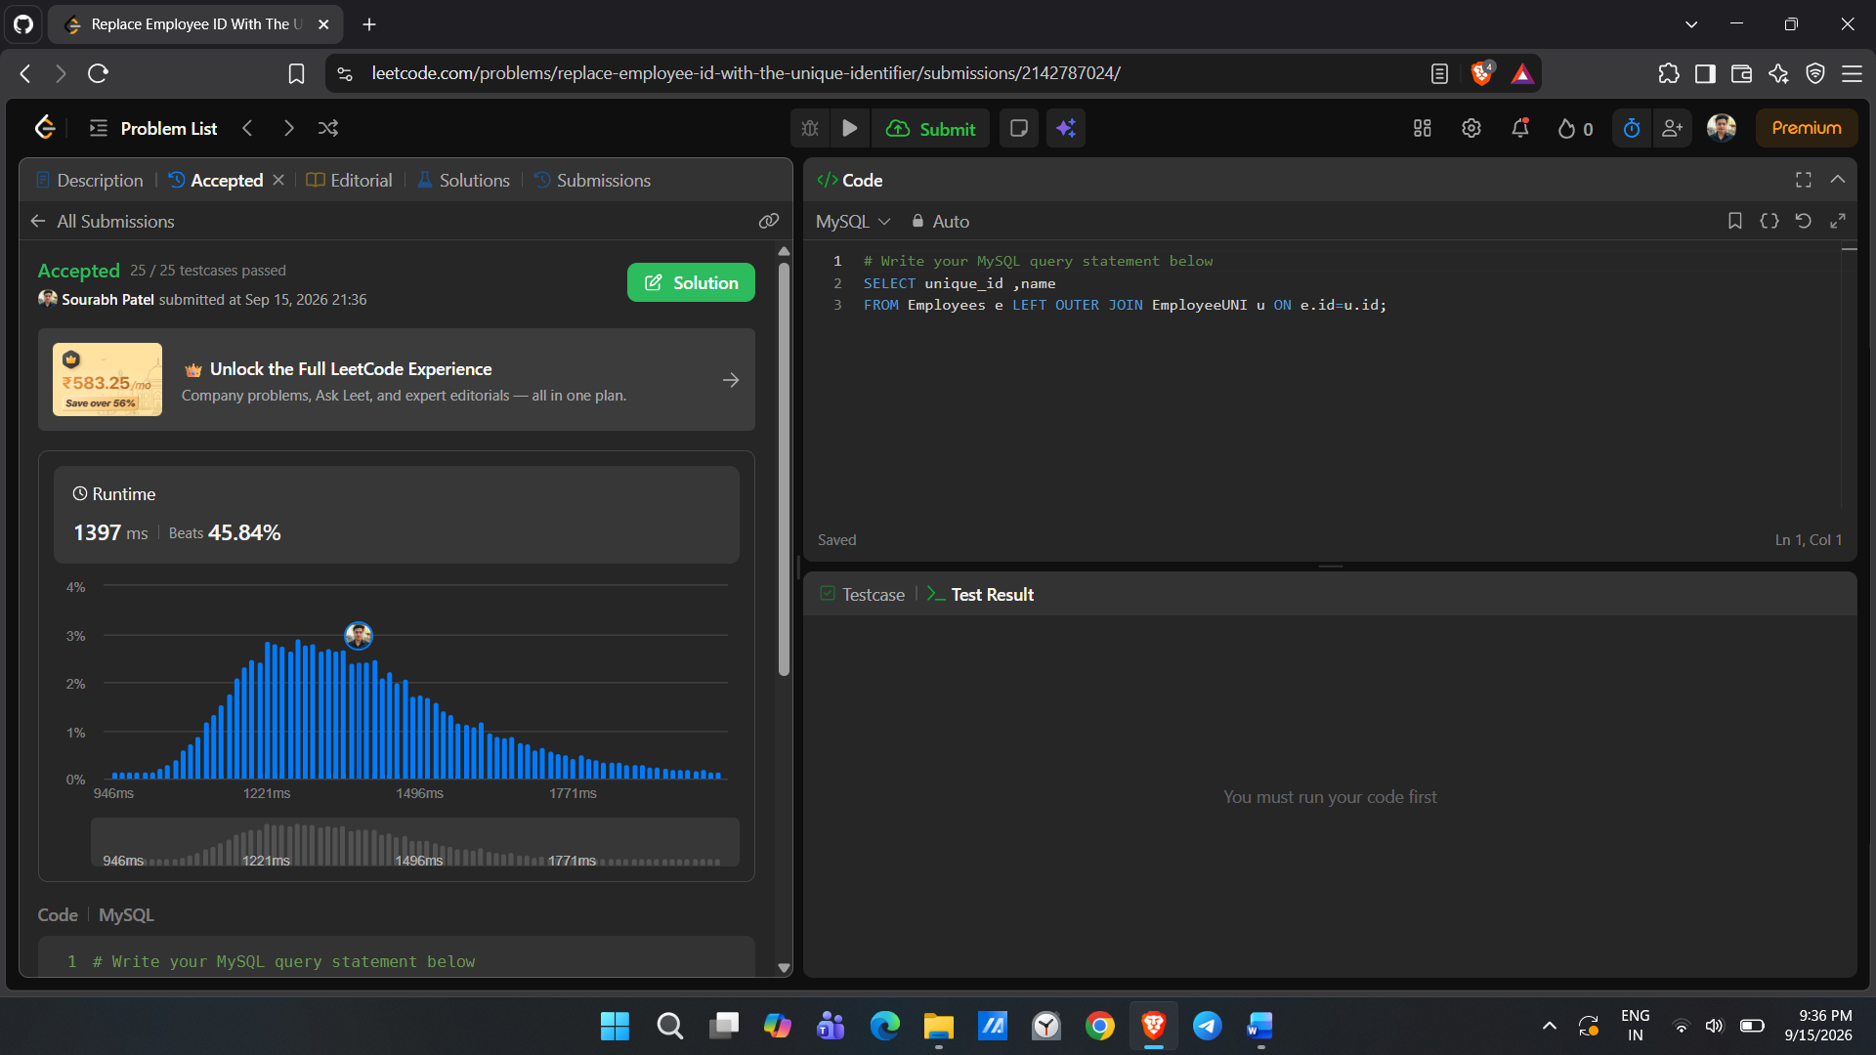
2. Product Sales Analysis I https://leetcode.com/problems/product-sales-analysis-i
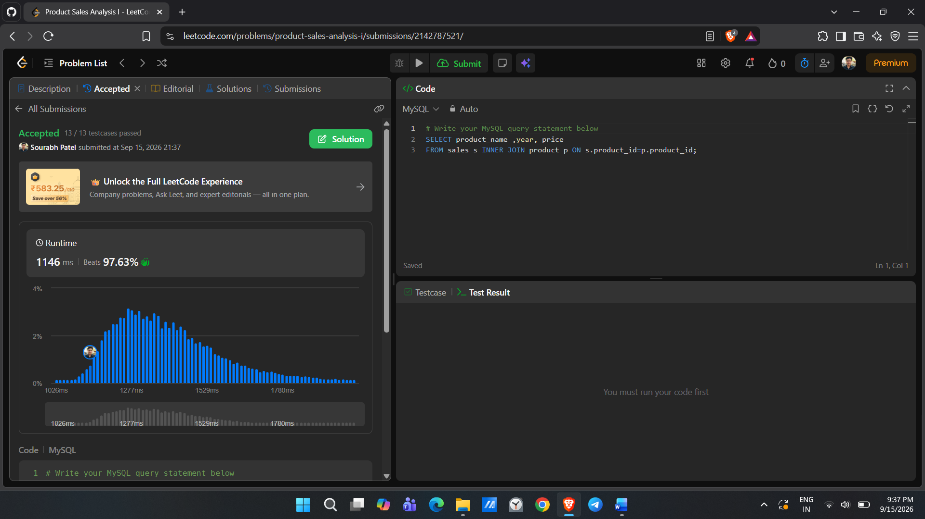
3. Employee Bonus https://leetcode.com/problems/employee-bonus
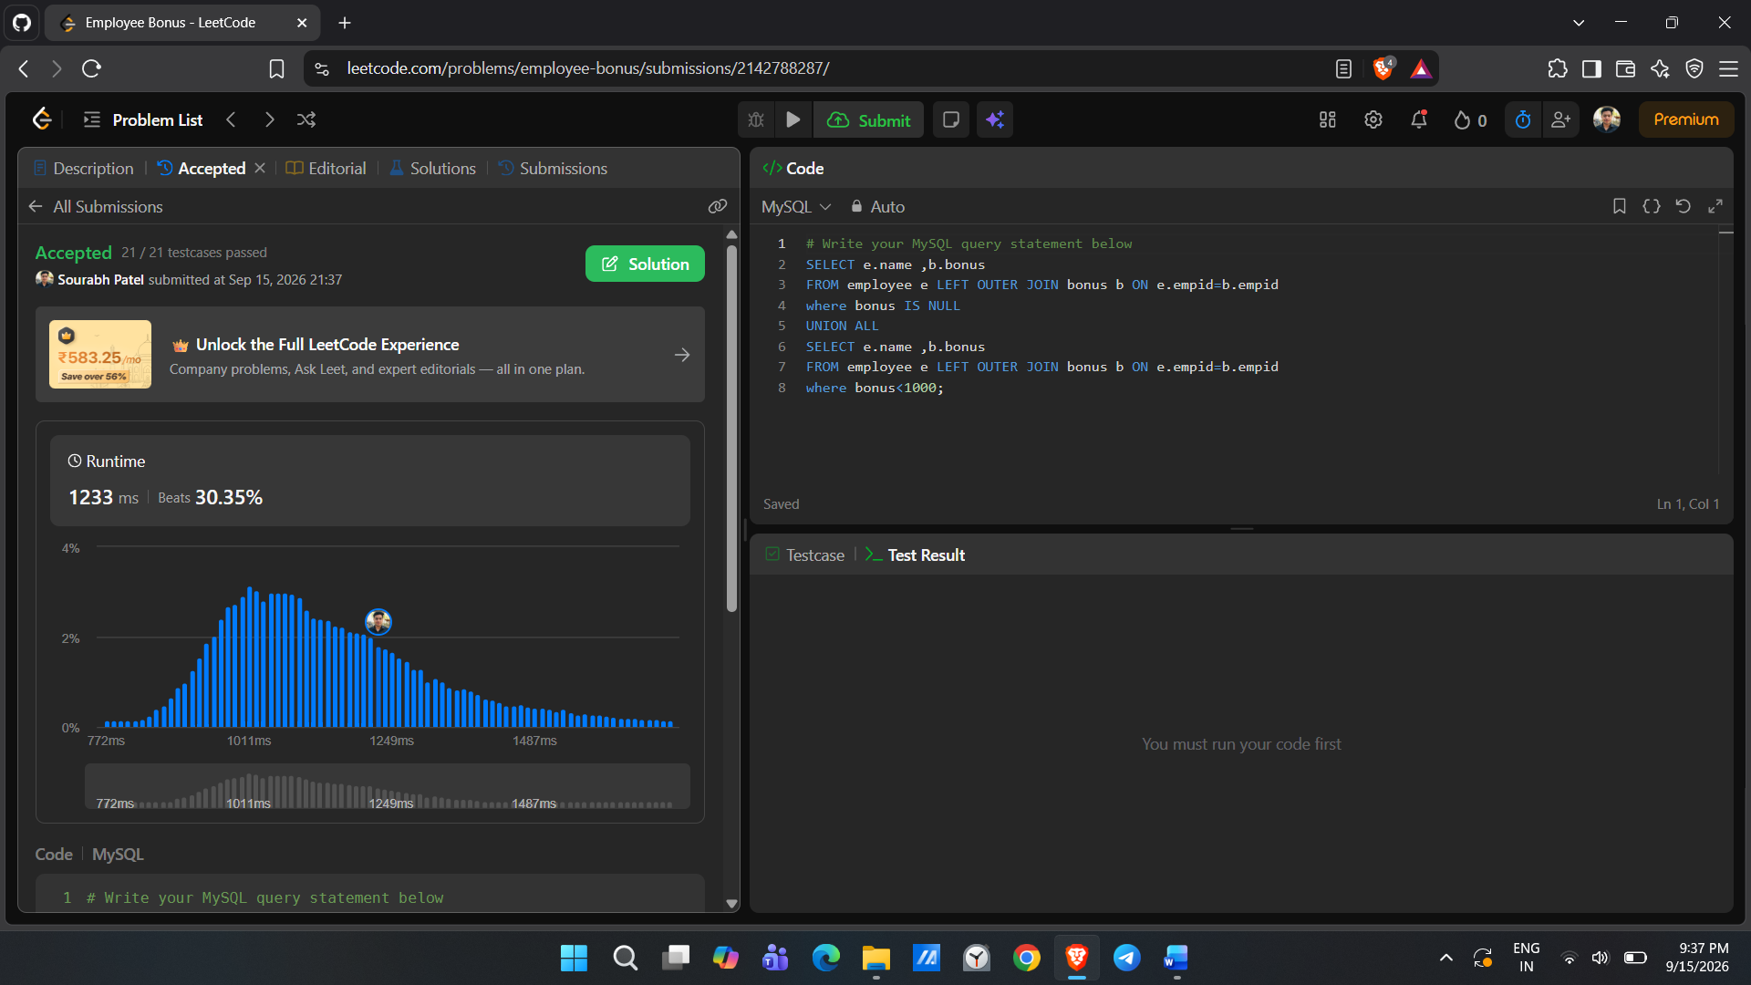
4. Students and Examinations https://leetcode.com/problems/students-and-examinations
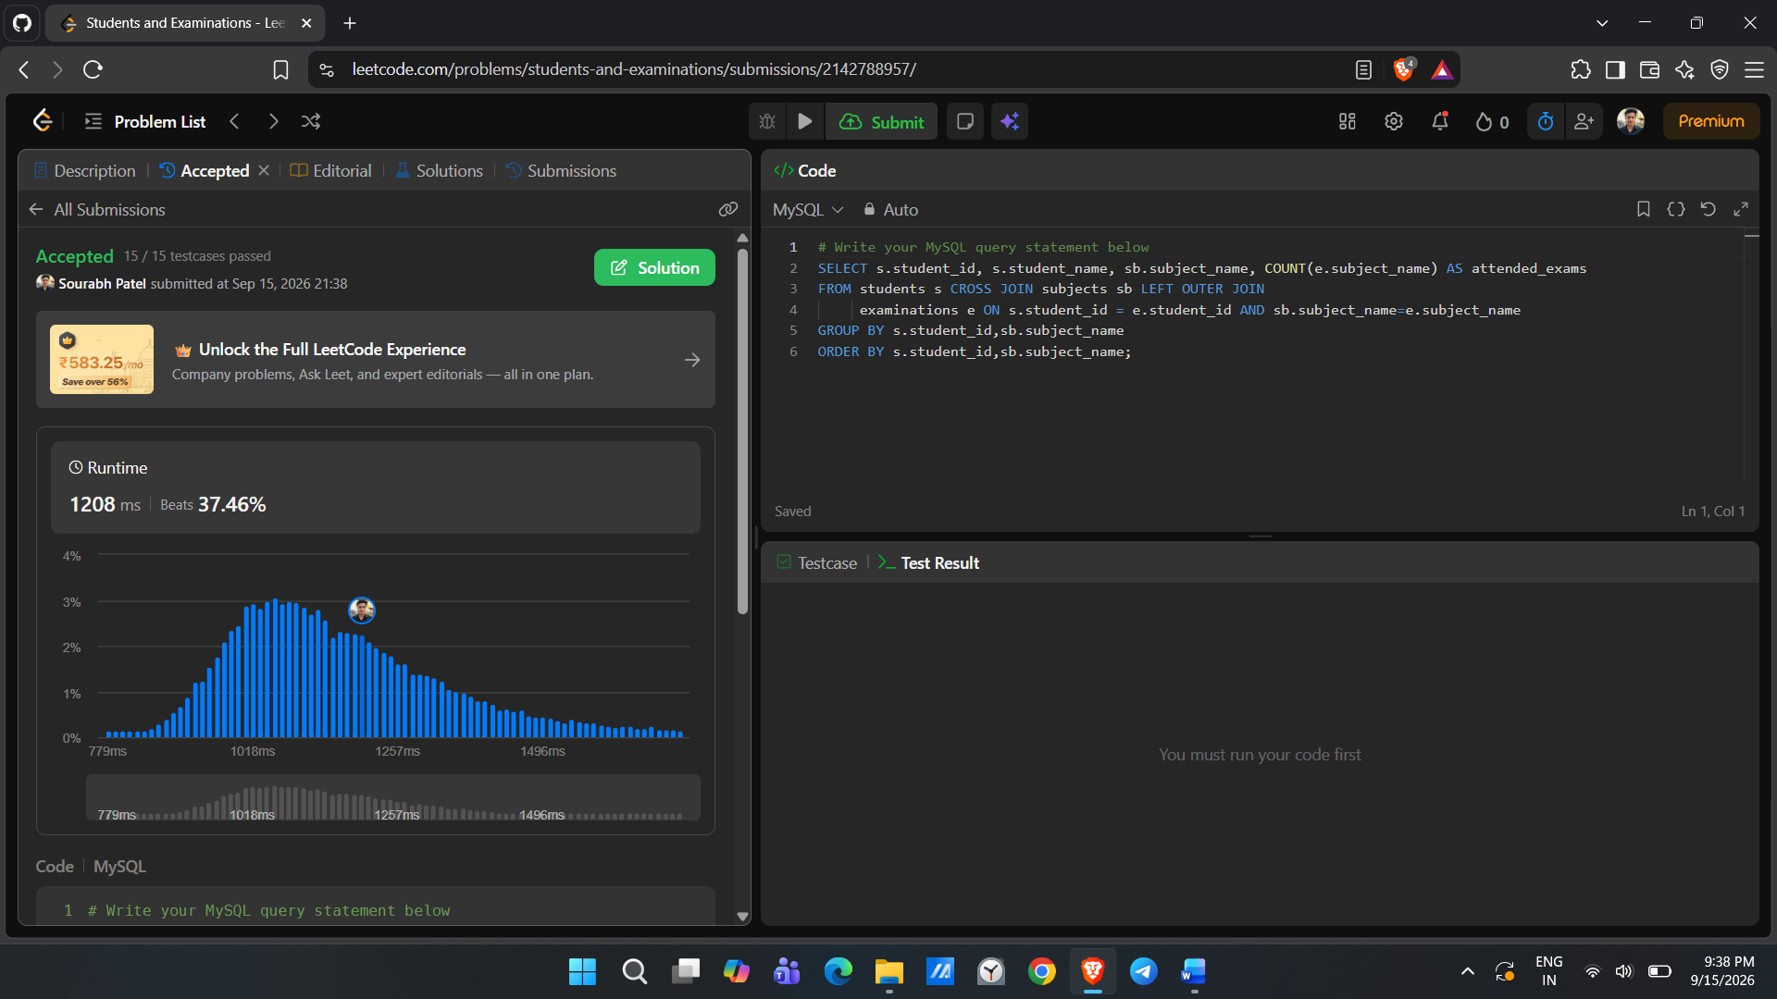
5. Managers With At Least 5 Direct Reports https://leetcode.com/problems/managers-with-at-least-5-direct-reports
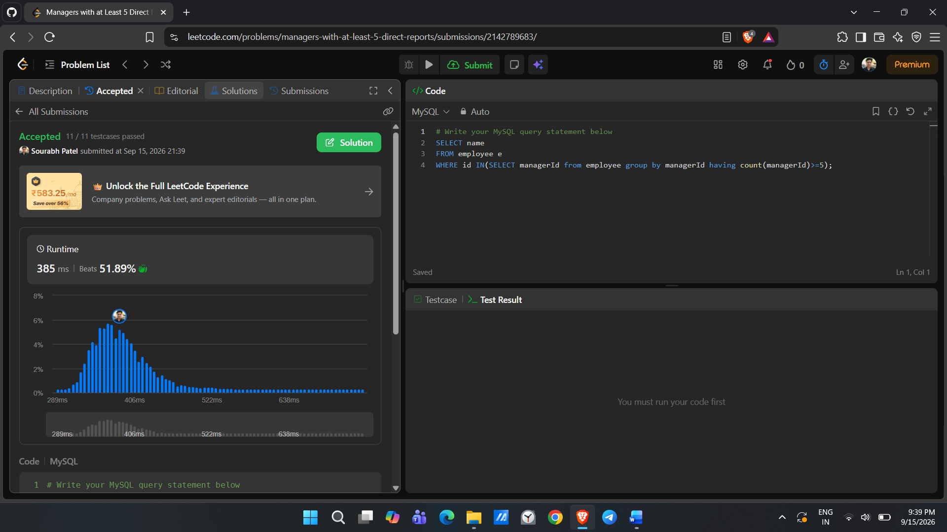

8. Last Person to Fit in the Bus https://leetcode.com/problems/last-person-to-fit-in-the-bus
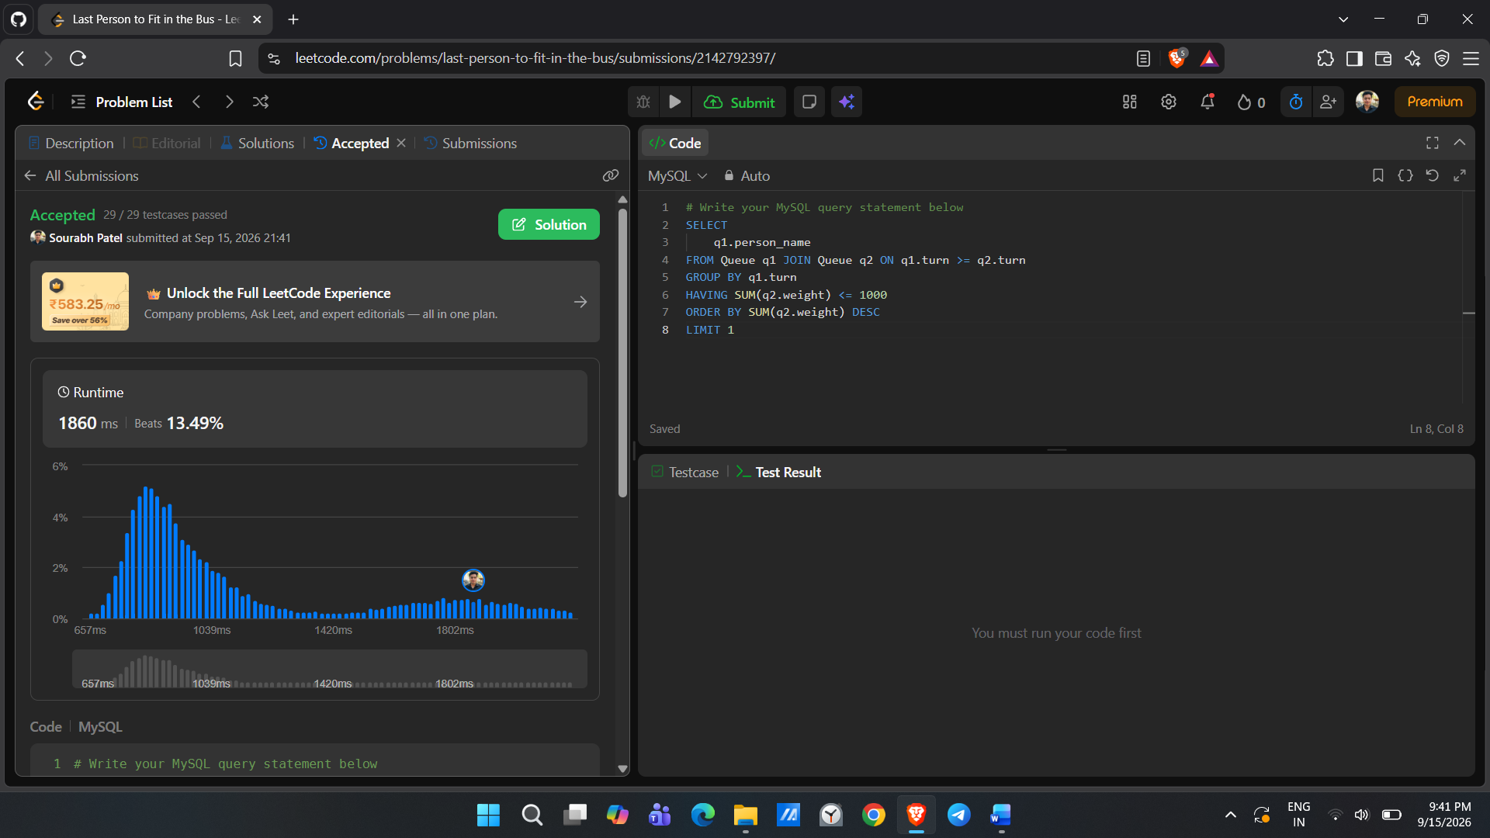
9. Product Price at a Given Date https://leetcode.com/problems/product-price-at-a-given-date
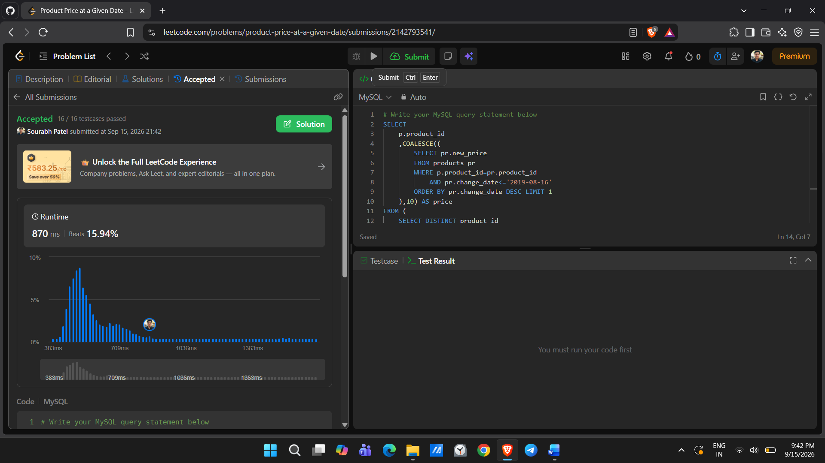

Subquery
1. 181. Employees Earning More Than Their Managers https://leetcode.com/problems/employees-earning-more-than-their-managers/
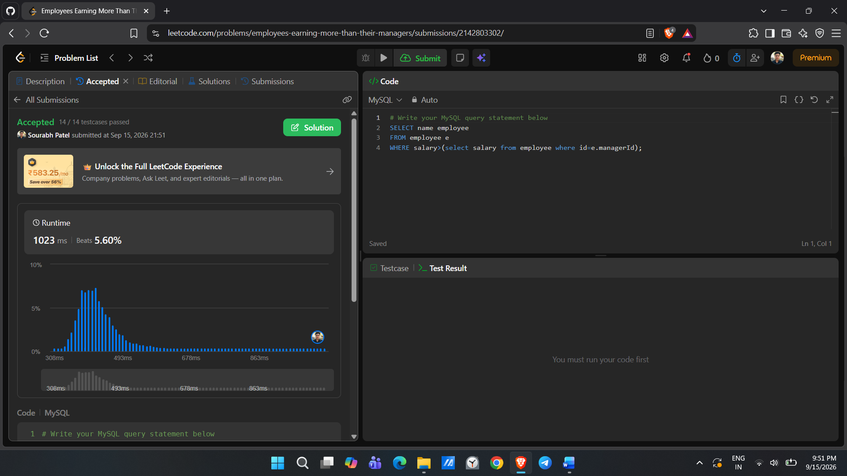
2. 183. Customers Who Never Order https://leetcode.com/problems/customers-who-never-order/ 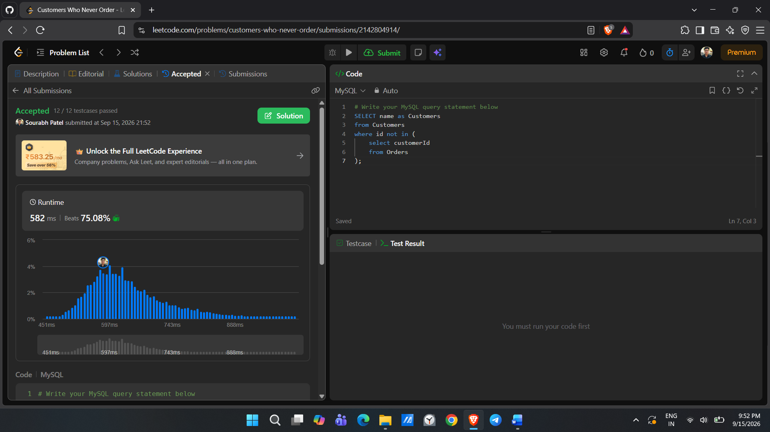

3. 197. Rising Temperature https://leetcode.com/problems/rising-temperature/
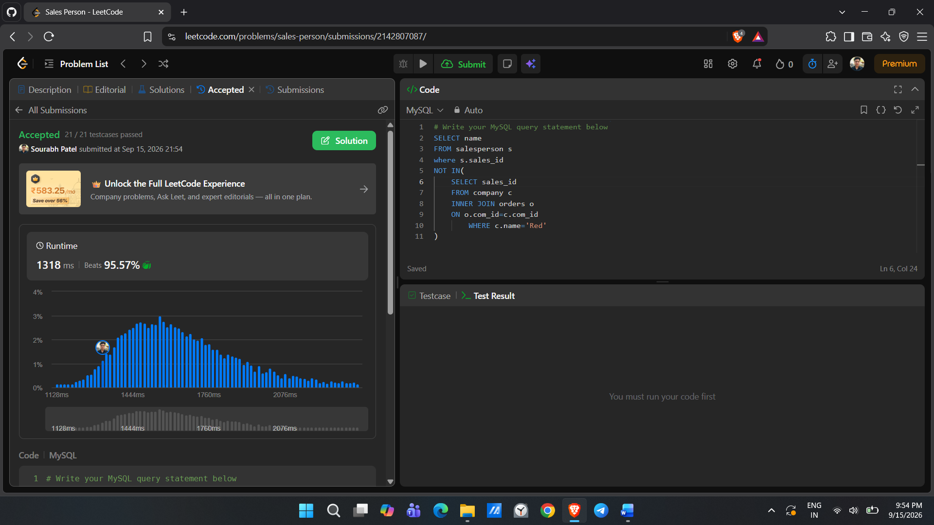
4. 607. Sales Person https://leetcode.com/problems/sales-person/
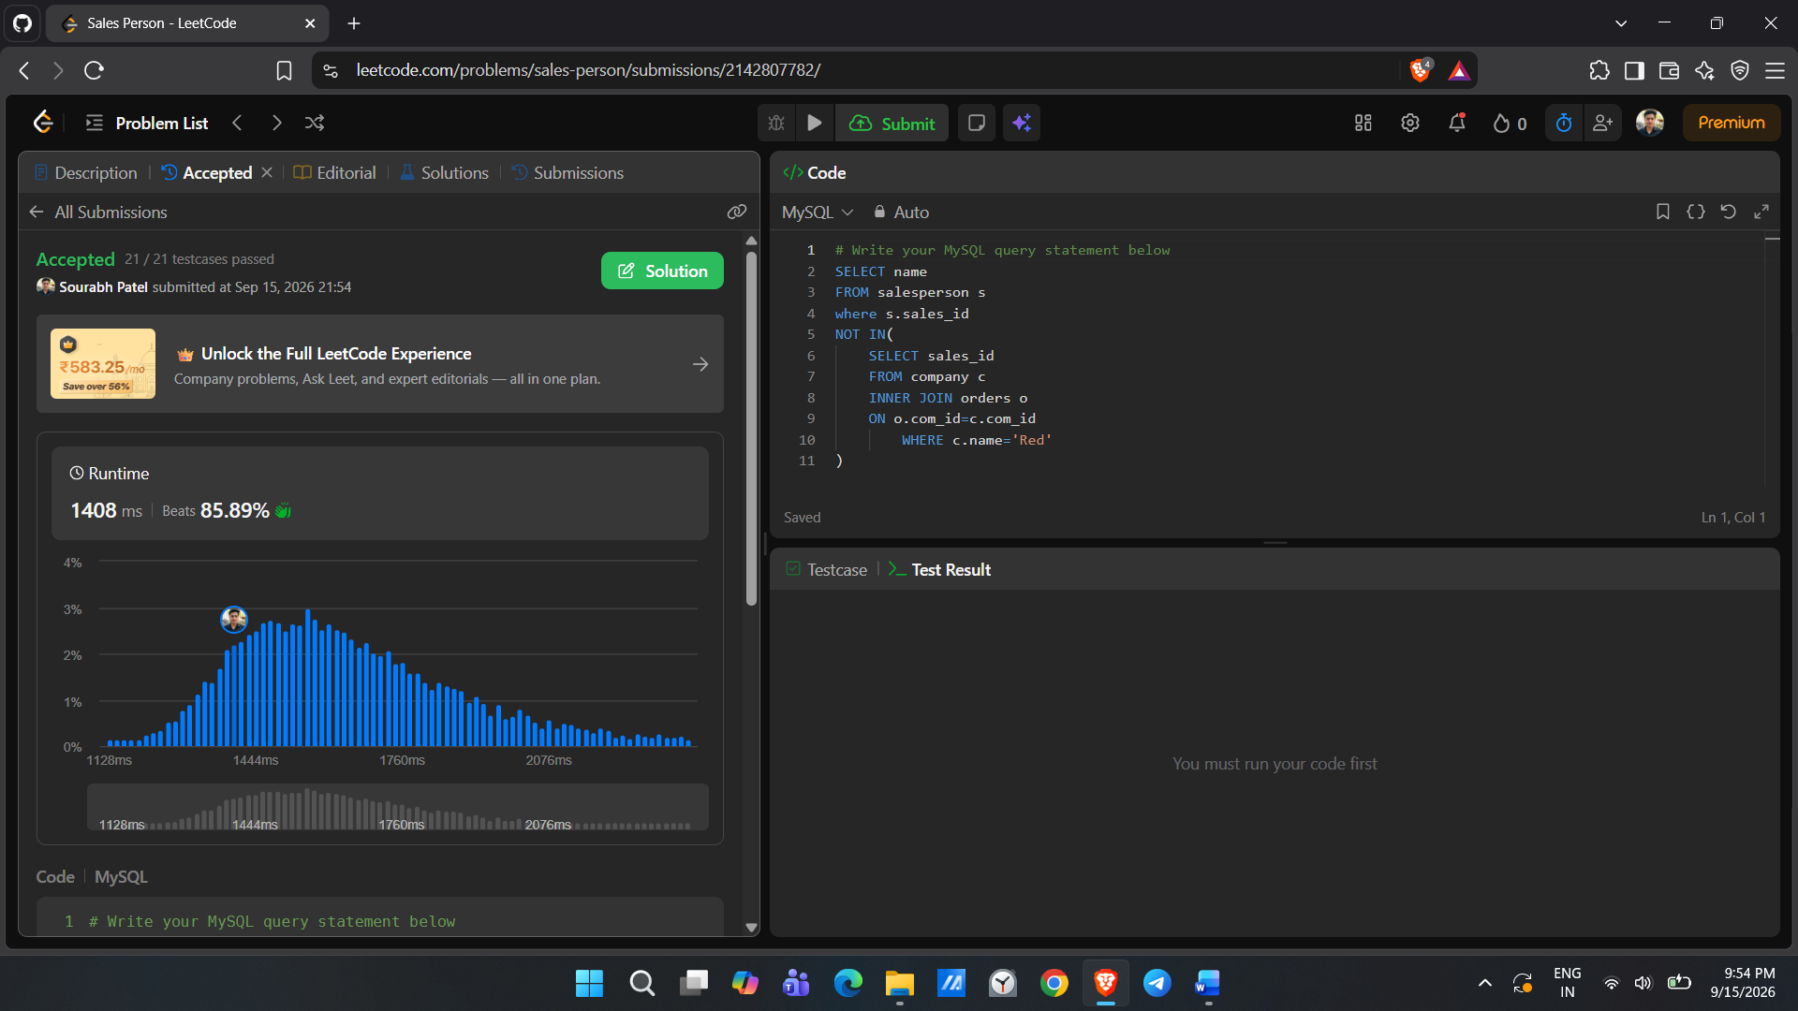
5. 180. Consecutive Numbers https://leetcode.com/problems/consecutive-numbers/
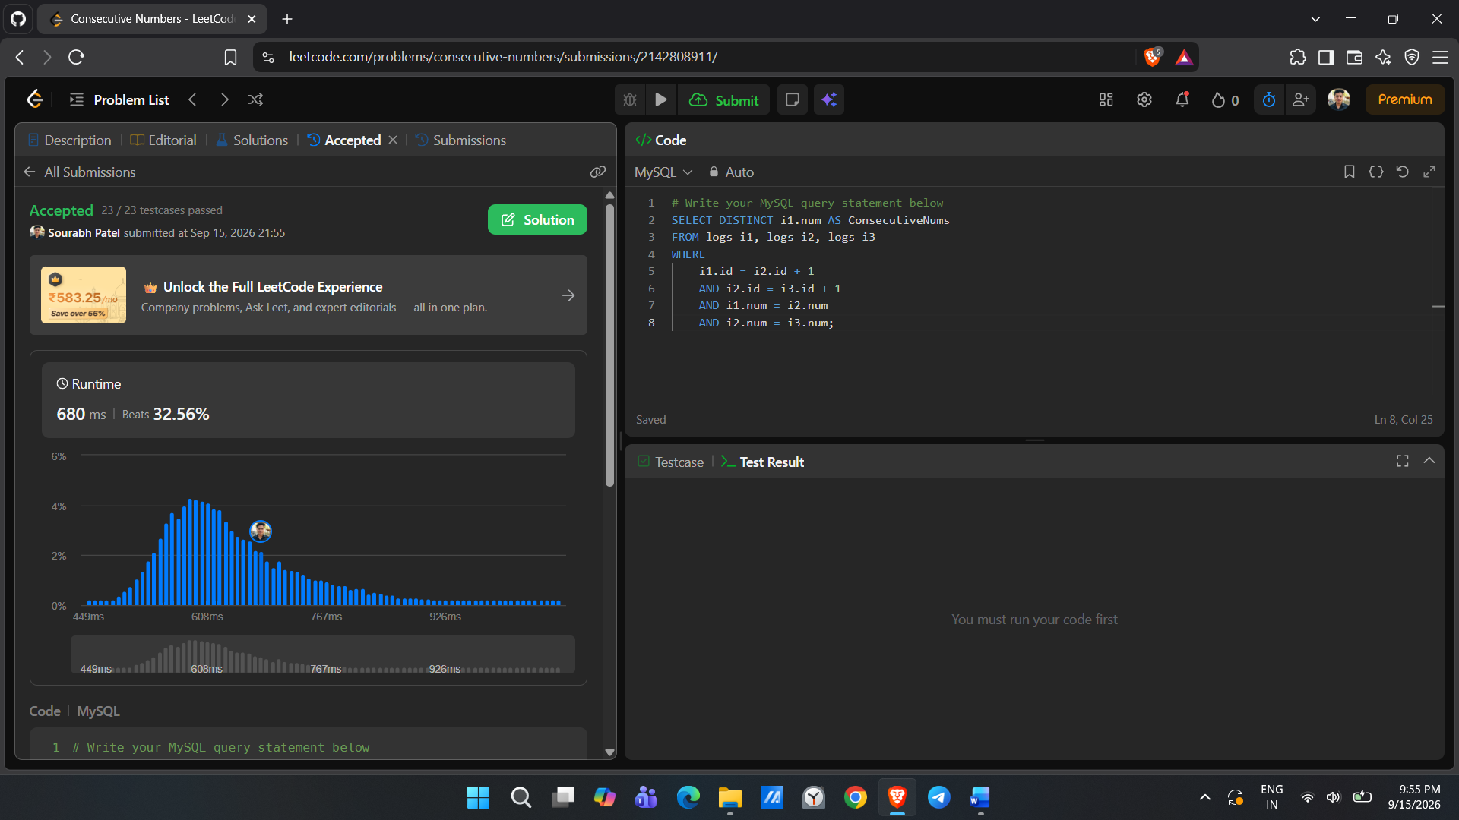
6. 175. Combine Two Tables https://leetcode.com/problems/combine-two-tables/
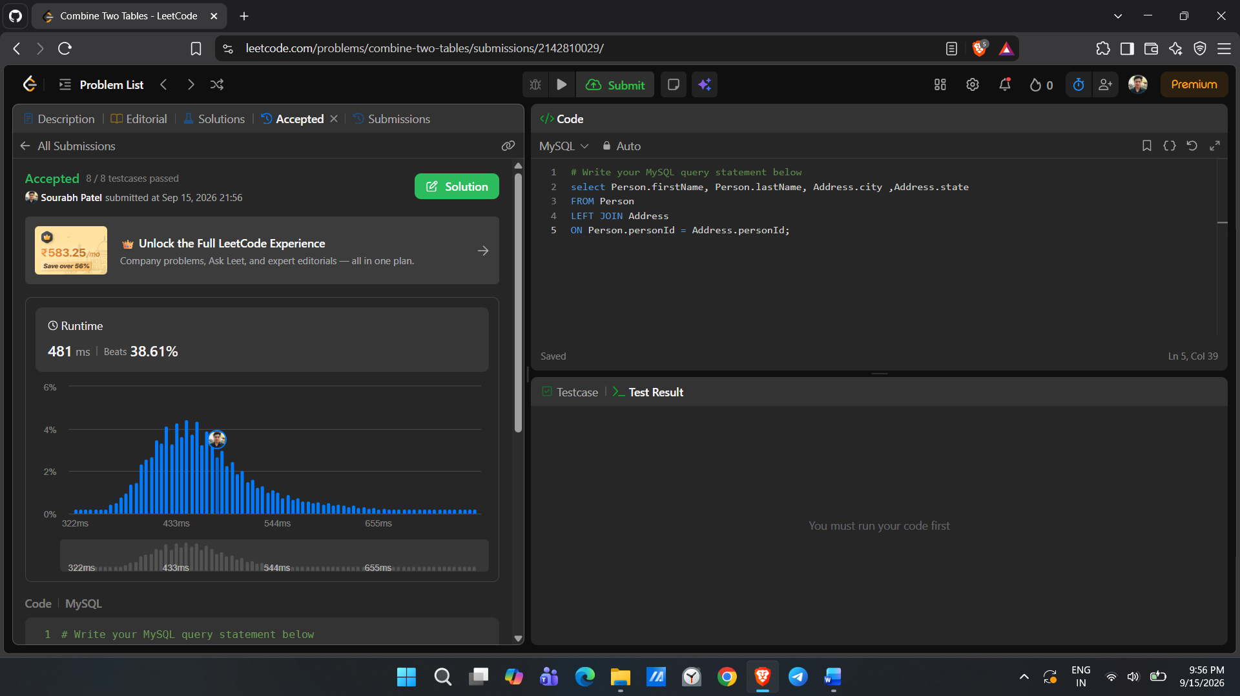
7. 178. Rank Scores https://leetcode.com/problems/rank-scores/
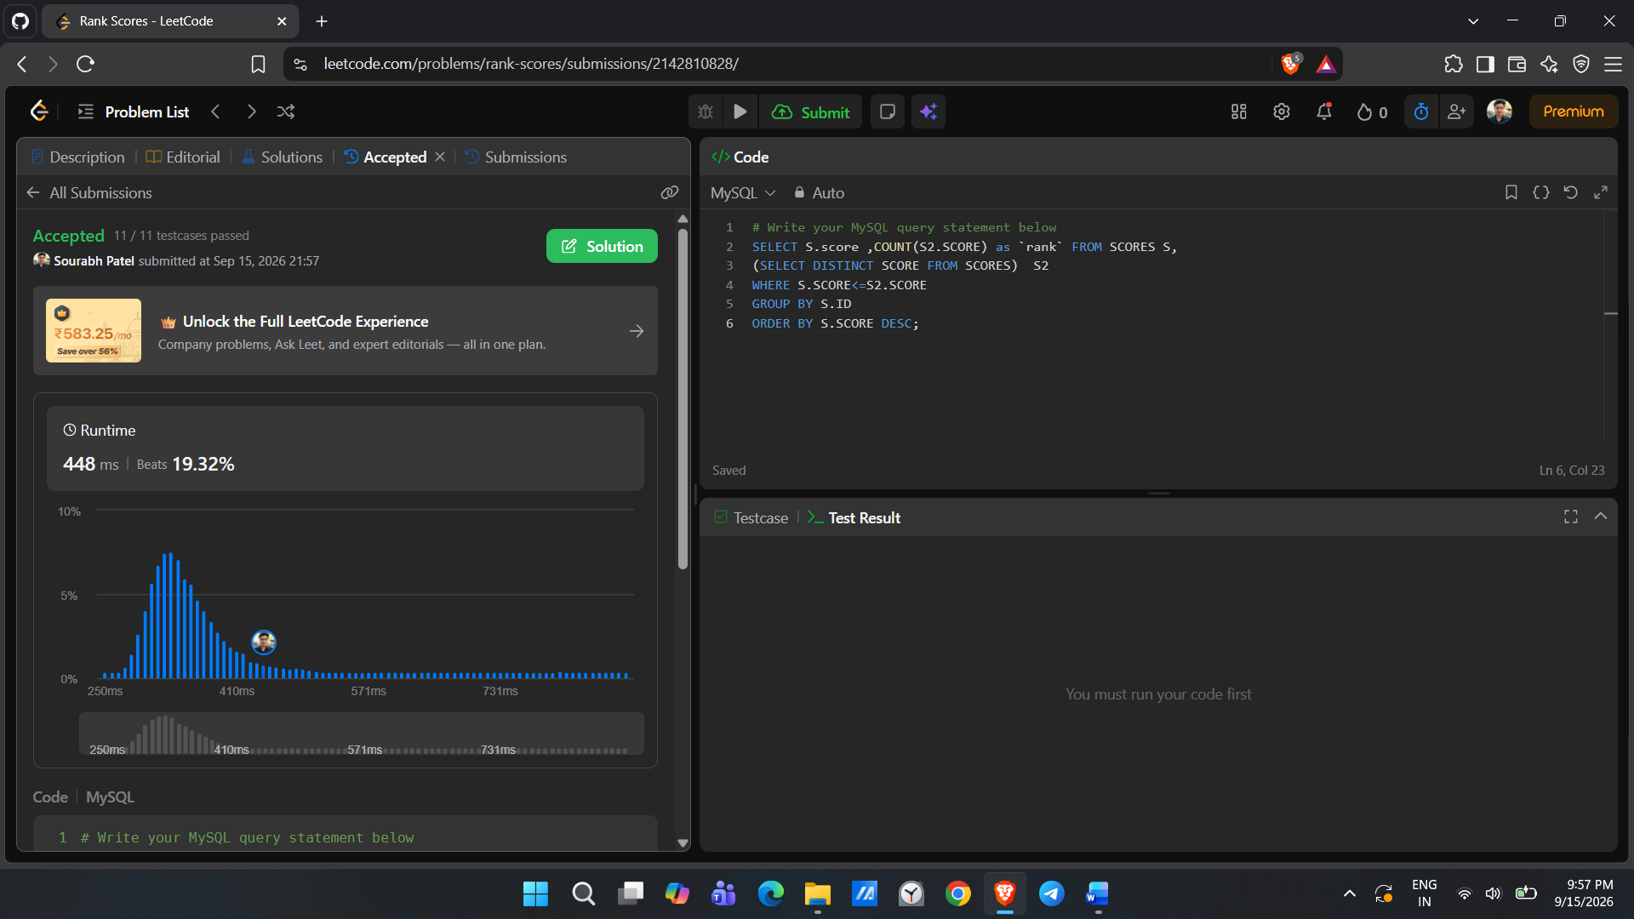
8. 570. Managers with at Least 5 Direct Reports https://leetcode.com/problems/managers-with-at-least-5-direct-reports
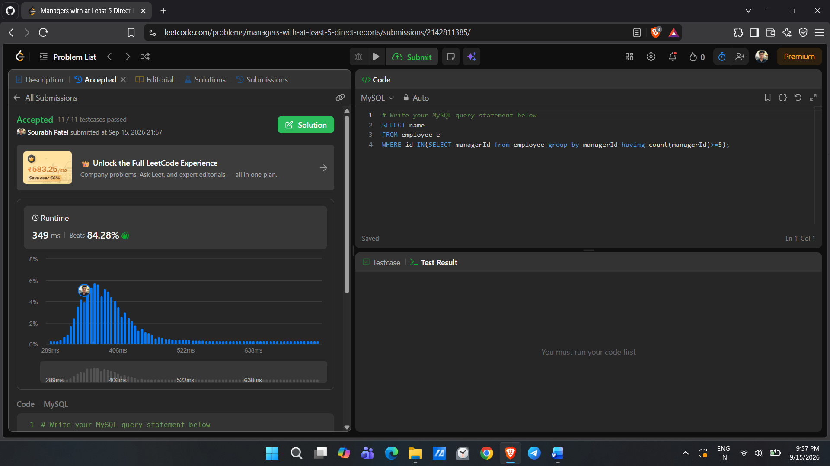
9. 196. Delete Duplicate Emails https://leetcode.com/problems/delete-duplicate-emails/
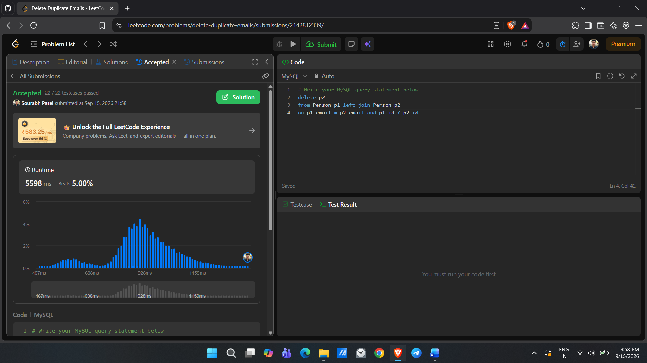
10. 1204. Last Person to Fit in the Bus https://leetcode.com/problems/last-person-to-fit-in-the-bus/
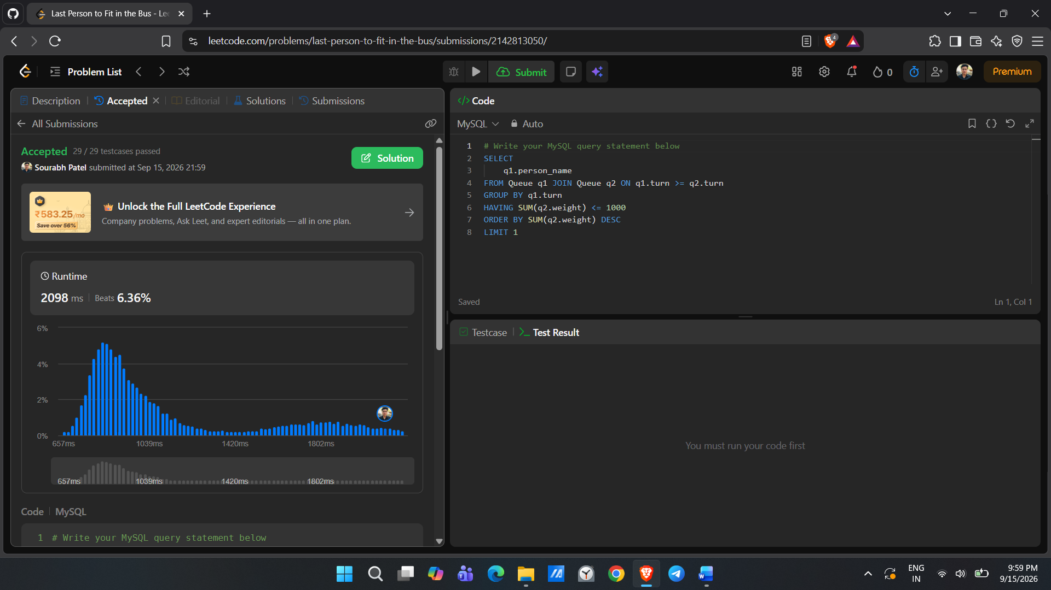
11. 176. Second Highest Salary https://leetcode.com/problems/second-highest-salary
