ASSIGNMENT 7

Use appropriate joins to solve following queries.
Note: To solve below queries, use “sales” database.

1. Write a query that lists each order number followed by the name of
the customer who made the order.

sol. SELECT onum ,cname
FROM orders o INNER JOIN customers c ON o.cnum=c.cnum;
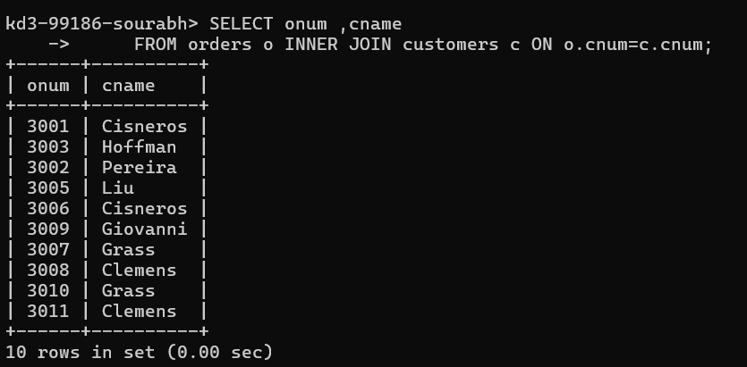
2. Write a query that gives the names of both the salesperson and
the customer for each order along with the order number.

sol. SELECT sname, cname, onum
FROM customers c INNER JOIN orders o INNER JOIN
salespeople s ON c.cnum=o.cnum AND o.snum=s.snum;
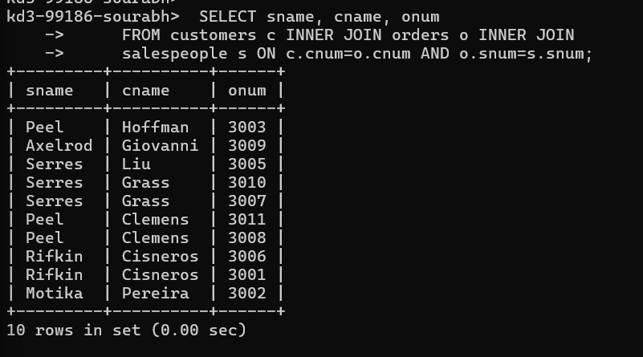
3. Write a query that produces all customers serviced by salespeople
with a commission above 12%. Display the customer’s name, the
salesperson’s name, and the salesperson’s rate of commission.

sol. SELECT c.cname ,s.sname ,s.comm
FROM customers c INNER JOIN orders o INNER JOIN salespeople s ON c.cnum=o.cnum AND o.snum=s.snum
WHERE s.comm>0.12;
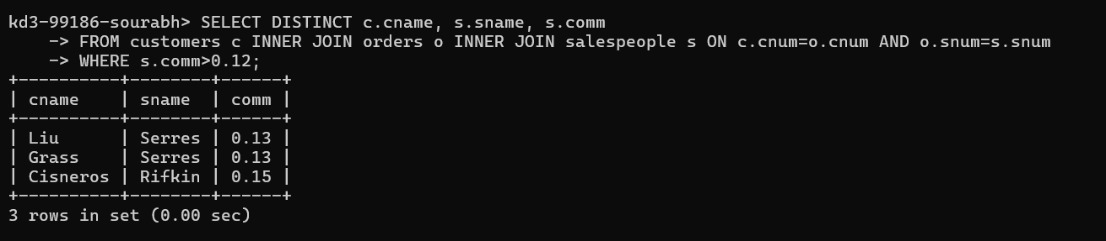

4. Write a query that calculates the commission earned by each
salesperson for orders placed by customers with a rating above 100.

sol. SELECT c.cname , o.onum ,o.amt*s.comm Commission
FROM customers c INNER JOIN orders o INNER JOIN salespeople s ON c.cnum=o.cnum AND o.snum=s.snum
WHERE c.rating>100;
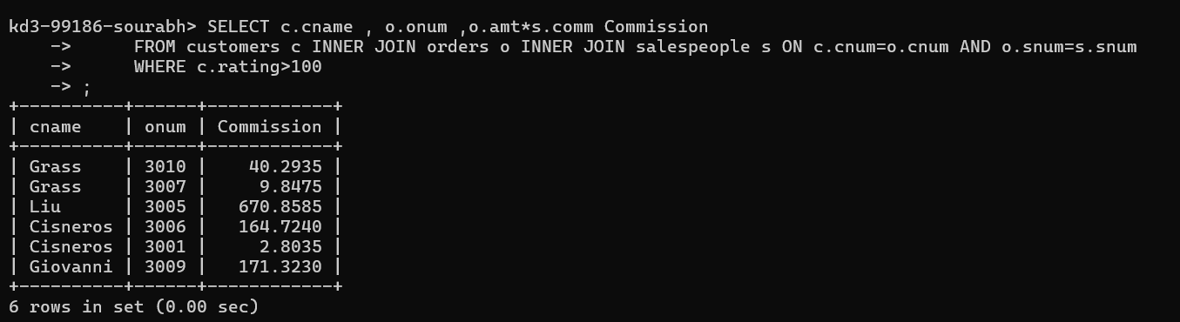

5. Write a query that produces all pairs of salespeople who are
living in the same city. Exclude combinations of salespeople with
themselves as well as duplicate rows with the order reversed.

sol.
