ASSIGNMENT 8

Use sub-query to solve following problems.
Note: To solve below queries, use “sales” database

1.
Write a query that uses a subquery to obtain all orders for the customer named
Cisneros. Assume you do not know his customer number (cnum).

sol. SELECT *
FROM orders
WHERE cnum IN (SELECT cnum FROM customers WHERE cname='Cisneros');
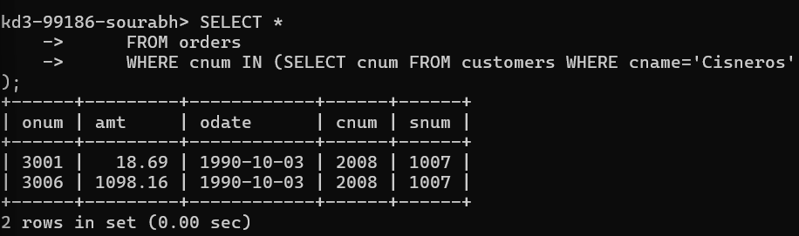
7.
Extract all the orders of Motika.
Sol. SELECT *
FROM orders
WHERE snum IN (SELECT snum FROM salespeople WHERE sname='Motika');
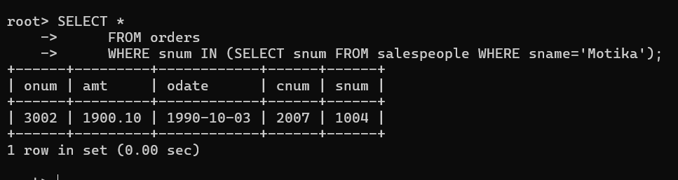

8.
Find all the orders of salespeople servicing customers in London.
Sol. SELECT *
FROM orders
WHERE snum IN (select snum from salespeople where city='london');
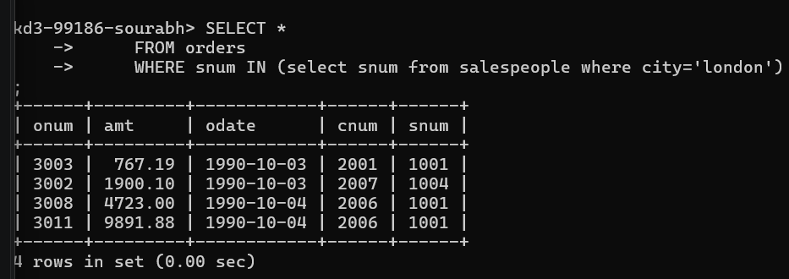
6.
Write a query that selects all orders for amounts greater than any for the customers in
London.
Sol. SELECT *
FROM orders
WHERE amt> ANY(select amt from orders where cnum IN (select cnum from customers where city='london'));

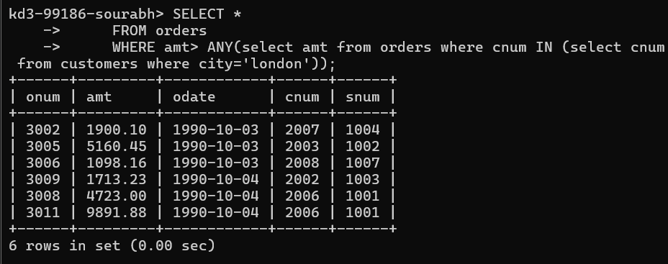
4.
Write a query that selects all customers whose ratings are equal to or greater than ANY
of Serres’. (Hint: find all customers of serres salesperson).
Sol. SELECT *
FROM customers
WHERE rating>=ANY(select rating from customers where snum=(select snum from salespeople where sname='Serres'));
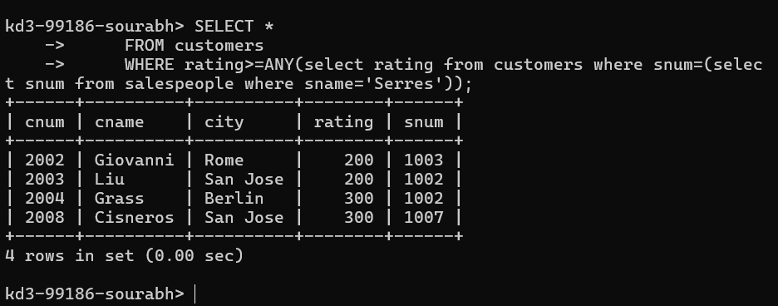
11.
Select customers who have a greater rating than any other customer in Rome.
Sol. SELECT *
FROM customers
WHERE rating > ALL(select rating from customers where city='rome');
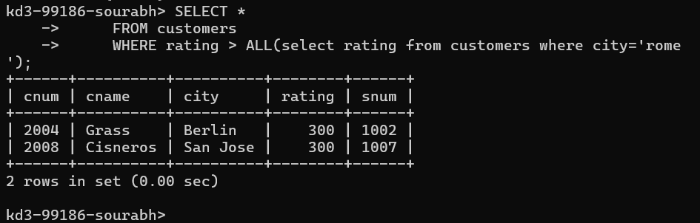
12.
Select all orders that had amounts that were greater that at least one of the orders from‘1990-10-04’.
Sol. SELECT *
FROM orders
WHERE amt>(select MIN(amt) from orders where odate='1990-10-04');
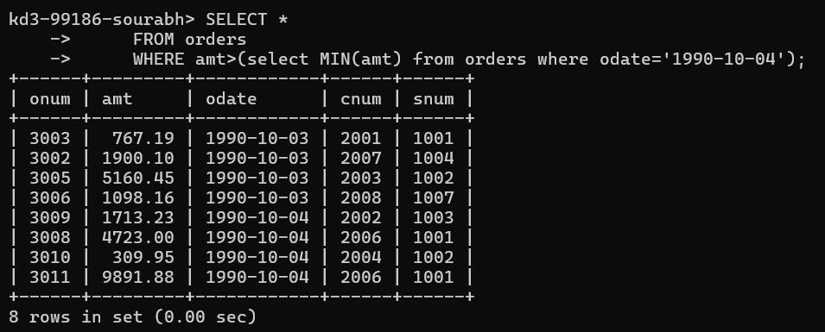

13. Find all orders with amounts smaller than any amount for a customer in San Jose.
Sol . SELECT *
FROM orders
WHERE amt<(select MAX(amt) from orders where cnum IN (select cnum from customers where city='san jose'));
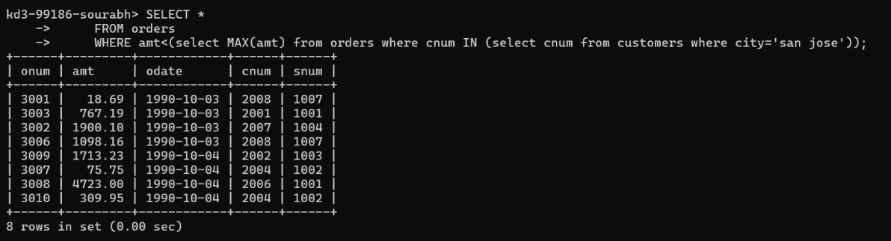

2. Write a query to display the order amount, customer names and ratings of all customers where the amount is greater than the average amount from the orders table.
Sol. SELECT amt, cname, rating
FROM orders o INNER JOIN customers c ON o.cnum=c.cnum
WHERE amt > (select AVG(amt) from orders);

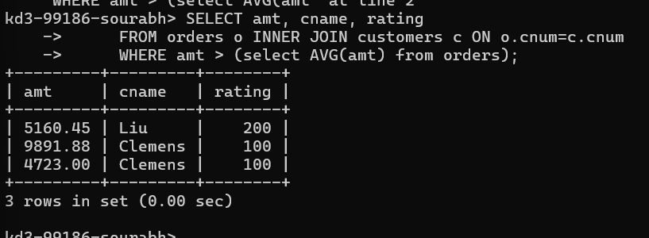

14. Select those customers whose rating are higher than every customer in London.
Sol. SELECT *
FROM customers
WHERE rating>ALL(SELECT rating FROM customers where city='london');
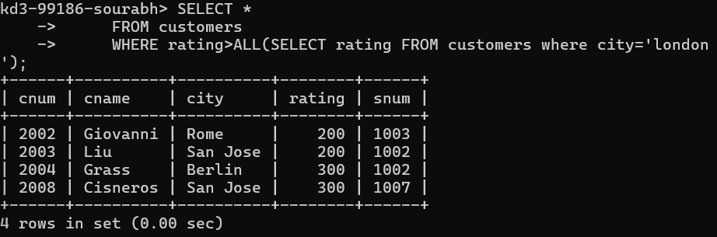

5. Write a query that will find all salespeople who have no customers located in their city. (Hint: Choose the correct keyword ANY/ALL).
Sol. SELECT *
FROM salespeople s
WHERE snum NOT IN (select snum from customers where city=s.city);

. SELECT *
FROM salespeople s
WHERE snum = ANY (select snum from customers where city<>s.city);

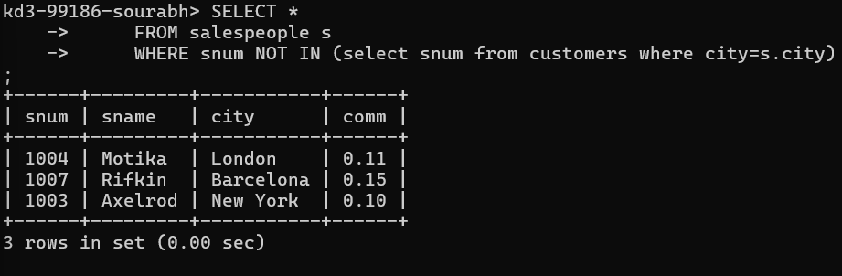
9. Find names and numbers of all salesperson who have more than one customer.
Sol. SELECT sname ,(select count(snum) from salespeople where snum IN (select snum from customers group by snum HAVING COUNT(cnum)>1)
FROM salespeople
WHERE snum IN (select snum from customers group by snum HAVING COUNT(cnum)>1);
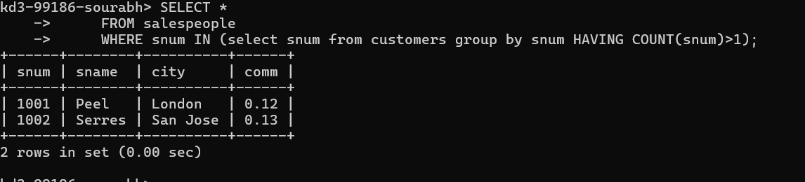

SELECT *
FROM salespeople
WHERE snum IN (select snum from customers group by snum HAVING COUNT(snum)>1);

10. Find salespeople number, name and city who have multiple customers. Display the count of customers as well.
Sol. SELECT snum ,sname, city
FROM salespeople
WHERE snum IN (select snum from customers group by snum HAVING COUNT(cnum)>1);
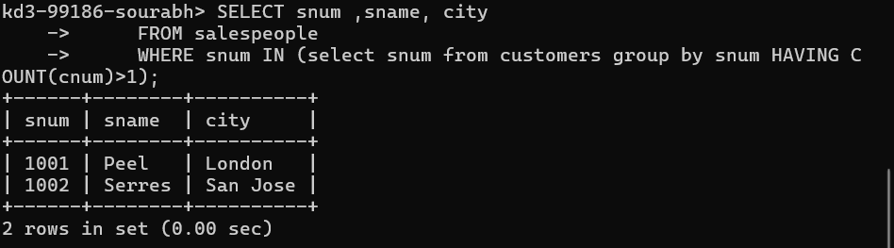

3. Write a query that selects the total amount in orders for each salesperson for whom this total is greater than the amount of the largest order in the table.
Sol. SELECT snum, SUM(amt) totalSale
FROM orders
GROUP BY snum
HAVING SUM(amt)>(select MAX(amt) from orders);
