ASSIGN 6

Use Group by clause with appropriate SQL functions to solve following queries. Note: To solve below queries, use “sales” database
1. Write a query that counts the number of salespeople registering orders for each day. (If a salesperson has more than one order on a given day, he or she should be counted only once.).
Sol. SELECT odate, COUNT(DISTINCT snum) AS salesperson_count FROM orders GROUP BY odate;
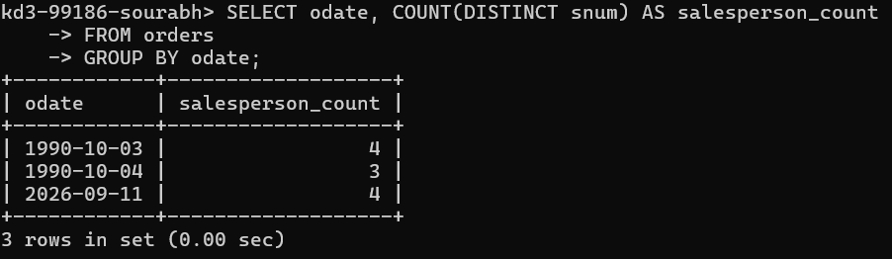

2. Write a query on the Customers table that will find the highest rating in each city. Put the output in this form: For the city (city), the highest rating is: (rating).
Sol. SELECT CONCAT( 'For the city ', city, ', the highest rating is: ', MAX(rating), '.' ) AS result FROM customers GROUP BY city;
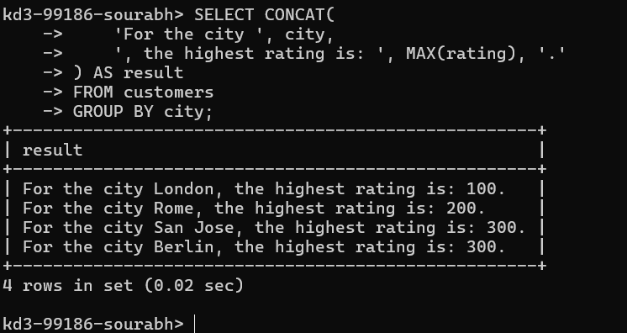
3 Write an SQL query to calculate the total order amount for each day and display the results in descending order of total orders.
Sol. SELECT odate, SUM(amt) AS total_order_amount FROM orders GROUP BY odate ORDER BY total_order_amount DESC;
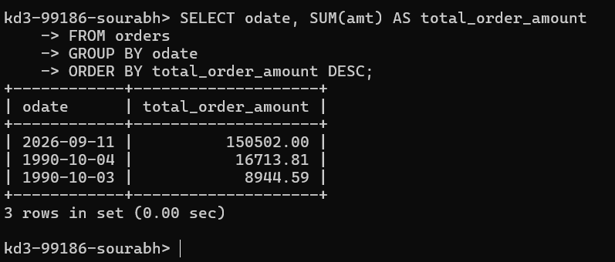

4. Write a query that selects the total amount in orders for each salesperson for whom this total is greater than the average amount of the order in the table. (Note Use the average amount value directly →2565.84)
Sol. SELECT snum, SUM(amt) AS total_amount FROM orders GROUP BY snum HAVING SUM(amt) > 2565.84;

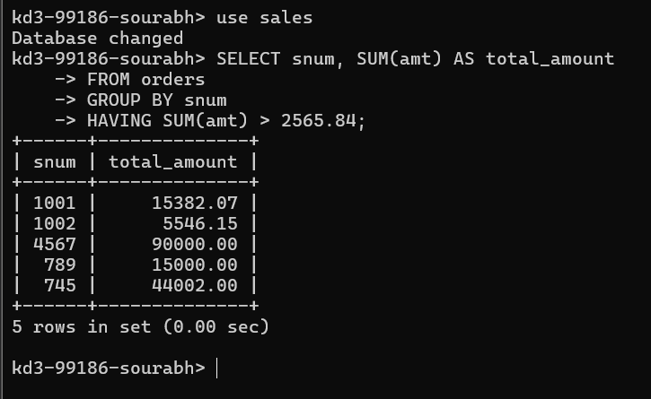

5.Write a query that selects the highest rating in each city.
Sol. SELECT city, MAX(rating) AS highest_rating FROM customers GROUP BY city;
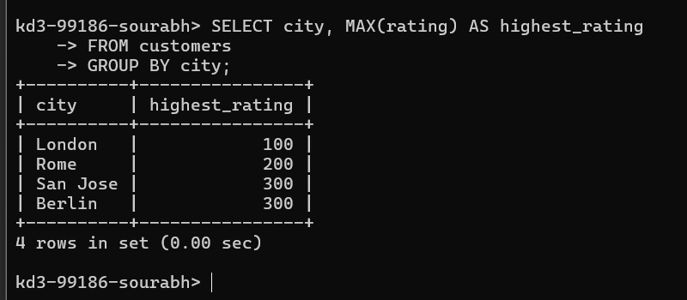
6.Retrieve the maximum order amount for each salesperson from the orders table, including only those orders whose value exceeds Rs. 3000.
Sol. SELECT snum, MAX(amt) AS maximum_order_amount FROM orders WHERE amt > 3000 GROUP BY snum;
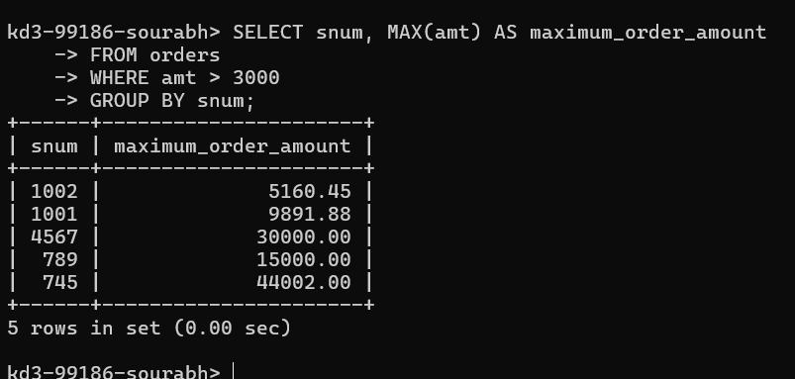
7.Write an SQL query to find the smallest order placed by every customer
Sol. SELECT cnum, MIN(amt) AS smallest_order FROM orders GROUP BY cnum;
