Q1
Create ‘spj’ database’. (Database for suppliers, parts and jobs)
2. use spj database; 3. Create following tables in spj database
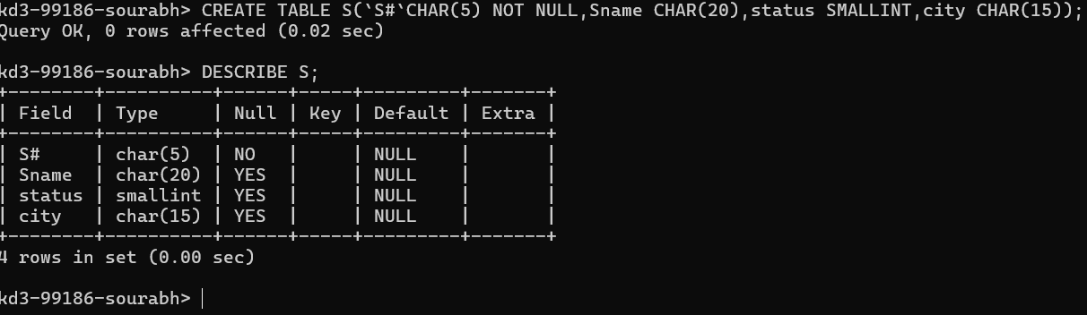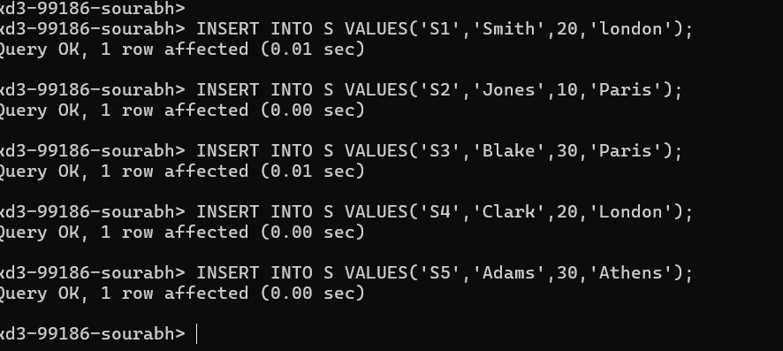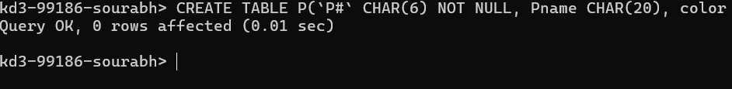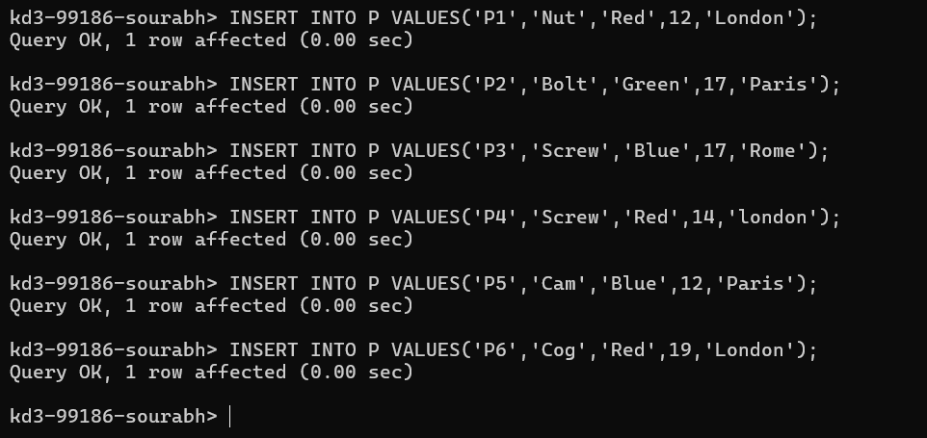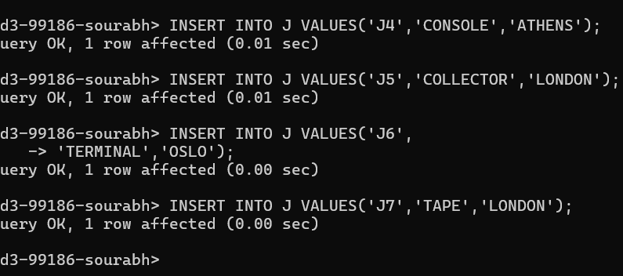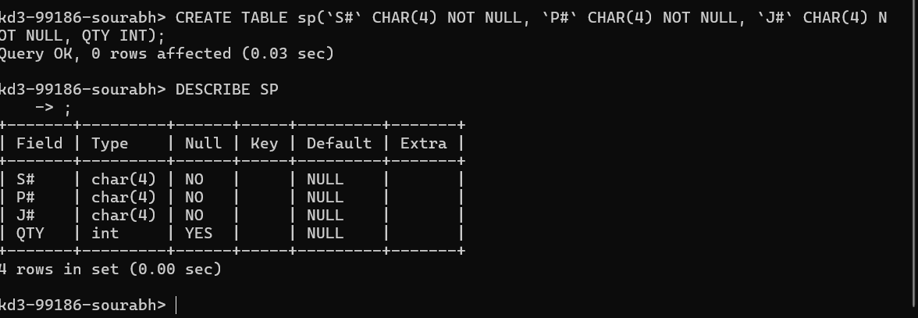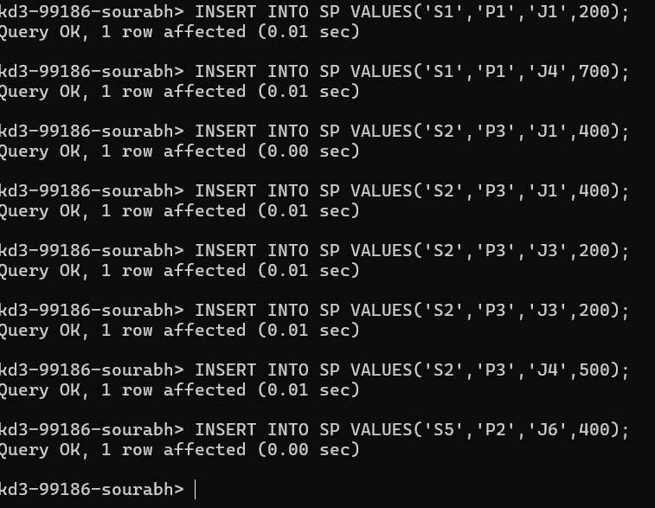

Q2
1. Create 'hr' database. Import hr-db.sql.
2. Create 'sales' database. Import sales-db.sql.
3. List all tables in hr database. Display contents of all tables (one by one).
4. List all tables in sales database. Display contents of all tables (one by one).
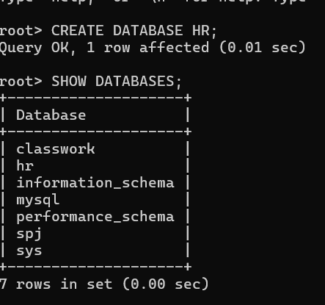
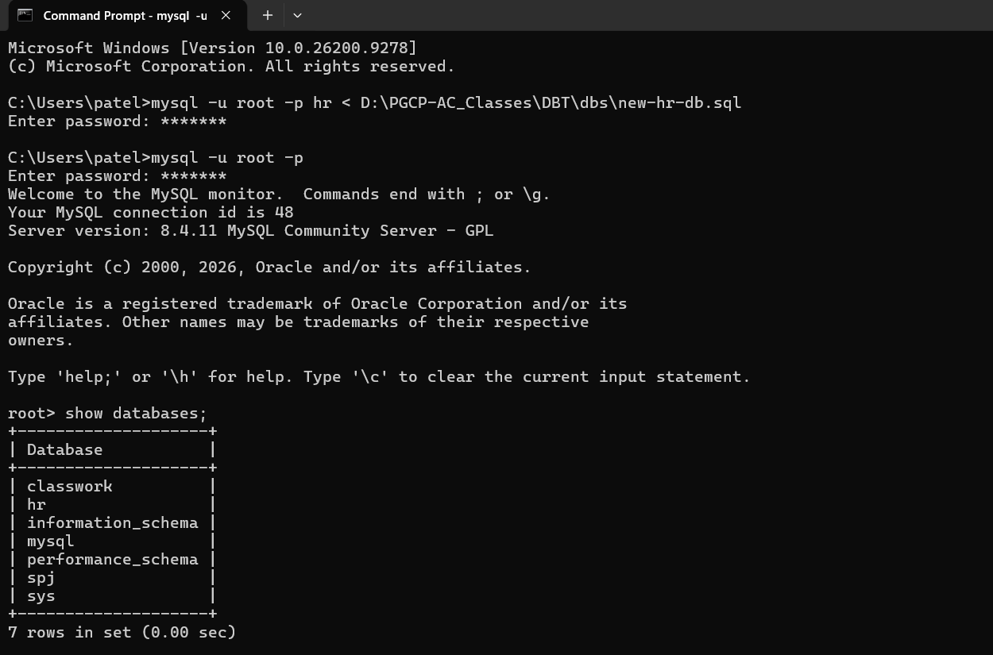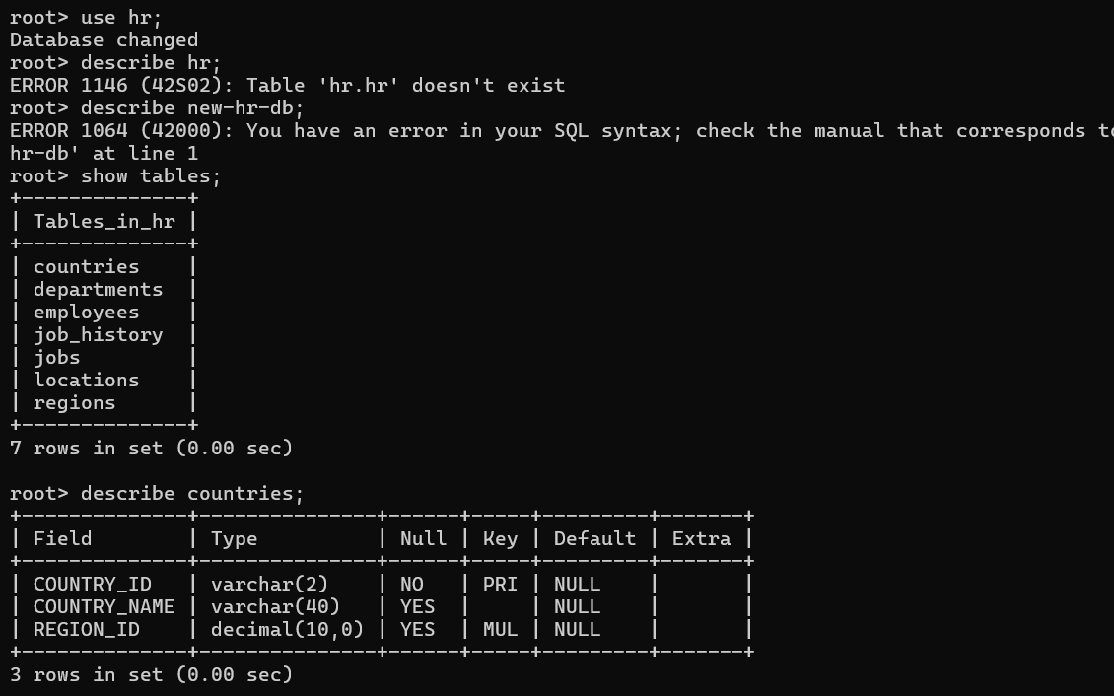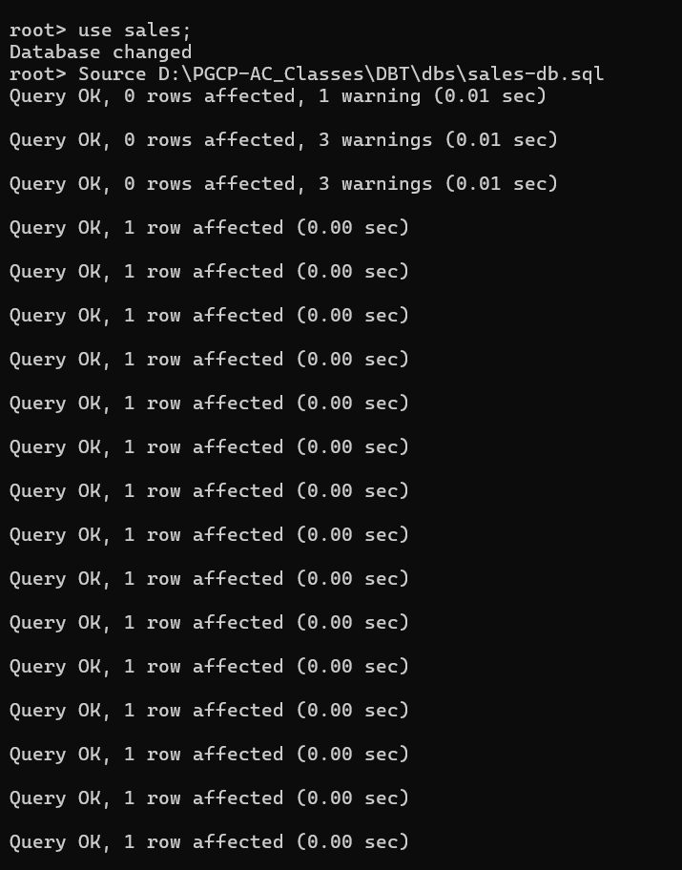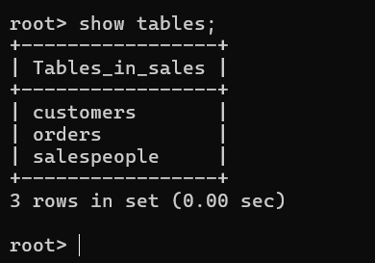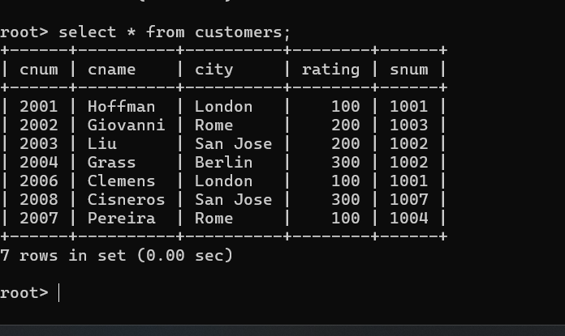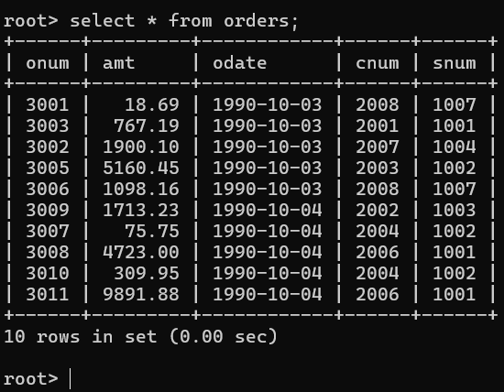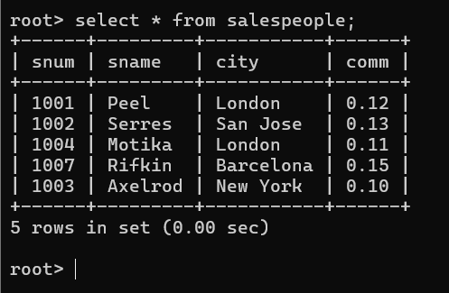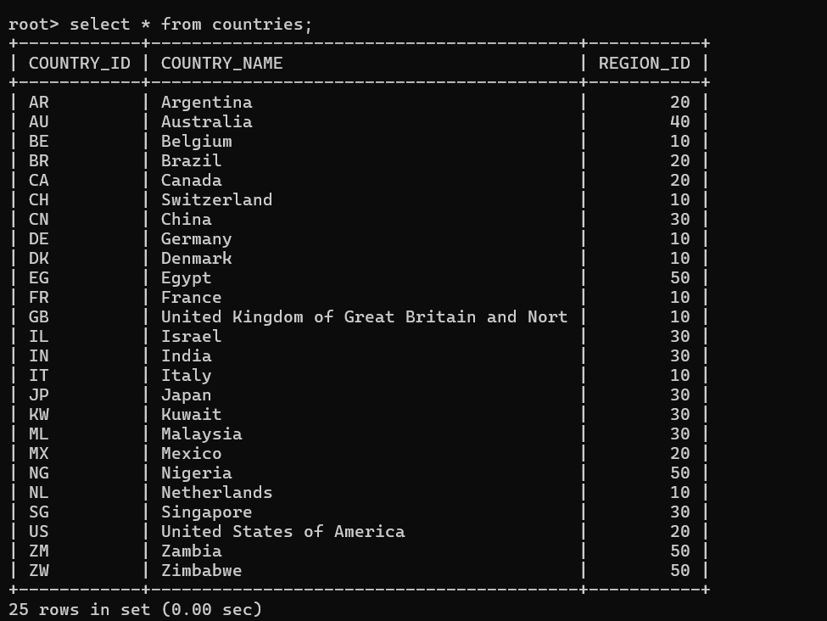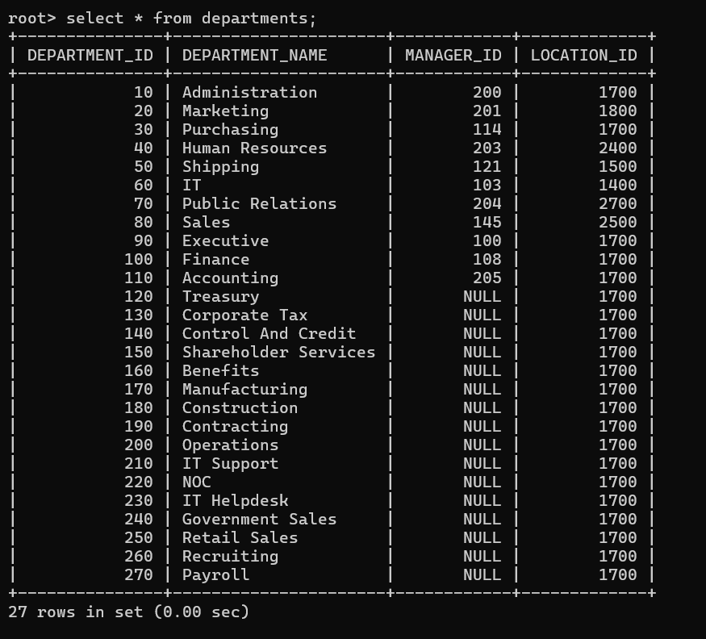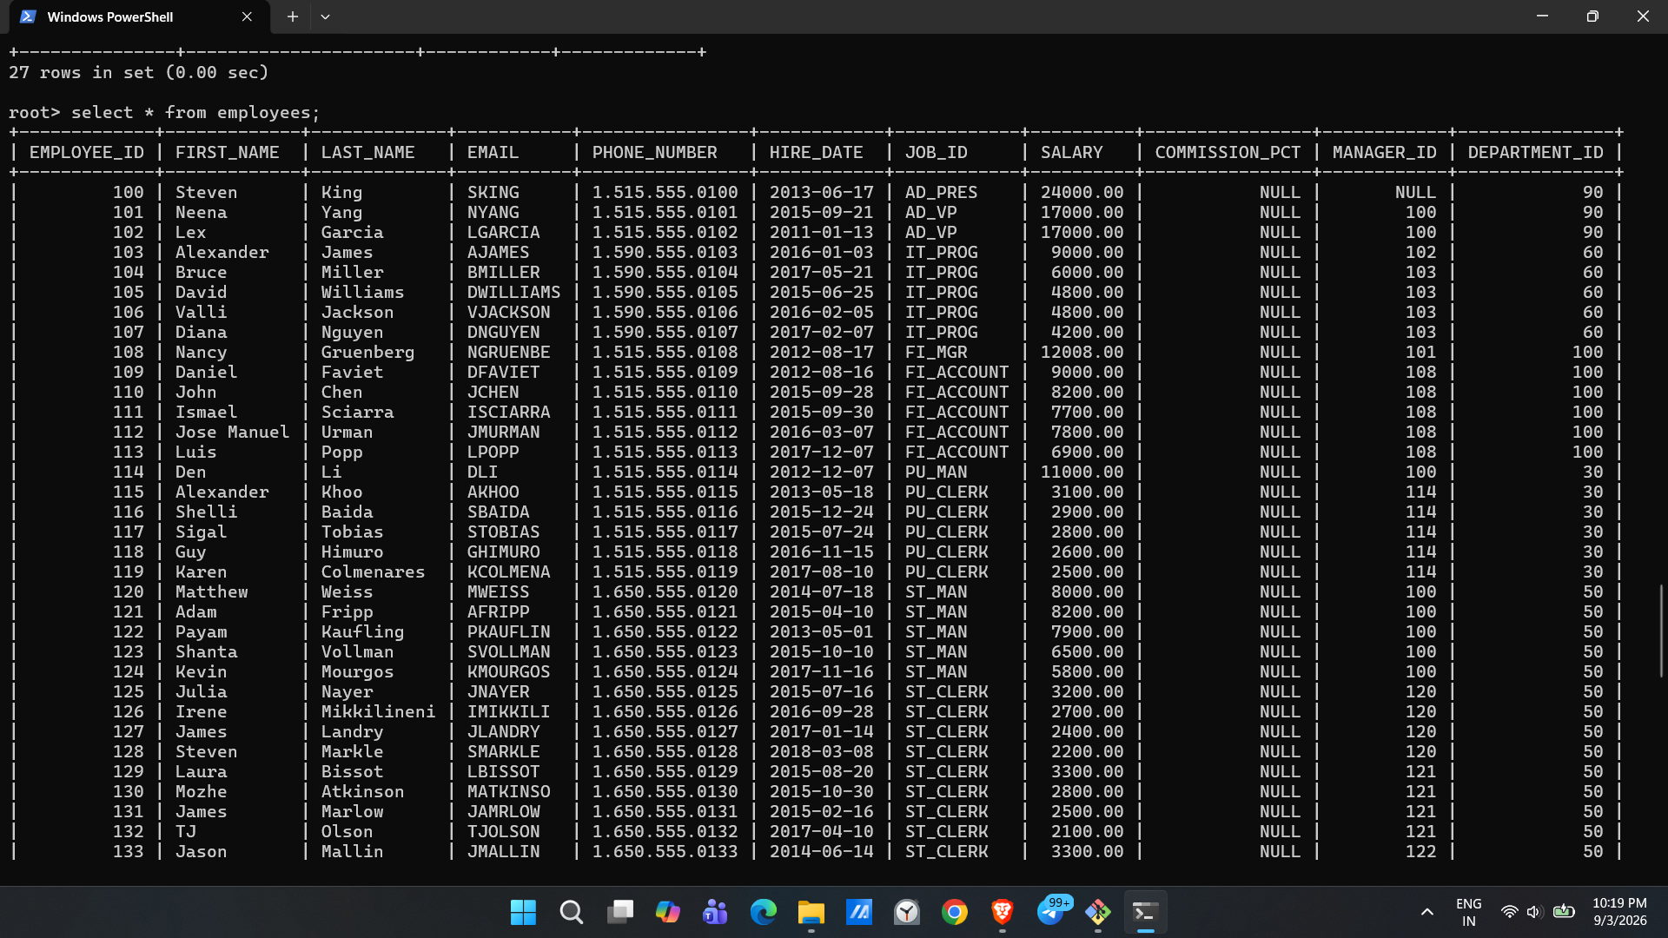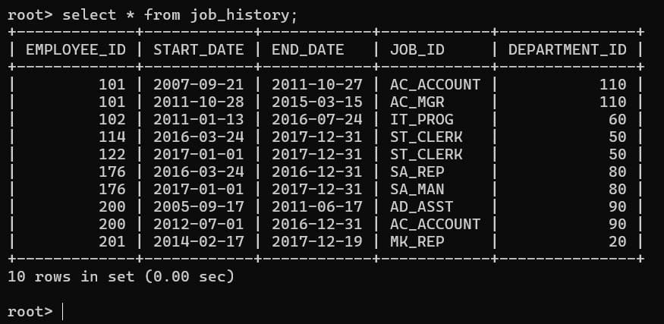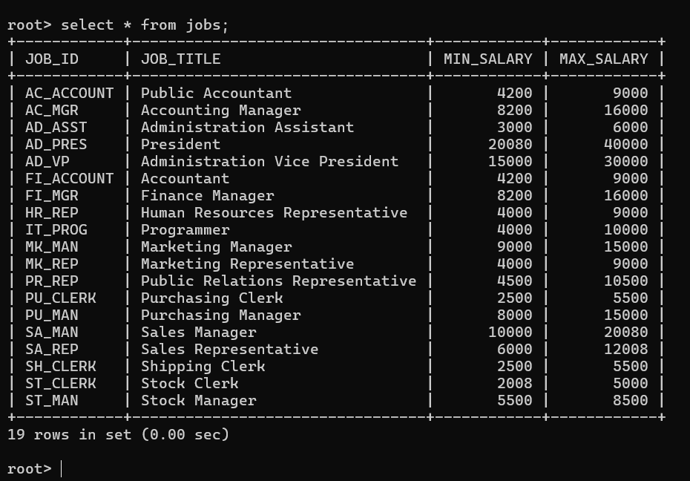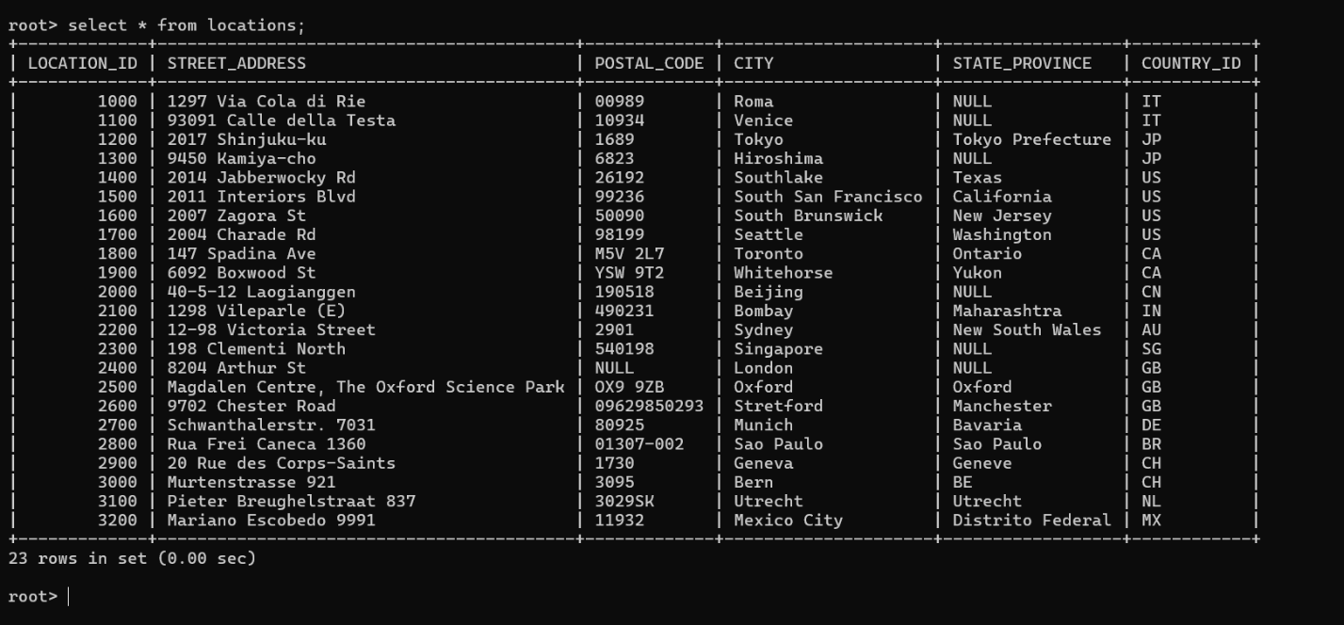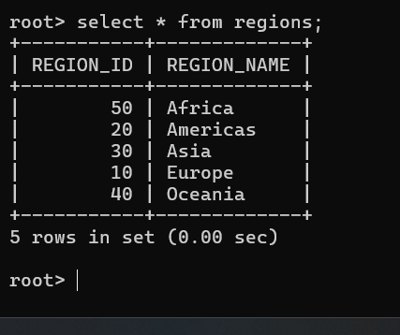

Q3
- How many orders data is present in the database?
Ans : when we run Query “select * from orders”
it returns full table and at the end it shows 10 rows in set.
It means there are 10 orders.
- How many customers are present in the database?
Ans : 7
- How many salespeople are present in the database?
Ans : 5
- On which date order with highest amount is placed?
Ans : 1990-10-04
5. For which order salesman got maximum commission? Hint: you need to refer data of two tables.
Ans: 3006
- Which salesmen are handling more than two customers? Hint: you need to refer data of two tables.
Ans: peel
- Which city have single customer?
Ans: Berlin
8. Which city has multiple salespeople?
Ans: London
9. What is name of customer and salesman of the maximum amount order?
Ans: Clemens and Peel
10.Study relationship between the tables in sales database
Ans: orders table store cnum of customer and snum of salesperson . it keeps record of orders and salesperson and customer

