Question 1:
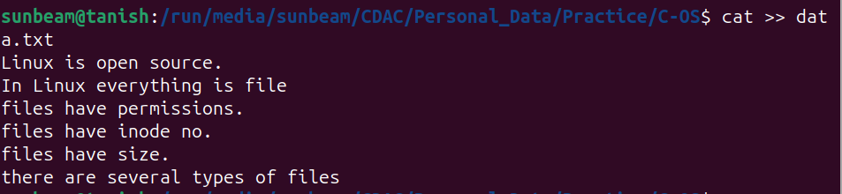
Question 2:
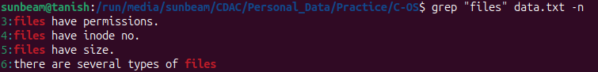
Question 3:
Question 4:
Question 5:
Question 6:

Question 7:
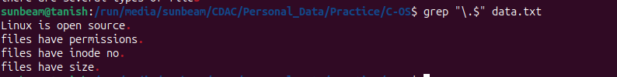

Question 8:
Question 9:
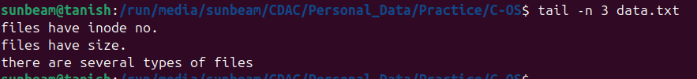
Question 10:
