Question:
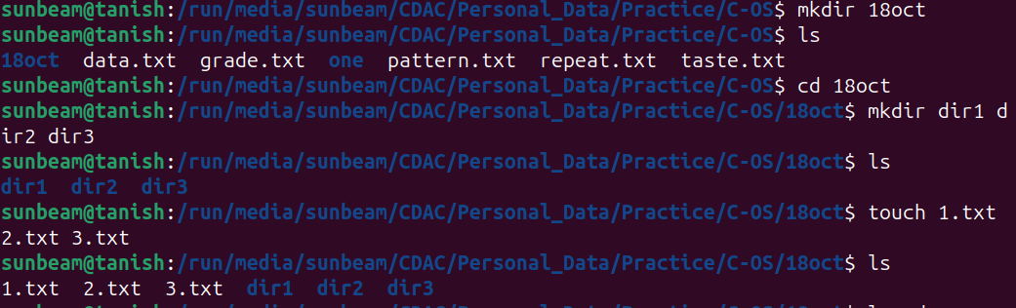
1:
2:
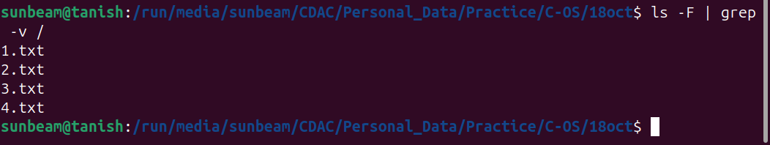
3:

4:

