Question 1:
Question 2:
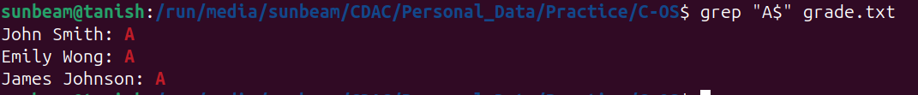
Question 3:
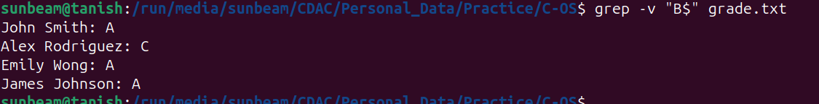
Question 4:
Question 5:
Question 6:
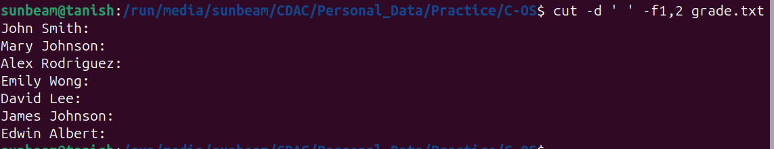
Question 7:
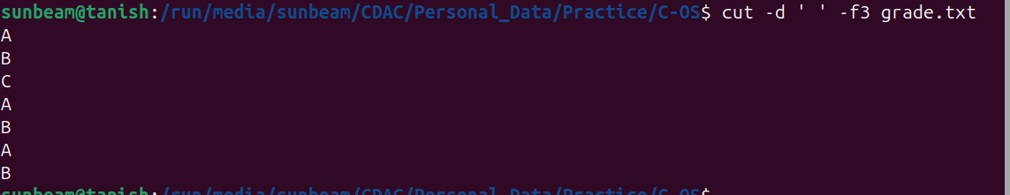

Question 8:
