QUESTION 1:
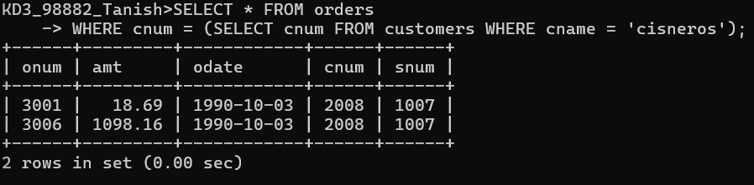
QUESTION 7:
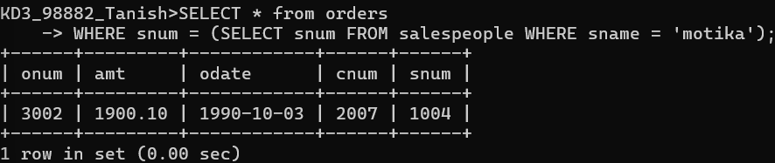
QUESTION 8:
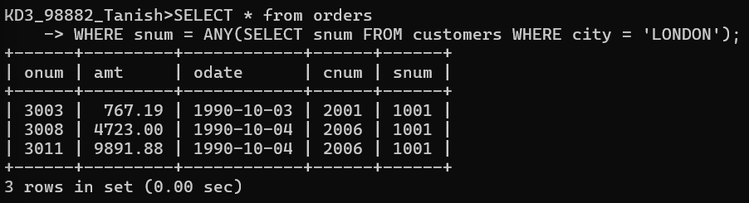
QUESTION 6:
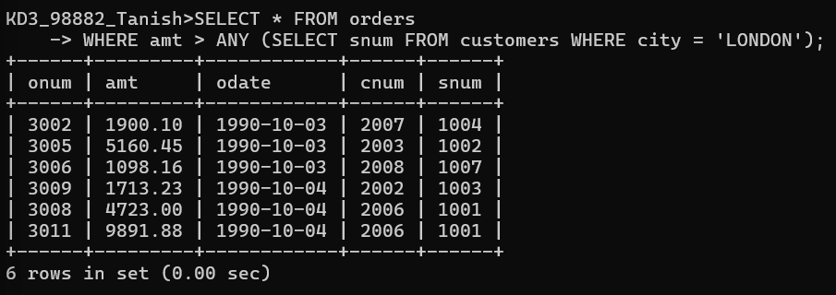

QUESTION 4:
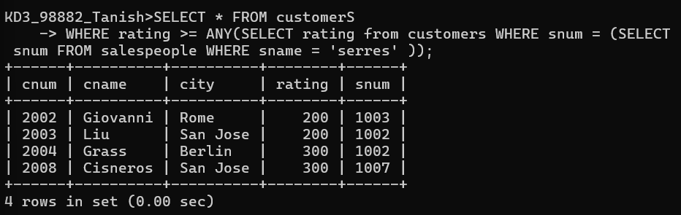
QUESTION 11:
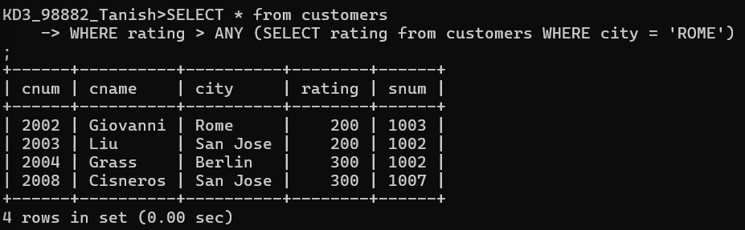
QUESTION 12:
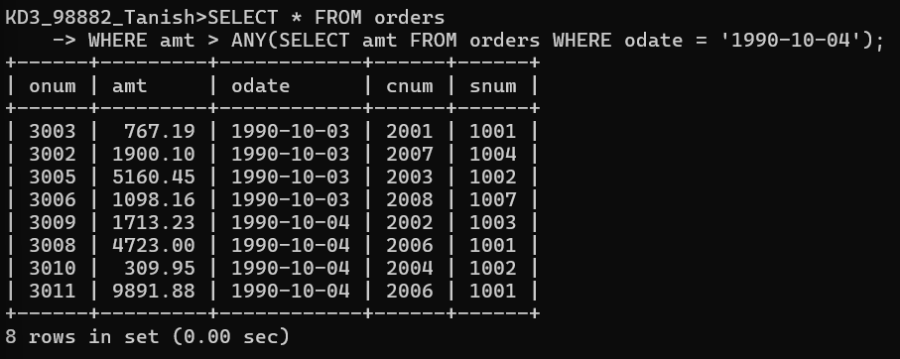

QUESTION 13:
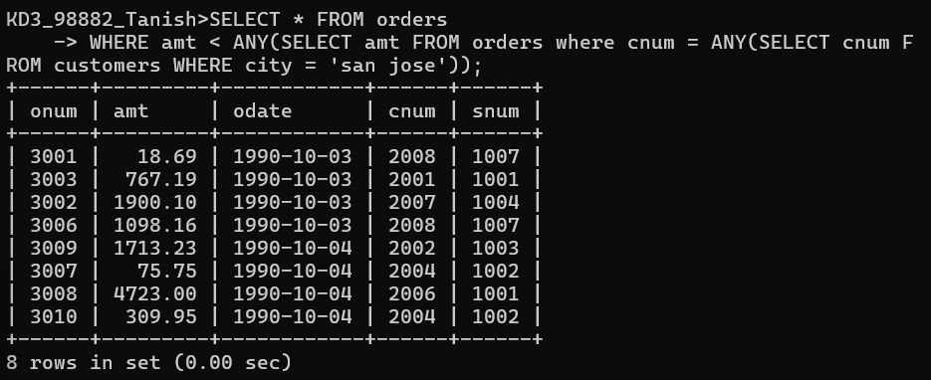
QUESTION 2:
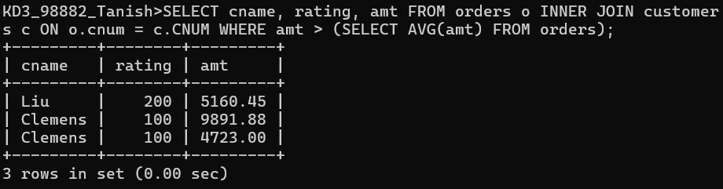
QUESTION 14:
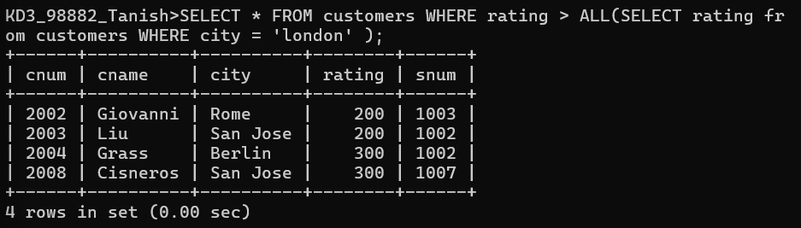
QUESTION 5:
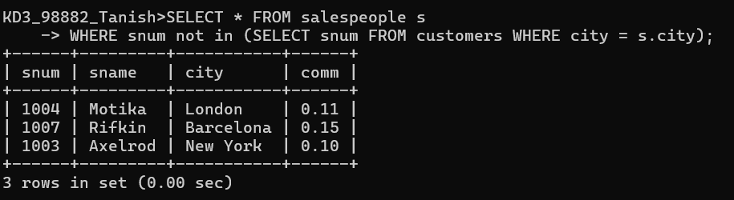
QUESTION 9:
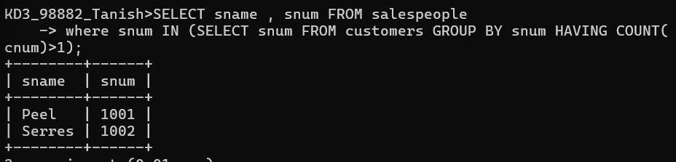
QUESTION 10:
