1. Write a query to get unique department ID from employee table.
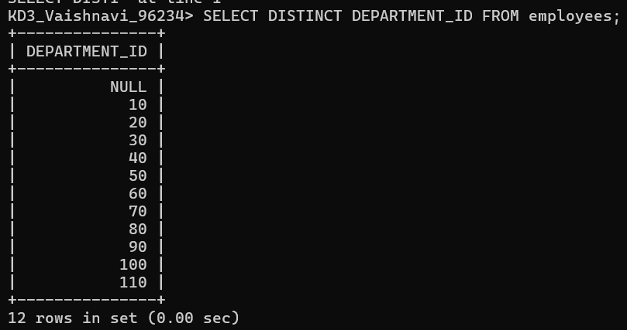

2. Write a query to get all the employee’s details from the employees table displaying the first names in descending order.
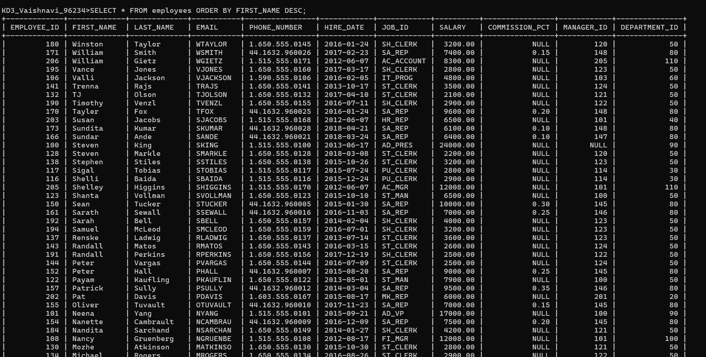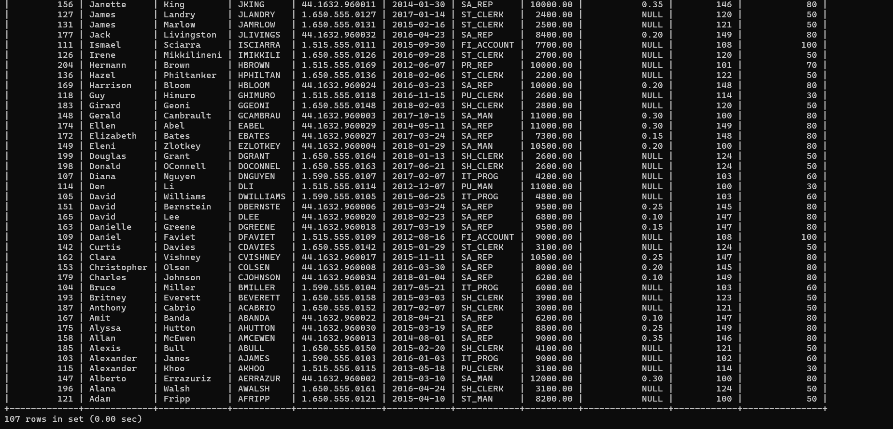

3. Write a query to get the employee ID, names (first_name and last_name), salary in ascending order of salary.
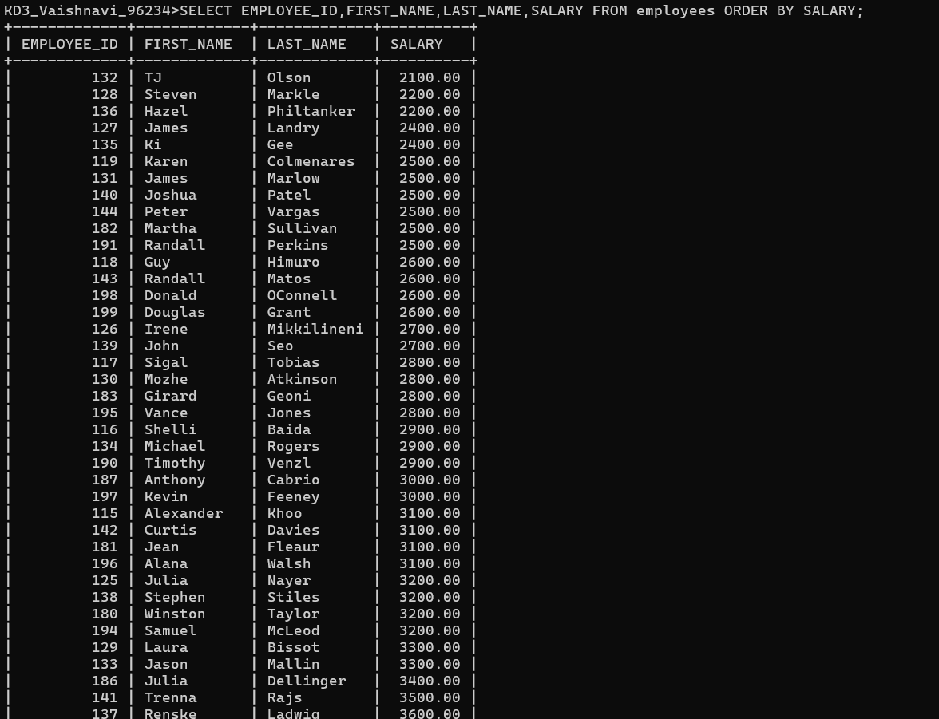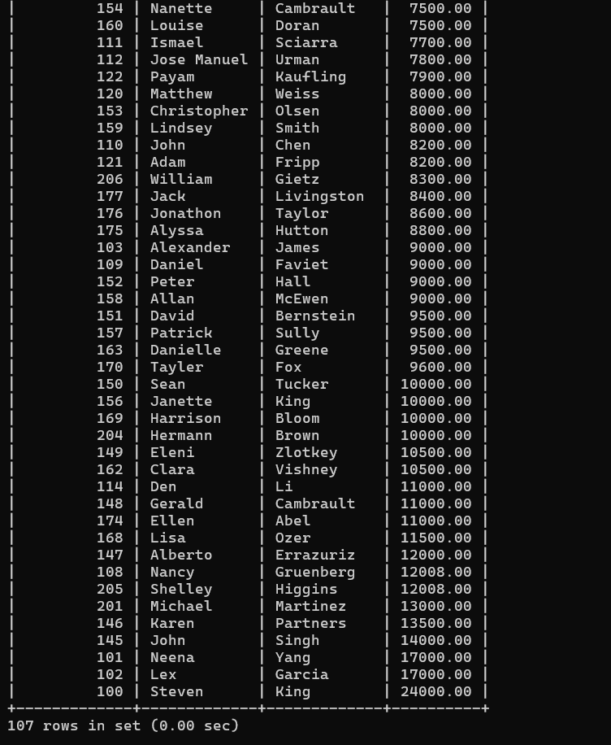

4. Display first name and joining date of the employees who are either IT Programmer or Sales Man.
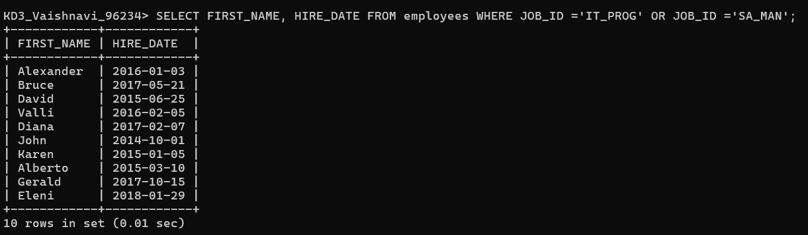

5. Display details of employees with employee ID 150 or 160.
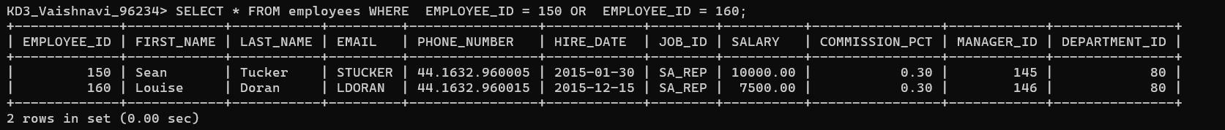

6. Display first name, salary, commission pct, and hire date for employees with salary less than 10000.
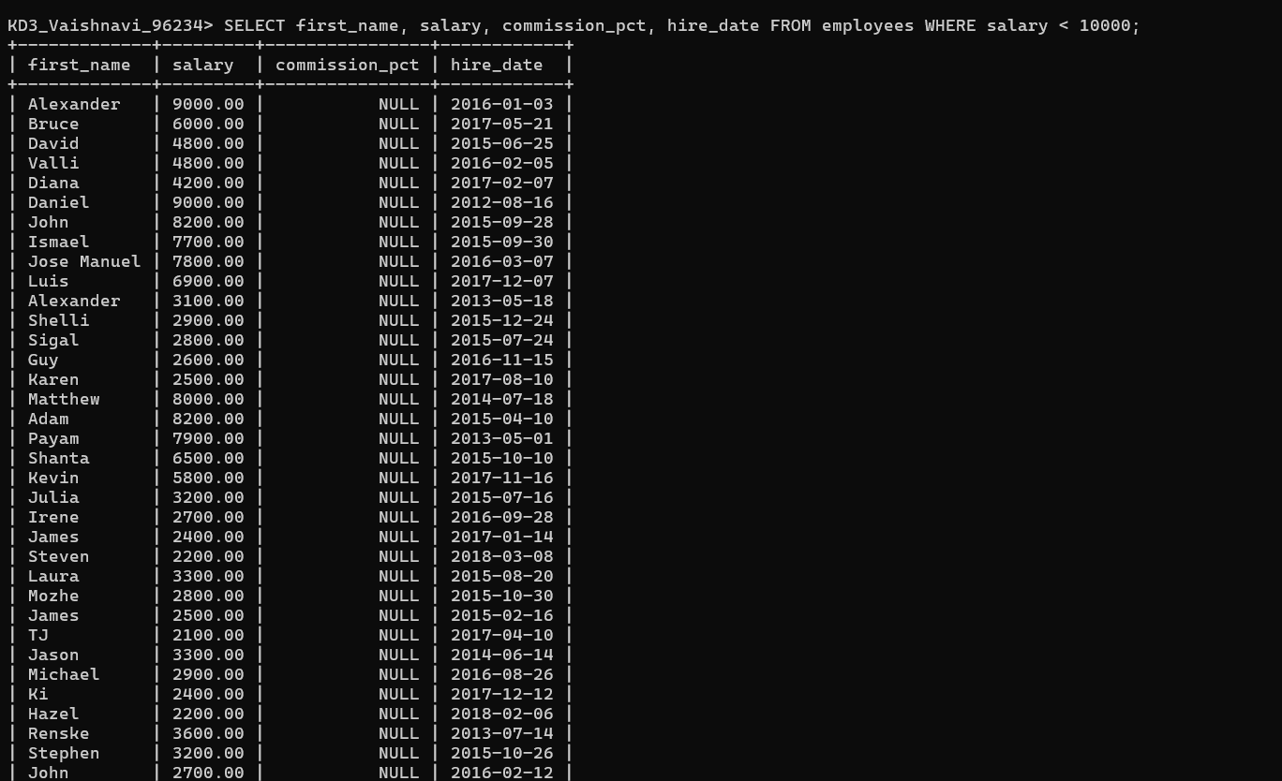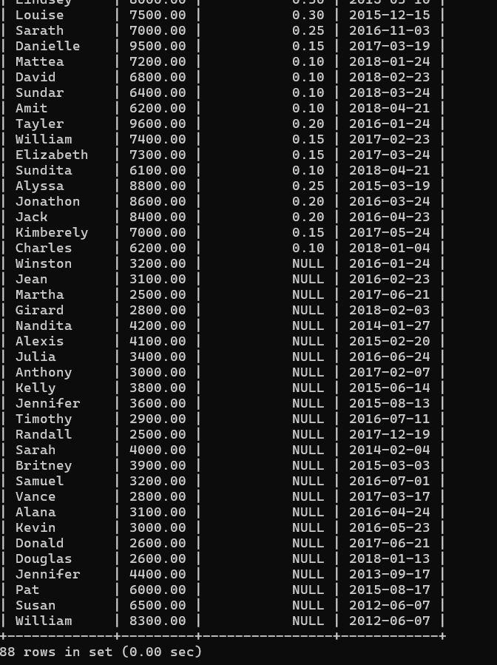

7. Display employees where the first name or last name starts with S.
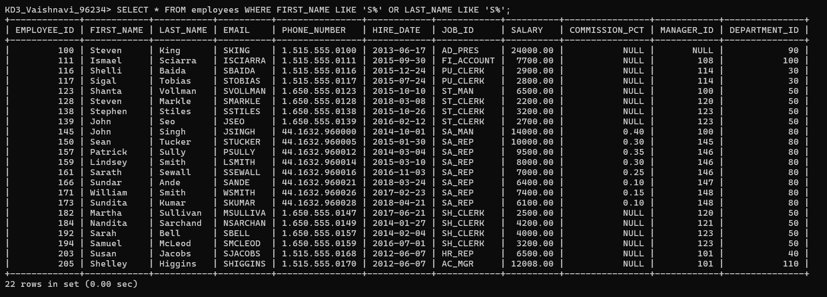

8. Display details of jobs in the descending order of the title.
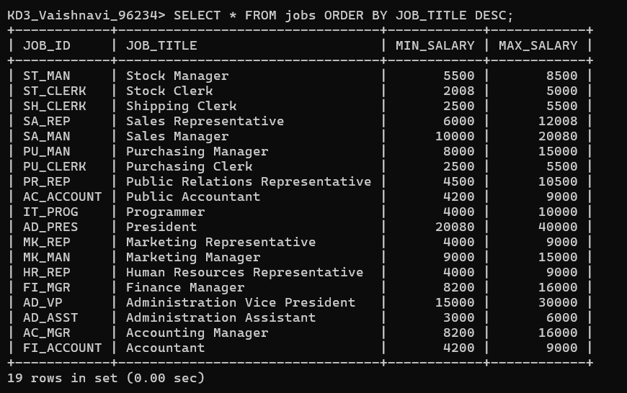

9. Display the details of the employees from department 30, earning the salary greater 10000 but do not receive the commission.
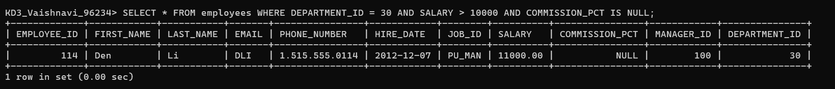

10. Display the details of employees reporting to the managers with employee id 100 and 120.
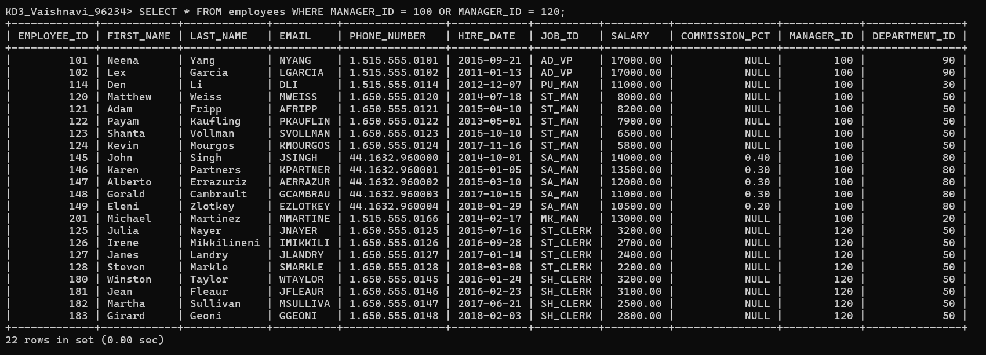

11. Display the unique country_id from locations table.
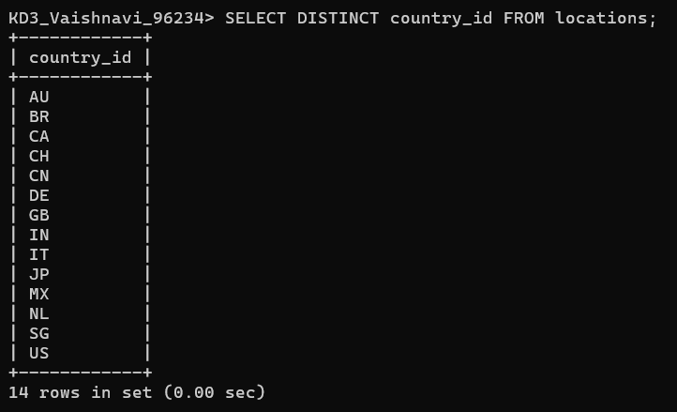

12. Display all employees whose have the job_id as IT_PROG and FI_ACCOUNT.
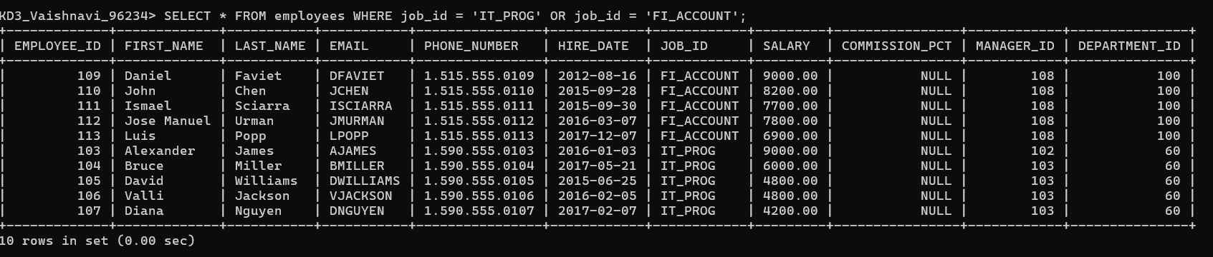

13. Display all countries in ascending order.
