LeetCode Exercises – JOINS Problems

- Replace Employee ID With The Unique Identifier https://leetcode.com/problems/replace-employee-id-with-the-unique-identifier

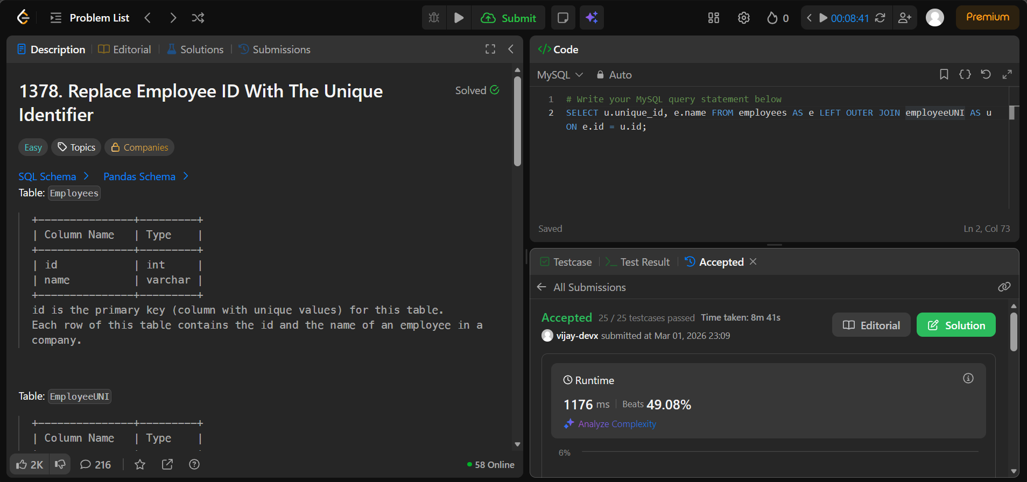

- Product Sales Analysis I https://leetcode.com/problems/product-sales-analysis-i

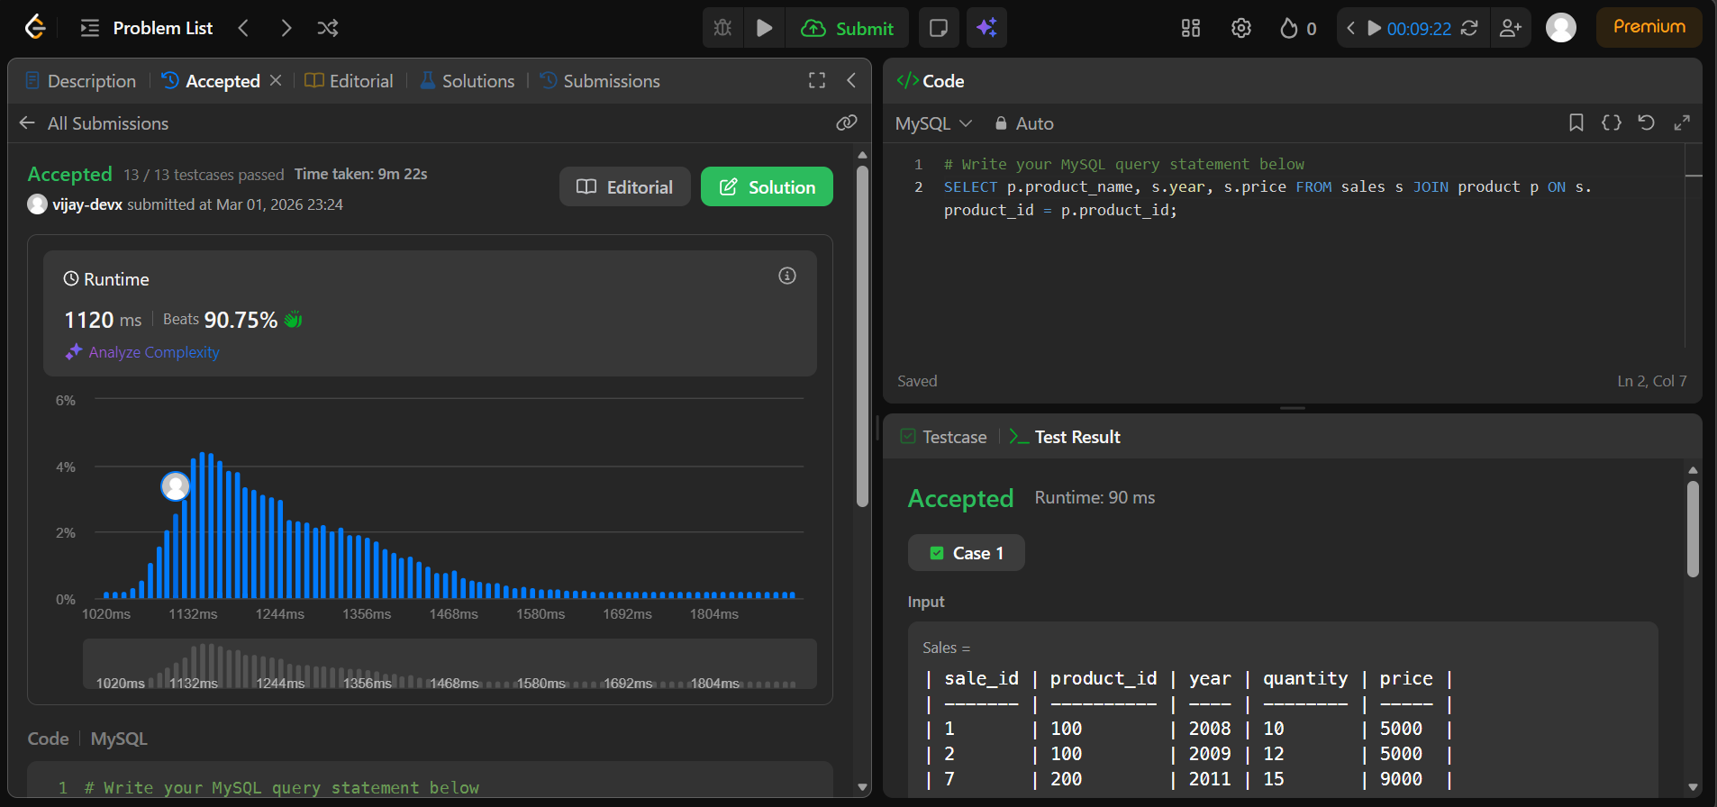

- Employee Bonus https://leetcode.com/problems/employee-bonus

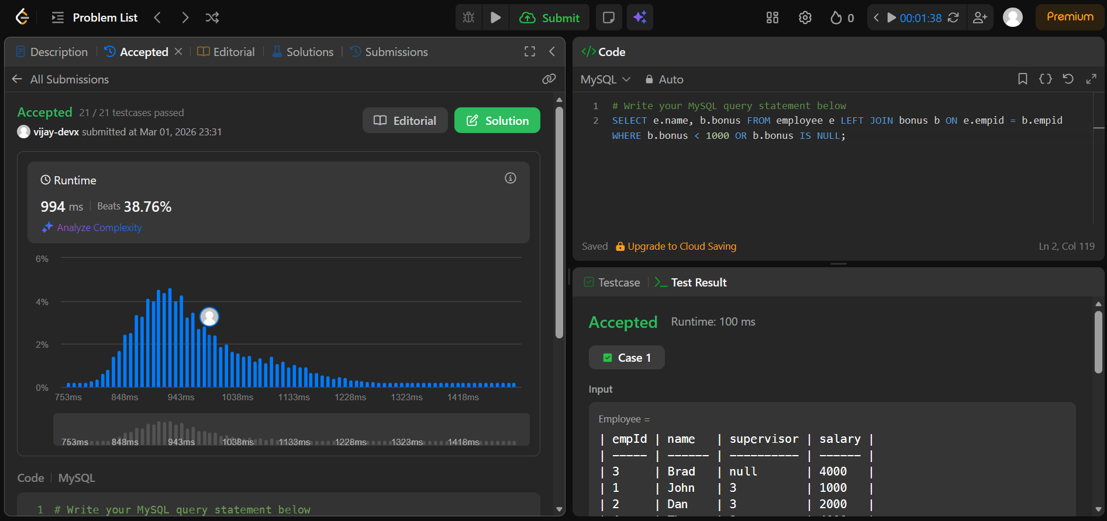

- Students and Examinations https://leetcode.com/problems/students-and-examinations

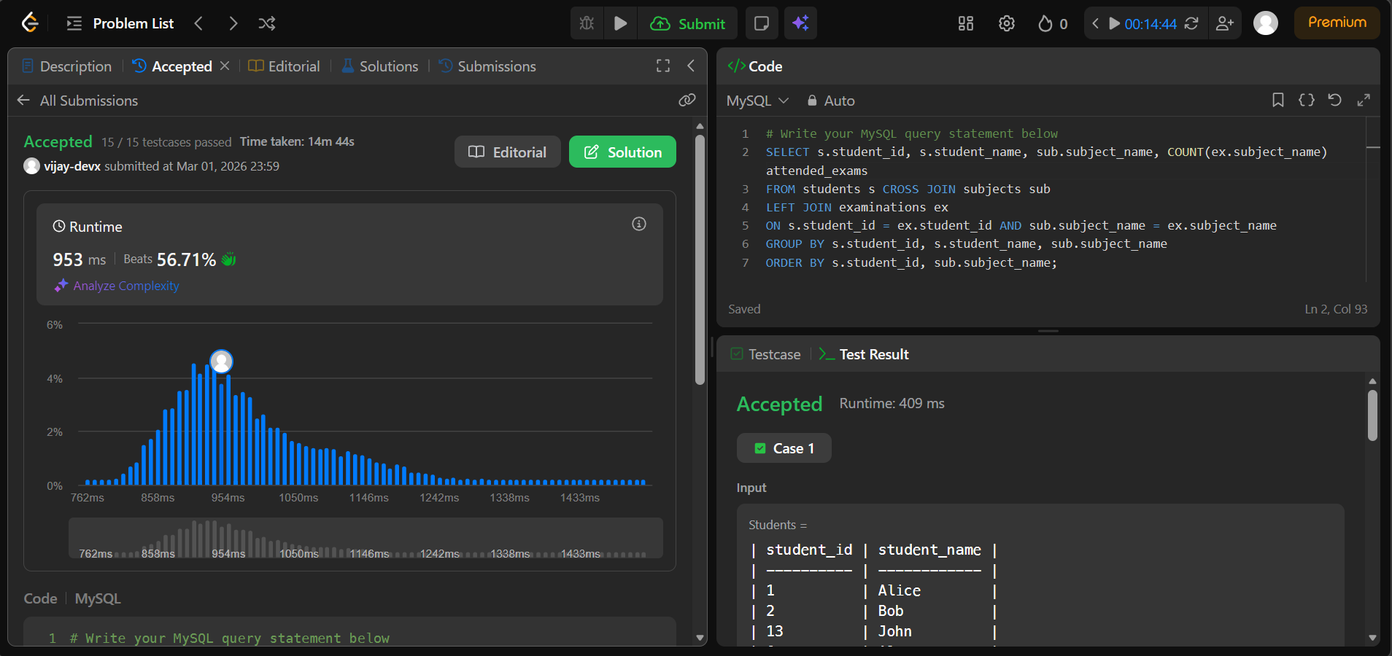

- Managers With At Least 5 Direct Reports https://leetcode.com/problems/managers-with-at-least-5-direct-reports

