Leetcode Exercises
GROUP BY Problems
- 586. Customer Placing the Largest Number of Orders https://leetcode.com/problems/customer-placing-the-largest-number-of-orders

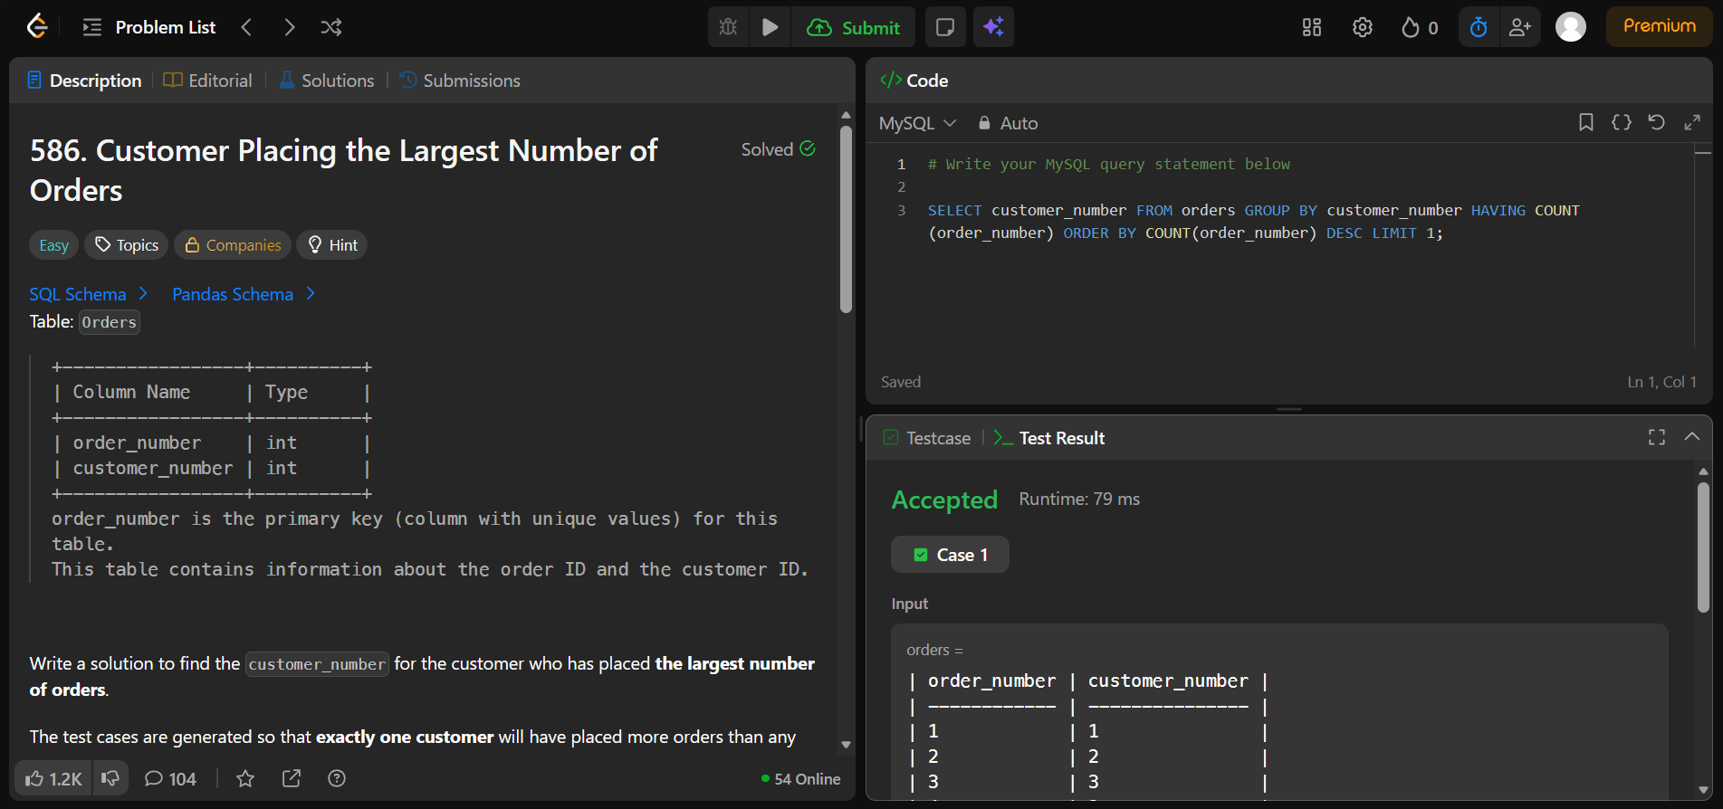

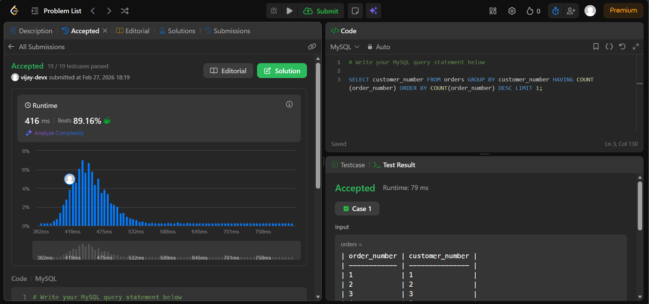

- 619. Biggest Single Number https://leetcode.com/problems/biggest-single-number

