Database Technologies – Assignment-01

- Create 'spj' database'. (Database for suppliers, parts and jobs).
- use spj database;
- Create following tables in spj database.
Note : S denotes the Suppliers Table. CREATE TABLE S (S# CHAR(5) NOT NULL, Sname CHAR(20), status SMALLINT, city CHAR(15));

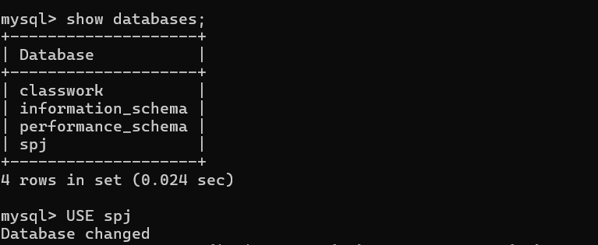
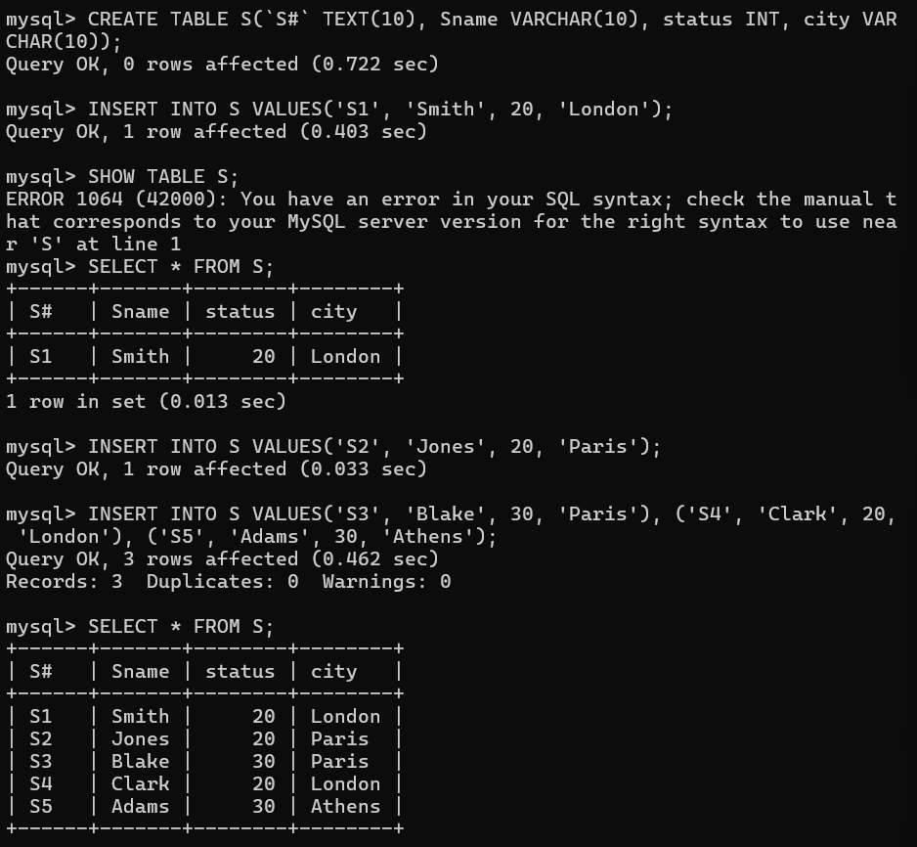
Note : P denotes the Parts table. CREATE TABLE P (P# CHAR(6) NOT NULL, Pname CHAR(20), color CHAR(6), weight SMALLINT, city CHAR(15));

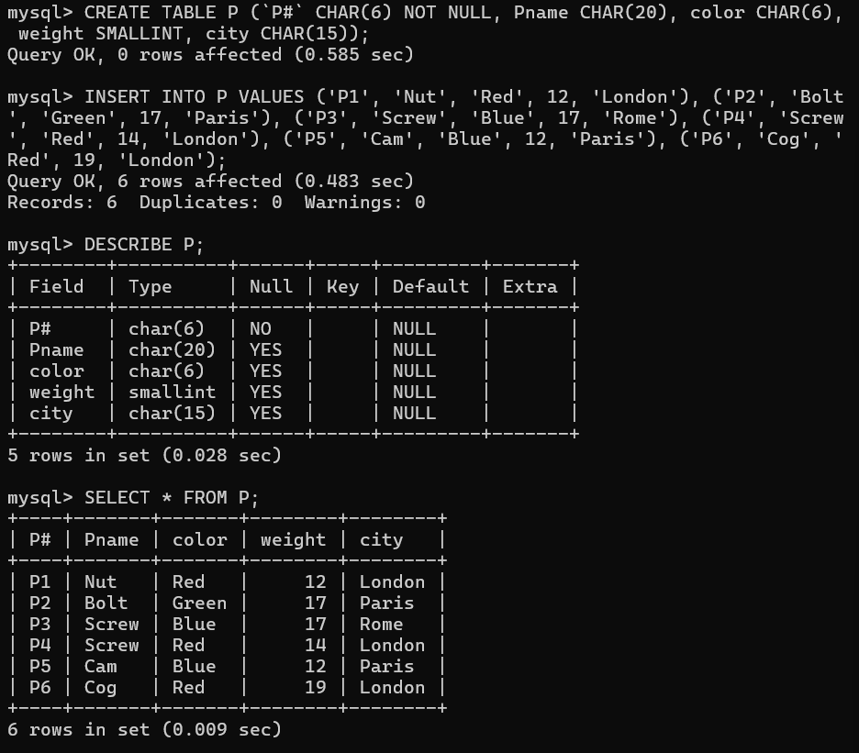

Note : J denotes the Jobs table. CREATE TABLE J (J# CHAR(4) NOT NULL, Jname CHAR(10), City CHAR(15));

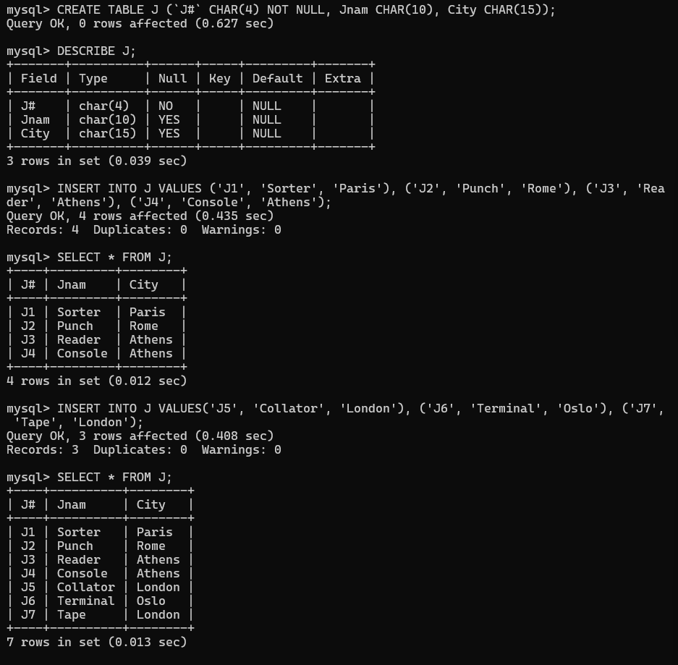

CREATE TABLE sp (S# CHAR(4) NOT NULL, P# CHAR(4) NOT NULL, J# CHAR(4) NOT NULL, QTY INT);
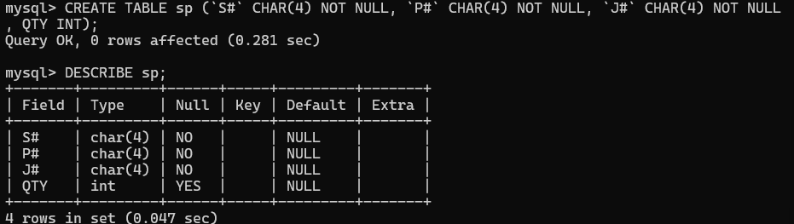
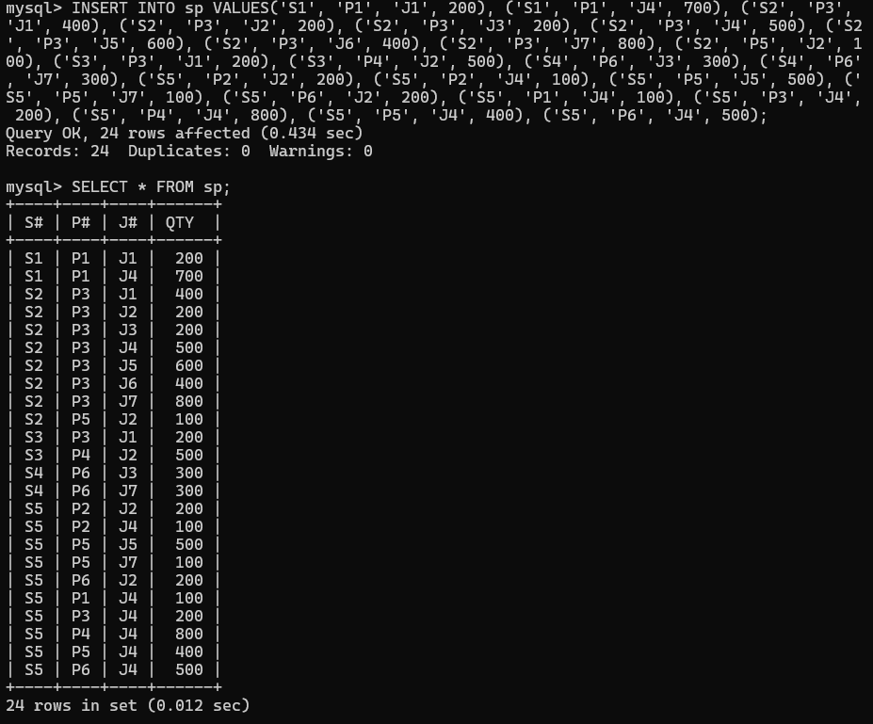

1. Create 'hr' database. Import hr-db.sql.
2. Create 'sales' database. Import sales-db.sql.
3. List all tables in hr database. Display contents of all tables (one by one). 4. List all tables in sales database. Display contents of all tables (one by one).
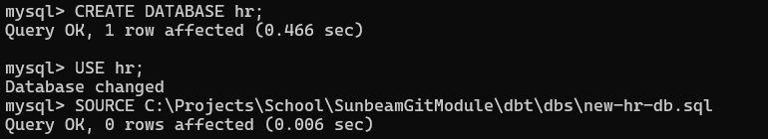
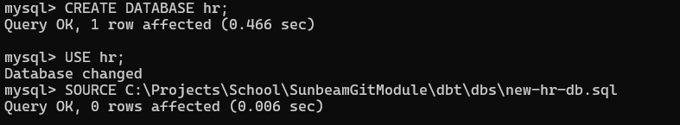
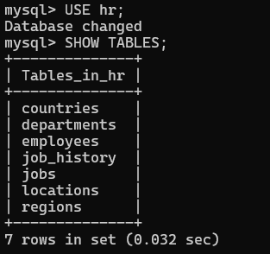

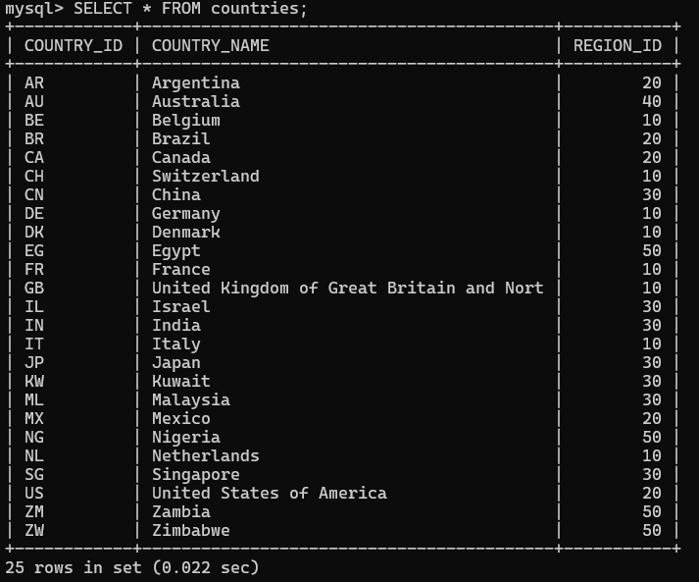
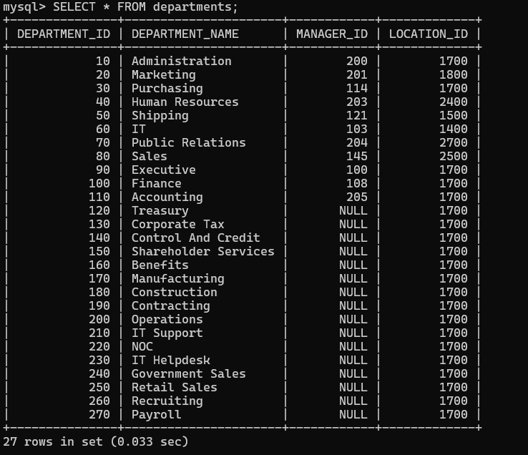
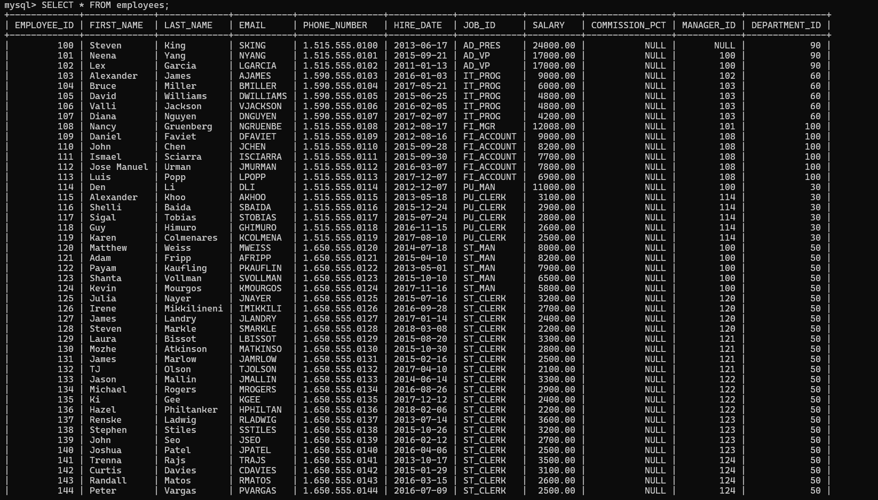
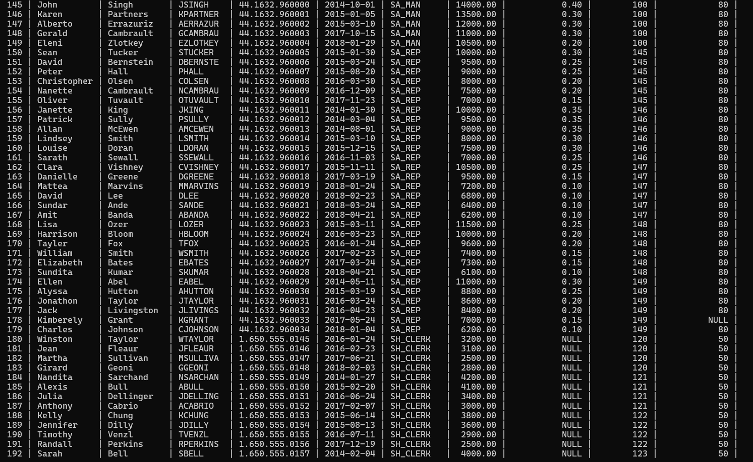
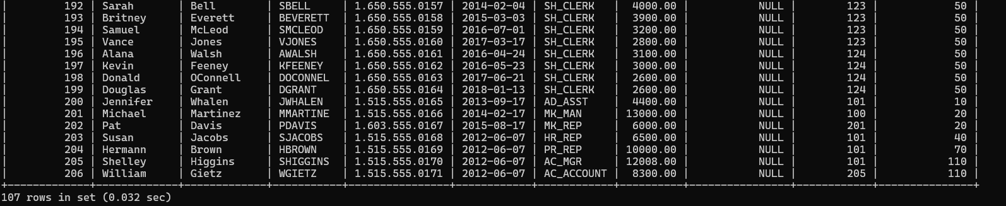
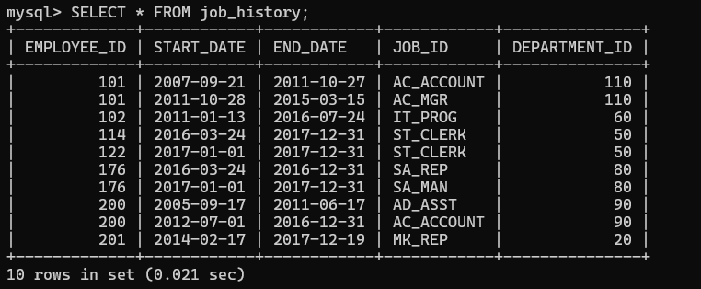
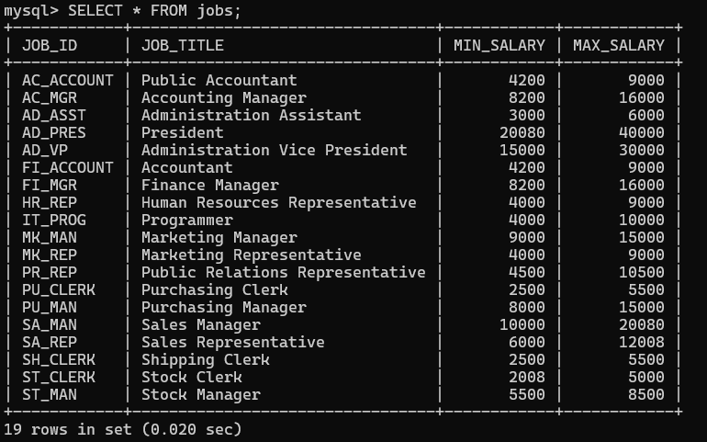
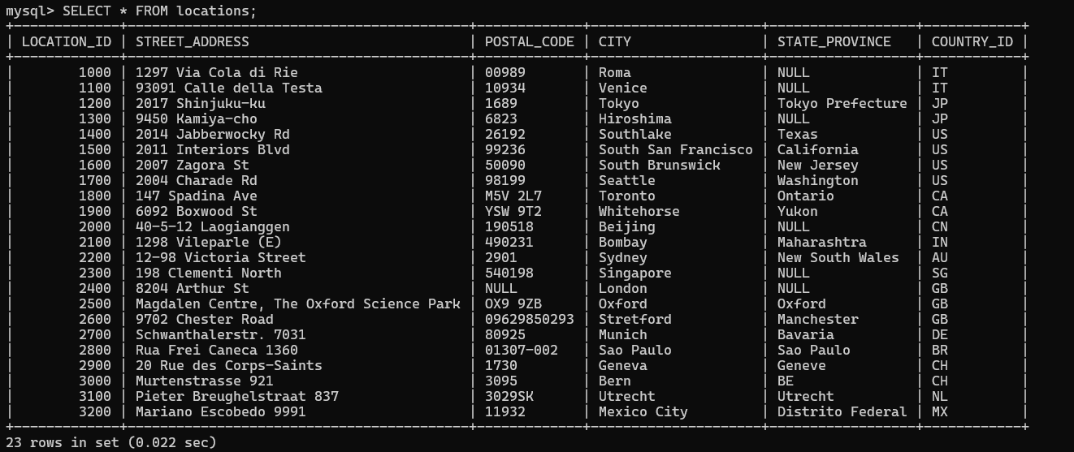
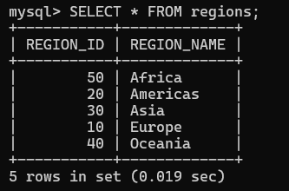

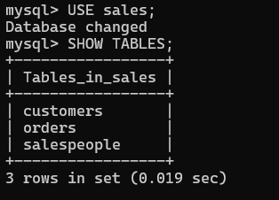
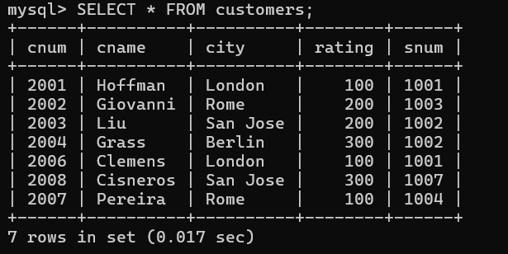
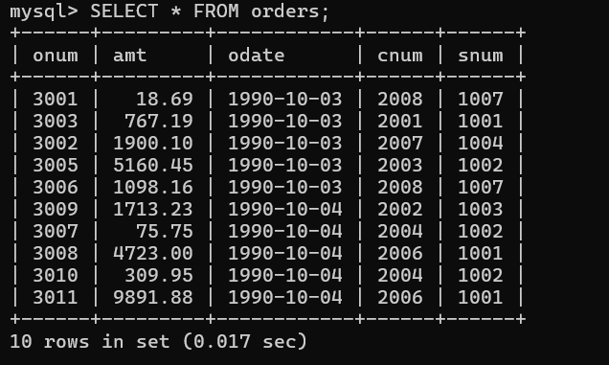
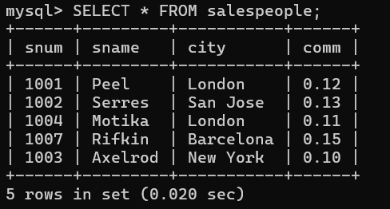

Answer the following questions (by observations only – not queries).

- How many orders data is present in the database?
Ans. 10.

- How many customers are present in the database?
Ans. 7

- How many salespeople are present in the database?
Ans. 5

- On which date order with highest amount is placed?
Ans. 1990-10-04

- For which order salesman got maximum commission? Hint: you need to refer data of two tables.
Ans. 3001 and 3006

- Which salesmen are handling more than two customers? Hint: you need to refer data of two tables.
Ans. 1002

- Which city have single customer?
Ans. Berlin

- Which city has multiple salespeople?
Ans. Rome and San Jose

- What is name of customer and salesman of the maximum amount order?
Ans. Clemens and Peel

- Study relationship between the tables in sales database.
Ans. Snum between Customers and Orders and Salespeople

