Database Technologies - Assignment 3

Note : To solve below queries use “hr” database

- Write a query to get unique department ID from employee table.

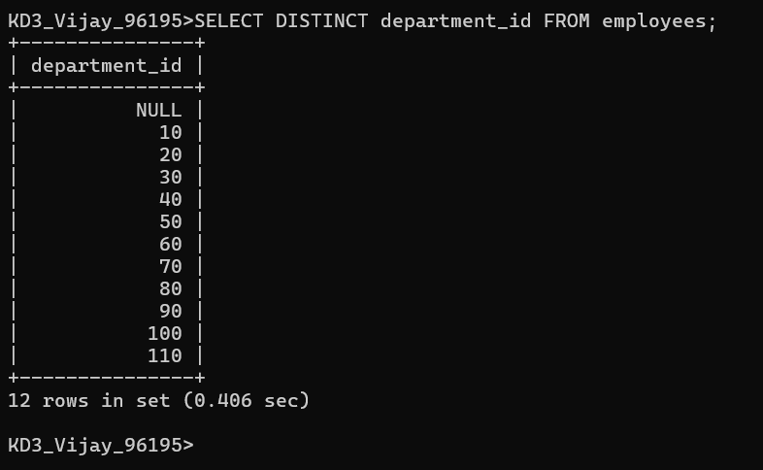

- Write a query to get all the employee’s details from the employees table displaying the first names in descending order.

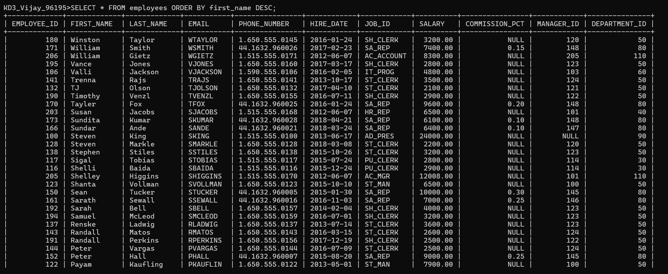
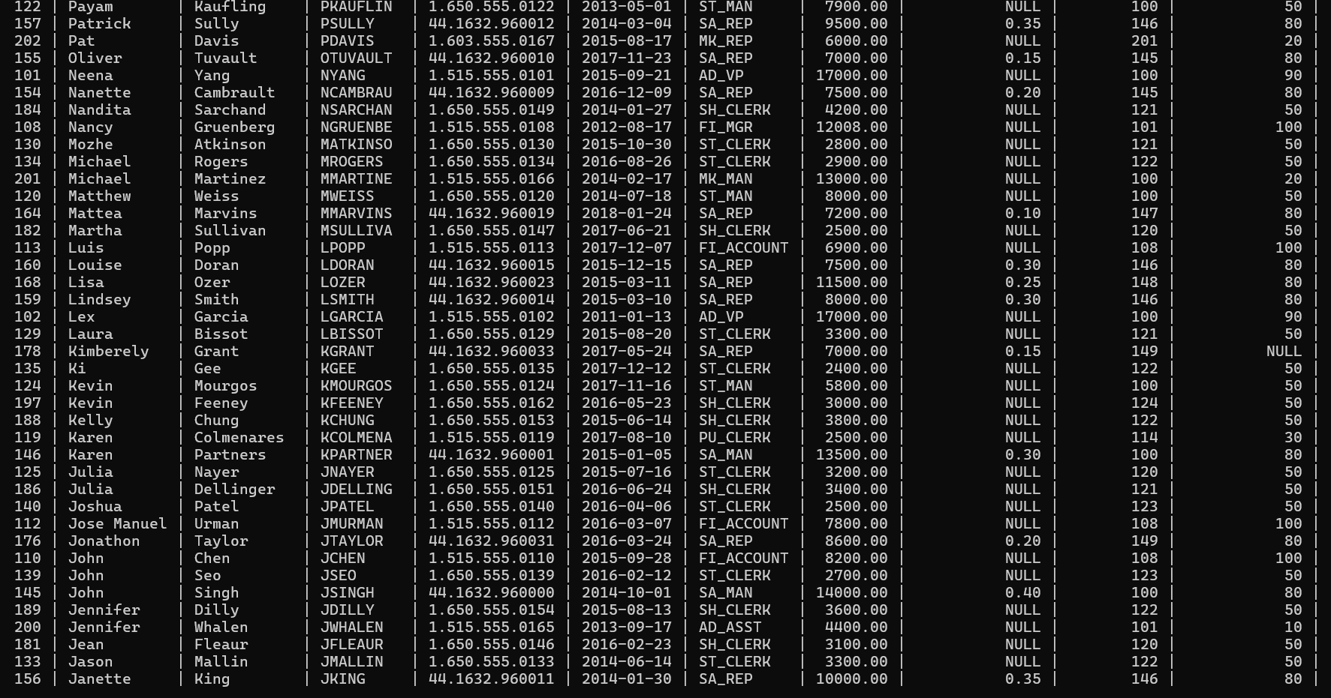

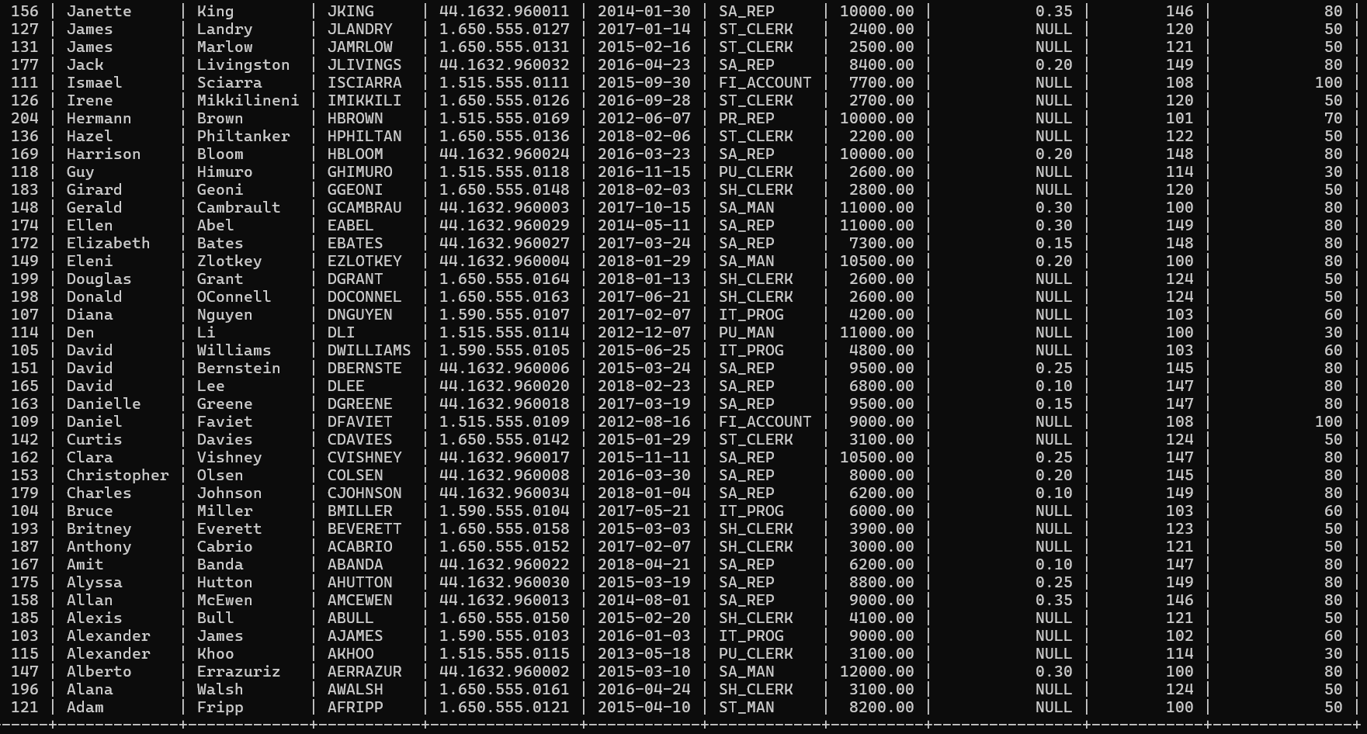

- Write a query to get the employee ID, names (first_name and last_name), salary in ascending order of salary.

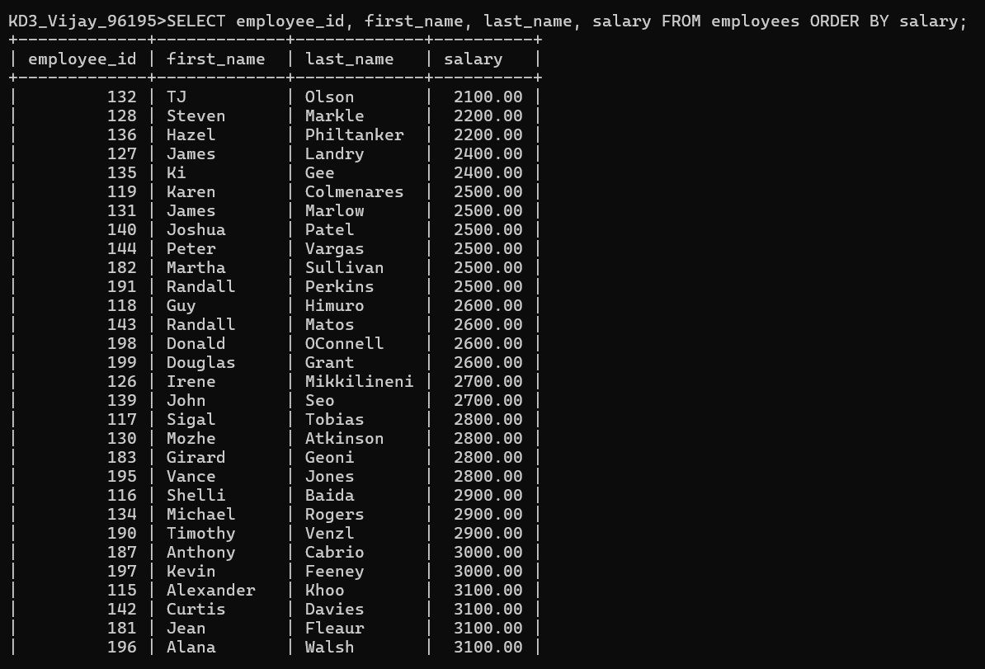

- Display first name and joining date of the employees who are either IT Programmer or Sales Man.

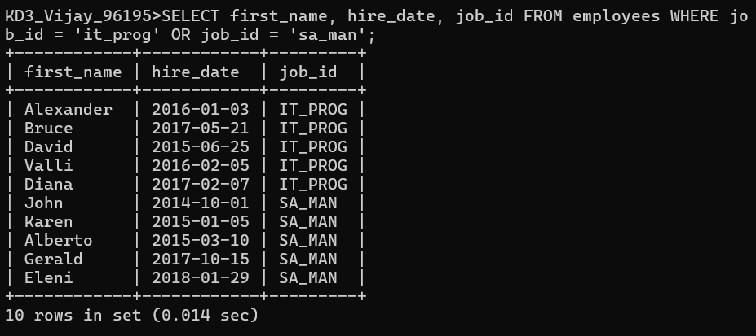

- Display details of employees with employee ID 150 or 160.

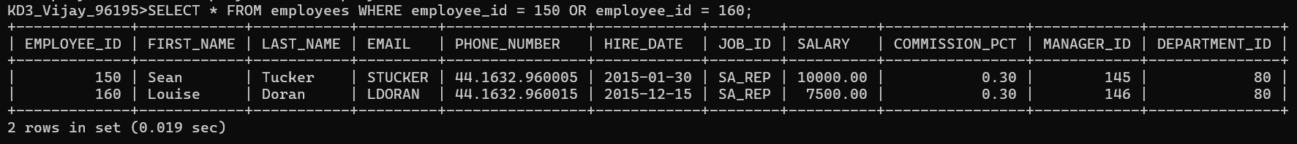

- Display first name, salary, commission pct, and hire date for employees with salary less than 10000.

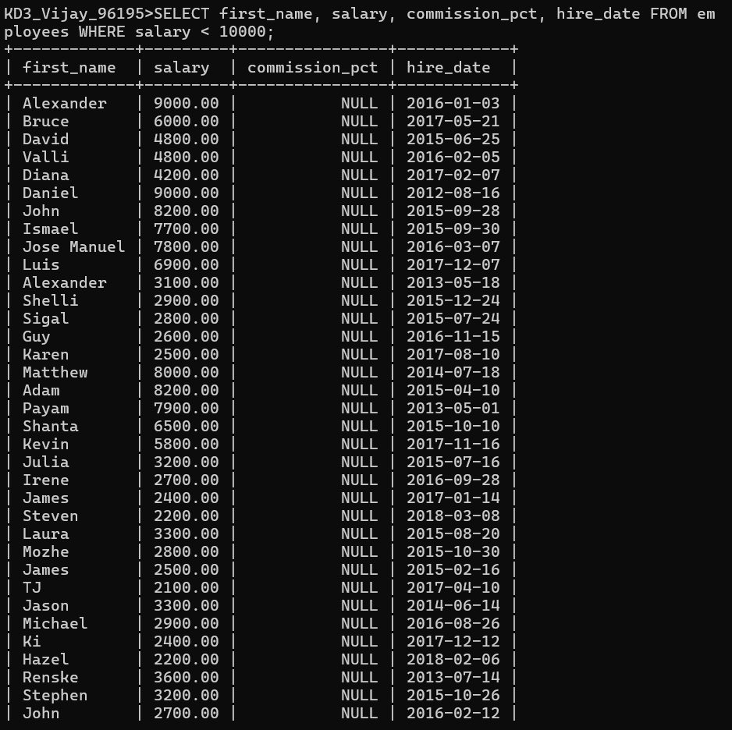

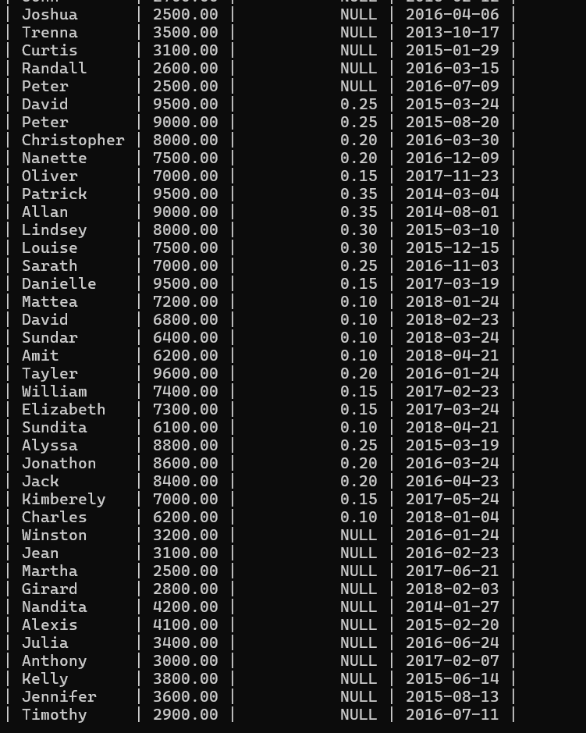

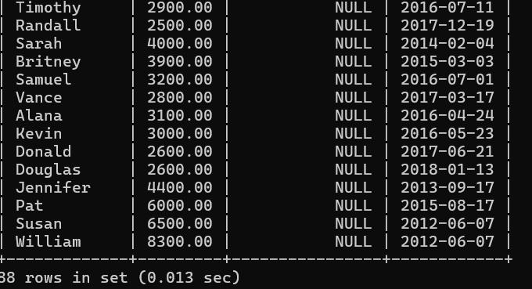

- Display employees where the first name or last name
starts with S.

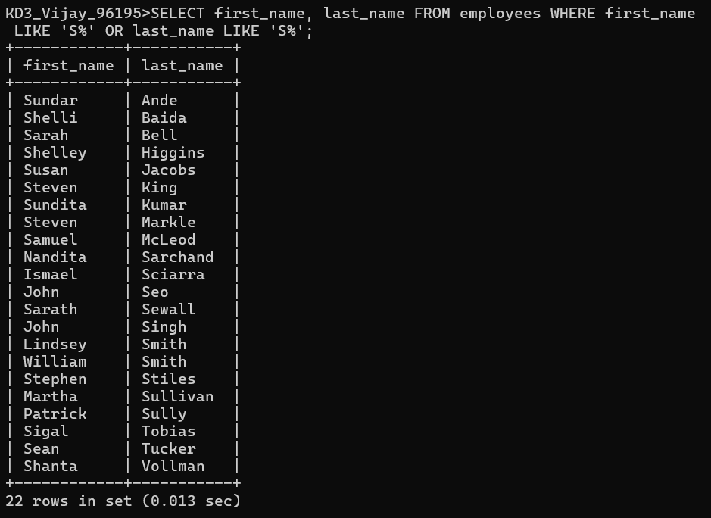

- Display details of jobs in the descending order of the title.

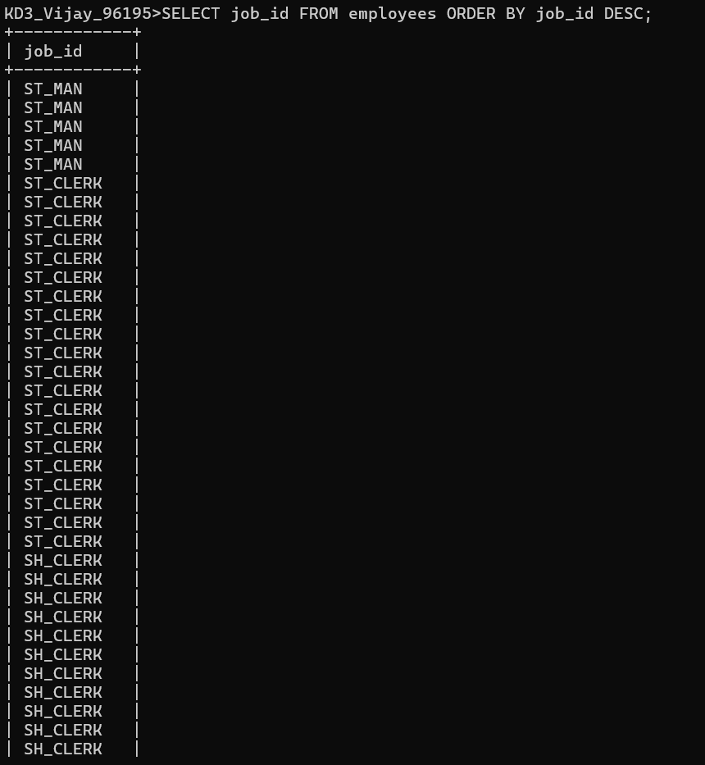
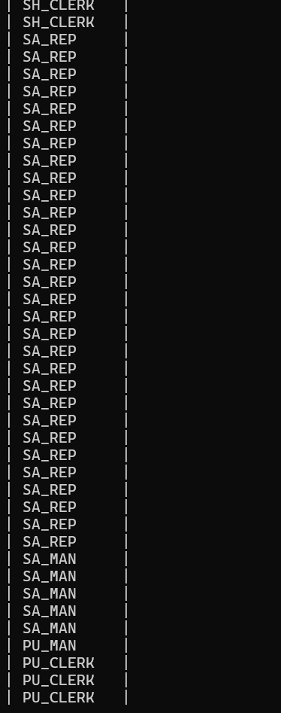
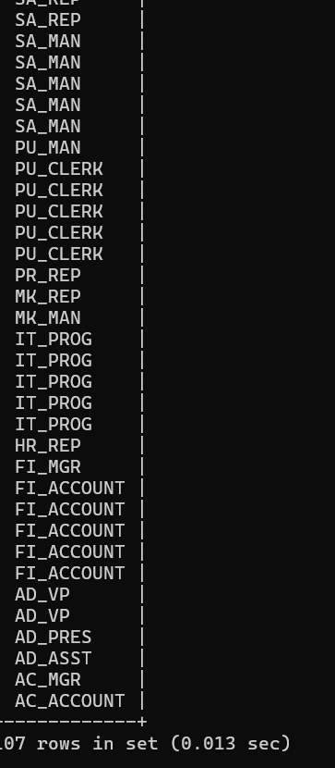

- Display the details of the employees from department 30, earning the salary greater 10000 but do not receive the commission.

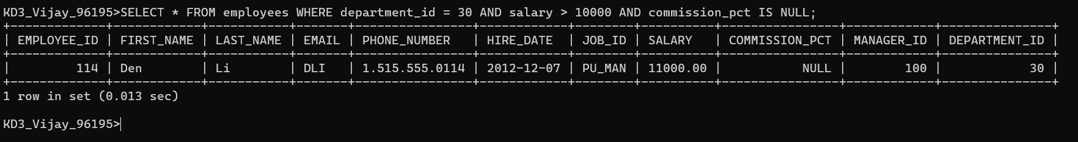

- Display the details of employees reporting to the managers with employee id 100 and 120.

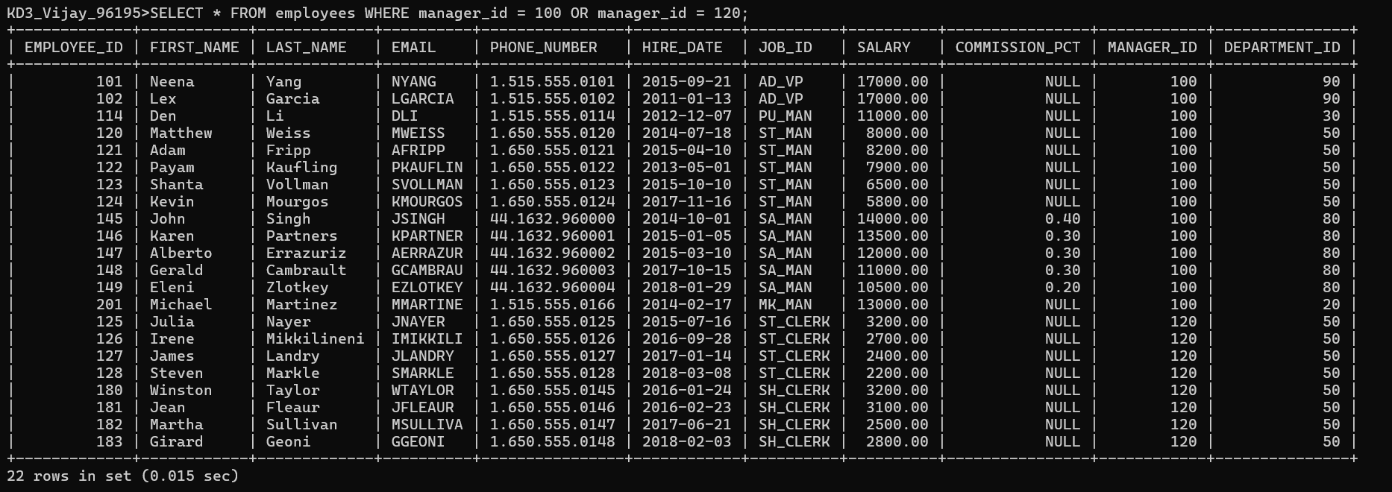

- Display the unique country_id from locations table.

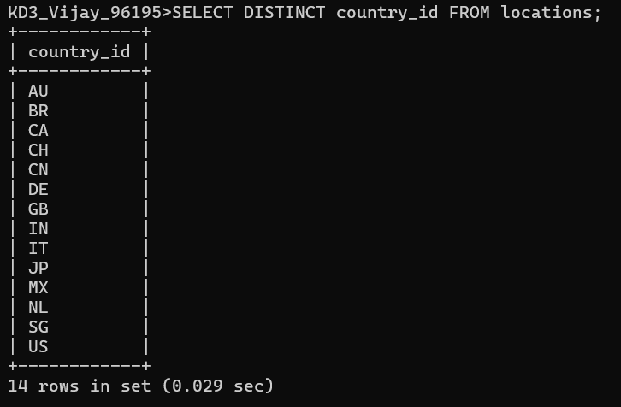

- Display all employees whose have the job_id as IT_PROG and FI_ACCOUNT.

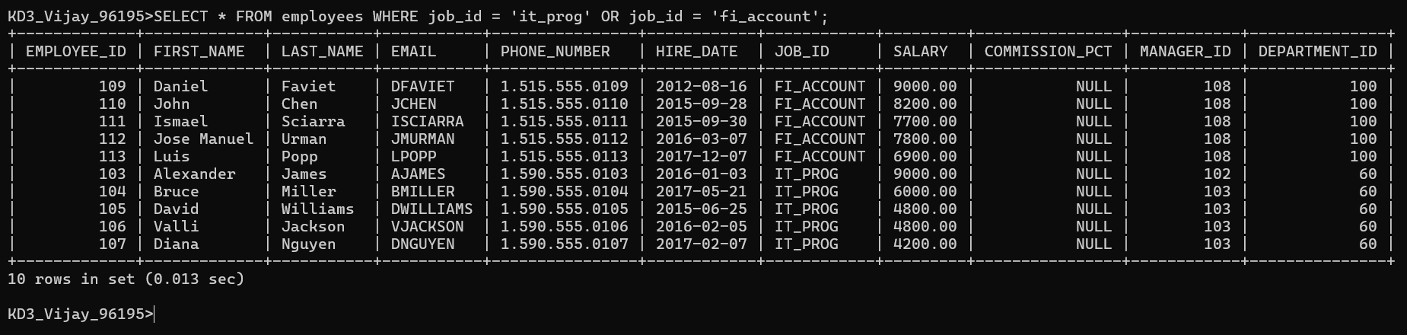

- Display all countries in ascending order.

