Database Technologies – Assignment 9
Create appropriate indexes to solve the following problems.
Note: use “sales” database to solve below queries.
- Create an index that will enable a user to pull orders for ‘1990-10-03’ out of the Orders table quickly. 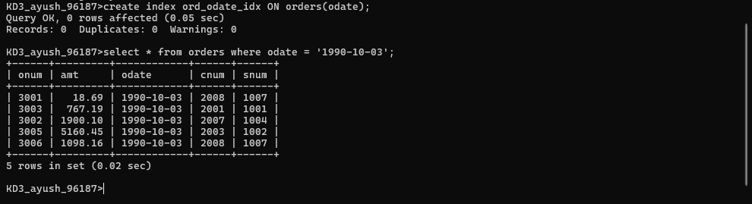
- If the Orders table has already been created, how can you force the onum field to be unique (assume all current values are unique)? 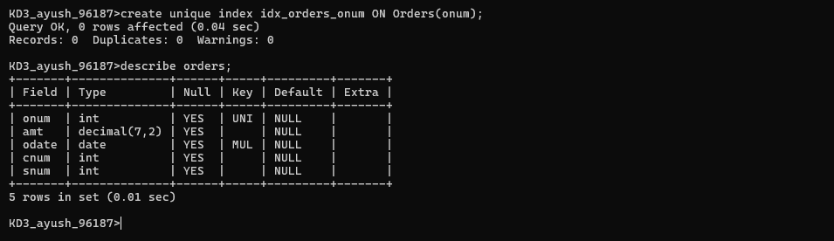
- Create an index that would permit salesperson to retrieve his orders. 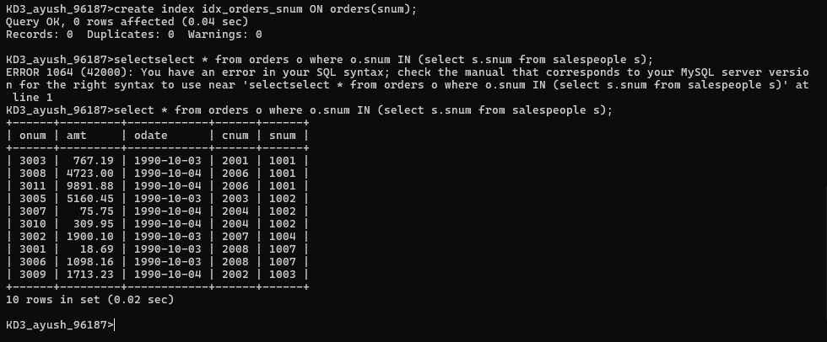
- Let us assume that each salesperson is to have only one customer of a given rating, and this is currently the case. Create an index that enforces it.

- Create an index to speed up searching order on a given date by given customer.

