1. Create 'spj' database'. (Database for suppliers, parts and jobs)
2. use spj database;
3. Create following tables in spj database.

S table
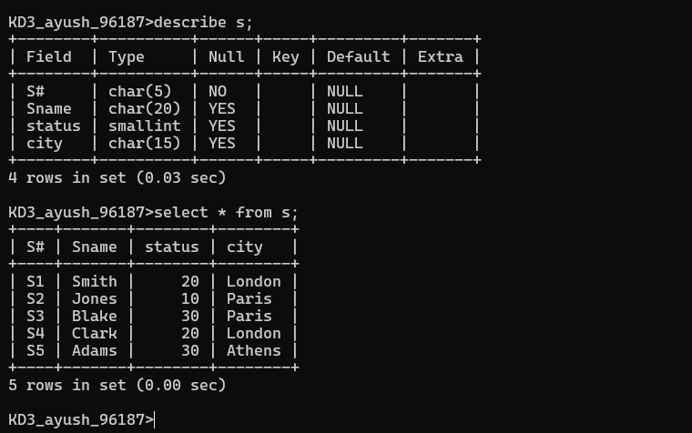

P table
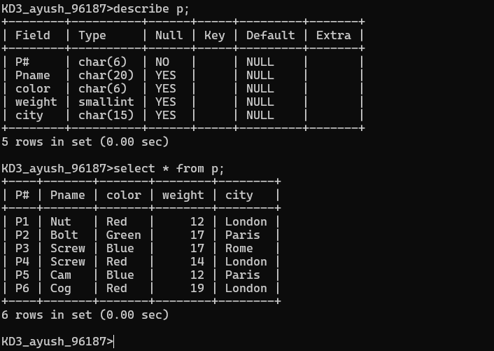

J table
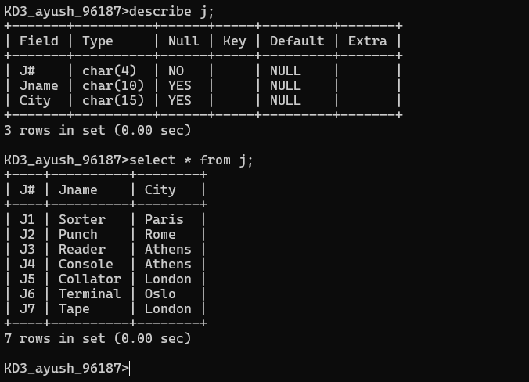

Sp table
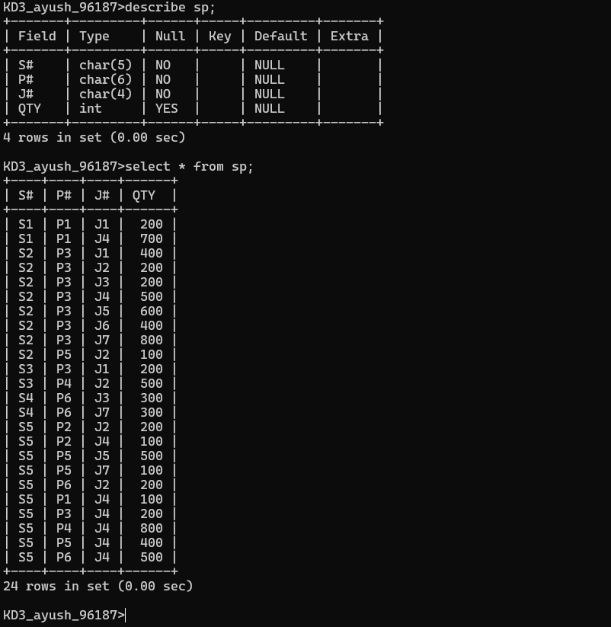

Answer the following questions (by observations only – not queries).
- How many orders data is present in the database?
-> 10
2. How many customers are present in the database?
-> 7
3. How many salespeople are present in the database?
-> 5
4. On which date order with highest amount is placed?
-> 1990-10-04
5. For which order salesman got maximum commission? Hint: you need to refer data of two tables.
-> 3011
6. Which salesmen are handling more than two customers? Hint: you need to refer data of two tables.
-> Peel
7. Which city have single customer?
-> Berlin
8. Which city has multiple salespeople?
-> London
9. What is name of customer and salesman of the maximum amount order?
-> customer : Clemens & salesman: Peel
10. Study relationship between the tables in sales database.
-> order tables having the : Order number of customer & amount of that order number & order date of that order & orderd by which customer(common in customer table) & sale by which salesperson(common in salespeople table).
->Customer table having the: customer number(common in order table) & customer name & city of the customer & rating of that customer & salesman who is providing the service to customer (common in salespeople table)
->salespeople table having the: salespeople number(common in the order table & customer table) & salesman name & city of the salesman & salesman commission on each oder

