Name: Chavan Jagdish Shivdas
Roll No : 80099
Group - KD4

Assignment No:-1

1)man:-

Command:- man cal(Command to get help about commands).
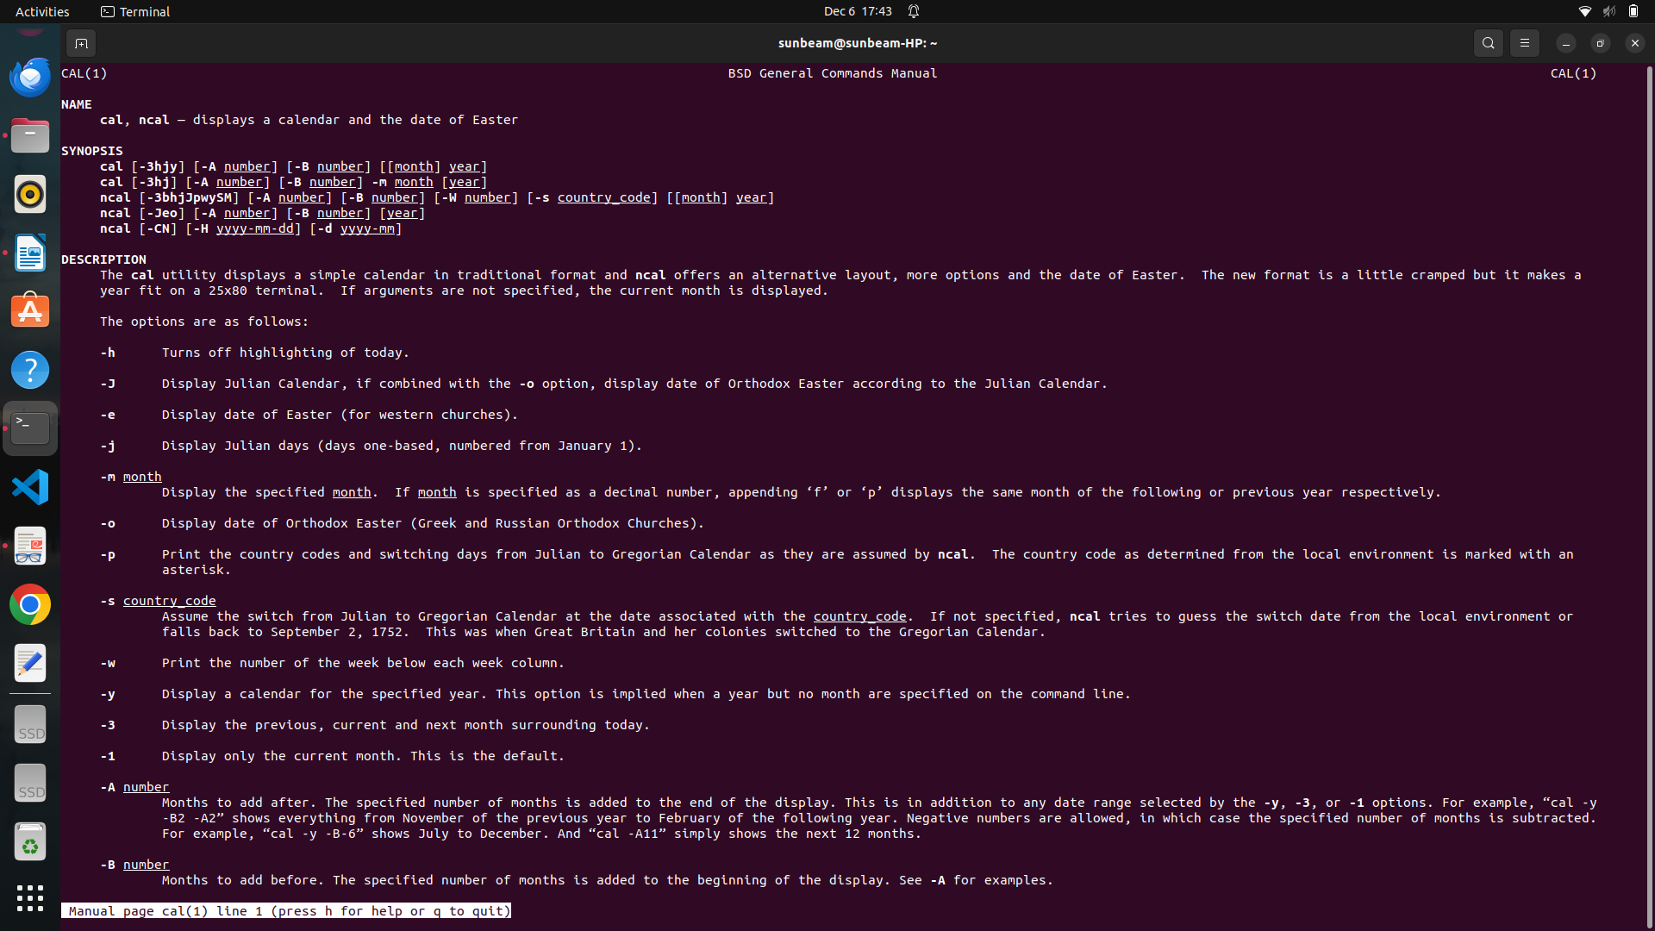

2)uname:-

command:-uname(Print System information).
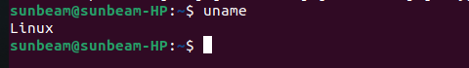

3)pwd:-

command:-pwd(Print current directory).

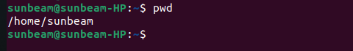

4)hostname:-

command:-hostname(Print IP address and hostname of the machine)



5)date:-

command:-date(Find today’s date)



6)cal:-

command:-cal(Print calendar for current year)

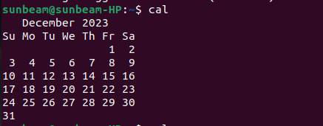

7)ls, dir:-

commnad:-ls,dir(See directory structure)

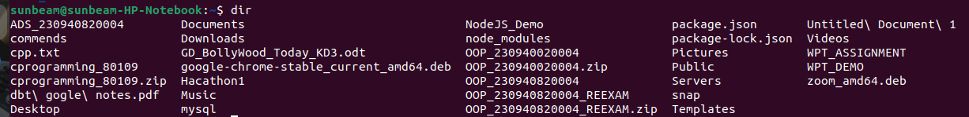

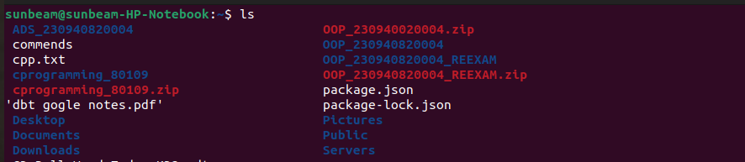

8)cat:-

command:-cat>Test.txt(create file)
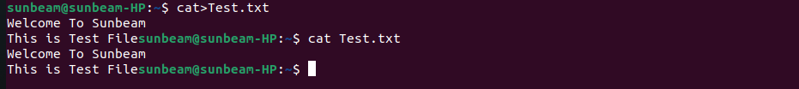

9)cat >>:-

command:- cat>>Test.txt(Append some text into existing file)

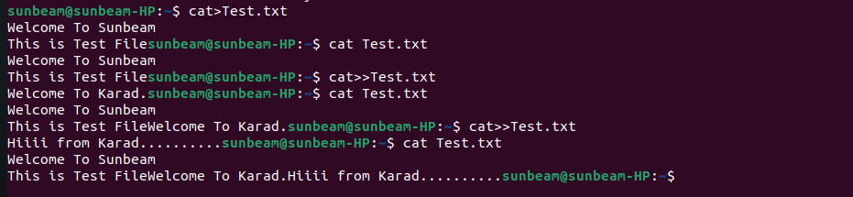

10)cp:-

command:-(Copy a file, Copy a directory)

Copy a file:-

Copy a directory:-

11)mv:-

command:- mv Test.txt new.txt-->for rename
mv new.txt OSC(Move the files)

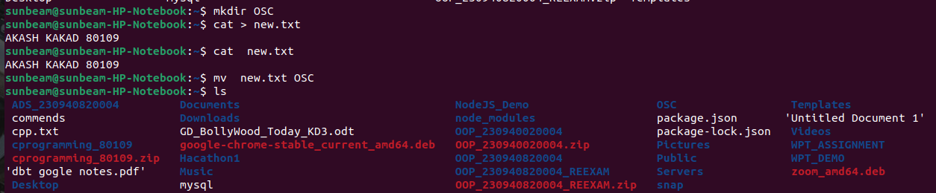

12)mv(Rename a file):-
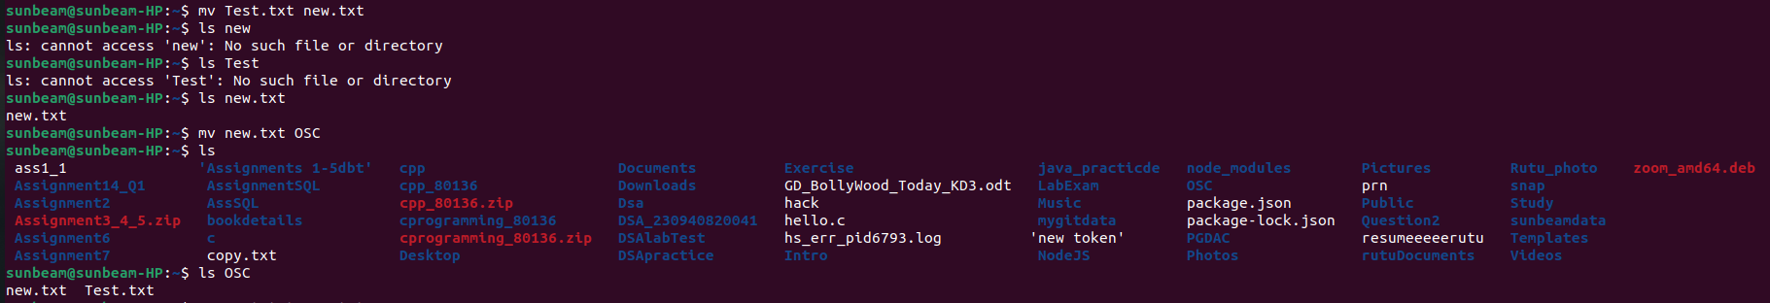

13)tac, rev(Print the file in reverse order, Reverse each line in the file):-

tac:-

rev:-

14)mkdir:-(Create directory)

15)wc:-(Count the words, characters and lines in a file)

16)cd(Change current directory):-

17)rm(Remove a file, remove a directory ( with -R )):-

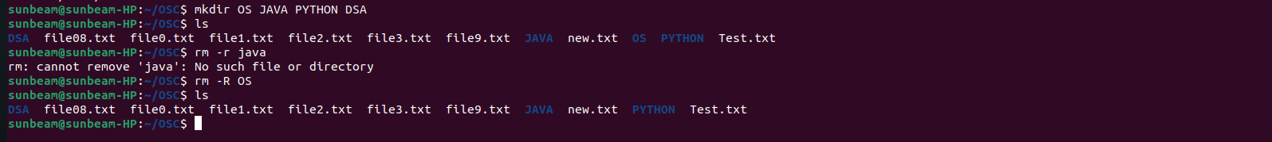
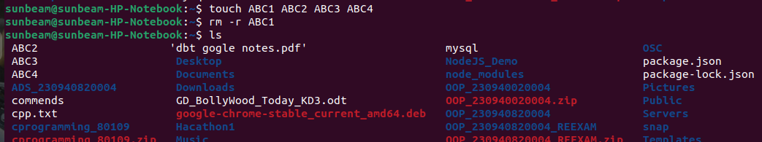

18)rmdir(remove empty directory):-

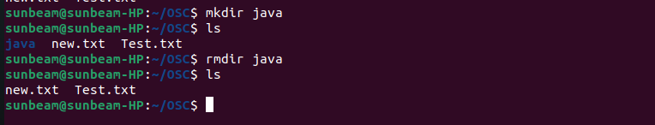

19)touch(change the modification time , Create Multiple empty files at once):-



20)sort(Sort file.):-
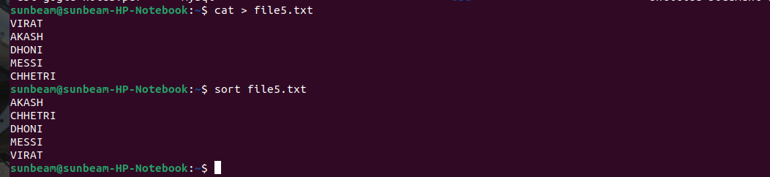

21)uniq(Avoid repetition in a file.):-



22)head(Print the specified number of lines from top in the file.):-

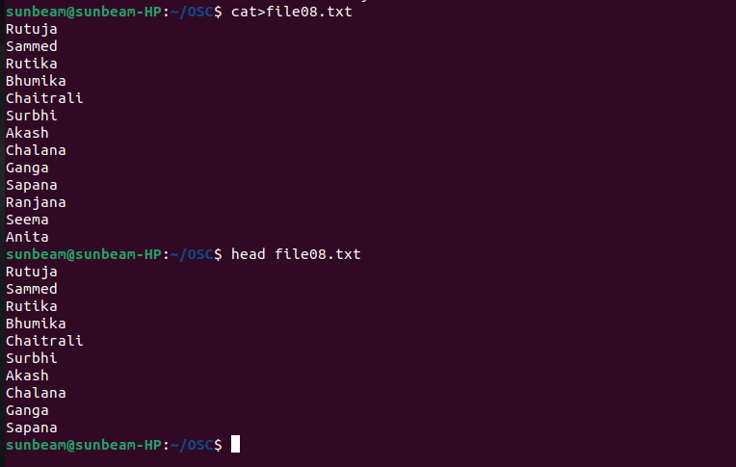

23)tail(Print the specified number of lines from bottom in the file.):-

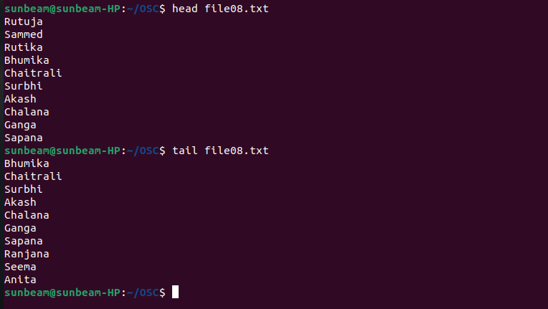

24)factor(Find the factors of a number):-

25)alias(Create command shortcut):-
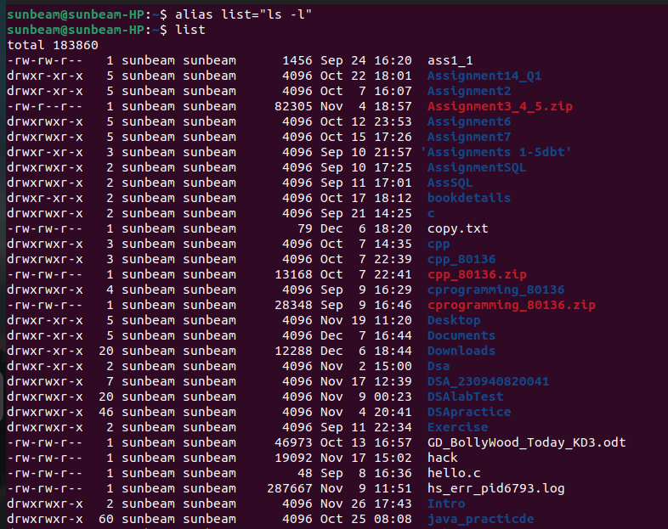

26)unalias(remove the command shortcut):-
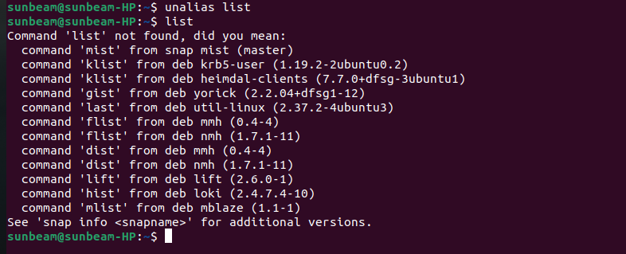

27)echo(Print environment variables individually):-

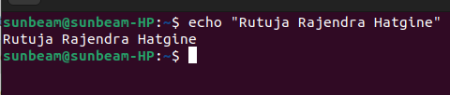

28)ps(Print current processes):-

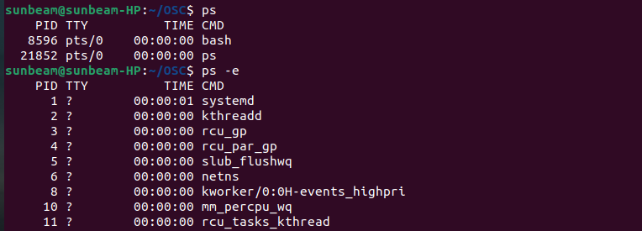

29)kill(Kill the process):-

30)env(Print environment variables):-

