SQL ASSIGNMENT NO1

Name – Tarun Gothwal

Roll No – 80113

Q1.Create the following tables with the given structures and insert sample data as specified :

1) Salespeople

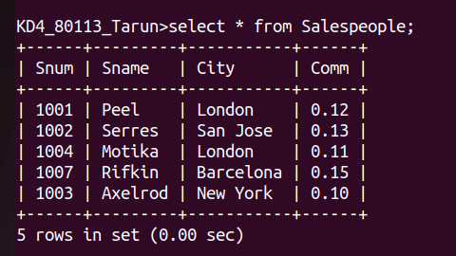

2) Customers

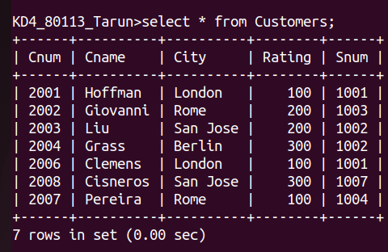

3) Orders :

