SQL ASSIGNMENT NO4

Name – Tarun Gothwal

Roll No – 80113

Retriving info from Tables:

Q1) Write a select command that produces the order no, amount , and date for all rows in the orders table?
Ans:

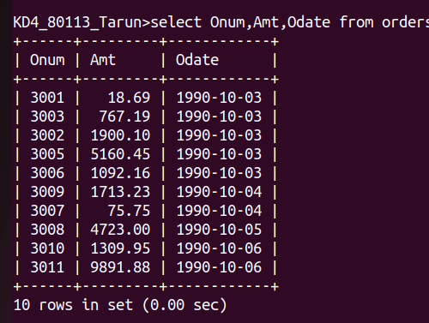

Q2)Write a query that produces all rows from customer table for which the salesperson’s number is 1001?
Ans:

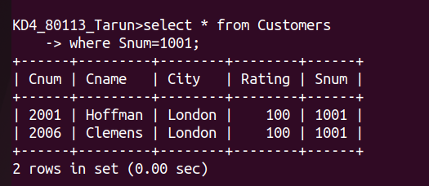

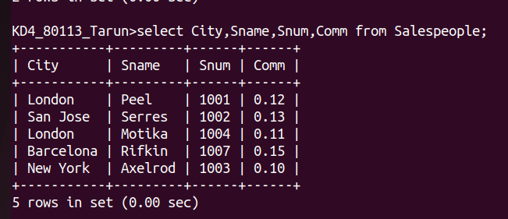
Q3) Write query that displays the Salespeople table with the columns in the following order : City, Sname, Snum,Comm?

Q4) Write a select command that produces the rating followed by the name of each customers in San Jose?
Ans:

