SQL ASSIGNMENT NO 6

Name – Tarun Gothwal

Roll No – 80113

Q1)Write two different queries that produces all orders taken on OCT 3rd and 4th ,1990?
Ans:

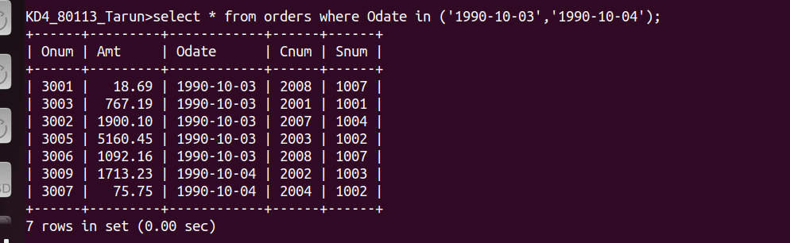

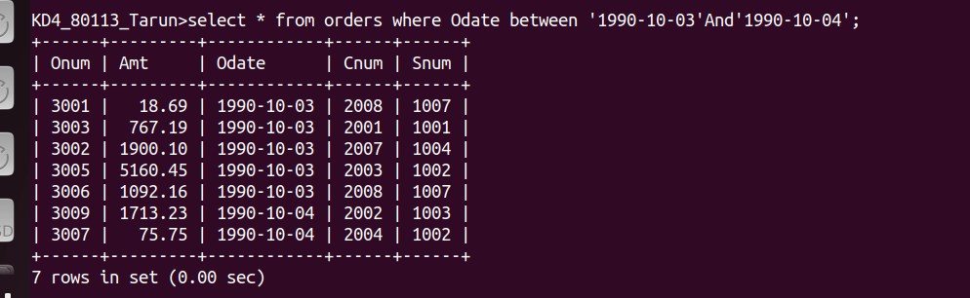

Q2)Write a query that selects all the customers services by Peel or Motika.
Ans:

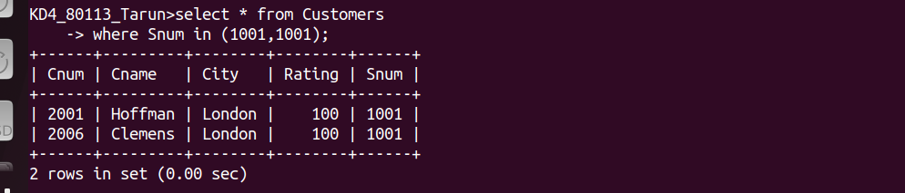

Q3)Write a query that produce all the customers whose names begin with leteer from “A” to “G”?
Ans:

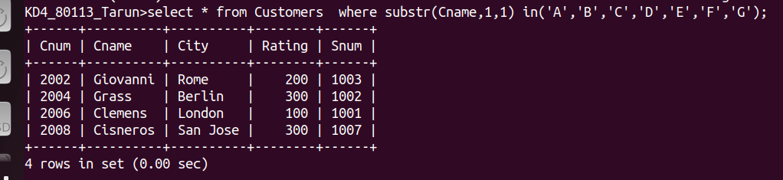

Q4)Write query that selects all customers whose names begin with the letters “C”?
Ans:

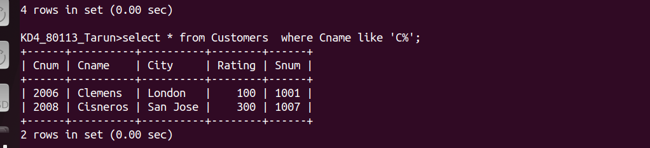

Q5)Write a query that selects all orders except those with zeroes or Nulls in the amt field?
Ans:

