SQL ASSIGNMENT NO 7

Name – Tarun Gothwal

Roll No – 80113

Q1)Write a query that counts all orders for OCT 3?
Ans:

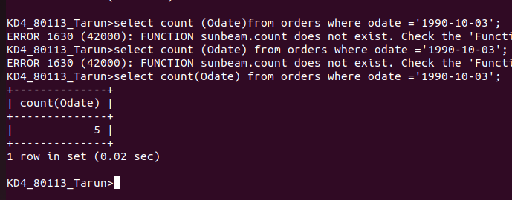

Q2) Write a query that counts the no of different non-Null city values in the customer table?
Ans:

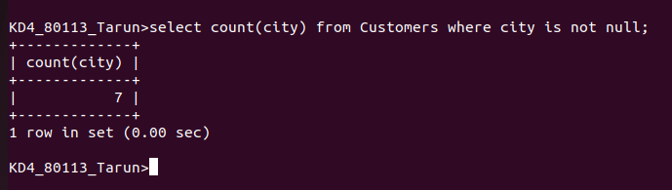
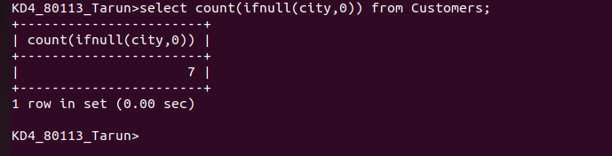

Q3) Write a query that selects each customers smallest order?
Ans:

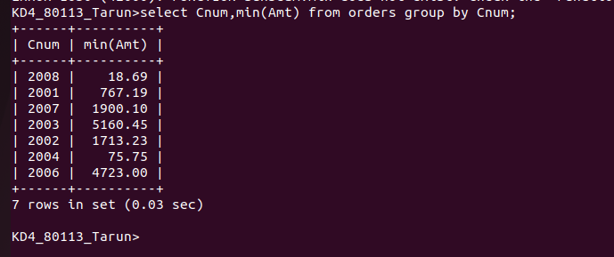

Q4)Write A query that selects the 1st customer in alphabetical order, whose nme begins with “G”?
Ans:

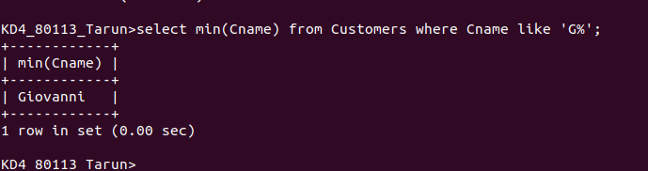

Q5) Write a query that selects the highest rating in each city?
Ans:

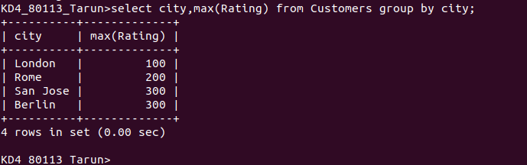

Q6)write a query that counts the no of salespeople registering orders for each day (if a salesperson has more than one orders on a givenday he or she should be counted only once)
Ans:
