SQL ASSIGNMENT NO 5

Name – Tarun Gothwal

Roll No – 80113

Q1)Write query that will give you all orders for more than Rs.1000?
Ans:

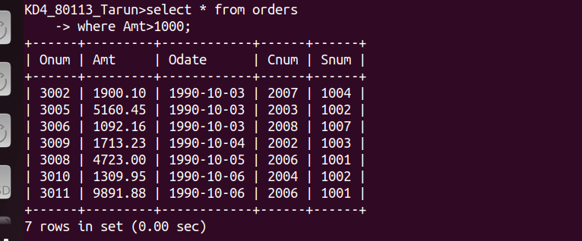

Q2)Write a query that will give you the names and cities of all salespeople in London with a commision above 0.10 ?
Ans :

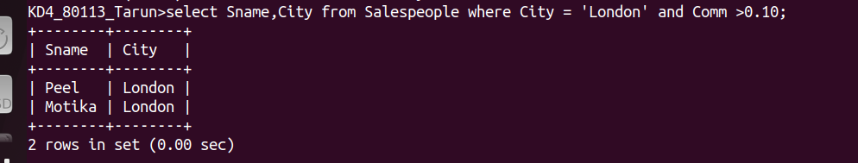

Q3)Write a query on the Customers tables whose output will exclude all customers with a rating <=100, unless they are located in Rome?
Ans:

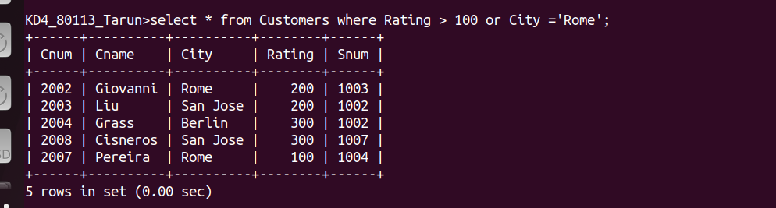

Q4)What will be the otuput of follwing query?
Ans:

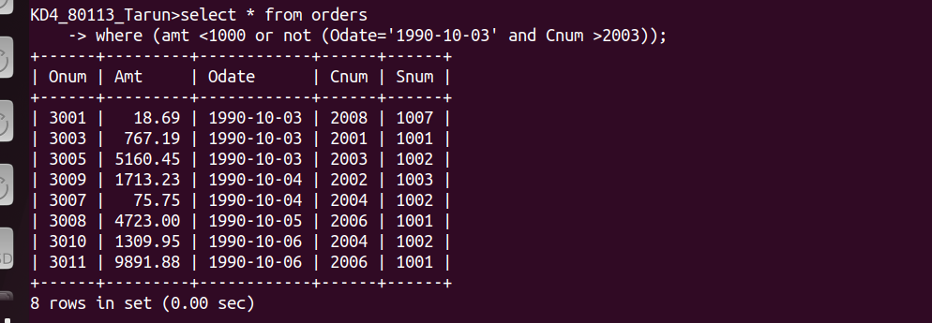

Q5)What will be the otuput of follwing query?
Ans:

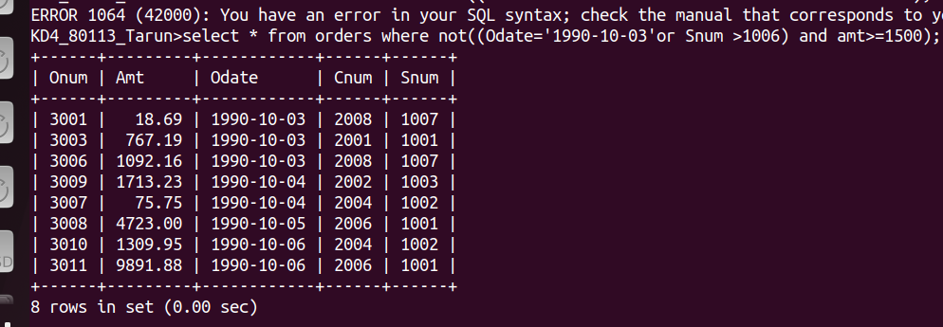

Q6)What will be the simpler way to write follwing query?
Ans:


