ASSIGNMENT 14
Q.1 Write a command that puts the following values , in their given order, into the salespeople table: city- San Jose, name – Blanco, comm – Null, cnum – 1100.
Ans.
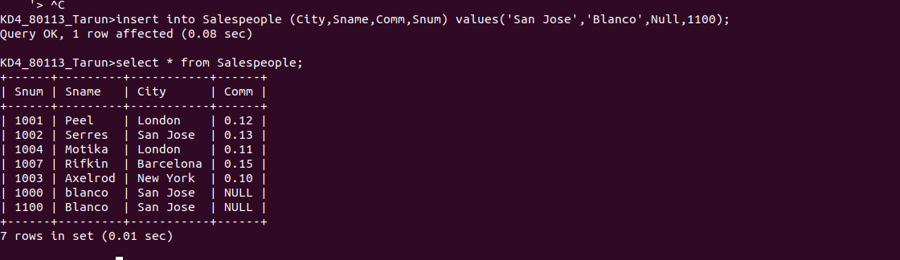
Q.2 Write a command that removes all orders from customer Clemens from the Orders table.
Ans.

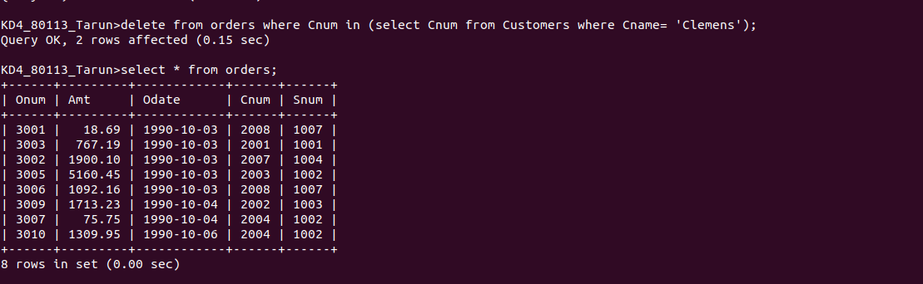

Q.3 Write a command that increases the rating of all customers in Rome by 100.
Ans.

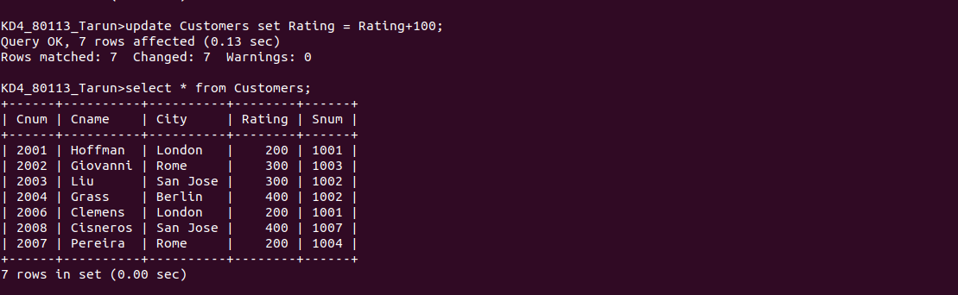

Q.4 Salesperson Serres has left the company. Assign her customers to Motika.
Ans.

