SQL ASSIGNMENT NO 8

Name – Tarun Gothwal

Roll No – 80113

Formatting Query

Q1)Assume each salesperson has a 12% commision ,Write a query on orders table that will produce the order numbers,salesperson num,and amount of the commision for that order?
Ans:

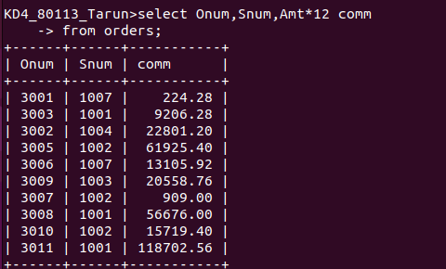

Q2) Write a query on the customer table that will find the highest rating in each city put the output in following form ?
(For city (city),the highest rating is :( rating )
Ans:

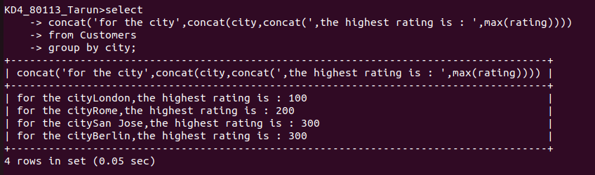

Q3) Write a query that lists customers in descending order of rating o/p the rating field 1st followed by customers name and number ?
Ans:



Q4)Write A query that totals the orders for each day and places the result in descending order?
Ans:



