SQL ASSIGNMENT NO 9

Name – Tarun Gothwal

Roll No – 80113

Querying Multiple Tables at once;

Q1) Write a query that lists each order numbers followed by the name of customer of who made the order?
Ans:

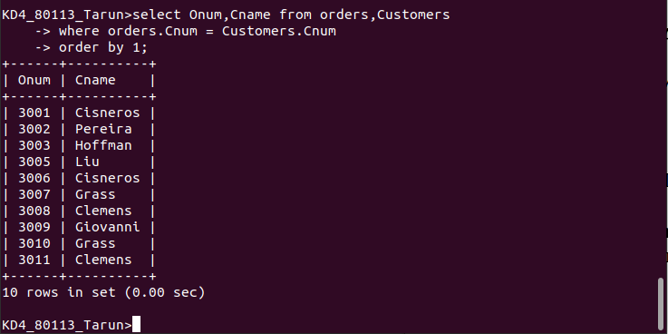

Q2)writeb a query that gives the names of both the salesperson and customer for each order along with the order number?
Ans:

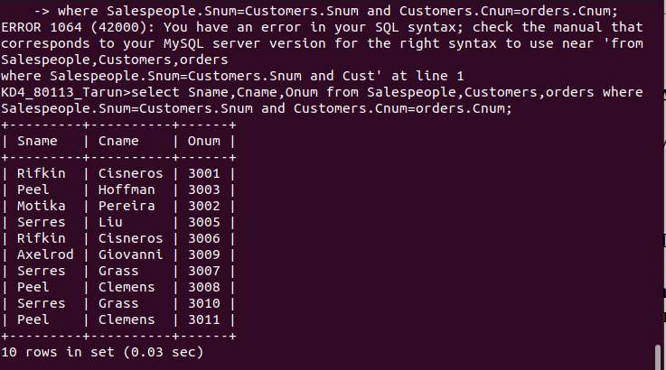

Q3) Write a query that produces all customers serviced by salespeople with a commision above 12%.output the customers name ,the salesperson name ,and the salespersons rate commision?
Ans:

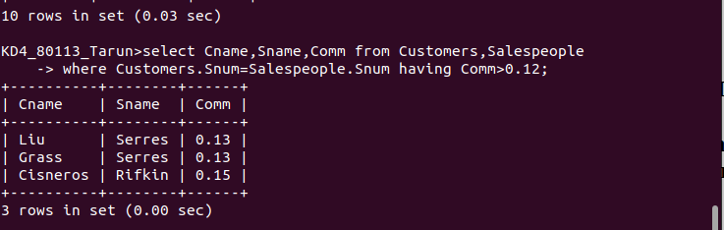

Q4)Write a query that calculate the amount of the salespersons commission on each order bt a customer with a rating above 100?
Ans:
