Assignment- 12
1) Write a query that selects all customers whose ratings are equal to or greater than ANY of Serres.
Ans:-
SELECT * FROM CUSTOMERS WHERE Rating >= ANY(SELECT Rating FROM CUSTOMERS WHERE Snum = (SELECT Snum FROM SALESPEOPLE WHERE Sname="Serres"));
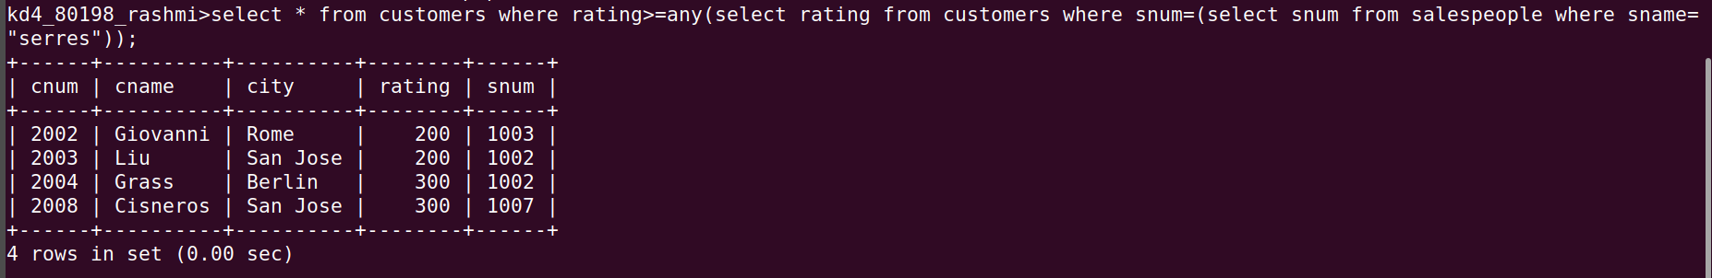
2) Write a query using ANY or ALL that will find all salespeople who have no customers located in their city.
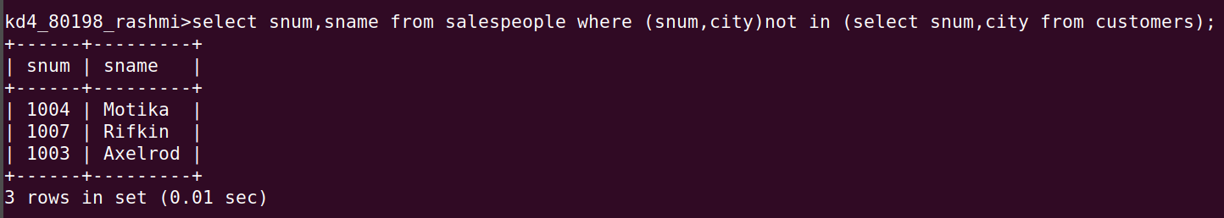
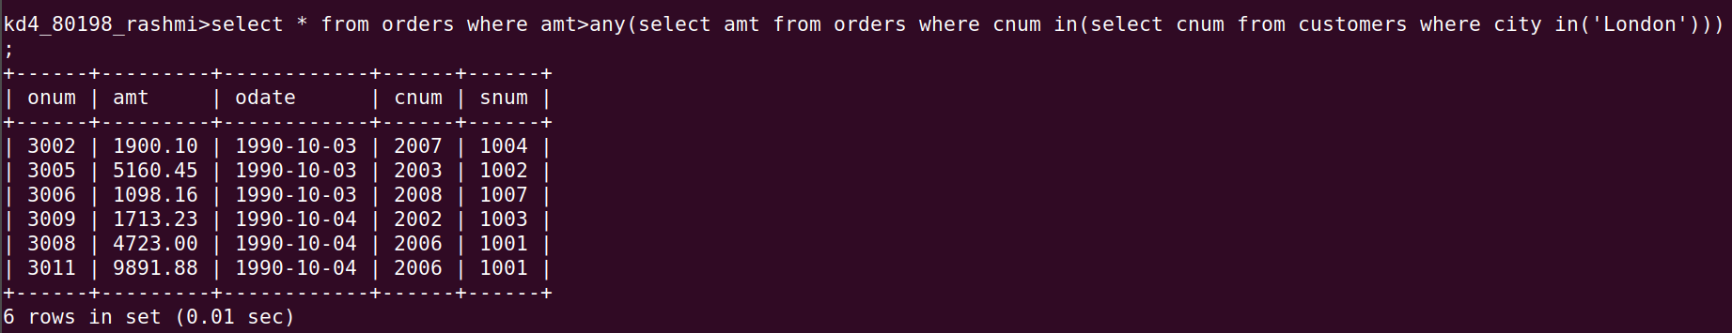
Ans:-
SELECT Snum, Sname FROM SALESPEOPLE WHERE (Snum ,City) NOT IN (SELECT Snum, City FROM CUSTOMERS);
3) Write a query that selects all orders for amounts greater than any for the customers in London.
Ans:-
SELECT * FROM ORDERS WHERE Amt> ANY (SELECT Amt FROM ORDERS WHERE Cnum IN (SELECT Cnum FROM CUSTOMERS WHERE City IN('London')));

4) Write the above query using MIN or MAX.
Ans:-
SELECT * FROM ORDERS WHERE Amt> (SELECT MIN(Amt) FROM ORDERS WHERE
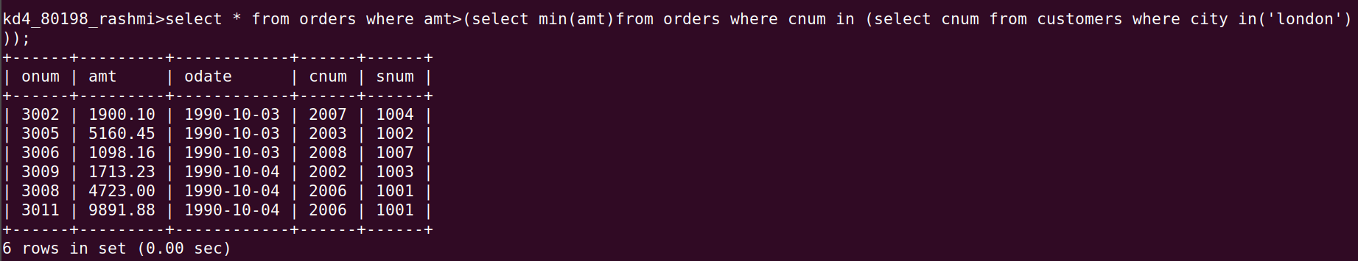
Cnum IN (SELECT Cnum FROM CUSTOMERS WHERE City IN('London')));

