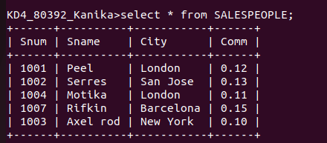
Q 1 Create the following tables with the given structures and insert sample data as specified:-

A) SALESPEOPLE

B) CUSTOMERS

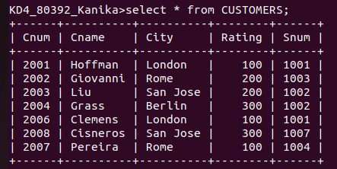

C) ORDERS

