Q 1 Write a select command that produces the order number, amount, and date for all rows in the Orders table.

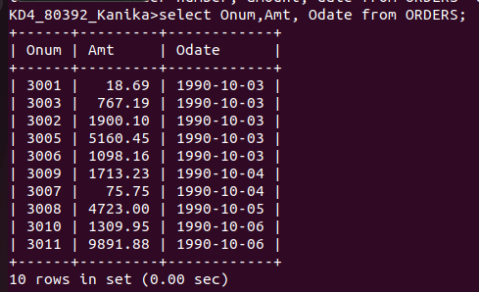

Q 2 Write a query that produces all rows from the Customers table for which the salesperson’s number is 1001.

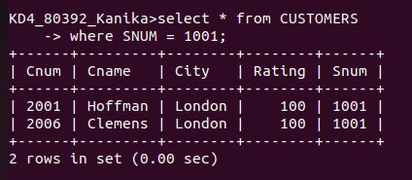

Q 3 Write a query that displays the salespeople table with the columns in the following order:
city, sname, snum, comm.

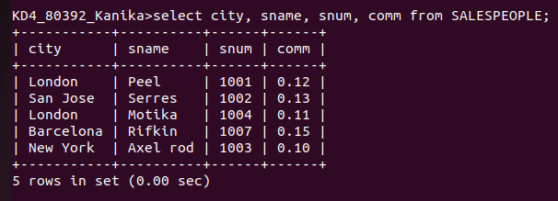

Q 4 Write a select command that produces the rating followed by the name of each customer in San Jose.

