Q 1 Write a query that will give you all orders for more than Rs. 1000.

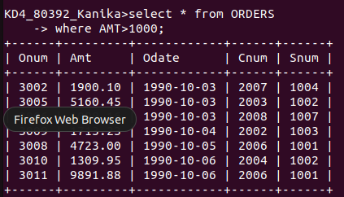
o

Q 2 Write a query that will give you the names and cities of all salespeople in London with a commission above .10.

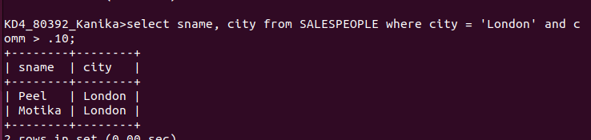

Q 3 Write a query on the customers table whose output will exclude all customers with a rating <=100, unless they are located in Rome.

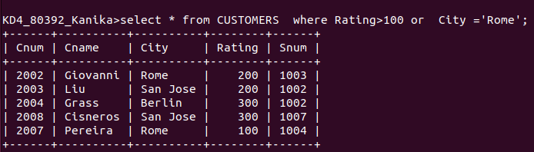

Q 4 What will be the output from the following query?

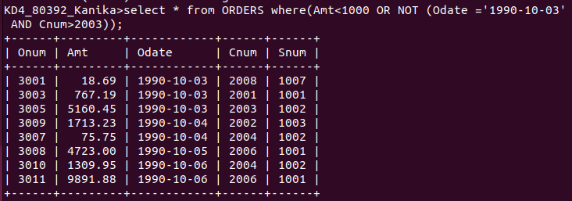

Q 5 What will be the output of the following query?

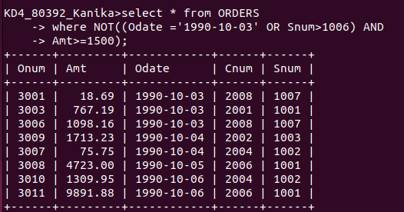
J

Q 6 What is a simpler way to write this query?

