Q 1 Write two different queries that would produces all orders taken on October 3rd or 4th, 1990.

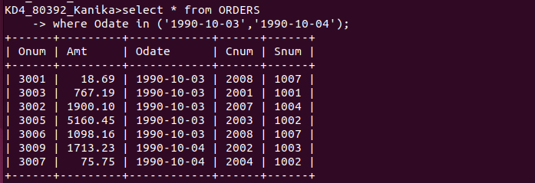

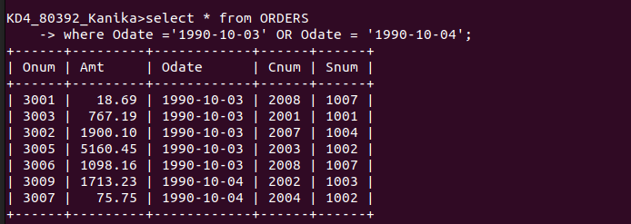

Q 2 Write a query that selects all of the customers serviced by peel or Motika.

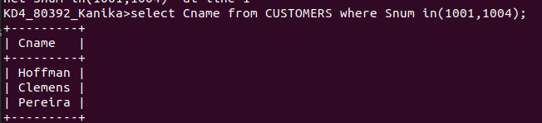

Q 3 Write a query that will produce all the customers whose names begin with a letter from ‘A’ to ‘G’.

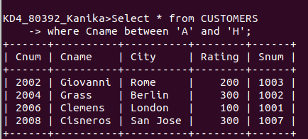

Q 4 Write a query that selects all customers whose names begin with the letter ‘C’.

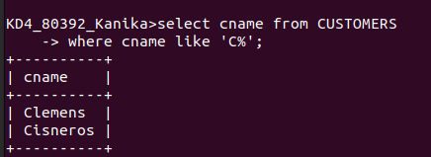

Q 5 Write a query that selects all orders except those with zeroes or NULLS in the amt field.

