Q 1 Write a query that counts all orders for October 3;

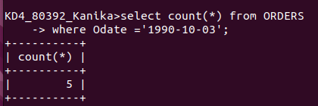
j

Q 2 Write a query that counts the number of different non – NULL city values in the customers table.

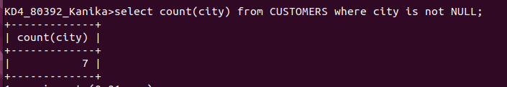

Q 3 Write a query that selects each customer’s smallest order.

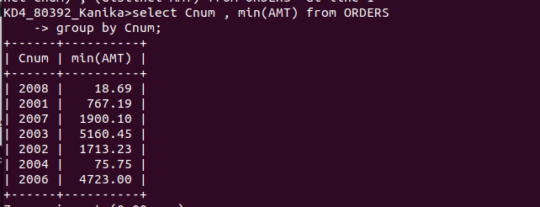

Q 4 Write a query that selects the first customer in alphabtical order, whose name begins with G.

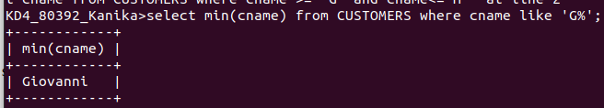

Q 5 Write a query that selects the highest rating in each city.

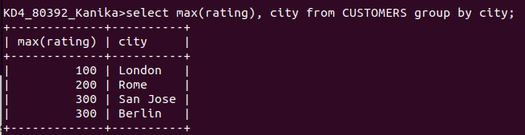

Q 6 Write a query theat counts the number of salespeople registering orders for each day.

