Q 1 Write a query that lists each order number followed by the name of the customer who made the order.
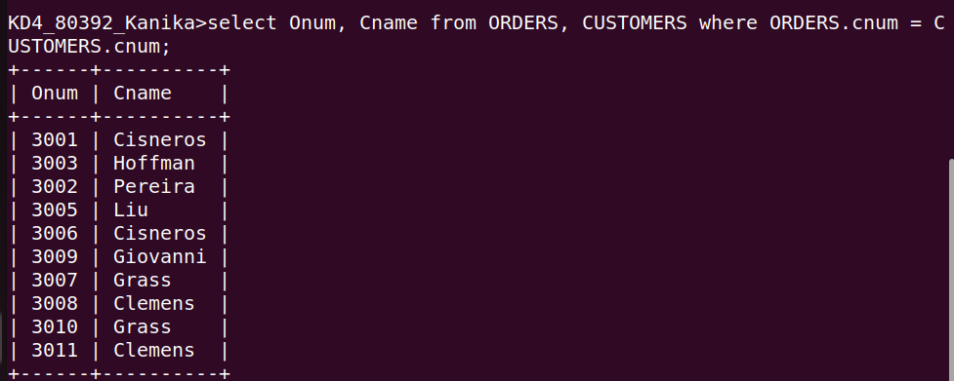

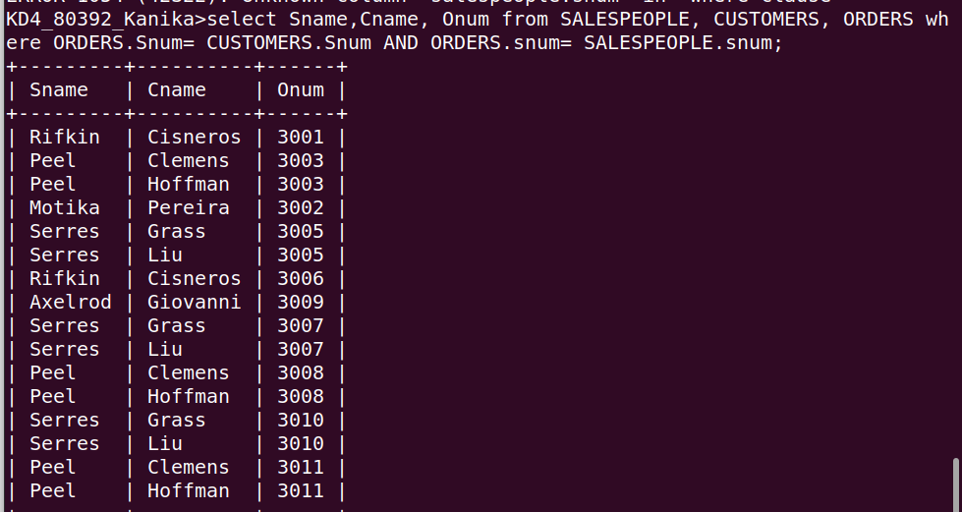
Q 2 Write a query that gives the names of both the salesperson and the customer for each order along with the order number.

Q 3 Write a query that produces all customers serviced by salespeople with a commission above 12%. Output the customer’s name, the salesperson’s name, and the saleseperson’s rate of commission.
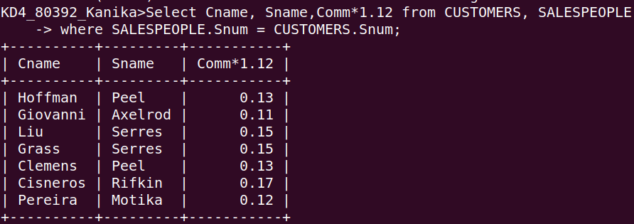

Q 4 Write a query that calculates the amount of the saleseperson’s commission on each order by a customer with rating above 100.

